House Votes Manual

|  |  |  |  |
| --- | --- | --- | --- |
|  |  | Predicted | |
|  |  | Democrat | Republican |
| Actual | Democrat | 258 | 9 |
| Republican | 8 | 160 |

(1) Overall classification accuracy = **0.961**

(2) Assuming “Democrat” is positive, sensitivity = **0.966** and specificity = **0.952**. If “Republican” is positive, then the opposite is true.

(3) Assuming “Democrat” is positive, positive predicted value = **0.970** and negative predicted value = **0.947**. If “Republican” is positive, then the opposite is true.

(4 Extra Point!) Calibration curve for a selected bin count or window size:

Bin count = 10

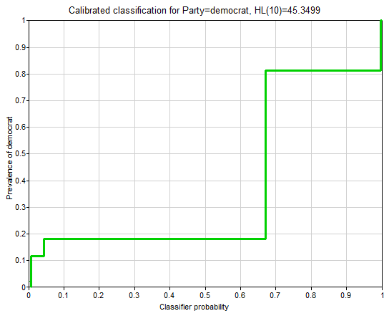

House Votes Naïve Bayes

|  |  |  |  |
| --- | --- | --- | --- |
|  |  | Predicted | |
|  |  | Democrat | Republican |
| Actual | Democrat | 238 | 29 |
| Republican | 14 | 154 |

(1) Overall classification accuracy = **0.901**.

(2) Assuming “Democrat” is positive, sensitivity = **0.891** and specificity = **0.917**. If “Republican” is positive, then the opposite is true.

(3) Assuming “Democrat” is positive, positive predicted value = **0.944** and negative predicted value = **0.842**. If “Republican” is positive, then the opposite is true.

(4 Extra Point!) Calibration curve for a selected bin count or window size:

Bin count = 10

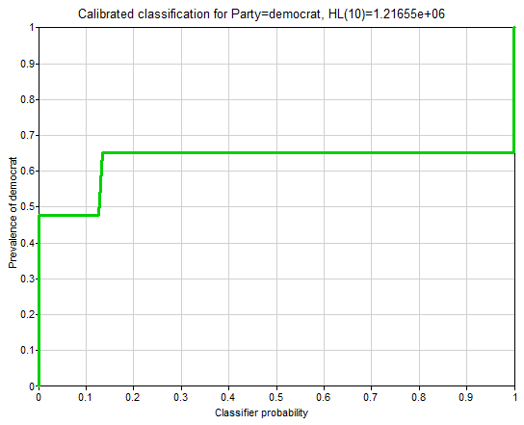

House Votes PC

|  |  |  |  |
| --- | --- | --- | --- |
|  |  | Predicted | |
|  |  | Democrat | Republican |
| Actual | Democrat | 256 | 11 |
| Republican | 7 | 161 |

(1) Overall classification accuracy = **0.959**.

(2) Assuming “Democrat” is positive, sensitivity = **0.959** and specificity = **0.958**. If “Republican” is positive, then the opposite is true.

(3) Assuming “Democrat” is positive, positive predicted value = **0.973** and negative predicted value = **0.936**. If “Republican” is positive, then the opposite is true.

(4 Extra Point!) Calibration curve for a selected bin count or window size:

Bin count = 10

