**Assignment 8**

**Katherine Rodgers and John Merranko**

1. **Apply the HITS algorithm to the following network:**

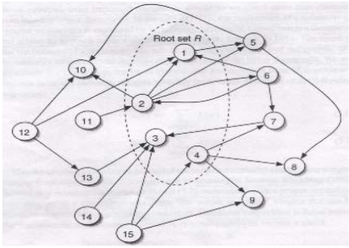

We used the igraph package in R to execute the HITS algorithm and calculate the authority and hub scores shown below:

|  |  |  |
| --- | --- | --- |
| **Node** | **Authority Score** | **Hub Score** |
| 1 | 1 | 0.17289322 |
| 2 | 0.28590987 | 1 |
| 3 | 0.07432706 | 0 |
| 4 | 0.04145797 | 0.29469999 |
| 5 | 0.49353221 | 0.43728074 |
| 6 | 0.42078188 | 0.57931349 |
| 7 | 0.36776903 | 0.02603811 |
| 8 | 0.30800422 | 0 |
| 9 | 0.16546238 | 0 |
| 10 | 0.94023519 | 0 |
| 11 | 0 | 0.10015937 |
| 12 | 0 | 0.79721472 |
| 13 | 0.33545351 | 0.02603811 |
| 14 | 0 | 0.02603811 |
| 15 | 0 | 0.09852603 |

Given the results above, we believe the best base set would be S={1,2,4,5,6,7,8,9,10,12,13}, as these nodes all have authority and/or hub scores above 0.1.

1. **Find the hubs and authorities of the graphs below given by HITS. Are the results consistent with the notions of hubs and authorities?**

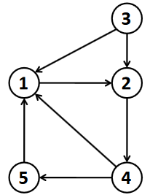

|  |  |  |
| --- | --- | --- |
| **Node** | **Authority Score** | **Hub Score** |
| 1 | 1 | 0.3472964 |
| 2 | 0.5320889 | 0 |
| 3 | 3.38423E-17 | 1 |
| 4 | 0 | 0.8793852 |
| 5 | 0.3472964 | 0.6527036 |

The primary authority in the network above is node 1, and node 2 is a lesser authority. The primary hubs are nodes 3 and 4. Node 5 is a lesser hub and somewhat of an authority, but is not nearly as much of either. I believe these results are consistent with the notions of hubs and authorities given that node 1 is linked to by every node except node 2, which links to node 1 indirectly through node 4; likewise, node 3 has only out-links which link directly or indirectly to every other node in the network. It is also important to note that the strongest hub out-links to the strongest authority, which is an expected result.

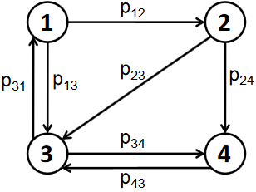

|  |  |  |
| --- | --- | --- |
| **Node** | **Authority Score** | **Hub Score** |
| 1 | 0.2090569 | 0.8270909 |
| 2 | 0.3382612 | 1 |
| 3 | 1 | 0.5111703 |
| 4 | 0.618034 | 0.618034 |

The primary authority in the network above is node 3. The primary hub is node 2, and node 1 a lesser hub. I believe these results are consistent with the notions of hubs and authorities given that node 3 has the maximum number of in-links; likewise, node 2 ties for the most number of out-links, and it out-links to the strongest and second strongest authorities (nodes 3 and 4). Again, it is important to note that the strongest hub out-links to the strongest authority.