**TO DISCOVER QUICK AND EFFECTIVE ROUTES AGAINST SEXUAL STREET HARASSMENT**

| Juan Martín Espitia Gonzalez Universidad Eafit  Colombia  jmespitiag@eafit.edu.co | David Alejandro Blandón Román  Universidad Eafit  Colombia  dablandonr@eafit.edu.co | Daniel Stiven Betancur Rodriguez Universidad Eafit  Colombia  dsbetancu1@eafit.edu.co |
| --- | --- | --- |

**ABSTRACT**

Despite the human society have evolved a lot on this last centuries, some of the most relevant problems that we have had throughout our history are still relevant to this day. One of them, and a really worrying one is the sexual street harassment. They are non-consensual practices of sexual connotation carried out by an unknown person, in public spaces such as the street, transport or semi-public spaces that usually generate discomfort in the victim. Is something to be concerned of that those kinds of behaviors could be normalized pretty easily in our society, at the same that are beginning to be more and more common along the streets of our city, compromising the free movement of people and their safety, even sometimes refraining them from taking a short path for fear of being abused, taking a longer or simpler one, instead deciding not to go anywhere. Besides, the victims of abuses of this kind can experience fear to be outdoors, social isolation, trigger symptoms of depression and anxiety that are new to the person; or it can exacerbate a previous condition that may have been controlled or resolved.[1] According to above, is pertinent to find an efficient solution by giving an alternative navigation system that take into account both the ease of the journey and the safety of the users as far as this problem is concerned

**Key words**

| Street sexual harassment, path, fear, alternative navigation system, journey and safety |
| --- |

**1. INTRODUCTION**

The street harassment against women in Medellín is a complete worrying situation. The office of Councilwoman Daniela Maturana presented a survey in which 940 women participated and which revealed that women are commonly harassed in public spaces. The place where the most respondents reported having been victims of harassment was in the streets, with 94.4%; However, other scenarios are also sources of aggression, since spaces such as the subway and transport (54%), parks (44%), shopping centers (21%), sports venues (20%) and universities (20%) followed. 14%). [2].

* 1. **The problem**

Sexual street harassment is a unwelcome behavior of a sexual nature for example a man who says uncomfortable and sexual comments about a women

In the last years the 61.5% of women of some neighborhoods of Medellín, manifest discomfort when they hang out later than 7:00pm, that reflex that this behavior affects women for the most part, since apart from discomfort, women can also present psychological consequences like depression, anxiety, fear, among others [3]

**1.2 The Solution**

Not all streets of Medellín have a high harrasment risk, some streets are recognized for being non-dangerous, and others are recognized as dangerous, this gives us an advantage because we can know where to go without risking ourselves, the thing is that there are people who don't know this, such as those who arrive new to the city, or those who simply do not know since they do not know since they do not live in these areas etc…

For this we created a solution that is, through a database there the level of risk is found in each street of Medellín and using the dijkstra’s algorithm, we determine which is the route from the point of origin to the destination most safest, the shortest route, and the average of these two, that mean safe and short

**1.3 Structure of the article**

Next, in Section 2, we present work related to the problem. Then, in Section 3, we present the datasets and methods used in this research. In Section 4, we present the algorithm design. Then, in Section 5, we present the results. Finally, in Section 6, we discuss the results and propose some directions for future work.

**2. RELATED WORK**

Below, we explain four works related to finding ways to prevent street sexual harassment and crime in general.

**2.1 Preventing Sexual Harassment Through a Path Finding Algorithm Using Nearby Search**

This software developed by Omdena is focused on predict places at high risk of sexual harassment incidents. First, the program generates a heatmap layer using gmaps Python package where the places with high risk are the hottest places, next, the algorithm finds the safest spots on the map based on the previous one. Finally, it superimposes the directions layer on the top of the safest spots of the map, which retrieves the safest routes for a specific place. The directions layer is based on the instruction given by the user, for example, find the nearest hospital.

The software implements the Bresenham’s line algorithm, which is a line drawing algorithm that determines the points of an n-dimensional raster that should be selected in order to form a close approximation to a straight line between two points. This is useful for tracking the hotspots in a map. [4]

**2.2 Beyond the Shortest Route: A Survey on Quality-Aware Route Navigation for Pedestrians**

This work contributes to the existing research domain by providing a big overview of the different quality-aware route navigation systems that have been proposed in past research for pedestrians. Examination different qualities which have been used as key criteria in route recommendation. Also, outlining the various data sources, algorithms and evaluation approaches that have been used to implement quality-aware route navigation systems. Of the most popular algorithms for solving these problems is Dijkstra’s algorithm. This one, given a starting node s in a weighted graph G, Dijkstra’s algorithm finds the shortest path between the node and every other node in the graph. [5] 2.3 Write a title for the third related problem

**2.3 Incorporating a Safety Index into Pathfinding**

This research incorporates a “safe pathfinding process”. It had three objectives: shorter travel time, lower route safety hazard index, and avoidance of sites with the highest safety hazard index along the route. The methodology was applied in a real-world street network to demonstrate its use and prove the concept of finding a safe path. The solution includes two main parts: a route-specific safety hazard index and a route-finding algorithm that considered both travel time and safe. That algorithm is derived from the median shortest-path problem (MSPP), normally solved using Dijkstra's algorithm. [6]

**2.4 Route-The Safe: A Robust Model for Safest Route Prediction Using Crime and Accidental Data**

People who are new to the city, have no idea about the safe routes. Though people rely on google maps for planning their routes; yet it only provides the shortest path & give no consideration for safety of the path

The algorithm uses application such as SafetyPad and Naive Bayes, that use a density map to assign risks to the routes, also through publications on social networks, classify and geocode crimes, so they can suggest routes that vary from the shortest distance to safety [7]

**3. MATERIALS AND METHODS**

In this section, we explain how the data were collected and processed, and then different alternative path algorithms that reduce both the distance and the risk of sexual street harassment.

**3.1 Data collection and processing**

The map of Medellín was obtained from *Open Street Maps* (OSM)[1]  and downloaded using the Python API[2] OSMnx. The map includes (1) the length of each segment, in meters; (2) the indication of whether the segment is one-way or not, and (3) the known binary representations of the geometries obtained from the metadata provided by OSM.

For this project, a linear combination (LC) was calculated that captures the maximum variance between (i) the fraction of households that feel insecure and (ii) the fraction of households with incomes below one minimum wage. These data were obtained from the 2017 Medellín quality of lifesurvey. The CL was normalized, using the maximum and minimum, to obtain values between 0 and 1. The CL was obtained using principal components analysis. The risk of harassment is defined as one minus the normalized CL. Figure 1 presents the calculated risk of bullying. The map is available on GitHub[3] .

**Figure 1.** Risk of sexual harassment calculated as a linear combination of the fraction of households that feel unsafe and the fraction of households with income below one minimum wage, obtained from the 2017 Medellín Quality of Life Survey.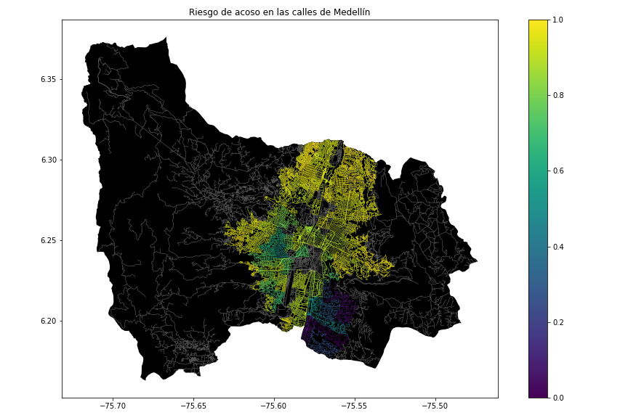

**3.2 Algorithmic alternatives that reduce the risk of sexual street harassment and distance**

In the following, we present different algorithms used for a path that reduces both street sexual harassment and distance.

**3.2.1 Lee Algorithm**

In this algorithm, given a maze in the form of the binary rectangular matrix, finds the shortest path’s length in a maze from a given source to a given destination. Namely, it allows to find the shortest route from a given start point to a given final point in a binary rectangular matrix. Is important to have into account that the time complexity of the backtracking solution will be higher since all paths need to be traveled. The complexity is O(M × N) where M and N are dimensions of the matrix. [8]

**3.2.2** **Floyd-Worshell algorithm**

The Floyd-Worshell algorithm is a dynamic algorithm for finding the shortest distances between all vertices of a weighted directed graph. Designed in 1962 by Robert Floyd and Stephen Worshell.

The general problem of finding the shortest paths is to find for each ordered pair of vertices v, w) any path from the vertex v to the vertices w whose length is minimal among all possible paths from v to w. [9]

**3.2.3 Backtracking**

This algorithm looks for shortest path in maze like Lee Algorithm, the difference is that this algorithm go backwards, it means, go from final to start, the idea of this algorithm is keep moving through a valid path until it get stuck, otherwise it go backtrack to the last traversed cell and explore other paths to the destination, this algorithm validate every move before undertaking it. If any move is not valid, it checks for the next one

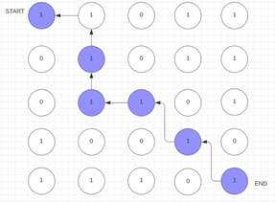

**3.2.4 Dijkstra's algorithm**

Dijkstra's algorithm allows us to find the shortest path between any two nodes of a graph. It differs from other algorithms because the shortest distance between two vertices might not include all the vertices of the graph.

Dijkstra's Algorithm works on the basis that any sub path B -> D of the shortest path A -> D between vertices A and D is also the shortest path between vertices B and D. The algorithm uses a greedy approach in the sense that we find the next best solution hoping that the end result is the best solution for the whole problem. [10]

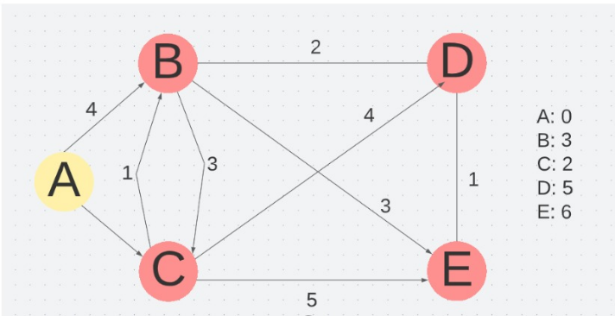

**4. ALGORITHM DESIGN AND IMPLEMENTATION**

## In the following, we explain the data structures and algorithms used in this work. The implementations of the data structures and algorithms are available on Github[4] .

**4.1 Data Structures**

The data structure to represent the map of the city was from the NetworkX library, this takes a panda dataframe and what it does is convert it into a graph with an adjacency matrix. It was made with three different weights that are, the weight of the length of the street, the weight of the risk of harassment and the average weight of these two. thus resulting in three graphs, one for each: the long, the risk and the average weights. The data structure is presented in Figure 2.

a)

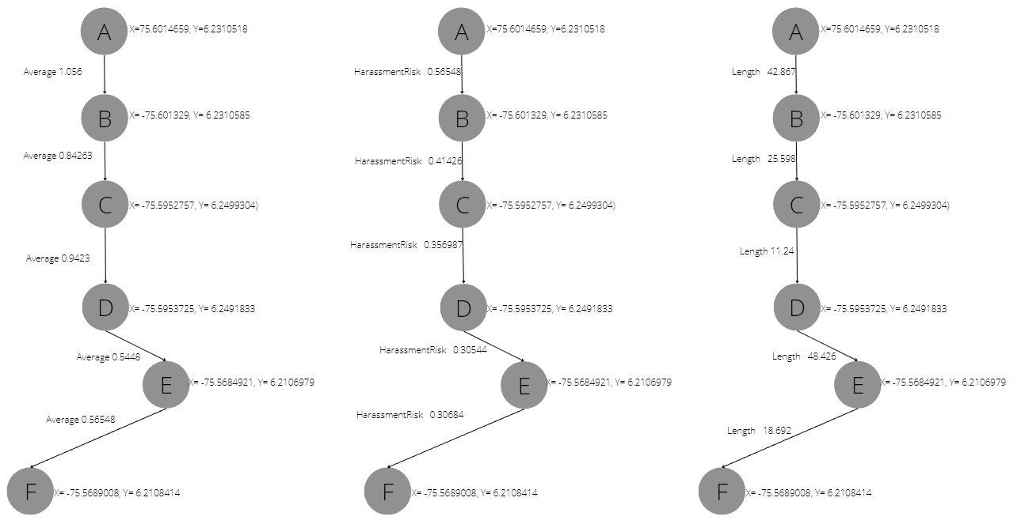

*graph for each variable (long, risk and average)*

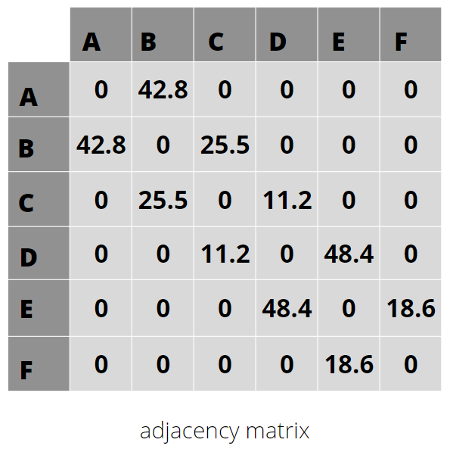

b)

**Figure 2:** An example street map is presented in (a) and its representation as an adjacency matrix in (b).

**4.2 Algorithms**

In this paper, we propose an algorithm for a path that minimizes both the distance and the risk of street sexual harassment.

**4.2.1 Algorithm for a pedestrian path that reduces both distance and risk of sexual street harassment**

For the road to be efficient, a safe and short street has to be used, sacrificing a little safety but with shorter streets

the design of this algorithm is based on measuring the streets and adding them with the risk. We did this by dividing all the streets by the longest street, so that we could have a reference value with which it is easier to operate with the risk of harassment. The value that gives us this operation is a percentage of 0 to 1, this values added with the risk of harassment and the result is the way where both the distance and de risk of harassment are reduced.The algorithm is exemplified in Figure 3.

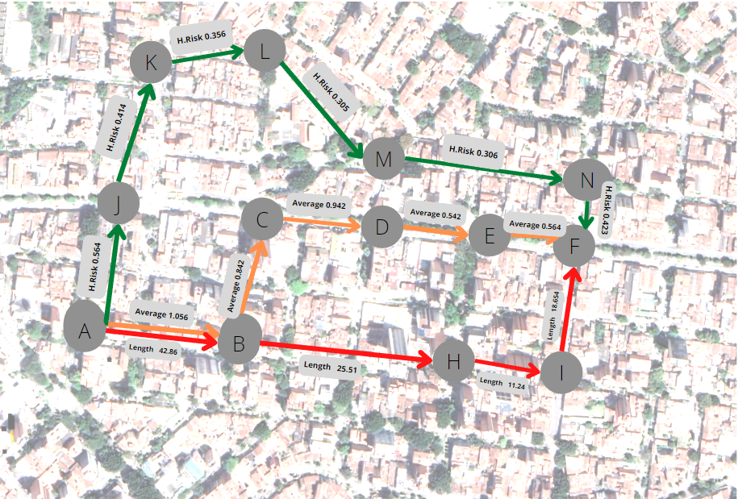

**Figure 3:** Calculation of a path that reduces both distance and risk of harassment

**REFERENCES**

1. Spector, N. The Hidden Health Effects Of Sexual Harassment, *BETTER by today,* 3. Retrieved August 15, 2072, from: <https://www.nbcnews.com/better/health/hidden-health-effects-sexual-harassment-ncna810416>
2. NN. 94% de las mujeres de Medellín ha sufrido acoso callejero, *Mujeres emprendedoras.* Retrieved August 16, 2022, from: <https://emprendedorasencalgary.ca/94-de-las-mujeres-de-medellin-ha-sufrido-acoso-callejero>
3. N.N, EL 90,1 POR CIENTO DE LAS MUJERES NO DENUNCIA EL ACOSO CALLEJERO, *EL TIEMPO,*1-5. Retrieved from: https://www.eltiempo.com/colombia/medellin/el-90-1-por-ciento-de-las-mujeres-no-denuncia-el-acoso-callejero-en-medellin-355056
4. NN. Preventing Sexual Harassment Through a Path Finding Algorithm Using Nearby Search, *Omdena.* Retrieved August 16, 2022, Pag 7
5. Siriaraya, P. Beyond the Shortest Route: A Survey on Quality-Aware Route Navigation for Pedestrians, IEEE Access, 1-23
6. He, Z. Qin, X. Incorporating a Safety Index into Pathfinding, 1-8.
7. SHIVANGI SONI, VEKATESH GAURI SHANKAR, DR. SANDEEP CHAURASIA, ROUTE-THE SAFE: A ROBUST MODEL FOR SAFEST ROUTE PREDICTION USING CRIME AND ACCIDENTAL DATA
8. N.N. Shortest path in a maze, *Techie Delight.* Retrieved August 16, 2022 Pag 1-5
9. NN. Floyd-Worshel Algorithm, *Intellect.icu. Retrieved August 16, 2022 from* [*https://intellect.ml/floyd-worshel-algorithm-4135*](https://intellect.ml/floyd-worshel-algorithm-4135)
10. N.N. Dijkstra's Algorithm. Programiz, 1-5. Retrieved from: https://www.programiz.com/dsa/dijkstra-algorithm

1. <https://www.openstreetmap.org/>
2. https://osmnx.readthedocs.io/
3. https://github.com/mauriciotoro/ST0245Eafit/tree/master/proyecto/Datasets
4. **https://github.com/jmespitiag/Routes_against_street_harassment.git**