**Data representation in React:**

We have represented the data in two forms as follows:

1. Table View
2. Card View

**Data manipulation**

To download the data from “<https://finance.yahoo.com/quote/%5EGSPC/history?p=%5EGSPC>” link in CSV format. We convert the data from CSV to JSON format through online link ‘<http://www.convertcsv.com/csv-to-json.htm>’ and bind the JSON data in the Table and Card View.

**Dependencies**

We have used the following packages for this sample

* ***react***
* ***react-dom***
* ***material-table – for rendering in Table view***
* ***@material/react-card – for rendering in Card view***
* ***react-router-dom - for Routing***

**Table View**

We have used ***React Material UI Table*** for represent the data in tabular view.

**Card View**

We have used ***React Material UI Card*** for represent the data in Card view.

***Run the application:***

To use the following command to run the application as :

* ***npm start***

***Note: Need to install the package in first time run the application . To use the following command for install react packages as :***

* ***npm install or yarn install***

***Screen shot :***

1. ***run the sample***

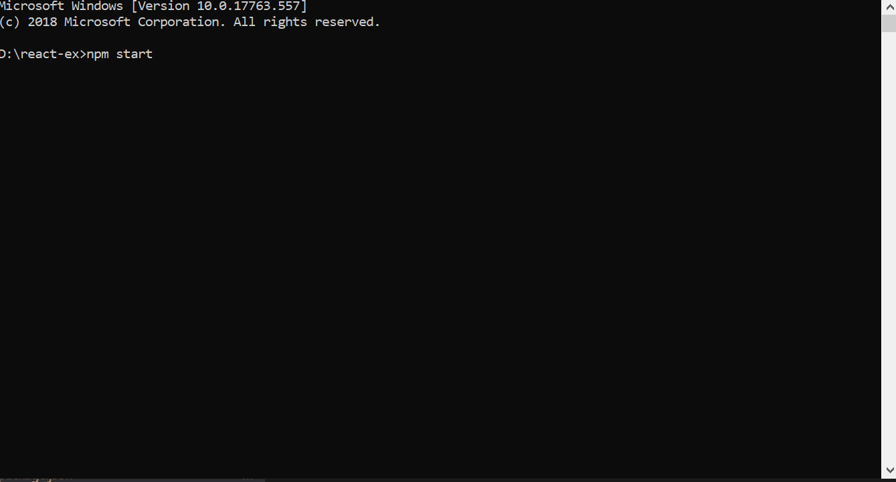

1. ***Table View***

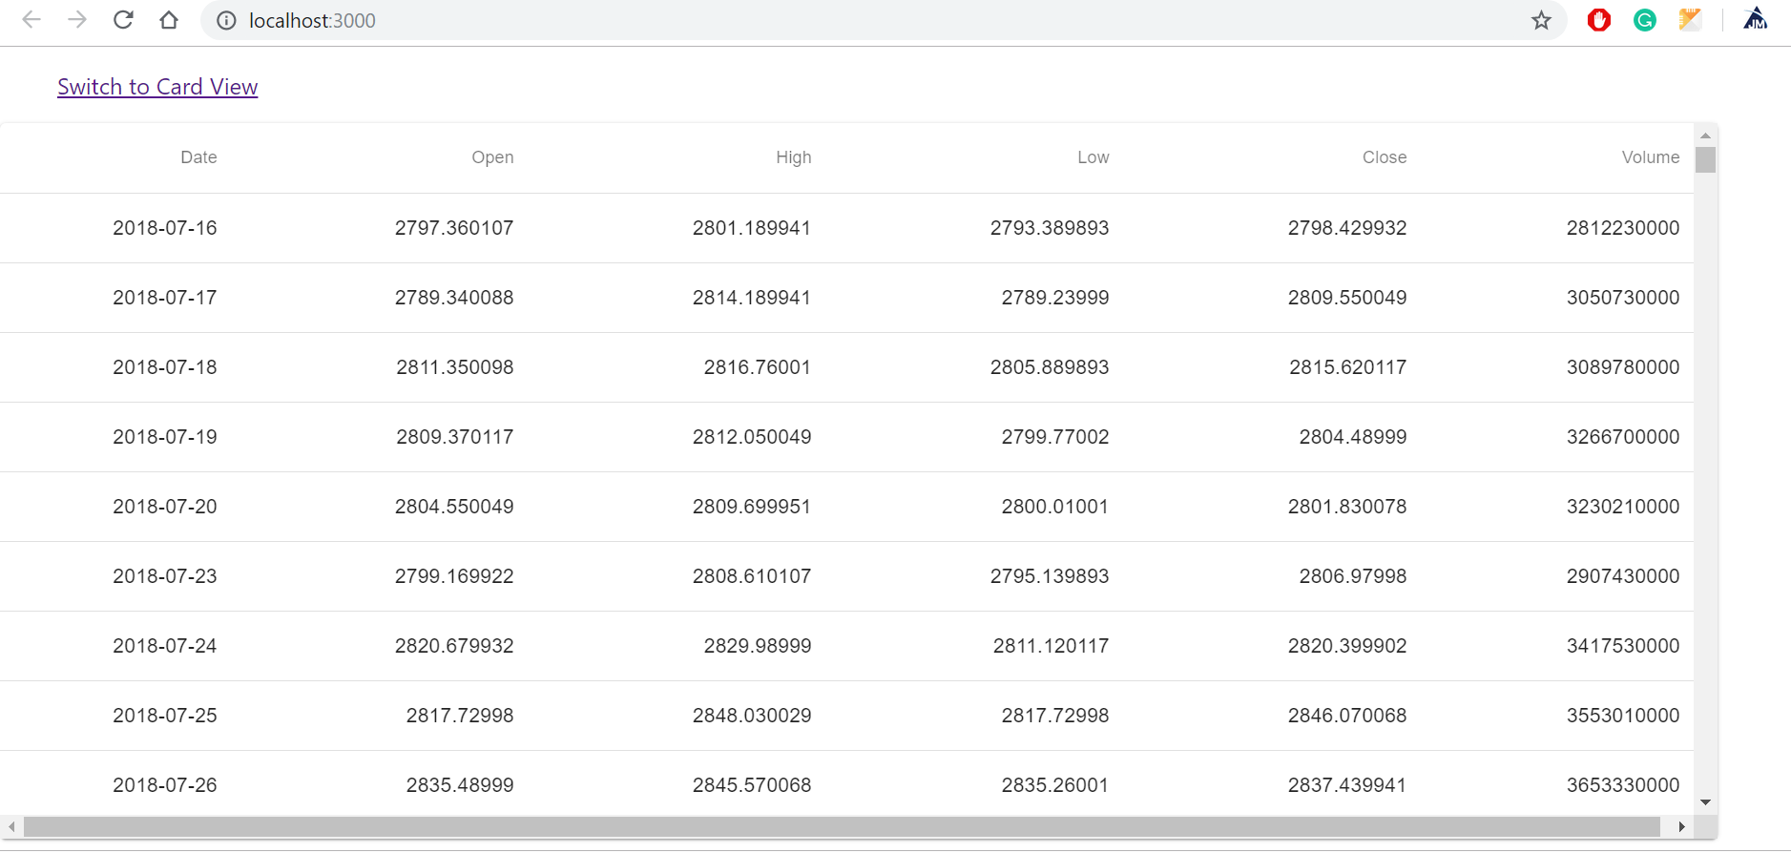

1. ***Card View***

