|  |  |
| --- | --- |
| ***Journal of Scientific Exploration,*** Vol. ***21, No.*** 3,**pp.**501-510, 2007 | 0892-3310107 |

**Effects of Psychokinesis on Computer Colors: A Big-Data**

**Centered Approach Towards Measuring PK.**

***College of Engineering*** & ***Applied Science***



***University of Colorado at Boulder***

***Boulder, CO 80309-0425, USA***

***e-mail: Jacob.Fiola@colorado.edu***

**Abstract**-Subjects were asked to carry out a psychokinetic task as a study of the effect of mind and its modulation on an RNG’s output. The task was to fixate vision on a computer program which was randomly generating computer colors. The participants were asked to focus their will on generating the color blue. During their fixation, the program generated 391 colors per participant. In total, 11,730 colors were generated by 30 participants. All randomly generated colors were recorded and scored via their distance from the RGB vector of (0, 0, 255), which was the exact color shown to the participants before each trial began. These psi-generated colors were compared to an even more massive “control” random distribution of 3,485,726,894 colors which underwent the same aforementioned scoring process, but with no participants involved. The difference between these two datasets (difference in average distance from blue) was unable to support anything but the null hypothesis. (p = 0.3807) The participants still technically beat the computer average distance, though.

Keywords: psi-ESP-Psychokinesis--colors-quantum random-parapsychology

**Background and Motivation**

Within the past 50 years, a para-psychic phenomenon known as psychokinesis has gained attention by many psi scientists. “Psychokinesis” is the ability of the mind to exert power over matter. It is some physical embodiment of an isolated intention. In practical terms, using psychokinesis, humans may be able to affect objects solely by the power of their mind.

How can we observe such a phenomenon, though? How can we measure or score its presence? Historically, one of the most empirically sound methods to measure psychokinesis is the use of dice rolling tests. To do this, participants will a specific roll by some die, rolls the die, and the odds against chance of the participant’s accuracy is then measured. High odds against chance suggest some factor that is affecting the roll of the die, AKA, psychokinesis.

With these experiments, parapsychologists pondered: If the mind is able to influence each die in approximately the same way, then our ability to detect that PK effect ought to improve as we toss more dice at once. (Radin & Nelson, 2003)

After testing this idea out, parapsychologists have come to realize that the effect size of psychokinesis does, in fact, have a positive correlation with the number of dice tossed at once. (See fig. 1)

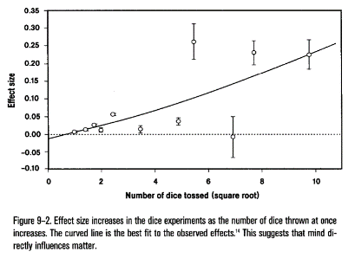

**1**

(^Graph courtesy of Radin & Nelson, 2003)

1

This begs the question: How does psychokinesis behave when millions of dice are tossed at once? Does the effect size ever approach some limit? These questions are what garnered the inspiration for this paper.

Thanks to true RNGs (Random Number Generators), we are able to bring insight to this question without having to actually toss a million dice at once. If the source of the noise which generated the random numbers is truly random (usually chaotic), then psychokinesis when tested with RNG rolls behaves similarly to dice experiments.

Thousands of RNG psychokinesis experiments have been performed around the world. Nowadays, many of these experiments have transitioned to computer programs. Computers allow us to take the experiment to a higher level of efficiency. Below are some advantages which computers have:

1. Unlike with manual throws of dice, RNGs make it possible to conduct experiments with large sample sizes in a short space of time.
2. The RNG is completely impersonal— unlike dice, it is not open to any classical (normal human) biasing of its output.
3. The output of the RNG can be stored automatically by the computer, thus eliminating recording errors.

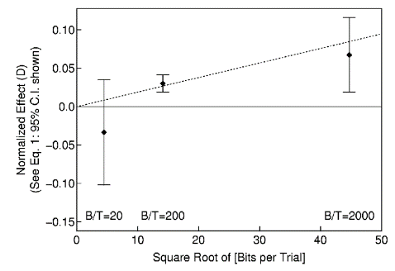Another prior experiment relevant to this study is one by the name of the MegaREG (Random Event Generator) Experiment. As illustrated by the second graph, past parapsychologists have found that the number of random bits per trial has a positive correlation with the effect size of Psychokinesis as well. (Dobyns, 2004)

The present study makes use of a Quantum Random number generator, and will focus on seeing how Psychokinesis behaves when the number of bits per trial is very large. (Approx. 7k Bits per Trial)

**Experimental Methods and Results**

The subject comprised 30 University of Colorado students of college age. At the outset of each run, the subject was shown the color blue.



RGB (0, 0, 255) = =

This exact color, to be precise:

Each subject was to fixate vision on a computer program which was randomly generating colors on a screen in front of them. The participants were asked to focus their will on generating the color blue. During their fixation, the program would generate 391 colors over a period of 40 seconds.

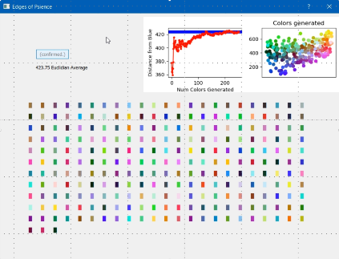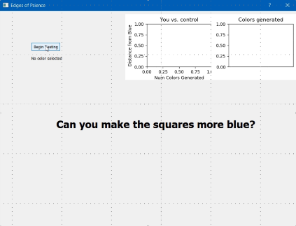

As the colors generated, the subjects were given real-time feedback of how their colors matched up to blue. The left graph was a plot of the average distance from blue. The horizontal bar in the left graph roughly represented the asymptote in which the computer averaged out upon after millions of colors. If the participant stayed under it, they beat the control’s average.

The right graph was a scatterplot of every single color generated from that session, and how far they each were from blue. After each session, the program would spit out some statistics at the subject (P value, average distance, control average distance).

This might have some readers wondering: How do you measure the distance between colors? The answer: The Euclidian algorithm.

All digital colors just correspond to some hex value. For example, black = #000000, white = #FFFFFF, red = #FF0000, etc… These hexadecimal numbers directly correlate to base 10 integers as well.

In order to accurately calculate a difference in color, the numbers themselves cannot be directly compared within some simple plus or minus range. Rather, the hex color will be componentized into its 3 RGB members. These members will be compared to the RGB members of the participant’s favorite color, and scored via a weighted Euclidian color distance formula:

The Euclidian algorithm is what underlies the Pythagorean Theorem as well. It’s just that this time, color distances are being calculated from color dimensions instead of spatial distances being calculated from spatial dimensions.

A Euclidian color distance calculation was performed for every color generated during the trials. Each of these distances were written to an excel file, in which the program would reference to calculate the global p value.

These psi-generated colors were compared to a massive “control” random distribution of 3,485,726,894 colors which underwent the same aforementioned scoring process, but with no participants involved.

**Results & Analysis**

There were 11,730 colors generated during the 30 trials. These colors averaged at a distance of 423.10 Euclidian color units from blue. As for the control, the computer generated 3,485,726,894 colors. These colors averaged at a distance of 424.40 Euclidian color units from blue.

The P-value calculation was performed on these two massive arrays of color distances. It is (P = 0.3807).

This P-value is greater than 0.1, and therefore supports the null hypothesis. There is no statistically significant difference between the two color distance datasets.

**Discussion and Conclusions**

It is important to note that the participants did technically beat the control’s average distance from blue. If this trend can continue, then perhaps the next step is for this application to be distributed via the internet. From there, further consistencies in replication may bring the p value down.

Alas, psychokinesis has failed in making some RNG numbers significantly different than another set of RNG numbers. My results suggest that psychokinesis may actually have better effect sizes when the number of bits per trial is taken down from 7000 to more like 2000.

|  |  |
| --- | --- |
|  |  |

**References**

Dobyns, Y. H., et al. "The MegaREG experiment: Replication and interpretation." Journal of Scientific Exploration 18.3 (2004): 369-397

Radin, D. I., and R. D. Nelson. "Meta-analysis of mind-matter interaction experiments: 1959-2000." *Healing, Intention and Energy Medicine. London: Harcourt Health Sciences* (2003): 39-48.

Random numbers were acquired from Australia National University’s web API. (URL): https://qrng.anu.edu.au