Assignment 1 Team 3

# Distribution of all the terms in the Lexicon

### FreeMind

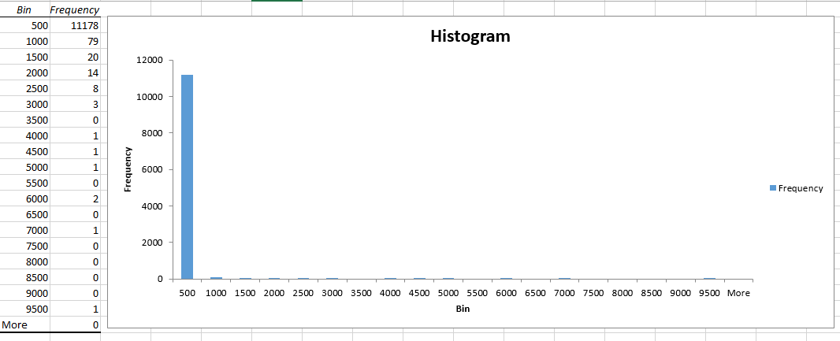

### Weka

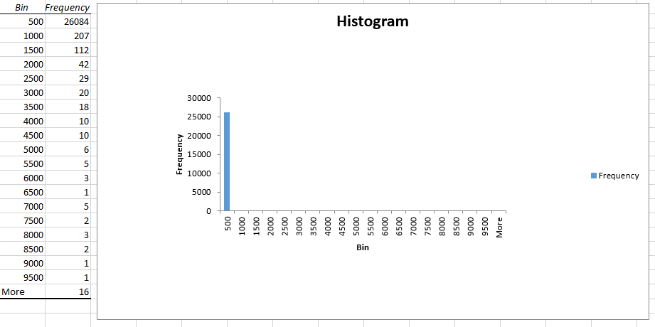

# Most frequent terms in the corpus with tf

### FreeMind

1. ('node', 9463)
2. ('map', 6835)
3. ('string', 5980)
4. ('action', 5600)
5. ('set', 4839)
6. ('control', 4399)
7. ('mind', 3717)
8. ('view', 2890)
9. ('select', 2745)
10. ('name', 2710)

### Weka

1. ('set', 28090)
2. ('string', 27302)
3. ('instanc', 26212)
4. ('valu', 24211)
5. ('option', 18234)
6. ('attribut', 17423)
7. ('return', 16781)
8. ('class', 16447)
9. ('result', 15788)
10. ('name', 15548)

# Highest document frequency

### FreeMind

1. ('free', 489)
2. ('modifi', 487)
3. ('thi', 487)
4. ('version', 487)
5. ('write', 487)
6. ('copyright', 487)
7. ('public', 486)
8. ('softwar', 486)
9. ('purpos', 485)
10. ('later', 485)

### Weka

1. ('thi', 1640)
2. ('ani', 1639)
3. ('http', 1638)
4. ('gener', 1637)
5. ('www', 1630)
6. ('org', 1626)
7. ('java', 1620)
8. ('new', 1467)
9. ('distribut', 1390)
10. ('version', 1385)

# Documents with highest number of unique terms

### FreeMind

1. ('freemind/freemind/modes/mindmapmode/MindMapController.java', 9229)
2. ('freemind/plugins/map/FreeMindMapController.java', 9082)
3. ('freemind/freemind/controller/Controller.java', 7431)

### Weka

1. ('weka-3-7-13/src/main/java/weka/gui/beans/KnowledgeFlowApp.java', 25151)
2. ('weka-3-7-13/src/main/java/weka/classifiers/bayes/net/GUI.java', 13246)
3. ('weka-3-7-13/src/main/java/weka/classifiers/evaluation/Evaluation.java', 12987)

# Documents with the least amount of unique terms

### FreeMind

1. ('freemind/freemind/modes/IconInformation.java', 22)
2. ('freemind/freemind/modes/common/plugins/NodeNoteBase.java', 77)
3. ('freemind/freemind/modes/mindmapmode/actions/HookAction.java', 79)

### Weka

1. ('weka-3-7-13/src/main/java/weka/core/json/sym.java', 33)
2. ('weka-3-7-13/src/main/java/weka/core/expressionlanguage/parser/sym.java', 38)
3. ('weka-3-7-13/src/main/java/weka/core/pmml/jaxbbindings/package-info.java', 42)