Renier Express: A Mobile-Based Scheduled and Batch Delivery Management Platform for Medium-Scale Delivery Services

OVERVIEW
Delivery coordination among informal, community-based courier services in the Philippines remains largely manual, relying on messaging apps, screenshots, and personal memory to manage bookings, rider assignments, and status updates. This capstone project proposes Renier Express, a mobile-based scheduled and batch delivery management platform designed for a motorcycle courier service operating within the Diecast-Car Collectors of the Philippines (DCPH) community. The system is developed with the primary objective of replacing the existing chat-based workflow with a centralized platform that digitizes the delivery lifecycle from booking intake through proof of delivery, serving four user roles: Admin, Member, Rider, and Buyer.
The system will utilize DBSCAN geographic clustering to group nearby deliveries into batches without requiring a predefined number of clusters, and Google OR-Tools to solve the Vehicle Routing Problem for optimized multi-stop route sequencing within each batch. It will use Facebook Prophet for AI-assisted demand forecasting and XGBoost for delivery time estimation, both designed to activate progressively as the platform accumulates real operational data during deployment. Key features include membership-gated booking, hub-catchment pre-filtering across two sorting locations, zone-based rider assignment, event-driven status tracking across thirteen delivery states, proof of delivery capture with digital receiver signature, real-time GPS-based rider tracking at the Out for Delivery status, and multi-channel notifications through push, SMS, and in-app updates. The system should conform to the software quality requirements as per the ISO 25010 standards to provide the client with a reliable and structured delivery management platform.

Categories and Subject Descriptors
Information Systems > Information Systems Applications> Logistics Information Systems
General Terms
Algorithms, Design, Performance, Reliability, Management, Geographic Clustering, Route Optimization
Keywords
Delivery Management System, Batch Delivery, Route Optimization, Geographic Clustering, AI Demand Forecasting, Last-Mile Delivery, Mobile Application
- THE PROBLEM AND ITS BACKGROUND
This chapter covers the context, rationale, and objectives of the study. It opens with an introduction to delivery management platforms and their role in logistics operations, followed by the specific operational challenges the client faces. It also covers the purpose and description of the proposed system, the general and specific objectives, scope and limitations, and key terms used throughout the paper.
- Project Context
- Introduction
Delivery management platforms are software systems that centralize and automate delivery operations, from order intake and dispatch to route planning and status tracking [1]. These platforms have become common in logistics, particularly for last-mile delivery, which makes up a substantial portion of total supply chain costs [2]. As e-commerce and peer-to-peer online selling grow, so does the need for more structured delivery coordination, across businesses of varying sizes [3].
In the Philippines, the e-commerce sector has expanded rapidly over the past several years. Growth was driven in part by rising internet penetration and smartphone adoption, and accelerated further by the shift to online transactions during the COVID-19 pandemic [4]. Higher order volumes have strained delivery infrastructure, particularly in urban and suburban areas [5]. Platforms like Grab Express, Lalamove, and J&T Express have grown to handle mainstream demand, but many smaller, owner-operated delivery services still coordinate through informal, manual methods [6].
Mobile applications have become a workable solution for logistics challenges, largely because smartphones are now widely available and consistently carried [4]. On the delivery management side, mobile and web platforms can handle order tracking, route optimization, automated dispatch, and real-time notifications, reducing the manual effort involved [7]. The actual adoption of these tools among small and informal operators is still low. In developing countries, barriers like cost, limited technical literacy, and unreliable infrastructure keep many of these operators from making the shift [8].
    - Background of the Study
According to the e-Conomy SEA 2024 report by Bain and Company, the gross merchandise value of the Philippine digital economy grew from 8 billion U.S. dollars in 2019 to 31 billion U.S. dollars in 2024, with e-commerce accounting for a large share of that growth [9]. A separate industry forecast ranked the Philippines first globally for projected retail e-commerce sales growth in 2025, at an estimated rate of 23 percent [4]. This expansion has increased the volume of parcels that need to move from sellers to buyers, and a large share of those sellers are Micro, Small, and Medium Enterprises (MSMEs). The MSME Development Plan 2023-2028 reported that MSMEs make up 99.59 percent of all business establishments in the Philippines, yet only 10 percent are fully digitalized. The majority still coordinate operations through basic digital tools such as messaging apps and simple work software. The same plan noted that MSMEs face barriers to adopting logistics applications, including subscription costs, limited connectivity, and the complexity of managing multiple software tools [10]. Large app-based courier services like Lalamove and GrabExpress serve the general market, but their per-kilometer pricing and on-demand service models do not always fit the needs of smaller, community-based trading groups whose volumes are low and whose items are specialized. In these situations, informal delivery arrangements have formed within closed communities, run by trusted individuals who know the members and offer flat-rate service. One such operation is Renier Express.
Renier Express is an informal courier service for the Diecast-Car Collectors of the Philippines (DCPH), run by Mr. Renier Alvarez, who has been in the community for around fifteen years. The delivery side started during the pandemic, specifically when Saturday meetups stopped in 2020 and in-person trading came to a halt, a pattern seen across community-based markets in the Philippines during that period [11], Mr. Alvarez began doing point-to-point motorcycle deliveries for people he knew in the group. After restrictions lifted, he kept going. Today, eight riders work under him, handling somewhere between 25 and 30 deliveries on a busy day across Metro Manila, Bulacan, Pampanga, Laguna, Rizal, and Cavite. They take collectibles only, including die-cast cars, Hot Wheels, Tomica, and figures. The service does not handle perishable goods.
The entire operation runs through group chats, with no app, no tracking system, and no logistics software of any kind. In an interview with the proponents, Mr. Alvarez described the workflow: a seller messages him to request a pickup, he screenshots the message, and at end of day he forwards pickup details to the assigned rider. A group chat is created for each transaction to handle status updates, questions, and disputes. When a delivery is done, the rider sends a timestamped photo with remarks such as "delivered, paid" or "delivered, not paid." Mr. Alvarez keeps a customer address list, but locating a specific entry or parcel at the Bulacan hub can take up to 30 minutes. Riders plan their own routes, and scheduled pickups sit in storage with the date marked, though items occasionally get overlooked.
Other small delivery services deal with the same thing [12]. Manual processes remain common in logistics operations among small enterprises in developing economies, where the adoption of digital tools is constrained by cost, limited technical capacity, and inadequate infrastructure [13].
There are platforms built for this. A centralized booking system removes the need to screenshot and forward messages one by one [14], and clustering algorithms like DBSCAN can group nearby drop-offs into batches by location without requiring the operator to specify a number of groups in advance [15]. Once batches exist, a route solver determines the stop order. OR-Tools, an open-source library from Google, handles this by solving the Vehicle Routing Problem [16]. Status tracking can also move off the chat. Instead of riders posting confirmation photos, the system logs each status change and pushes updates through push notification, SMS, or in-app alert [17][18].
Most platforms assume a different kind of operation, one that is high volume, open to the public, and uses distance-based pricing [19]. Renier Express is different, operating on flat rates, closed membership, and parcels limited to die-cast collectibles. Mr. Alvarez said in the interview that he uses no logistics software The proposed system is designed around those constraints, a mobile platform for scheduled and batch delivery management built for an informal courier operating within a closed community.

  - Purpose and Description
The proposed Renier Express system replaces the chat-based workflow with a structured platform for managing deliveries within the DCPH community. Only verified DCPH members can access the system, keeping delivery data within the same trusted network the business already relies on. Sellers submit requests through the app rather than messaging Renier directly, standardizing order intake and reducing errors from manual transcription.
The system groups nearby deliveries using geographic clustering through Density-Based Spatial Clustering of Applications with Noise (DBSCAN) and sequences them into optimized routes through Google Operations Research Tools (OR-Tools). Status tracking is event-driven, pushing updates at key milestones so the admin and riders stay informed without checking in constantly. When a delivery reaches the Out for Delivery status, the system activates real-time GPS-based tracking which allows the admin and recipient to view the rider’s live location until the delivery is completed or the status changes. Notifications are delivered through role-specific channels. Members and riders receive in-app and Firebase Cloud Messaging (FCM) push notifications at each status change. The admin receives the same channels with persistent re-alerts for new bookings and rider declines. Buyers, who do not have accounts in the system, receive status updates through SMS only.
The system also includes two AI-assisted components that support planning and recipient visibility. The first is a demand forecasting capability that analyzes historical booking volume to estimate future delivery demand for a given date. These forecasts are also displayed on the admin dashboard as demand trend charts to support operational planning. The second is a delivery time estimation capability that provides recipients with an estimated delivery window on the tracking page once a parcel is marked as out for delivery. The booking form includes optional time window preferences for both pickup and delivery, where members can indicate morning, afternoon, or evening as a soft preference. These preferences are displayed to the rider as metadata per stop and are not enforced as hard scheduling constraints.
Because the AI components require historical booking and delivery records to produce reliable predictions, they are designed to activate progressively as the system accumulates real operational data during deployment. The core delivery management features operate independently of the AI components from the outset. Together, these features replace the manual processes that currently define Renier Express operations and move the service toward a more reliable, repeatable, and data-informed delivery workflow.

  - Objectives of the Study
    - General Objective
To develop a mobile-based scheduled and batch delivery management platform with AI-assisted demand forecasting and delivery time estimation capabilities for the operations of Renier Express.
    - Specific Objectives
In order to achieve the general objective, the following specific objectives must be met.
- To analyze the current delivery workflow of Renier Express and identify operational pain points through a structured client interview.
- To design and develop a centralized booking and order management module with role-based access control for administrators, sellers, and riders on the mobile application.
- To implement geographic clustering using DBSCAN for automated batch delivery grouping based on geographic proximity as the primary qualifier, with time window compatibility and delivery count constraints as secondary qualifiers.
- To implement route optimization using OR-Tools (VRP) for efficient multi-stop delivery sequencing per rider assignment.
- To develop an event-driven delivery status tracking and multi-channel notification system covering in-app updates, push notifications, and SMS for administrator and recipient visibility.
- To implement real-time GPS-based rider tracking that activates when a delivery status reaches Out for Delivery, enabling the admin and recipient to view the rider’s live location until the delivery is completed.
- To restrict platform access to verified DCPH members through a dual-pathway membership verification mechanism that supports DCPH collector ID upload with admin review as the primary method and admin-generated expiring codes as a secondary method.
- To implement AI-assisted demand forecasting using a time-series model that analyzes historical booking volume to generate capacity-aware date selection for the booking interface.
- To implement AI-assisted delivery time estimation that provides recipients with an estimated delivery window on the tracking page at the out-for-delivery status.
- To develop an admin analytics dashboard that displays delivery volume, batch efficiency, rider activity, and demand forecast trends for operational monitoring.
- To evaluate the developed system using the ISO 25010 software product quality framework.

  - Scope and Limitations
    - Scope
Renier Express is a mobile platform for scheduled and batch delivery management, built for Renier Express, an informal, motorcycle-based delivery service that operates within the Diecast Philippines (DCPH) collector community. The system has four user roles. The admin oversees operations, including rider assignment confirmation, batch adjustments, member and rider management, and analytics monitoring. Members are verified DCPH participants who can initiate delivery bookings as sender or recipient. Riders receive batch assignments, carry out deliveries, and capture proof of delivery. Buyers are non-member recipients with no account in the system who interact only through Short Message Service (SMS) notifications. Registration requires verified DCPH membership through one of two verification pathways. The primary method requires the registrant to upload a valid DCPH collector ID during registration, which the admin reviews and approves. The secondary method allows the admin to generate a unique, expiring invite code which is sent to a known community member through an external channel. The invite code expires after a single use.
The mobile app, built with Flutter, is the primary interface for the admin, members, and riders. The backend runs on Node.js with NestJS and uses Supabase for the database and authentication. Coverage spans the National Capital Region (NCR), Bulacan, Pampanga, Laguna, Rizal, and Cavite. Members book deliveries by providing pickup and drop-off addresses, recipient contact details, a preferred date, an item description, and optional time window preferences for pickup and delivery (morning, afternoon, evening, or no preference). These are soft preferences displayed to the rider as metadata and are not enforced by the route optimizer. The system generates a unique delivery reference code for each confirmed booking. The booking interface restricts selectable dates based on daily capacity, and bookings are auto-confirmed when capacity is available. At the admin-configurable daily cutoff (default approximately 8 PM), the system assigns each booking to the nearest sorting hub (Bulacan for northern deliveries, Makati for southern) based on drop-off coordinates. DBSCAN then clusters orders within each hub pool into delivery batches using three qualifiers: geographic proximity as the primary grouping criterion, time window compatibility as a secondary signal where orders with similar pickup or delivery time preferences are grouped together when geographically feasible, and delivery count constraints that enforce minimum and maximum batch sizes per rider. The admin can manually create, edit, or move orders between batches.
The system maps each batch to a rider based on pre-assigned coverage zones and presents a suggested assignment for the admin to confirm or override. Once assigned, OR-Tools solves the VRP to determine the best stop sequence. Riders receive the optimized route on the mobile app and may rearrange stops based on their own judgment. The rider interface includes an earnings summary that displays the number of completed deliveries for the day and the estimated earnings calculated from the completed delivery count multiplied by the per-delivery rate. New bookings arriving after the daily cutoff while riders are active may be inserted into an existing route, subject to a geo-proximity constraint. The system checks whether the pickup location falls within a defined geographic threshold from the rider’s current position. If the pickup is within range, the system presents the request to the rider for acceptance or decline. If the pickup falls outside the threshold, the request is automatically deferred to the next scheduled date without notifying the rider, which prevents mid-route backtracking across zones. Priority insertions flagged by the admin display an urgency indicator but still leave the acceptance decision with the rider. Declined or timed-out requests queue for next-day batching.
The system includes two AI-assisted components. The first is demand forecasting, which uses Facebook Prophet, a time-series forecasting model, trained weekly on historical booking volume data. The model outputs forecasted capacity thresholds that feed into the booking date picker to limit selectable dates based on projected demand. The admin dashboard displays demand trend charts generated from these forecasts. Model accuracy is evaluated using Mean Absolute Percentage Error (MAPE). The second AI component is delivery time estimation, which uses XGBoost. This component is triggered when a delivery is marked as Out for Delivery and returns an estimated delivery time. Accuracy is evaluated by the percentage of predictions falling within a 30-minute margin of actual delivery time and by Mean Absolute Error (MAE).
Delivery progress follows these statuses: Order Placed, Confirmed, Assigned to Rider, Out for Pickup, Picked Up, In Transit (only if the order is going to the hub), Arrived at Hub, Out for Delivery, Delivered, Failed Attempt, Rescheduled, Returned to Sender, and Cancelled. After three consecutive failed delivery attempts for the same order, the system automatically changes the status to Returned to Sender. This three-attempt threshold is based on the operational protocol described by the client during the stakeholder interview, where undeliverable parcels are returned and rescheduled with priority status, and items are sent back to the sender if the recipient remains unreachable after repeated attempts. On completion, the rider captures proof of delivery consisting of a photo, a digital signature from the receiver captured on the rider’s device, written remarks, and a timestamp. Notifications are sent at each status change. Members and riders receive in-app and FCM push notifications. The admin receives the same channels with persistent re-alerts. Buyers who do not have an existing account in the system receive status update notifications through SMS. Each notification includes a prompt to download the mobile application and join the DCPH community for full tracking capabilities. The system will be evaluated using the ISO 25010 software product quality framework through a quantitative-descriptive research method. The evaluation targets five quality characteristics: Functional Suitability, Reliability, Performance Efficiency, Usability, and Security. A structured survey questionnaire using a 5-point Likert scale will serve as the evaluation instrument. Respondents will include the client, the active riders, and a sample of DCPH members who will interact with the booking features of the system. The detailed evaluation methodology, including specific survey items, sampling procedure, and data analysis approach, will be documented in Chapter 3.

    - Limitations
The study has the following limitations. The non-member buyer role is passive by design. Non-members cannot create accounts and cannot book deliveries or perform in-app actions. This constraint comes directly from the client, who expressed concern that exposing the platform to non-member bookings could generate volumes the current team cannot fulfill, risking failed deliveries and loss of trust. Payment processing is not included. The platform records a payment acknowledgment at proof of delivery but does not process, collect, or reconcile digital payments. Insurance, claims management, and liability tracking are also outside scope.
Real-time GPS-based rider tracking is limited to the Out for Delivery status only. Outside of this status, the system depends on event-driven status updates submitted by the rider at each delivery milestone. Inventory management at the sorting hubs is not covered. The platform tracks delivery orders from booking to proof of delivery but does not record physical parcel movement or storage location at either hub.
The mobile application requires internet connectivity for all core functions including status submission, address lookup, map rendering, and route updates. Assigned route lists and delivery details are cached locally for offline viewing, but no full offline synchronization mechanism is implemented. New user registration requires manual admin verification through DCPH collector ID review or admin-generated invite code approval. No third-party membership registry integration is included.
The mobile application is limited to Android devices only and is not available for iOS devices. This limitation is due to the project’s development scope, available testing devices, and target user environment, where the intended admin, members, and riders are expected to access the system through Android smartphones. As a result, users with iPhones or iPads will not be able to install or use the mobile application during the study implementation.
The AI components, specifically demand forecasting using Facebook Prophet and delivery time estimation using XGBoost, require real operational data before they can produce reliable predictions [42][43]. Because no transaction records exist prior to deployment, the system implements a phased deployment approach where the AI components are architecturally present but gated behind a data sufficiency threshold during Phase 1.
Rule-based static values are used for capacity limits and delivery time estimates until the models accumulate sufficient data to begin training in Phase 2. Retraining is performed manually on a weekly schedule.
Renier Express is designed for the specific operational context of Mr. Renier Alvarez's delivery service and is not intended for use by other operators or generalization to other delivery contexts. The system requires riders to have smartphones with stable internet connectivity.
  - Definition of Terms
The following terms are defined according to how they are used in this study.
AI Delivery Time Estimation. A predictive capability that uses historical delivery data to provide recipients with an estimated delivery window, displayed on the tracking page at the Out for Delivery status.
AI Demand Forecasting. A predictive capability that uses historical booking volume data to estimate future delivery demand for a given date, enabling the system to set dynamic capacity limits for the booking date picker.
Batch. A group of delivery orders clustered together based on geographic proximity which are assigned to a single rider for fulfillment on the same day.
Booking. A delivery transaction initiated by a member through the mobile application. A booking includes the pickup address, drop-off address, recipient contact information, preferred date, and item description.
Buyer. The end recipient of a delivery who does not have a registered account in the system. Buyers receive status updates via SMS. Buyers do not receive FCM push notifications.
DBSCAN. Density-Based Spatial Clustering of Applications with Noise. A clustering algorithm that groups confirmed bookings by the geographic proximity of their drop-off locations, without requiring a predefined number of clusters.
DCPH. Diecast-Car Collectors of the Philippines. A community of diecast car and toy collectible enthusiasts in the Philippines. DCPH membership is a prerequisite for registering as a member in the system.
Delivery Reference Code. A system-generated unique identifier assigned to each order which serves as the tracking number for status inquiries.
Event-Driven Status Tracking. A tracking approach in which status updates are triggered by specific fulfillment events rather than continuous Global Positioning System (GPS) monitoring.
FCM. Firebase Cloud Messaging. A cross-platform messaging service by Google used to deliver push notifications to members and buyers at each delivery status change.
Hub-Catchment Pre-Filter. A geographic pre-processing step that assigns each order to the nearest sorting hub (Bulacan or Makati) based on drop-off coordinates before DBSCAN clustering is applied.
Intra-Day Insertion. The process of adding a new booking to a rider's active delivery route after the daily batch cutoff. The rider may accept or decline the insertion. Admin-flagged priority insertions show an urgency indicator to the rider.
Member . A verified DCPH member with a registered account in the system. Members can initiate delivery bookings, track booking status, and view booking history.
OR-Tools VRP. Google's Operations Research Tools Vehicle Routing Problem solver, a software library that calculates the optimal sequence of delivery stops to minimize total travel distance.
Proof of Delivery (POD). Documentation captured by the rider upon successful delivery, consisting of a photograph, a digital signature from the receiver, written remarks, and a timestamp. POD is the definitive record of delivery completion.
Vehicle Routing Problem. VRP. A combinatorial optimization problem that determines the most efficient set of routes for a fleet of vehicles delivering to multiple locations, subject to constraints like vehicle capacity and distance.

- REVIEW OF RELATED LITERATURE AND STUDY/SYSTEMS
This chapter presents articles, studies, and existing systems that support the need for and feasibility of the proposed system. The review is organized into four subsections. Section 2.1 covers local literature published in the Philippines, focusing on the e-commerce logistics environment, MSME digitalization challenges, and last-mile delivery conditions in the country. Section 2.2 covers foreign literature, establishing the academic foundations of route optimization, geographic clustering, delivery management systems, and AI-assisted logistics planning. Section 2.3 reviews local studies and systems from Philippine academic institutions that address technical components related to the proposed system. Section 2.4 examines foreign studies and deployed international platforms that handle delivery optimization at scale. The collective gap identified across these subsections is that no existing local or foreign system combines geographic batch clustering, route optimization, AI-assisted demand forecasting, and AI-assisted delivery time estimation in a platform designed for an informal, community-based delivery operation.
  - Local Literature
    - Last-Mile Delivery Software: Transforming the Future of Fast, Accurate Deliveries (2025)
The article published on PhilNews describes last-mile delivery software as a digital platform designed to handle the final stage of the supply chain, covering the movement of goods from a distribution hub directly to the recipient's location. The last mile is identified as the most expensive segment of the delivery process because fuel costs, driver shortages, traffic delays, and rising customer expectations all converge at this single point in the chain. The article puts this in concrete terms by reporting that last-mile operations account for up to 53% of total delivery costs. This figure shows why businesses that continue to coordinate this stage manually face growing inefficiency as order volumes increase. Without a dedicated platform, businesses risk late deliveries, excess fuel consumption, and poor customer satisfaction because manual processes are not built to handle the speed and accuracy that recipients now expect. Core features discussed in the article include automated route optimization, smart dispatching, digital proof of delivery with photo and timestamp capture, and analytics dashboards that give operators visibility over every active delivery [20].
Renier Express currently operates without any of these features, relying entirely on chat-based coordination for booking intake, rider assignment, and delivery updates. The proposed system addresses this gap by providing membership-gated booking, geographic batch formation, zone-based rider assignment, and event-driven status tracking with proof of delivery capture – the same functional areas the article identifies as the foundation of a working last-mile platform [20].
2.1.2 Empowering Philippine MSMEs Through Digital Transformation (2024)
The article by the University of the Philippines Institute for Small-Scale Industries distinguishes between digitization, which is the conversion of paper-based records into digital format, and digitalization, which is the replacement of traditional business processes with digital technologies. The authors emphasize that many Philippine MSMEs have only reached the digitization stage because their operations still rely on unstructured communication methods and informal recordkeeping. Financial constraints, limited digital literacy among operators, and the absence of systems designed specifically for small-scale businesses are identified as the three major factors contributing to this delay [6].
The proposed system addresses the three barriers the article identifies because it is built specifically for the operational context of a community-based delivery service rather than requiring the operator to adapt a general commercial platform. Renier Express currently operates below even the digitization stage, and the proposed system represents a direct transition from informal chat-based coordination to full digitalization through a single centralized platform for booking, batch management, and delivery tracking.
    - Micro, Small, and Medium Enterprise Development Plan 2023–2028 (2024)
According to the Office of the President's Memorandum Circular No. 73, which approved the MSME Development Plan 2023–2028, MSMEs are the main drivers of the Philippine economy, making up 65.1% of all jobs and 99.59% of all business establishments. Despite this, 56% of MSMEs still rely on email and simple messaging services for day-to-day operations, and only 10% are completely digitalized. The plan specifically identifies high subscription costs, connectivity issues, and the difficulty of managing multiple applications as the obstacles that keep MSMEs from implementing logistics and delivery platforms under Strategic Goal 4.[10].
Because the proposed system offers a purpose-built digital platform for the type of informal, chat-based operation that the plan identifies as typical of under digitalized small businesses, it directly aligns with the strategic direction of the plan. Renier Express is one of the 56% of MSMEs which depend on basic messaging tools for coordination, and the proposed system moves the operation toward the digitalization stage described in the plan's MSME Digital Transformation Path.
    - Digital Innovation and Entrepreneurial Success in the Philippine MSME Sector: Challenges and Opportunities (2025)
Using a mixed-method approach that combines surveys with 150 MSME respondents and interviews with industry experts, Cordova et al.'s study [2025] investigates how digital innovation affects the entrepreneurial success of Philippine MSMEs. According to the study, advanced technologies are still largely underutilized, with AI-based analytics at 25% and ERP systems at 30%, whereas basic digital tools have achieved high adoption rates, with social media marketing at 80% and digital payments at 70%. In line with the study, 60% of respondents, financial limitations were the biggest obstacle, with a severity rating of 4.8 out of 5, followed by a lack of technical expertise at 50%. The findings conclude that Philippine MSMEs are becoming more digital in their customer-facing operations, but they have not implemented the systems that would enhance their internal operations.[21].
Because Renier Express relies on messaging tools for coordination yet operates without any structured system for order management, batch processing, or delivery tracking, the business falls within the under digitalized segment the study identifies as most in need of purpose-built digital tools. The study's finding that cost and technical complexity are the primary barriers to adoption supports the decision to build the proposed system specifically for the context of Renier Express, rather than requiring the operator to adapt a large commercial platform which would present the same barriers the study documents.
    - Digital Technology Adoption among Philippine Micro-, Small-, and Medium-Sized Enterprises: Barriers, Enablers, and Challenges during COVID-19 (2024)
The study by Mia et al., [2024] published in the Journal of Business, Ethics and Society, Volume 4, Number 1, looked at how nine Philippine-based MSMEs handled digital technology adoption during the COVID-19 pandemic, using a multiple case study design and in-depth interviews. MSMEs became more open to digital tools during this period because mobility restrictions and market shifts pushed them away from face-to-face transactions toward online platforms and digital payments. Most of this adoption happened out of necessity rather than planning, which left many businesses only partially digitalized by the time restrictions lifted. The study also found that barriers did not disappear after adoption, with customers still cautious about transacting digitally, and many businesses struggling to keep their digital operations running without proper technical support [22].
Renier Express went through the same thing, taking up Messenger and Viber during the pandemic as its main way of handling bookings and coordinating riders, which is the same reactive pattern the study describes. The proposed system picks up where that informal adoption left off, replacing the chat-based workflow with a proper booking system, batch management, and status tracking.
  - Foreign Literature
    - A Systematic Literature Review and Bibliometric Analysis of Last-Mile E-Commerce Delivery in Urban Areas (2024)
Last-mile delivery refers to the final leg of the delivery chain, from the transit point to the destination. A systematic review of 317 publications identified this segment as the most complex and costly segment of urban freight transport. E-commerce has amplified truck usage for goods transportation, which contributes to traffic congestion and air pollution in urban areas [3]. The proponents' proposed system addresses these last-mile delivery challenges by implementing route optimization and batch grouping to reduce delivery inefficiencies. The system will cater to Renier Express, an informal courier service that handles deliveries from sorting hubs to recipients across Metro Manila and nearby provinces.
    - A Review of the Vehicle Routing Problem and the Current Routing Services in Smart Cities (2023)
The Vehicle Routing Problem is an optimization problem where a fleet of vehicles must satisfy customer delivery needs while minimizing total costs. Current routing services in smart cities utilize both classical algorithms and machine learning approaches, including Capacitated VRP and multi-objective VRP variants [23]. The proponents' proposed system utilizes the VRP framework to determine the optimal stop sequence for each delivery batch. The proponents implemented OR-Tools, an open-source optimization library from Google, to solve VRP instances. With the help of this feature, Renier Express riders can follow optimized routes instead of relying on personal area knowledge and handwritten logs.

2.2.3 Comprehensive Analysis of Clustering Algorithms: Exploring Limitations and Innovative Solutions (2024)
A comprehensive survey of clustering algorithms in machine learning covered five methodologies: centroid-based, hierarchical, density-based, distribution-based, and graph-based clustering. Among these, DBSCAN identifies clusters based on dense regions separated by sparse areas. It can accommodate clusters of arbitrary shapes and sizes without requiring a predefined number of clusters [24]. This characteristic makes DBSCAN suitable for applications with unknown data distributions, such as geographic data. The proponents' proposed system utilizes DBSCAN for batch delivery grouping. The algorithm clusters delivery destinations by geographic proximity before the VRP solver determines the stop sequence. The proponents selected DBSCAN because the operator does not need to specify the number of delivery batches in advance, and the algorithm can handle the irregular distribution of delivery addresses across NCR and surrounding provinces.
    - Theories of Digital Platforms for Supply Chain Management: A Systematic Literature Review (2024)
Digital platforms have changed how supply chains operate. A systematic review of 43 papers identified 41 pertinent theories used to explain this shift, with the most common being resource-based view, transaction cost economics, internalization theory, and dynamic capabilities approach. The research established that digital platforms transform supply chains by altering firm boundary decisions and enabling new approaches to resource coordination [25]. The proponents' proposed system functions as a digital platform that transforms the delivery coordination workflow of Renier Express. The proposed system replaces the fragmented chat-based coordination with a structured platform for administrators, riders, and members. It integrates order management, dispatch coordination, status tracking, and stakeholder communication into a single system.
    - The Digital Transformation of SMEs (2021)
Small and medium enterprises face barriers to digital adoption, including limited resources, technical expertise, and access to affordable tools. Many SMEs continue to rely on manual coordination methods instead of integrated digital systems. Existing digital logistics solutions are designed for larger enterprises with higher volumes and more structured operations, leaving smaller operators underserved [13]. The proponents' proposed system addresses the gap identified by the OECD report. Renier Express is an informal, owner-operated delivery service that currently relies on chat-based coordination with no logistics software. The existing enterprise platforms assume high volume, open-to-public access, and distance-based pricing, which do not fit the client's flat-rate and membership-gated operation. The proposed system is developed for micro-operators and caters to the constraints of informal couriers serving closed communities.
    - Comparative Analysis of ARIMA, SARIMA and Prophet Model in Forecasting (2024)
Forecasting delivery demand requires models that can work with patterns that shift over time. ARIMA is one of the older approaches, and it works on stationary time-series data, but it requires manual parameter tuning and does not handle seasonal or non-linear trends well on its own. Prophet, developed by Meta, works differently. It breaks time-series data down into three parts: trend, seasonality, and holidays. It also handles missing data and outliers without the preprocessing that ARIMA needs. A comparative analysis tested ARIMA, SARIMA, and Prophet on drug demand forecasting using records from the Australian Health Insurance Commission. Prophet came out ahead with an MAE of 0.74. SARIMA scored 2.18 and ARIMA scored 3.02 [26]. The proponents' proposed system utilizes Prophet for demand forecasting within the admin analytics dashboard. As booking data accumulates, the system applies Prophet to predict delivery volume by area and by day of the week. The proponents selected Prophet over ARIMA because it does not require manual differencing or stationarity checks. It can also model the weekly and seasonal patterns that show up in a community-based delivery service, where order volume goes up and down around collector meetups, payday cycles, and holiday periods.
    - Case Study on Delivery Time Determination Using a Machine Learning Approach in Small Batch Production Companies (2024)
Predicting how long a delivery will take is a recurring problem in logistics. A case study on delivery time determination in small batch production companies compared several machine learning models for predicting delivery dates early in the ordering process. Tree-based models came out on top. They handle non-linear relationships between inputs and delivery outcomes well, and they do not need the data to follow a specific distribution. The study also pointed out that most existing delivery time models were built for large-scale operations with structured order pipelines. Smaller operators with less predictable workflows have not received the same attention [27]. The proponents' proposed system implements XGBoost for delivery time estimation based on the finding that tree-based models are effective for this type of prediction task. The model takes in booking features: distance between the hub and destination, number of stops in the assigned batch, day of the week, and historical delivery times for the coverage zone. The proponents selected XGBoost because it is open-source, computationally lightweight, and handles tabular data with mixed feature types well, which fits the structured booking records that the proposed system collects.
    - Dynamic Dual-Phase Forecasting Model for New Product Demand Using Machine Learning and Statistical Control (2025)
New systems that rely on machine learning face a practical barrier at deployment: the models have no historical data to learn from. This is the cold-start problem. It affects any prediction component that needs accumulated records before it can produce useful output. One study on demand forecasting for newly introduced products tackled this directly. The solution was a dual-phase framework. In the first phase, XGBoost classification and analog forecasting generate predictions while historical data is still limited or absent. Once enough records accumulate, the system switches to a second phase that uses ARMA-based residual correction for better accuracy. Across five real-world manufacturing case studies, the framework cut mean absolute error by 35.7 percent compared to standalone ARIMA [28]. The proponents' proposed system follows a similar phased approach for handling the cold-start condition at initial deployment. In the first phase, the system runs on rule-based defaults while the system collects real operational data through normal use. In the second phase, as real booking and delivery records build up and minimum data thresholds are met, the Prophet and XGBoost models begin training on actual data. In the third phase, the models operate on sufficient historical data and the rule-based fallbacks are retired. This phased approach means the platform is fully functional from deployment, with the AI components activating progressively as the data required for reliable predictions accumulates.
  - Local Study/Systems
    - Web-based ordering system for Start-UP business with forecasting (2024)
Labastida et al. [2024] developed a website based ordering system in order to improve the business transaction and inventory monitoring for start-up businesses. The system would allow the customers to place orders through an online platform while enabling business owners to track transactions and forecast demand using historical data [29]. The study showed that digitizing manual ordering processes improves operational efficiency, reduces errors, and supports better decision-making. This highlights the importance of structured transaction systems in business operations. In relation to the proposed system, the proposed system applies a similar concept by replacing chat-based delivery requests with a centralized booking system that organizes delivery data.
    - RUI: A Web-based Road Updates Information System using Google Maps Application Programming Interface (API) (2023)
Grepon et al. [2023] developed a web-based road updates system using Google Maps API to provide real-time traffic and road condition information. The system was evaluated using ISO/IEC 25010 and achieved an overall rating of 4.21 (Excellent), indicating high system performance and usability [30]. These findings support the effectiveness of location-based systems in improving route awareness and decision-making, which is directly relevant to the proposed system because Renier Express riders currently navigate to delivery locations using personal memory and informal notes. The proposed system utilizes Google Maps API for address lookup, route visualization, and geographic data input for the DBSCAN clustering and VRP optimization pipeline, which represents a deeper integration than basic map display.
    - Geographic Information System-Based Framework for Sustainable Small and Medium-Sized Enterprise Logistics Operations (2024)
Agoo et al. [2024] developed a Geographic Information System (GIS)-based framework to improve logistics operations through route optimization and spatial analysis. The system demonstrated significant improvements, including a 92% reduction in turnaround time, 57% decrease in operational costs, and 43% reduction in carbon footprint, with a 72% increase in profit [31]. These results highlight the effectiveness of GIS-based spatial analysis in improving delivery efficiency and sustainability. The proposed system applies a similar spatial approach through DBSCAN geographic clustering and hub-catchment pre-filtering, using coordinate data from delivery addresses to group orders and assign them to the nearest sorting hub before route optimization is applied.
    - Surigao River Flood Watch and Warning App System (2022)
Mag-usara [2022] developed a flood monitoring system that provides real-time alerts using sensors, SMS, and a mobile application. The system was evaluated with an overall mean score of 3.87 (very high), with SMS notification functionality rated at 3.9, indicating effective and reliable alert delivery [32]. These findings highlight the effectiveness of automated notification systems in improving the reliability and timeliness of status communication. The proposed system implements a similar multi-channel notification approach through FCM push notifications, SMS, and in-app status history, but applies it specifically to the delivery lifecycle where status changes are triggered at thirteen distinct delivery milestones from Order Placed through Delivered.
    - Mobile-Based Smart Transport Route Optimization and Hazard Reporting System for San Juan (2025)
Escalona et al. [2025] developed a mobile-based route optimization system that uses Dijkstra’s Algorithm and real-time data to improve travel efficiency. The system reduces travel time and enhances route selection by considering dynamic conditions [33]. The study demonstrates the effectiveness of algorithm-based routing in determining efficient travel sequences within urban transportation networks. The proposed system extends this concept by applying OR-Tools to solve the multi-stop Vehicle Routing Problem within each DBSCAN-generated delivery batch, which is a combinatorial optimization problem rather than a single-origin, single-destination shortest path query.
    - Route Optimization for Blood Bank Visits in Tacloban City Using the Traveling Salesman Problem (2025)
Ladrillo et al. [2025] applied the Traveling Salesman Problem (TSP) using a Greedy Algorithm to determine efficient routes across multiple blood banks. The study generated optimized routes based on different starting points, producing travel distances ranging from 28.8 km to 37.3 km, travel times of approximately 1 hour 47 minutes to 1 hour 53 minutes, and costs between ₱175 and ₱218 [34]. These results demonstrate the practical application of algorithmic routing in structuring efficient multi-stop travel sequences, which validates the feasibility of computational route planning for logistics in the Philippine context. The proposed system builds on this concept by solving the Vehicle Routing Problem with capacity and geographic constraints across multiple concurrent rider routes, rather than a single traveler visiting all stops.
    - NEXTWAY: Open Source Last-Mile Delivery System for MSMEs (2023)
Navarro [2023] developed NEXTWAY which is a last-mile delivery system that integrates order management, delivery coordination, and tracking into a centralized platform. The study showed improved organization and efficiency in delivery operations [35]. This shows the importance of integrated logistics systems in managing delivery workflows. Similarly, Renier Express combines booking, batching, routing, and tracking into a unified platform.
    - Operational Strategies of Online Food Delivery Businesses in Camarines Norte, Philippines (2021)
Lamug and Abasolo [2021] examined delivery operations and identified challenges such as manual coordination, communication delays, and limited resources. The study highlights how informal delivery systems that depend on manual coordination and unstructured communication channels experience recurring operational disruptions [12]. Renier Express operates under the same conditions, relying entirely on group chats for booking intake, rider assignment, and delivery confirmation. The proposed system addresses these documented challenges by replacing the chat-based workflow with a centralized platform that structures the delivery lifecycle from booking through proof of delivery.
    - Multivariate Travel Time Forecasting in a Traffic Network Using Fuzzy Cognitive Mapping (2023)
Abellana [2023] developed a multivariate travel time forecasting model using fuzzy cognitive mapping to improve prediction accuracy. The study showed that the model effectively captures traffic patterns and supports better estimation of travel durations [36]. This highlights the importance of predictive analytics in transportation systems. In relation to the proposed system, Renier Express applies similar concepts for Estimated Time of Arrival (ETA) prediction.
    - Forecasting the Consumer Price Index in the Regions of the Philippines using Machine Learning for Time Series Models (2023)
Echevarria and Aranas [2023] applied a hybrid ARIMA-ANN model to improve forecasting accuracy for time series data. The study demonstrated that combining statistical and machine learning approaches enhances predictive performance [37]. This highlights the value of combining statistical and machine learning approaches for improving time-series forecasting accuracy. The proposed system applies a related methodology for demand forecasting using Facebook Prophet, which decomposes booking volume data into trend, seasonality, and holiday components to generate capacity-aware projections that feed into the booking date picker.
  - Foreign Study/Systems
    - Clustering and Heuristics Algorithm for the Vehicle Routing Problem with Time Windows (2022)
Villalba et al. [2022] applied a cluster-first, route-second methodology to solve a VRPTW (Vehicle Routing Problem with Time Window) for a real-world commercial delivery operation with 205 customers. In the clustering phase, K-Means was first used to generate broad geographic clusters, then DBSCAN was applied within each cluster to identify representative customer nodes and reduce the problem size. The study’s findings demonstrated that the clustering phase successfully reduced the exponential complexity of the VRP while satisfying all time window and capacity constraints across nine delivery routes. All routes complied with 100% of the service time and time window constraints [38].
The proposed system follows an identical clustering first, then routing after framework. DBSCAN clusters delivery locations into geographic batches first, then OR-Tools computes the optimized route within each batch. Villalba et al. validates this two stage decomposition as a viable method for solving delivery routing problems with time window constraints at real world scale. The study's finding that DBSCAN effectively reduces problem complexity by identifying representative nodes within geographic clusters directly supports the proposed system's use of DBSCAN to group deliveries that are geographically proximate into rider-assignable batches.
    - A Cluster-Based Optimization Framework for Vehicle Routing Problem with Workload Balance (2022)
The study proposed a framework for solving the VRP that uses a cluster-first, route-second methodology. Li et al. [2022] introduced DBSCAN+, an improved variant of the DBSCAN algorithm combined with a maximum-minimum distance clustering method. In the routing stage, a modified Ant Colony Optimization algorithm was used to determine the delivery sequence within each cluster. The framework was tested in a last mile delivery scenario, where there were 5 vehicles and each one is responsible for a region, as well as 67 customers grouped into 5 different regions [15].
The proponents’ proposed system will also employ clustering first, then routing second. DBSCAN will group deliveries by geographic proximity first, then OR-Tools computes the optimal route within each cluster. The study validates DBSCAN based clustering viable first stage in a delivery routing process, which directly supports the algorithmic design of the proposed system.
    - Google’s VRP Free Algorithm Evaluation Study and its Use in Small and Medium Transportation Problems (2025)
The paper presents Google OR-Tools' vehicle routing solver as a viable to capacitated vehicle routing problems with delivery time windows. The solver uses a constraint programming approach combined with heuristic search to solve a wide range of VRP variants, which includes capacitated VRP, VRP with time windows, VRP with pickups and deliveries, and multi-depot VRP. The outcome of comparative analysis shows that OR-Tools can be useful and accurate enough to meet the needs of small and medium sized CVRPTW applications. Small (25 customers) and medium (50 customers) sized problems were solved on average over 75% of the time [39].
The proposed system will use Google OR-Tools as its VRP solver for computing optimized stop sequences within each delivery batch. Balikos et al. provides methodologies in implementing OR-Tools for capacitated routing, time windows, and multi depot last mile configurations. These variations of the VRP are present in the context of solving for Renier Express’ delivery routing problem.
    - Machine Learning Implementation for E-commerce Delivery Delay Prediction Using XGBoost Algorithm (2025)
The study applied the XGBoost algorithm to predict delivery delays in an e-commerce context. The model achieved an overall accuracy of 93.24% in classifying whether a delivery would be delayed or on-time. The study demonstrated that XGBoost's gradient boosting approach effectively captured nonlinear relationships between delivery features and delay outcomes, outperforming simpler classification models on the same dataset [40].
The proposed system shall use XGBoost for delivery time estimation, this is for predicting how long a delivery will take based on constraints like distance, number of preceding stops, departure time, day of week, and geographic location. The Lesmana et al. [2025] study validates XGBoost as an effective algorithm for delivery prediction tasks with tabular feature data, which is the same data format the proposed system will use.
    - The Hybrid Prophet-SVR Approach for Forecasting Product Time Series Demand with Seasonality (2021)
The study proposed a hybrid forecasting model that combines Prophet with Support Vector Regression (SVR) for predicting demand in product time series that exhibit strong seasonal patterns. Prophet was used as the primary model to capture trend and seasonality components. SVR was then applied to the errors left over after Prophet's prediction. The hybrid model was evaluated against standalone Prophet, ARIMA, and SVR on real-world product demand data. Results showed that Prophet had a forecasting range of change of only 17.94%. Although not as accurate as the Hybrid Prophet approach, it is still comparatively better than the other standalone models [41].
The proposed system's demand forecasting component shall use Prophet as its primary model, which aligns directly with this study's methodology. For the initial implementation, the proposed system will use a standalone Prophet model due to the cold-start constraint and the simpler implementation requirements within the project timeline. The hybrid Prophet-SVR approach is noted as a potential future enhancement for the proposed system.
- METHODOLOGY, RESULTS AND DISCUSSION
This chapter presents the methodology, results, and discussion for the development of Renier Express, a mobile-based scheduled and batch delivery management platform for medium-scale delivery services. The processes, frameworks, and tools used throughout the study are described in detail to provide a clear account of how the proponents arrived at the proposed system. The chapter adopts the Agile methodology using the Scrum framework as the software development life cycle, which guides the iterative and sprint-based construction of the platform. Section 3.1 covers the requirement analysis, including the system's conceptual paradigm and the flow diagrams of both the existing and proposed systems. Section 3.2 presents the requirements documentation, covering the research method and data gathering instruments. Section 3.3 describes the technical background, and Section 3.4 outlines the development and testing approach for the working system deliverable.
  - Requirement Analysis

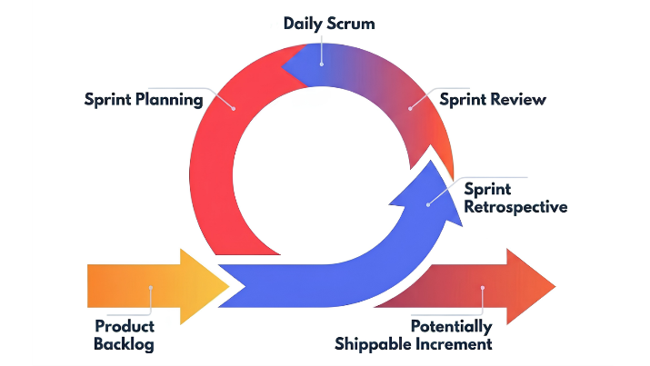
Figure 1. Software Development Life Cycle
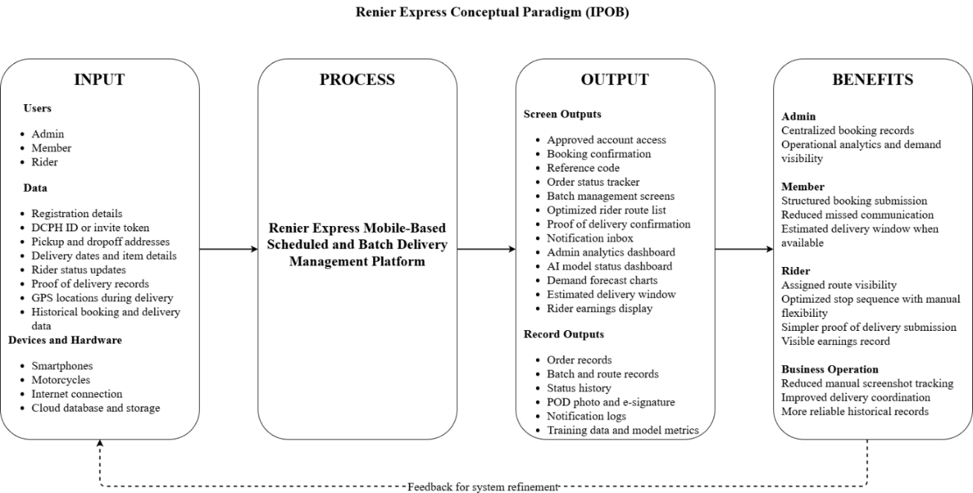
Figure 2. Conceptual Paradigm
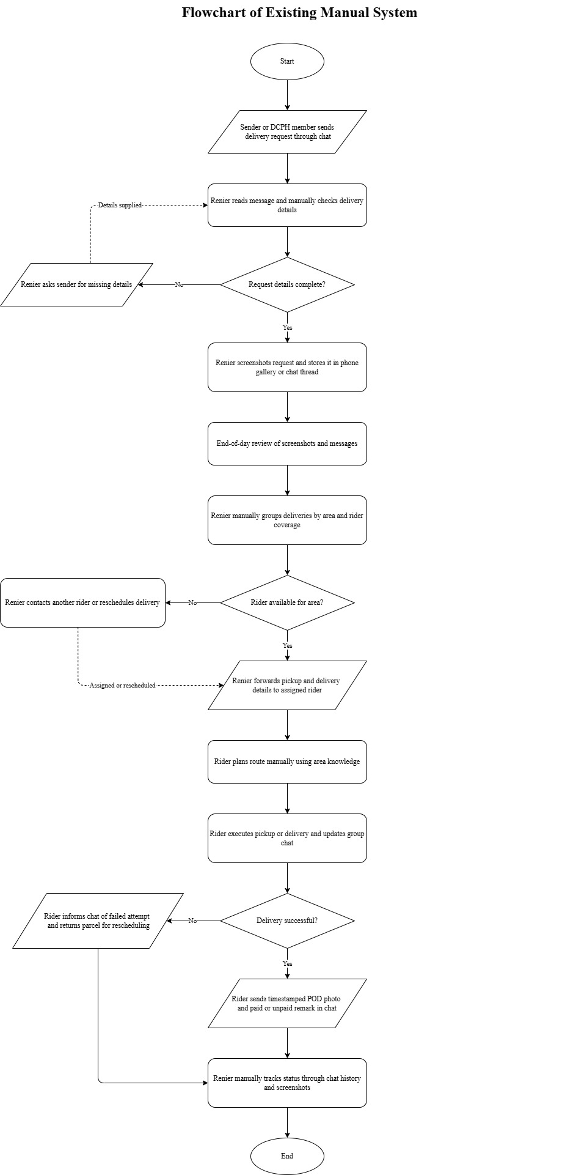
Figure 3. Flowchart of Existing System
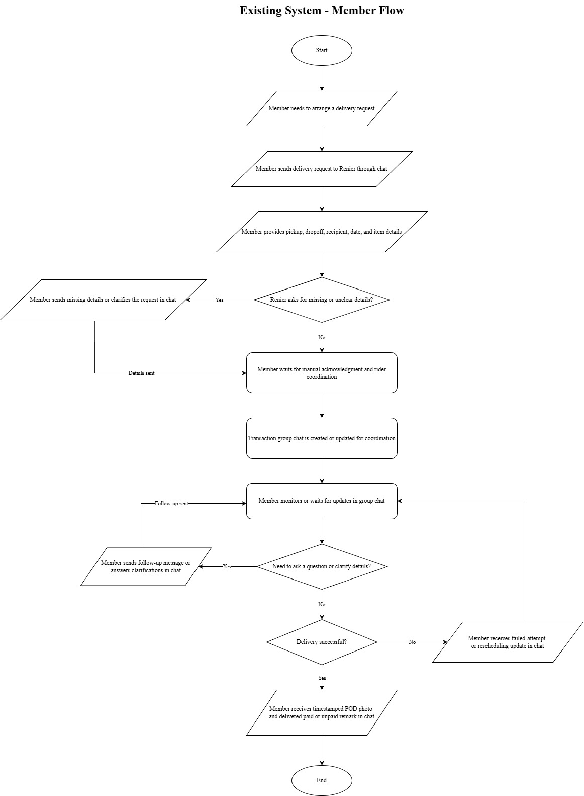
Figure 4. Flowchart of Existing System – Member
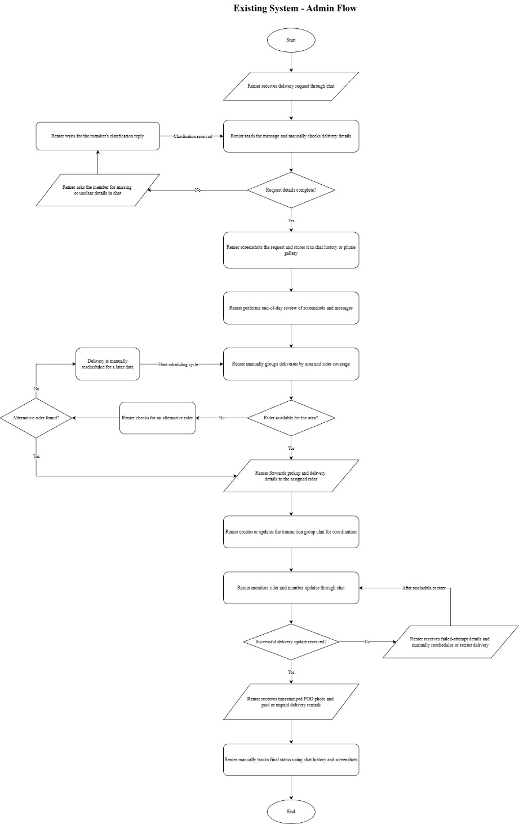
Figure 5. Flowchart of Existing System – Admin
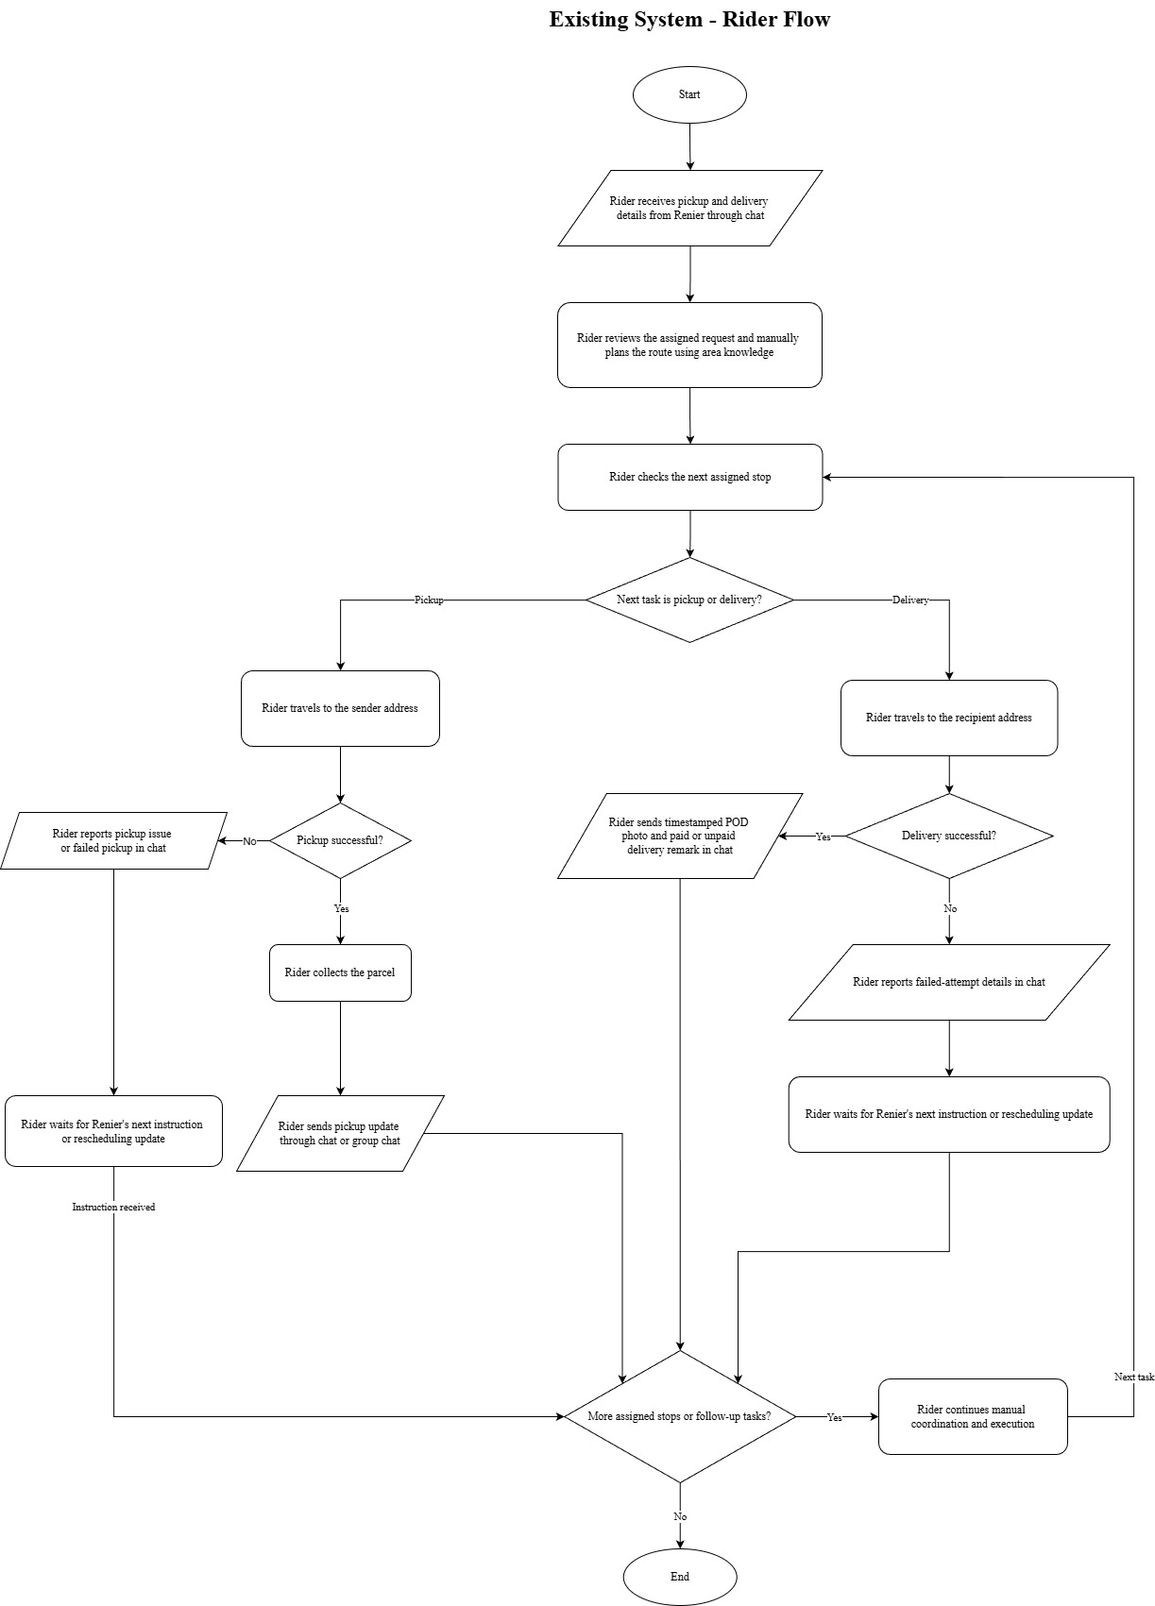
Figure 6. Flowchart of Existing System – Rider
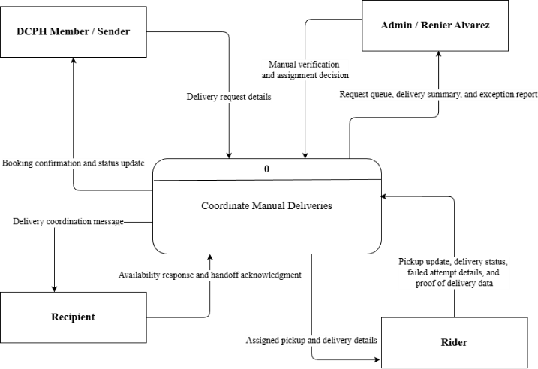
Figure 7. Existing System Context Data Flow Diagram
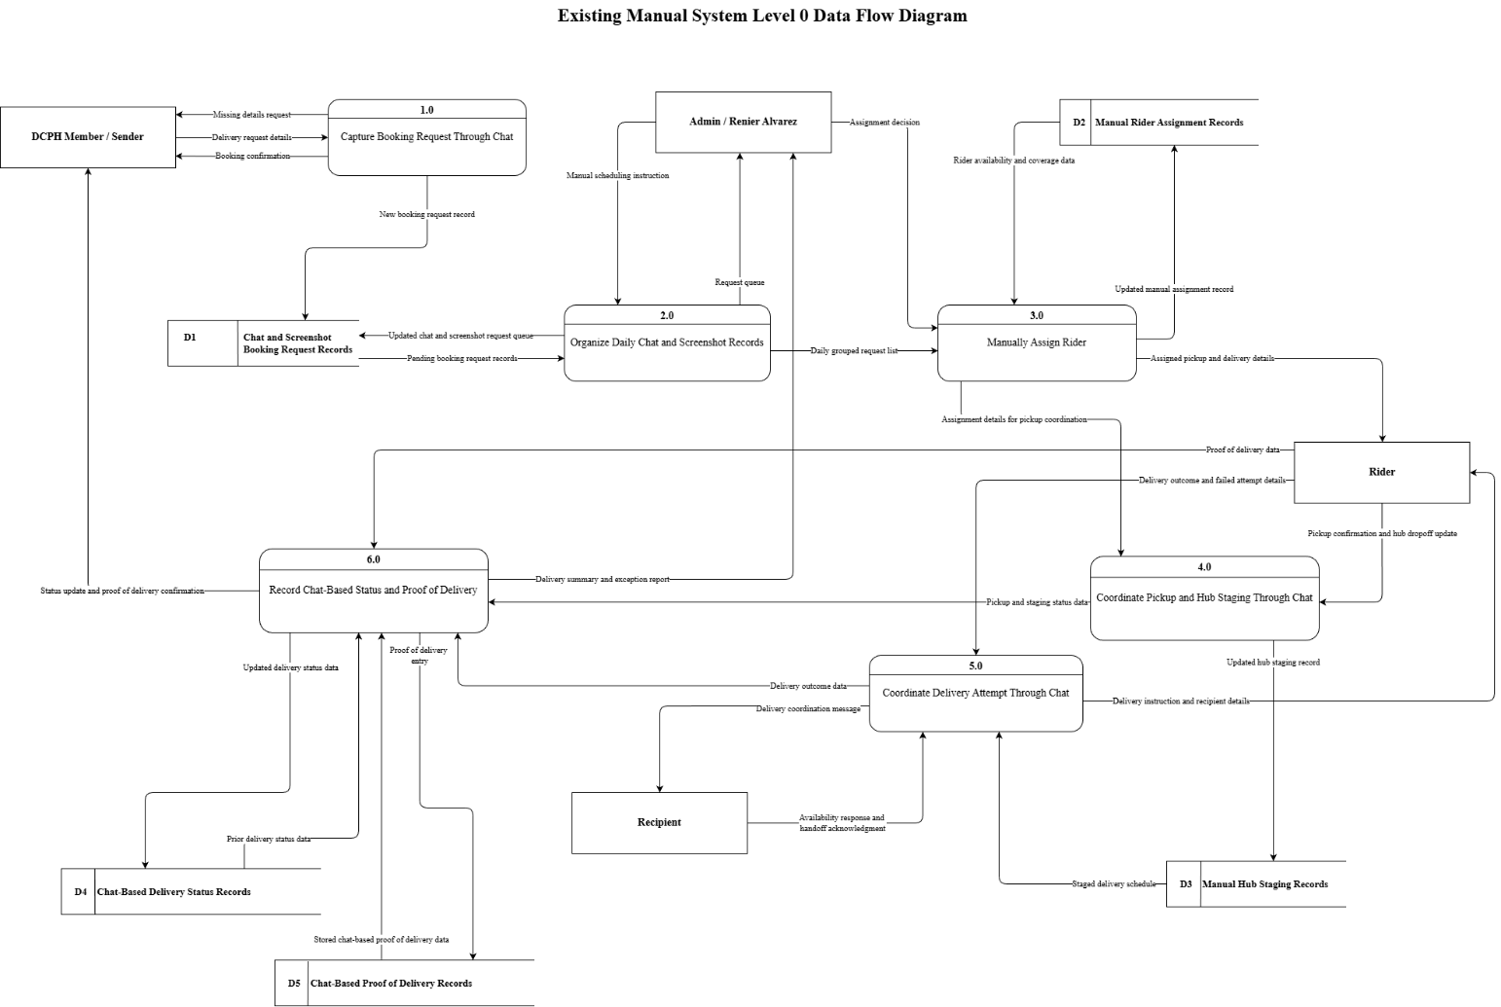
Figure 8. Existing System Level 0 Data Flow Diagram
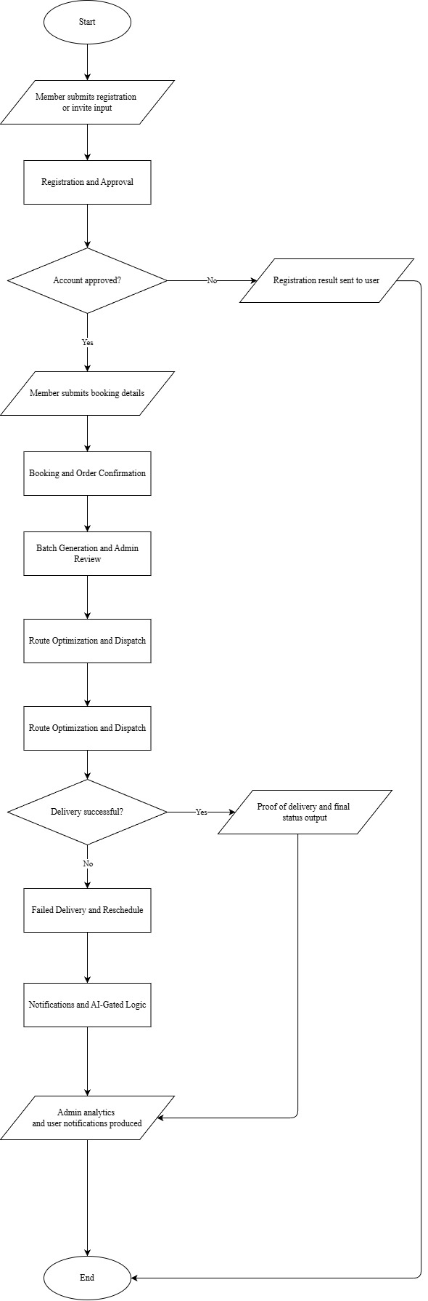
Figure 9. Flowchart of Proposed System
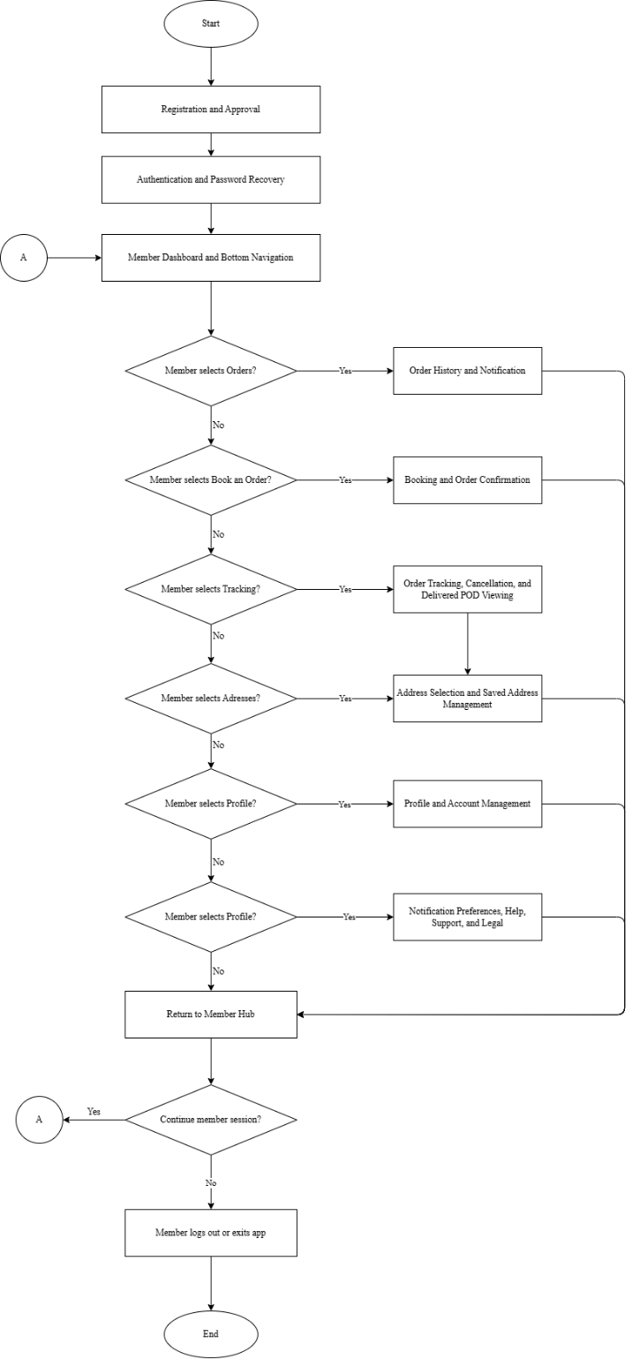
Figure 10. Flowchart of Proposed System – Member Overview Flow
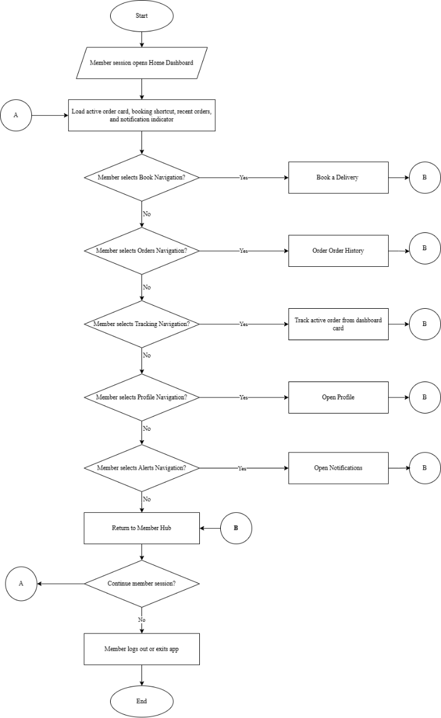
Figure 11. Flowchart of Proposed System – Member Dashboard and Bottom Navigation Flow
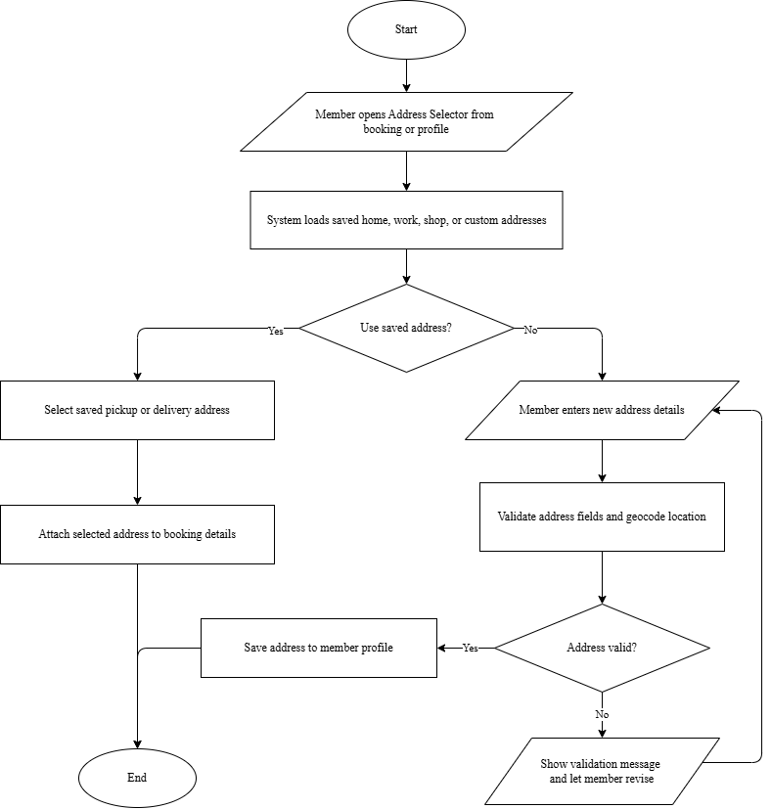
Figure 12. Flowchart of Proposed System – Member Address Selection and Saved Address Management Flow
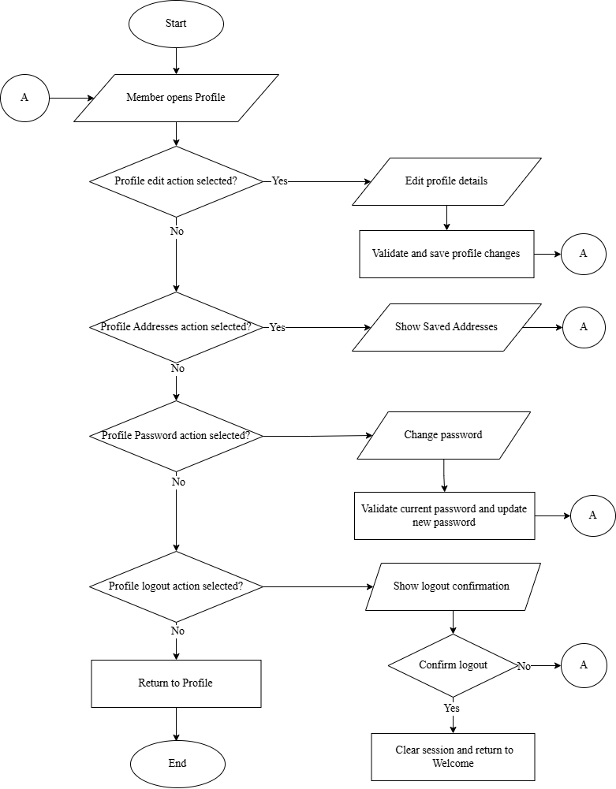
Figure 13. Flowchart of Proposed System – Member Profile and Account Management Flow
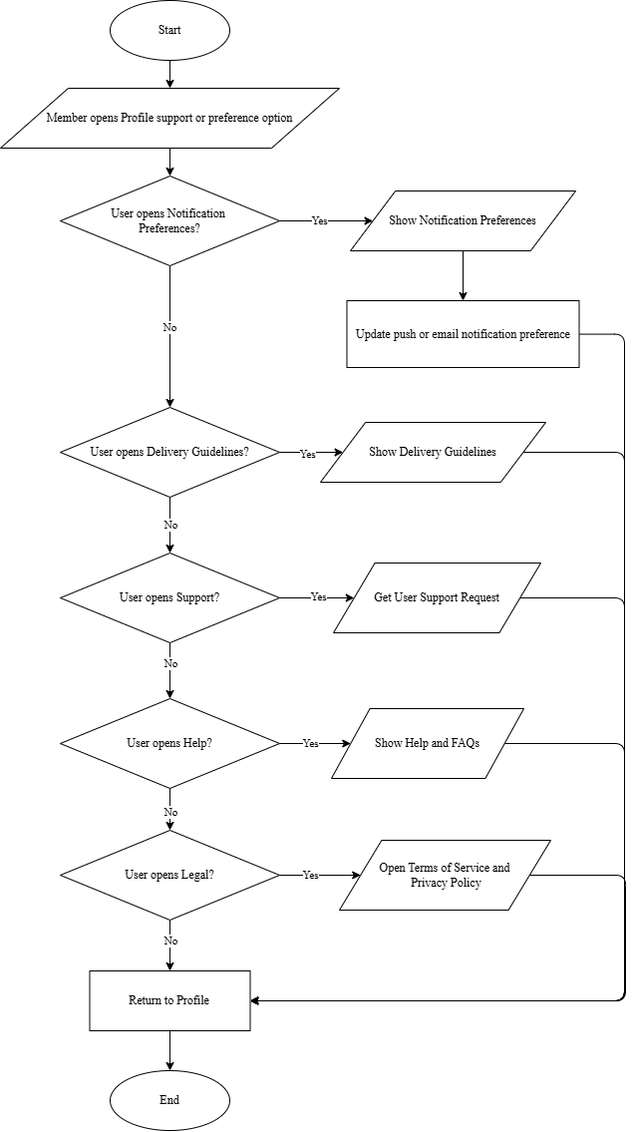
Figure 14. Flowchart of Proposed System – Member Notification Preferences, Help, Support and Legal Flow
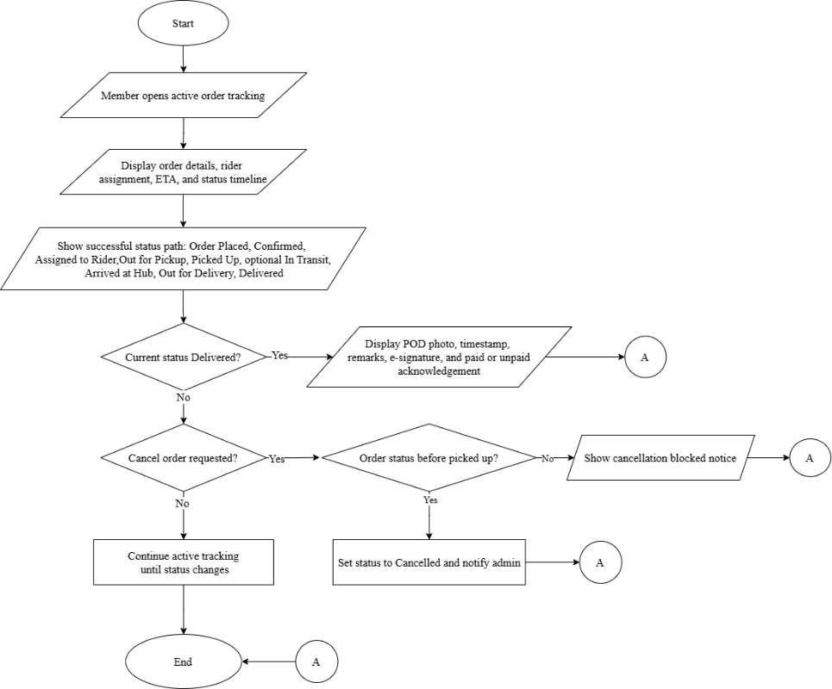
Figure 15. Flowchart of Proposed System – Member Order Tracking, Cancellation and Delivered POD Viewing Flow
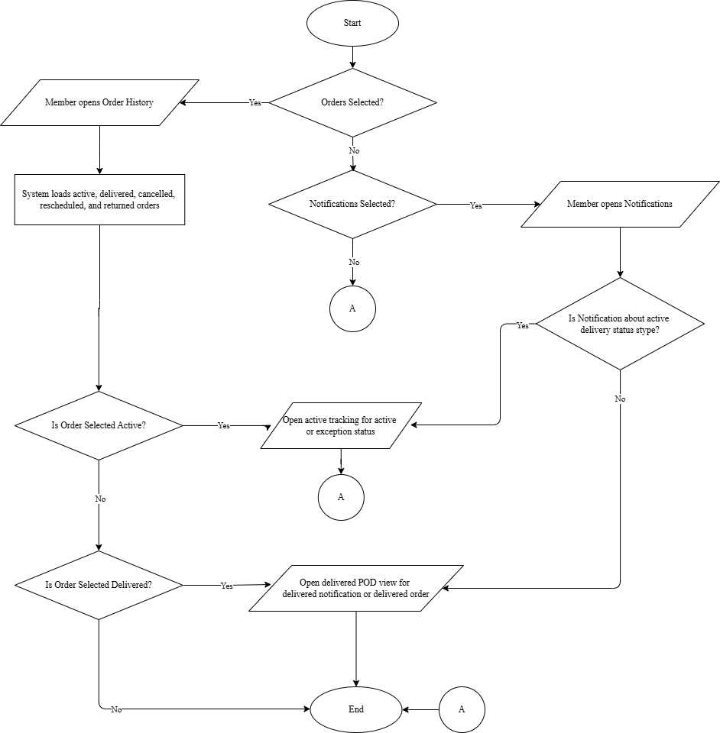
Figure 16. Flowchart of Proposed System – Member Order History and Notification Deep-Link Flow
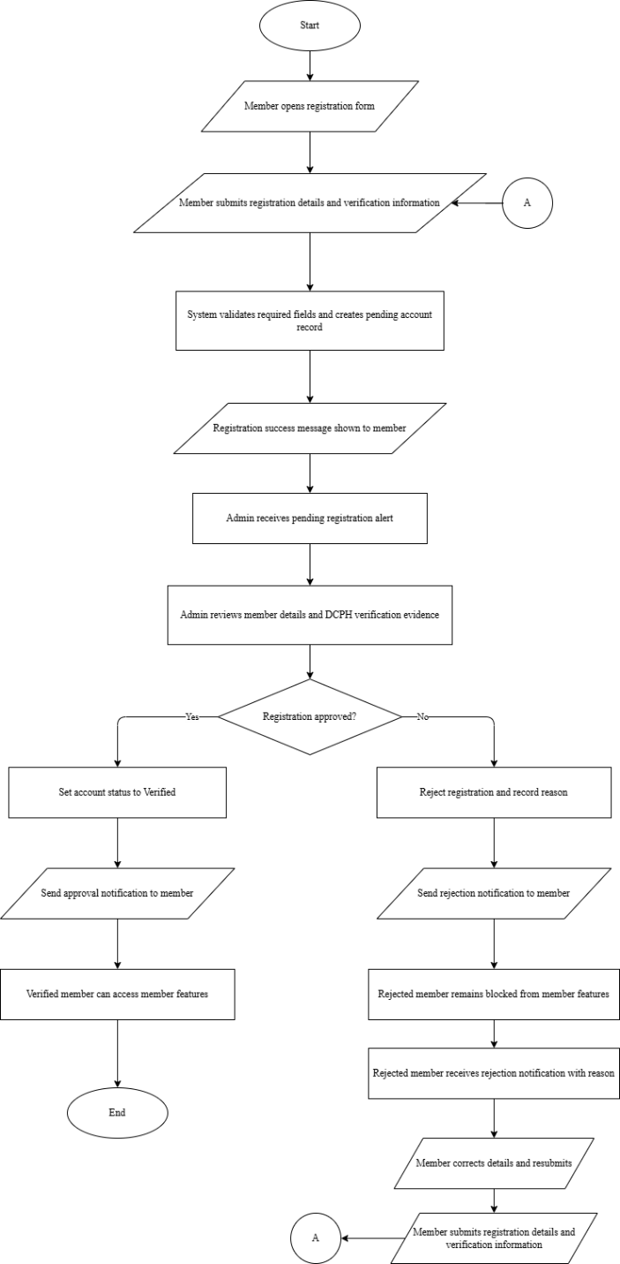
Figure 17. Flowchart of Proposed System – Member Registration and Approval Flow
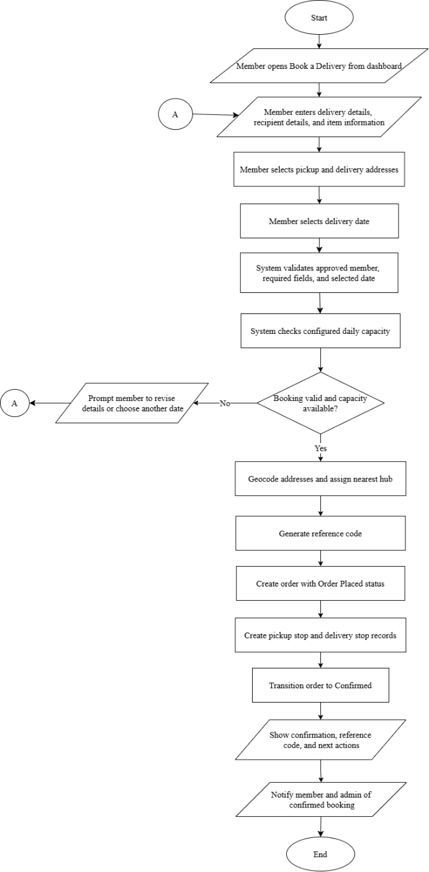
Figure 18. Flowchart of Proposed System – Member Booking and Order Confirmation Flow
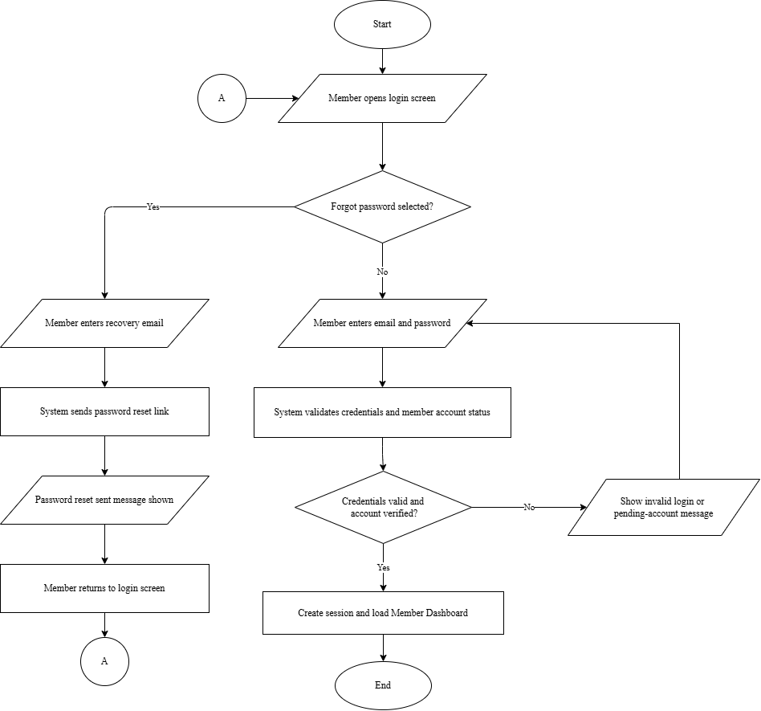
Figure 19. Flowchart of Proposed System – Member Authentication and Password Recovery Flow
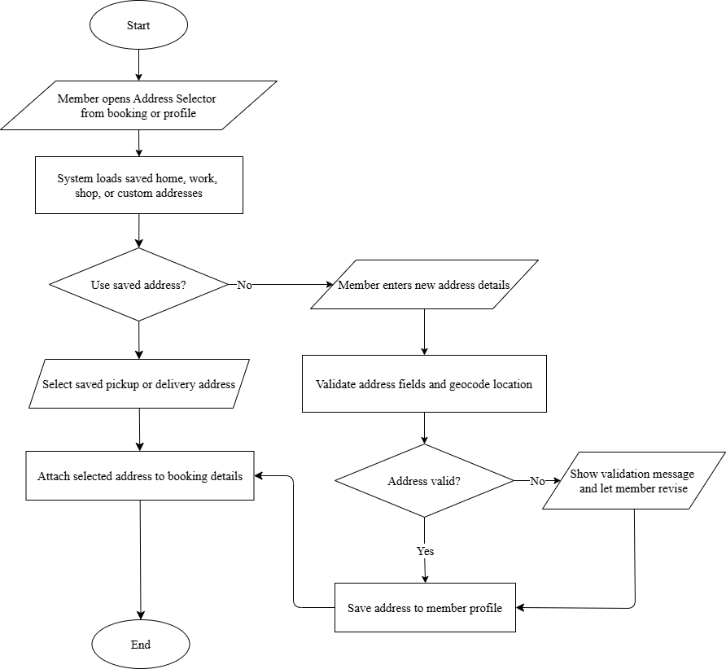
Figure 20. Flowchart of Proposed System – Member Post-Booking Self-Service Flow
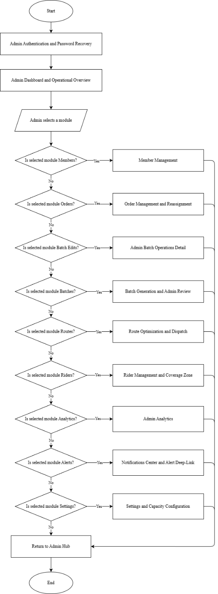
Figure 21. Flowchart of Proposed System – Admin Overview Flow
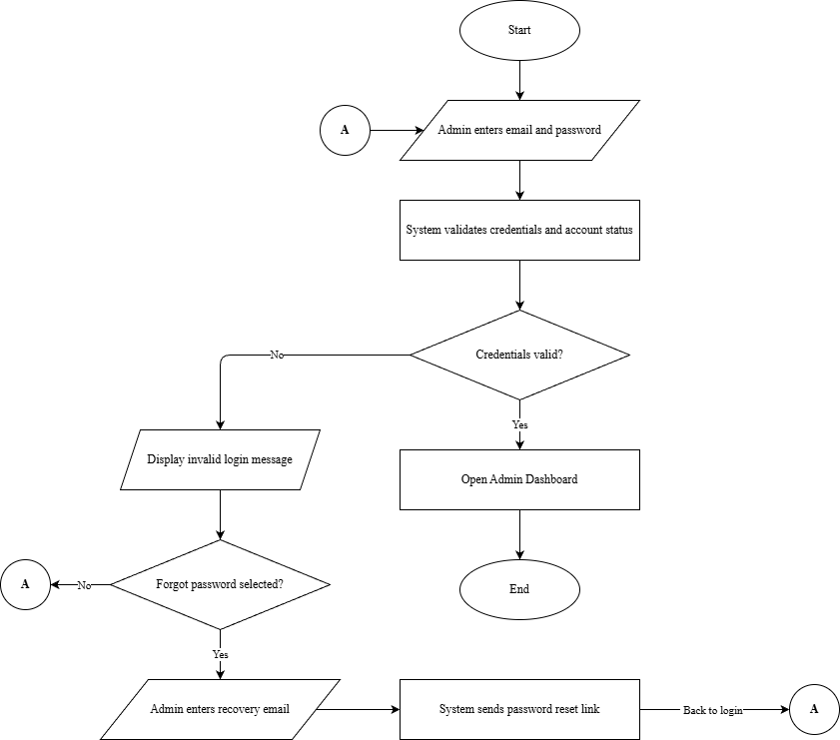
Figure 22. Flowchart of Proposed System – Admin Authentication and Password Recovery Flow
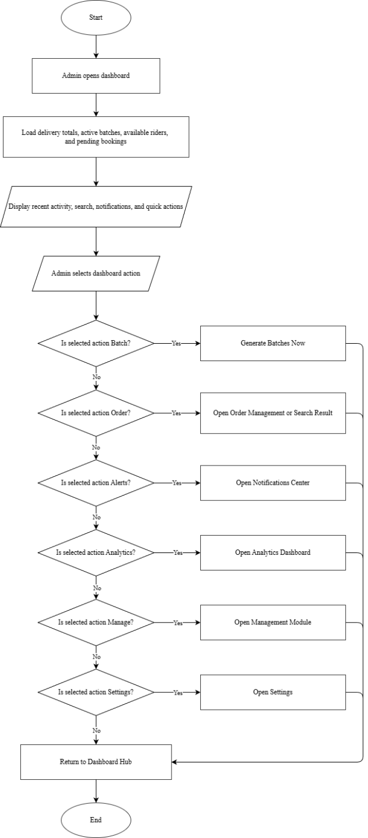
Figure 23. Flowchart of Proposed System – Admin Dashboard and Operational Overview Flow
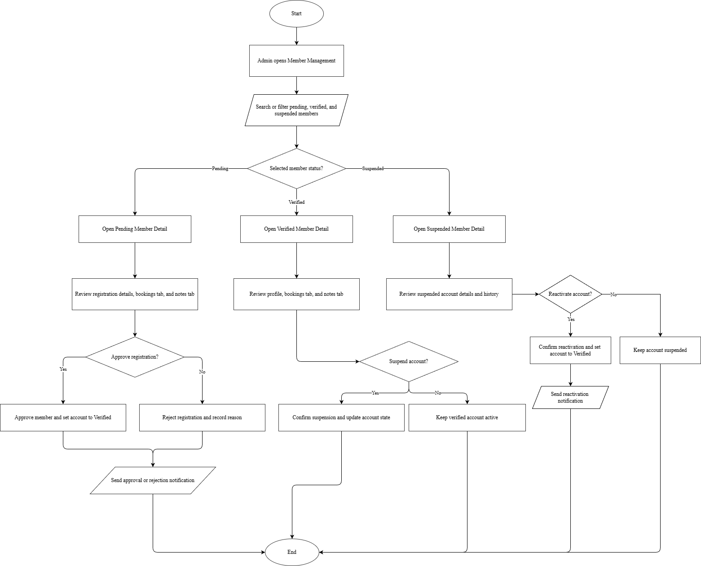
Figure 24. Flowchart of Proposed System – Admin Member Management Flow
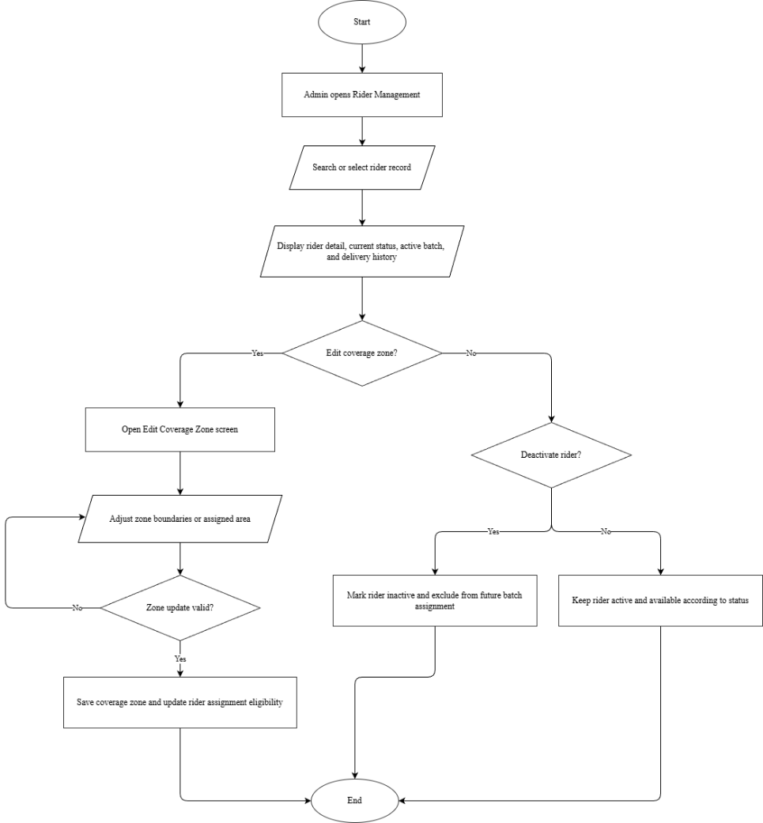
Figure 25. Flowchart of Proposed System – Admin Rider Management and Coverage Zone Flow
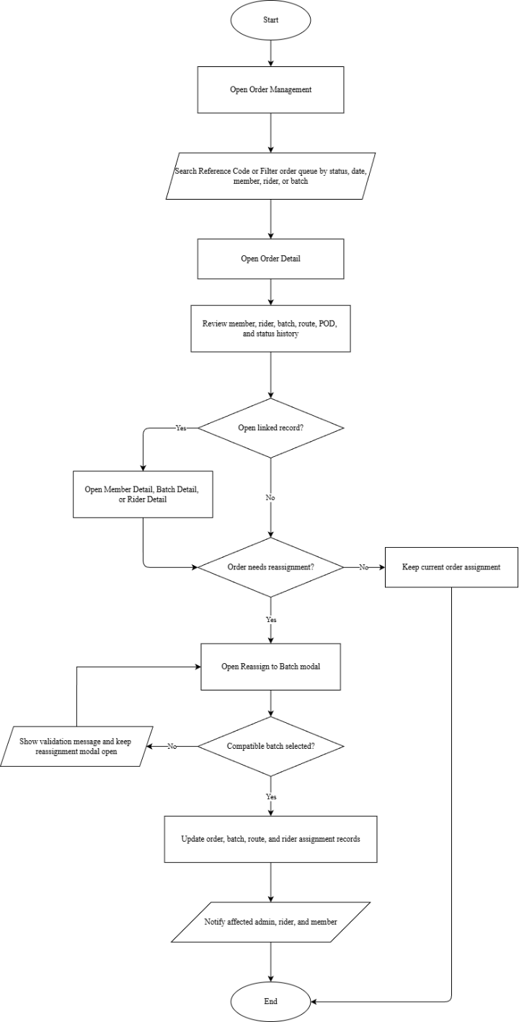
Figure 26. Flowchart of Proposed System – Admin Order Management and Reassignment Flow
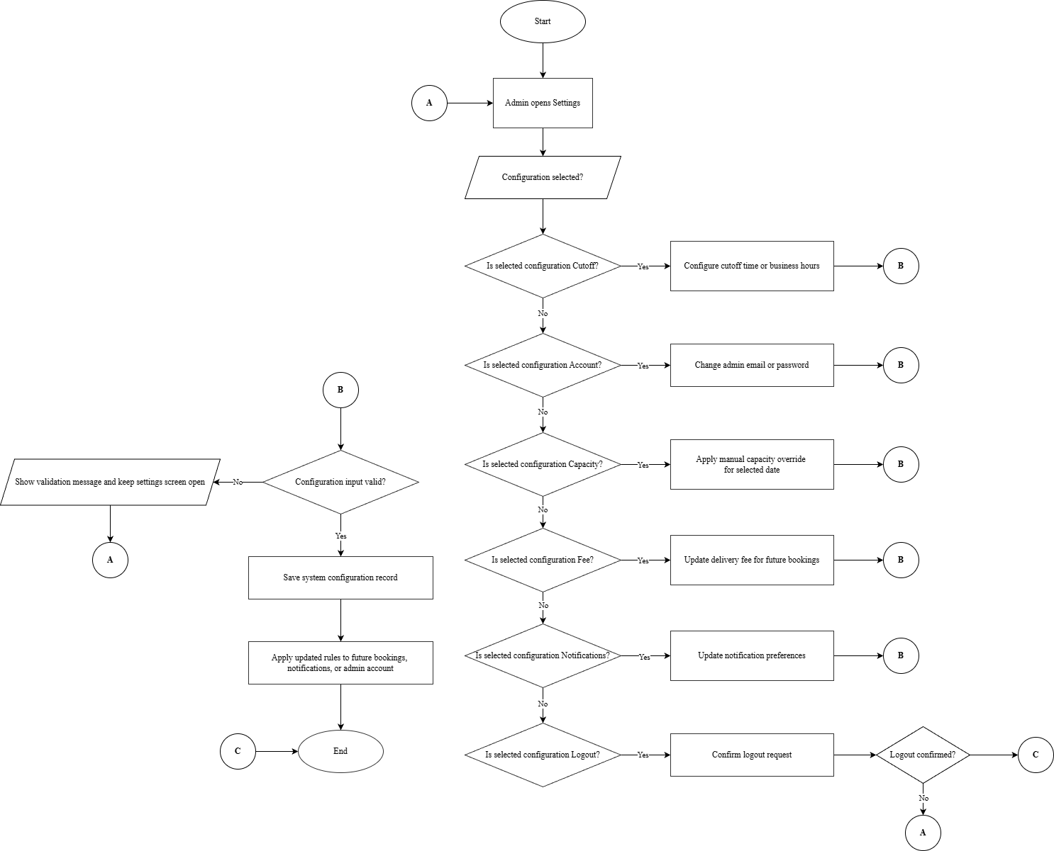
Figure 27. Flowchart of Proposed System – Admin Settings and Capacity Configuration Flow
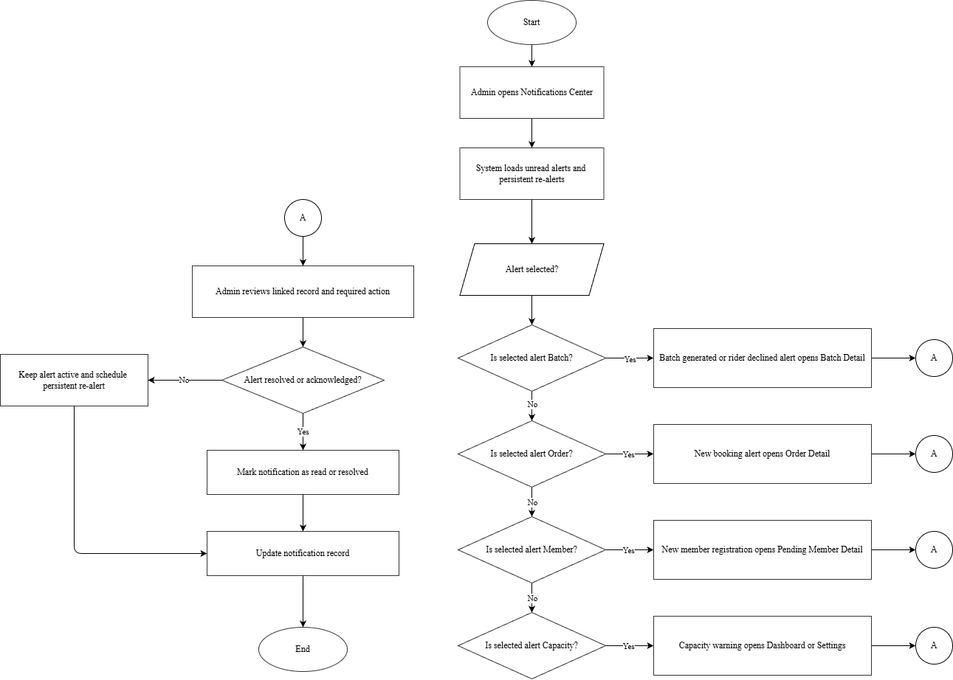
Figure 28. Flowchart of Proposed System – Admin Notifications Center and Alert Deep-Link Flow
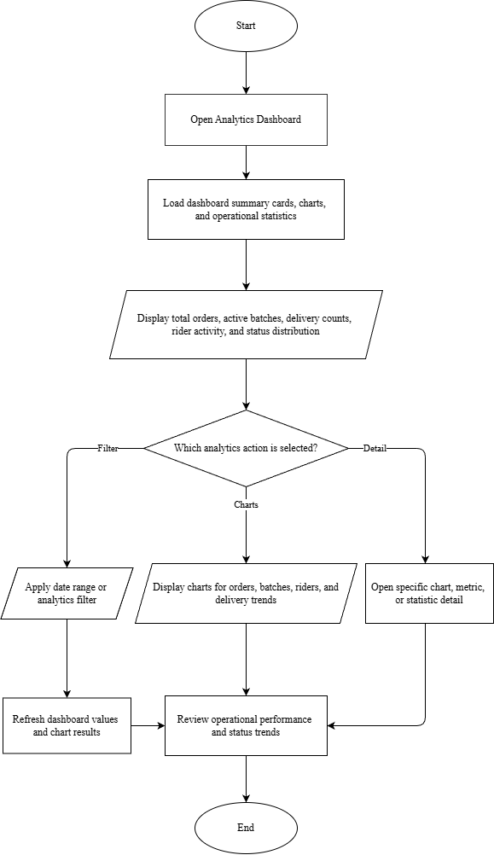
Figure 29. Flowchart of Proposed System – Admin Analytics
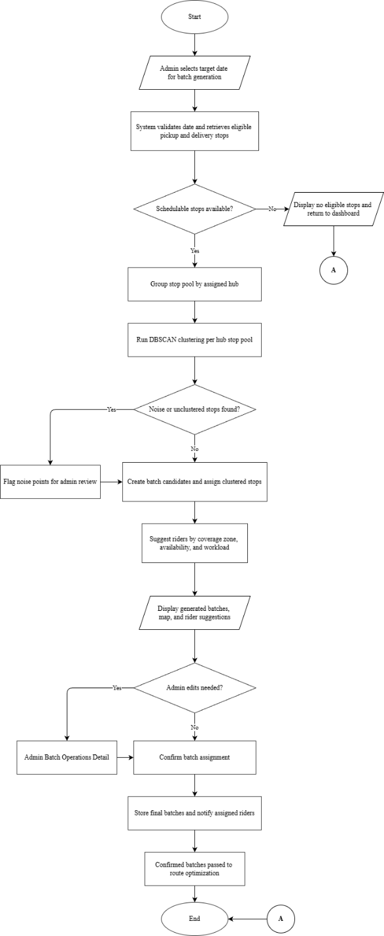
Figure 30. Flowchart of Proposed System – Admin Batch Generation and Admin Review Flow
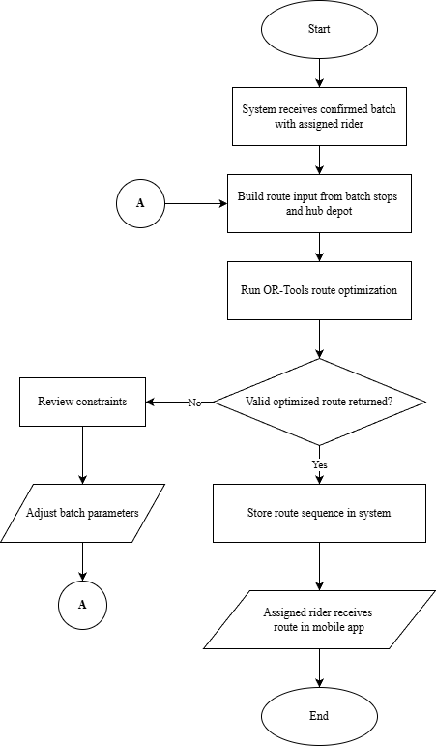
Figure 31. Flowchart of Proposed System – Admin Route Optimization and Dispatch Flow
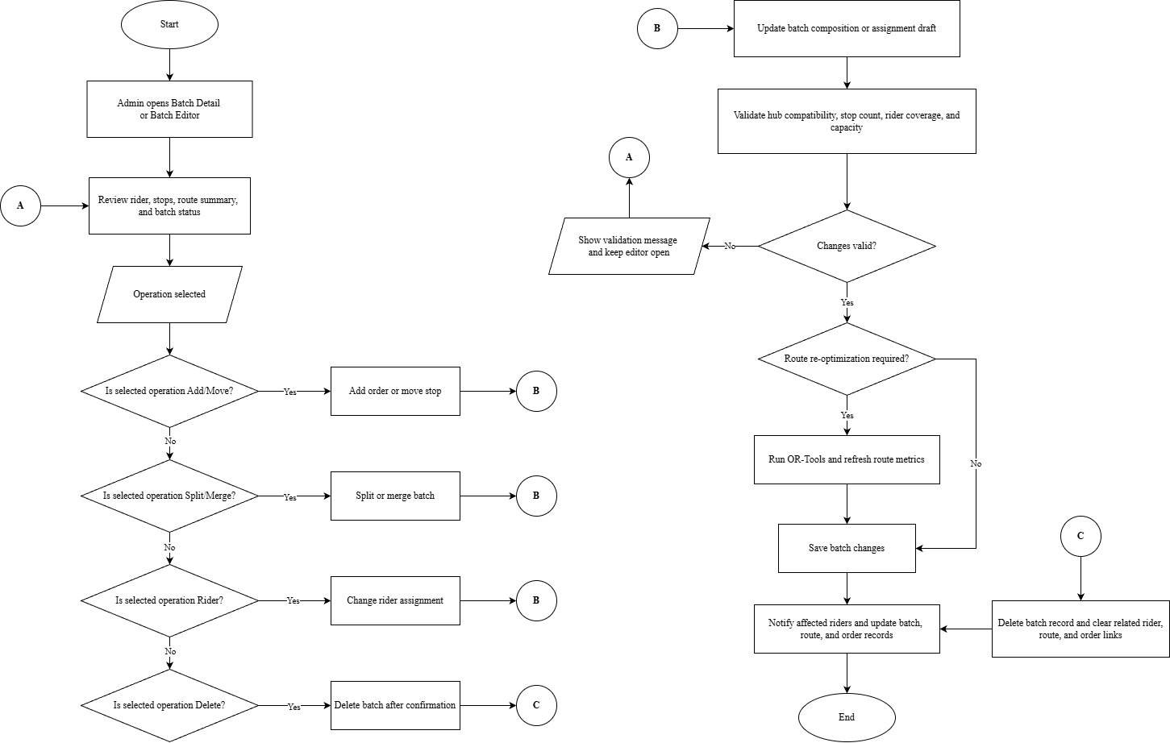
Figure 32. Flowchart of Proposed System – Admin Batch Operations Detail Flow
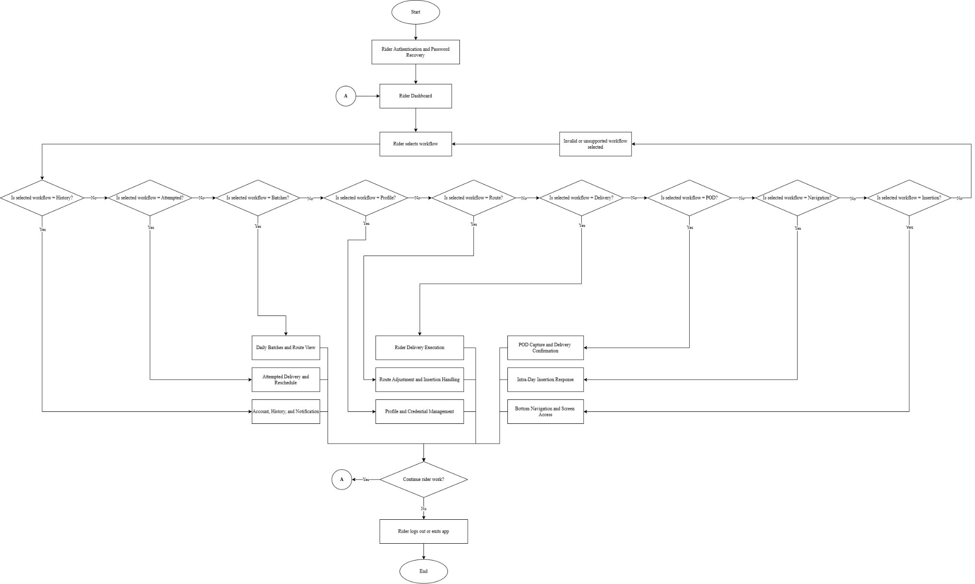
Figure 33. Flowchart of Proposed System – Rider Overview Flow
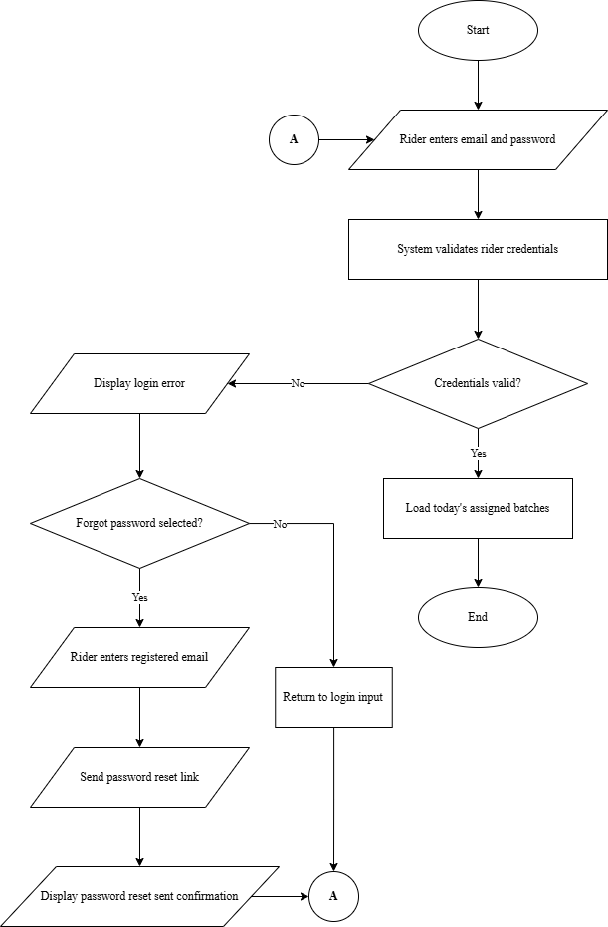
Figure 34. Flowchart of Proposed System – Rider Authentication and Password Recovery Flow
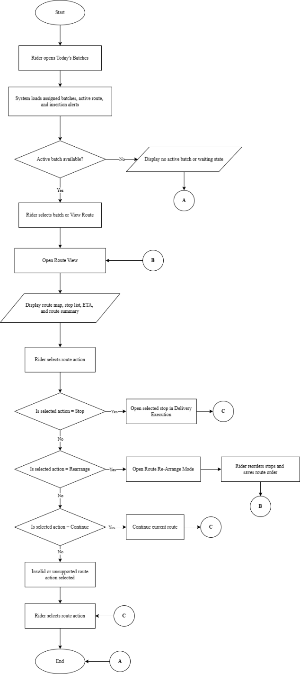
Figure 35. Flowchart of Proposed System – Rider Daily Batches and Route View Flow
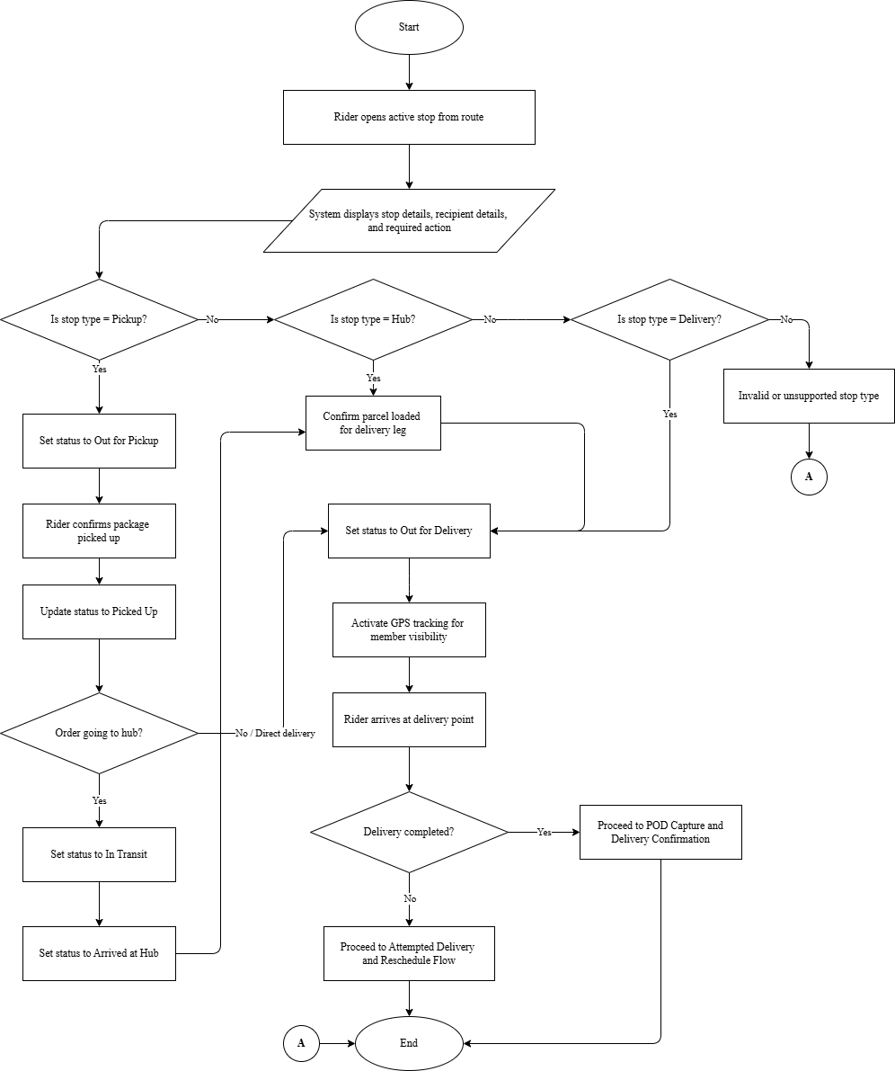
Figure 36. Flowchart of Proposed System – Rider Delivery Execution Flow
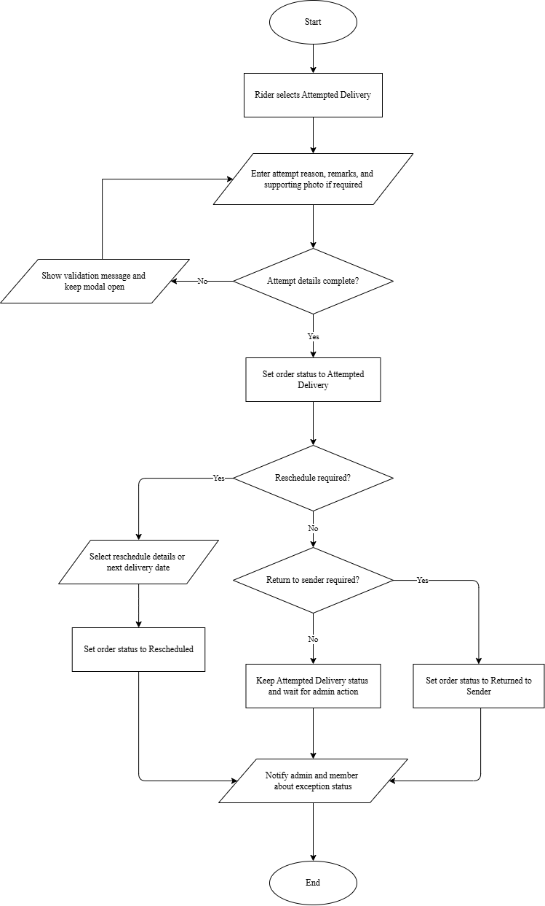
Figure 37. Flowchart of Proposed System – Rider Attempted Delivery and Reschedule Flow
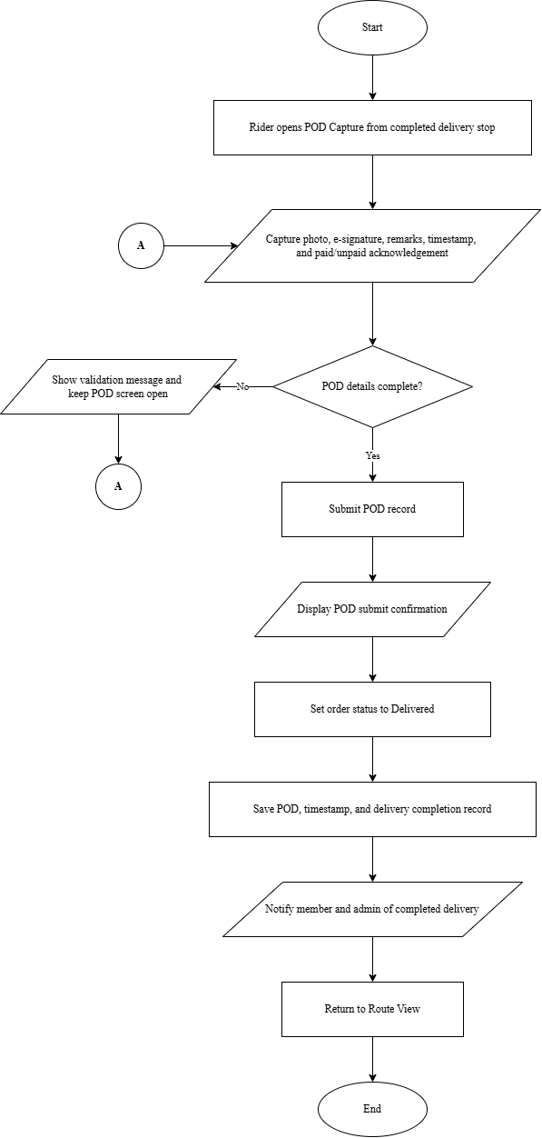
Figure 38. Flowchart of Proposed System – Rider POD Capture and Delivery Confirmation Flow
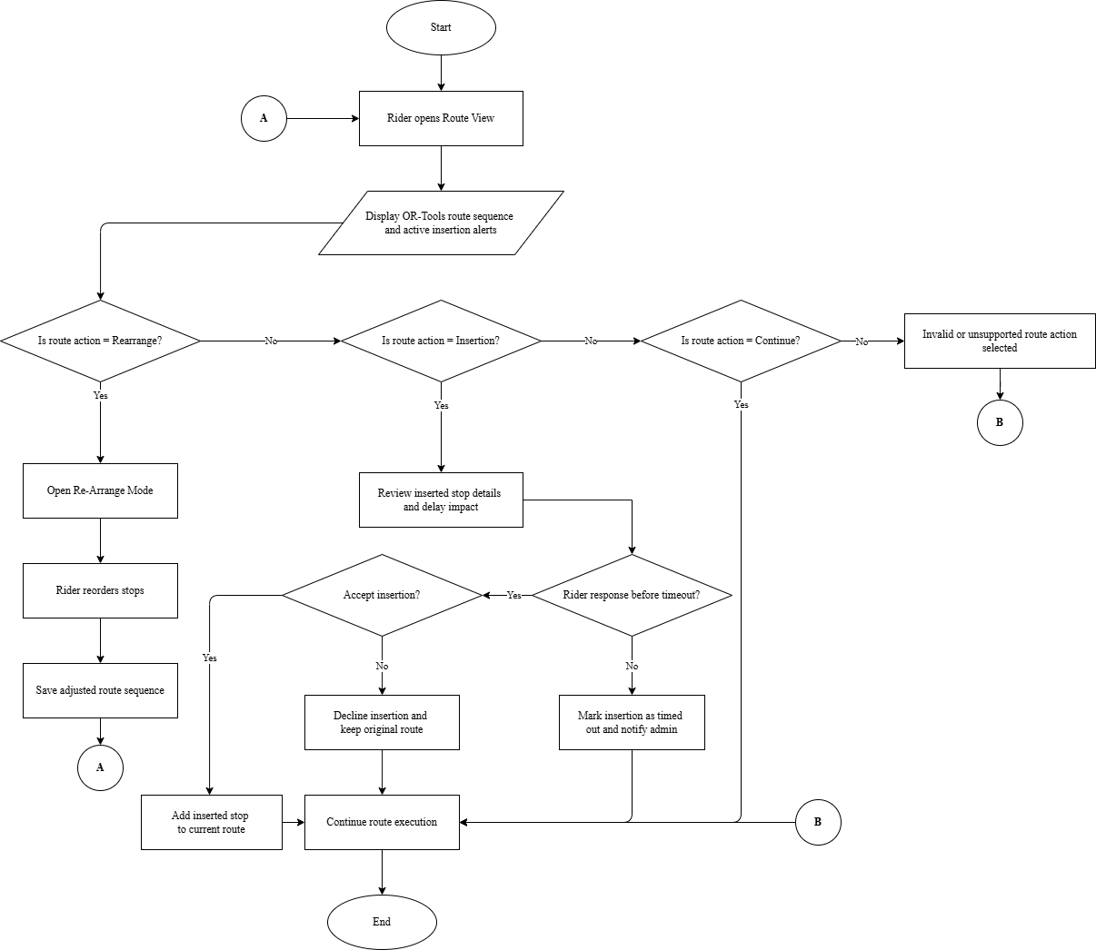
Figure 39. Flowchart of Proposed System – Rider Route Adjustment and Insertion Handling Flow
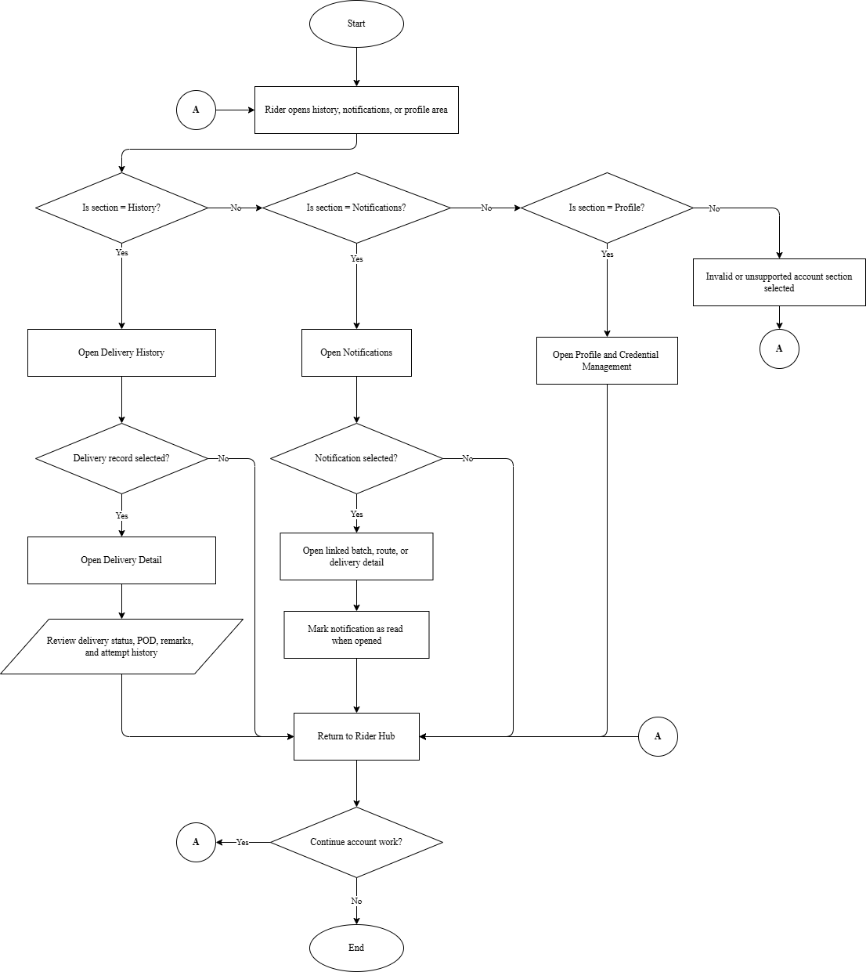
Figure 40. Flowchart of Proposed System – Rider Account History and Notification Flow
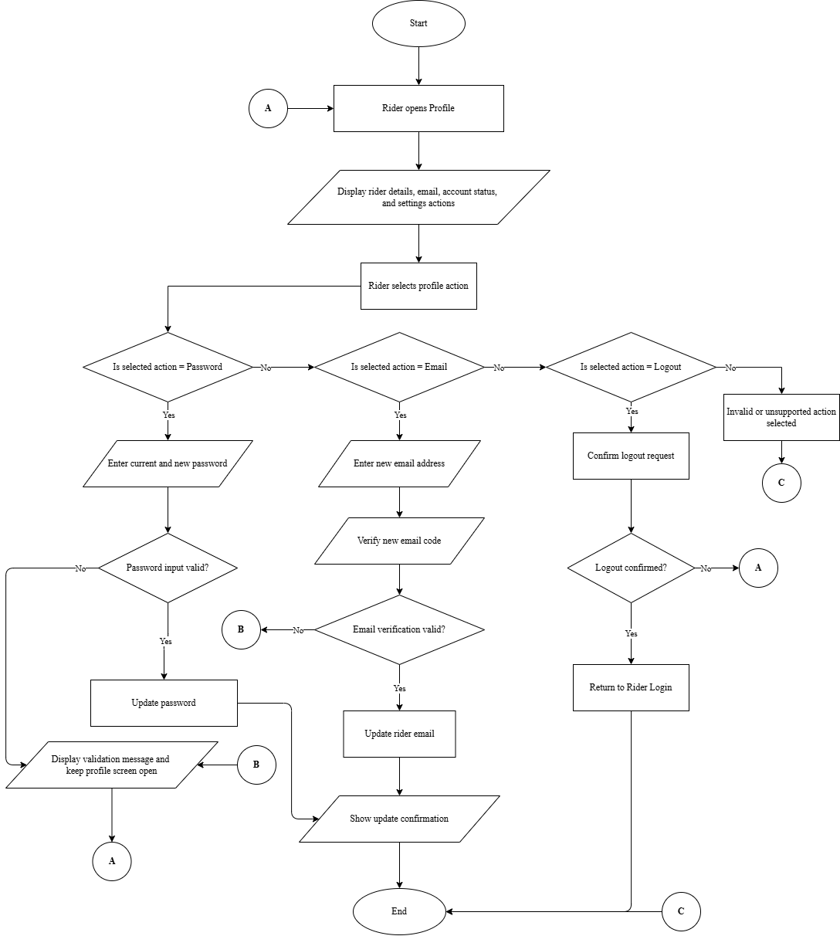
Figure 41. Flowchart of Proposed System – Rider Profile and Credential Management Flow
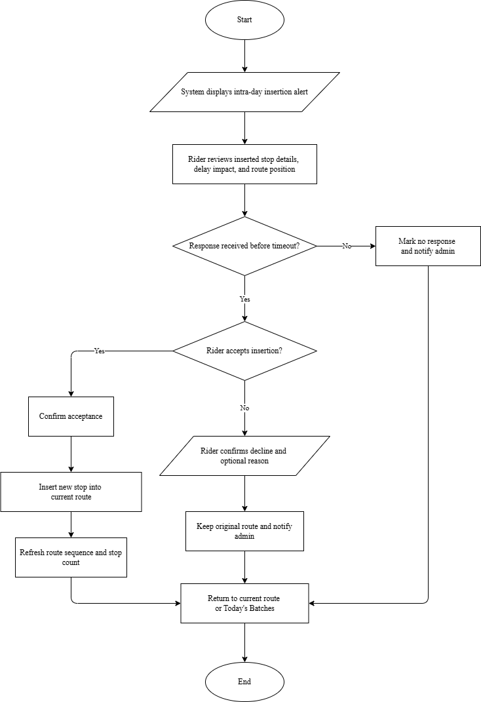
Figure 42. Flowchart of Proposed System – Rider Intra-Day Insertion Response Flow
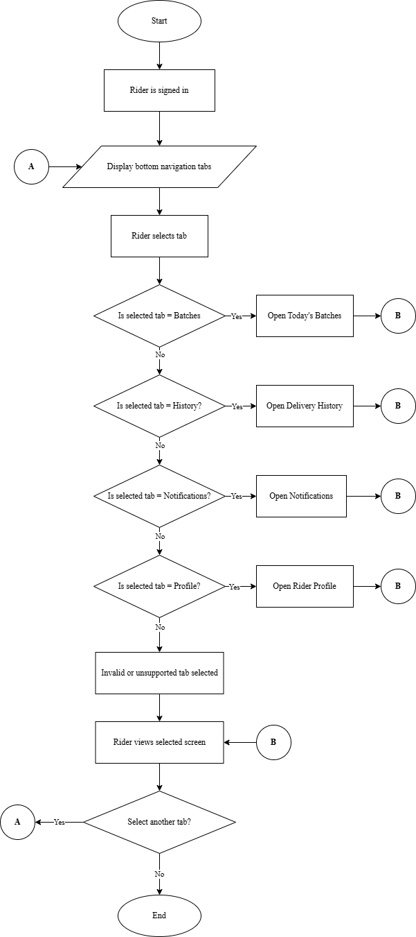
Figure 43. Flowchart of Proposed System – Rider Bottom Navigation and Screen Access Flow
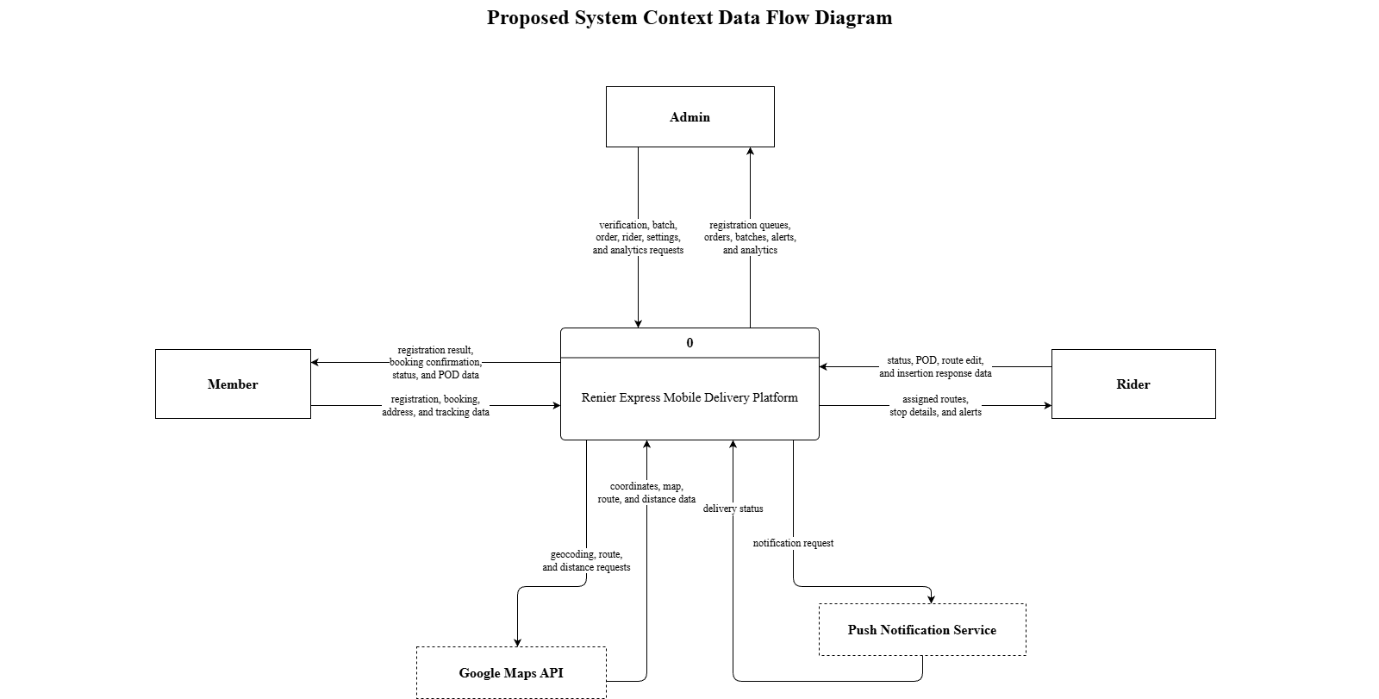
Figure 44. Proposed System Context Data Flow Diagram
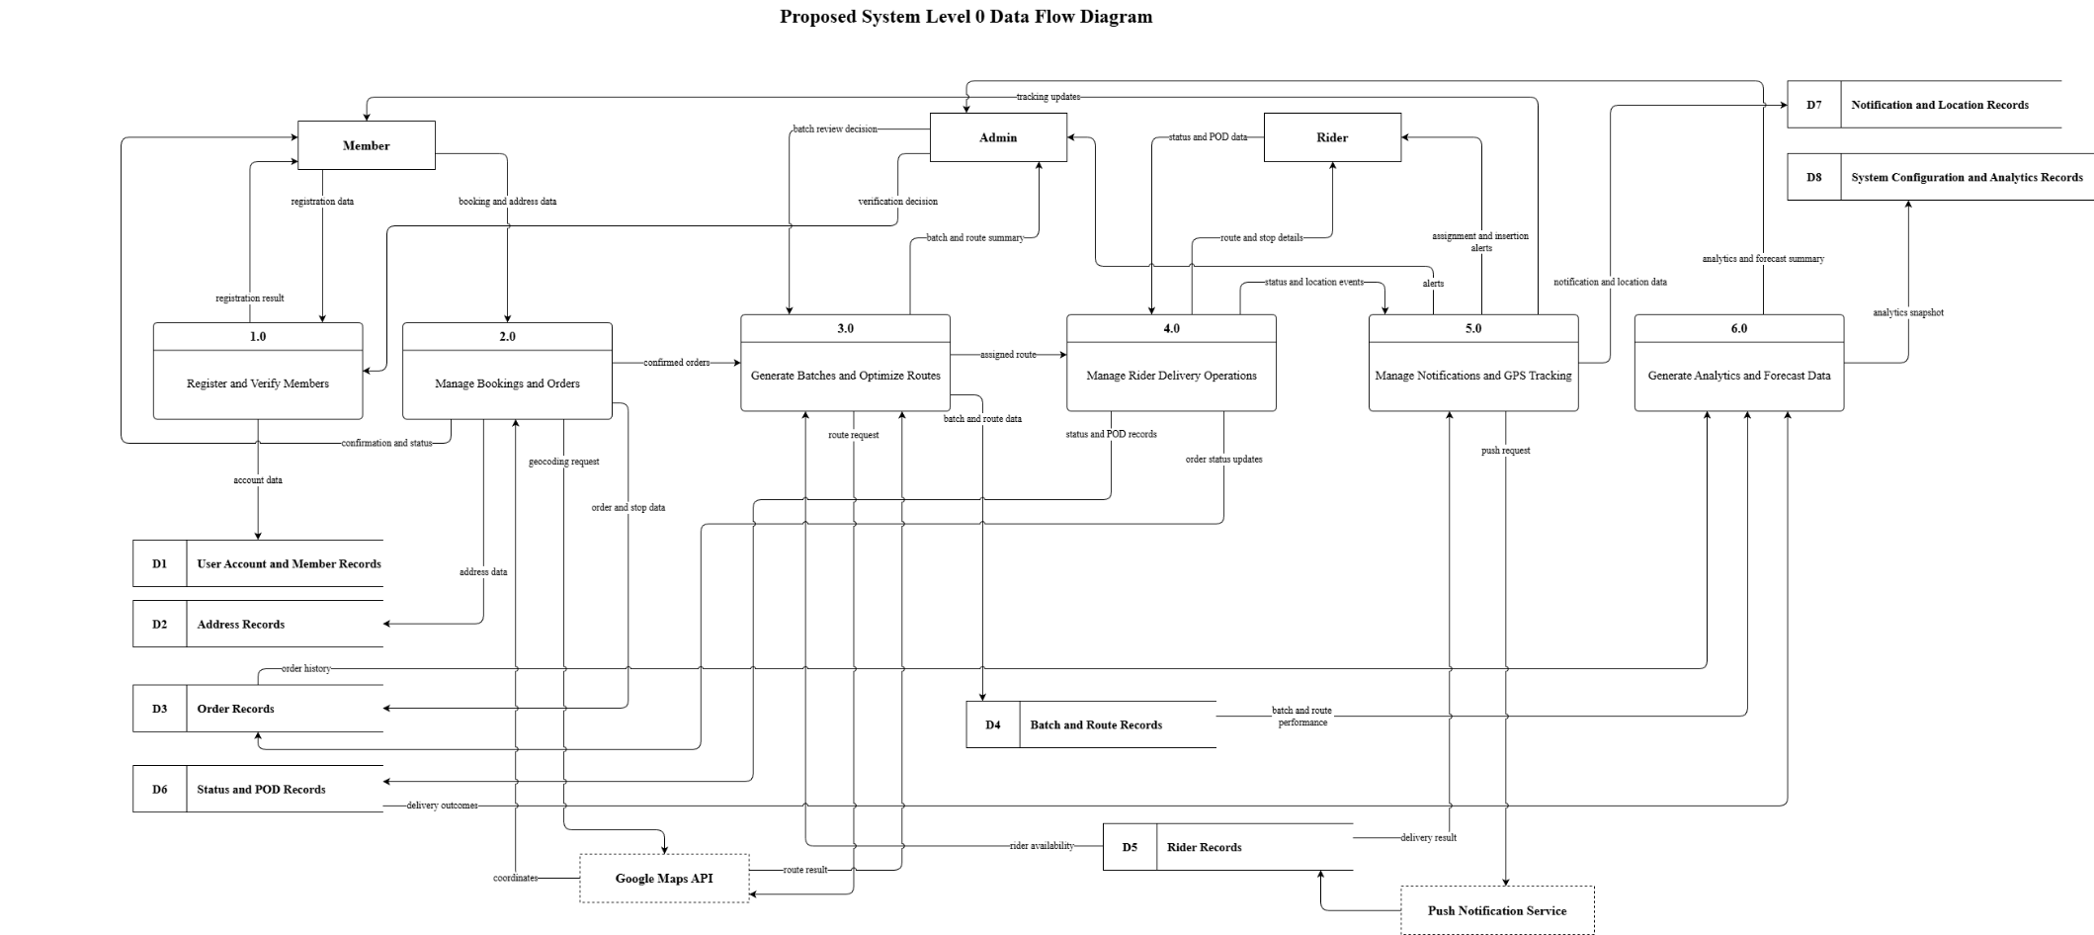
Figure 45. Proposed System Level 0 Data Flow Diagram
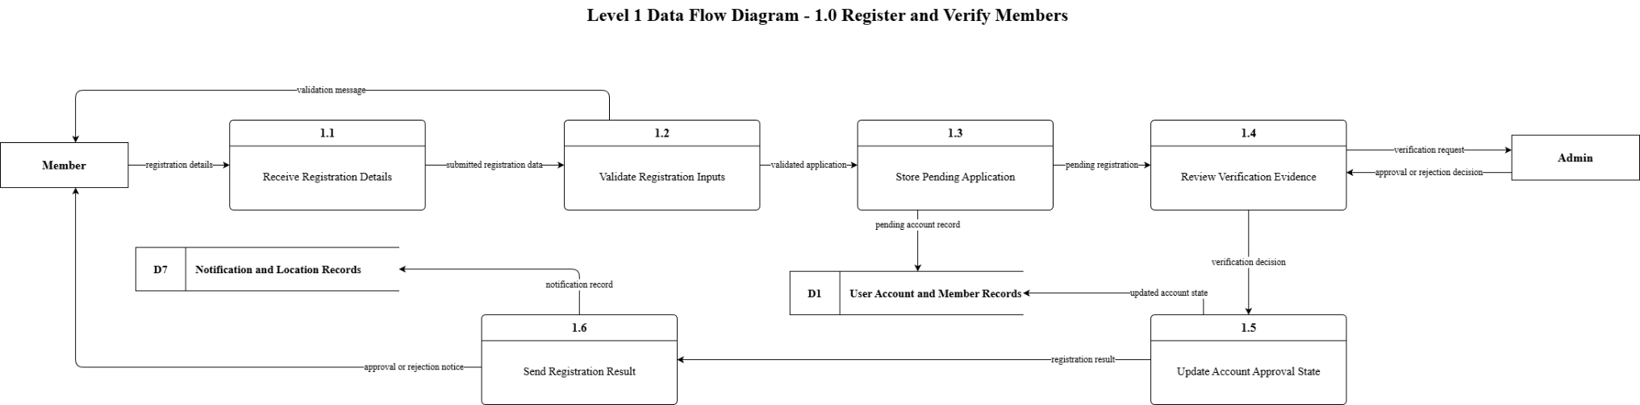
Figure 46. Proposed System Level 1 Data Flow Diagram – Register and Verify Members
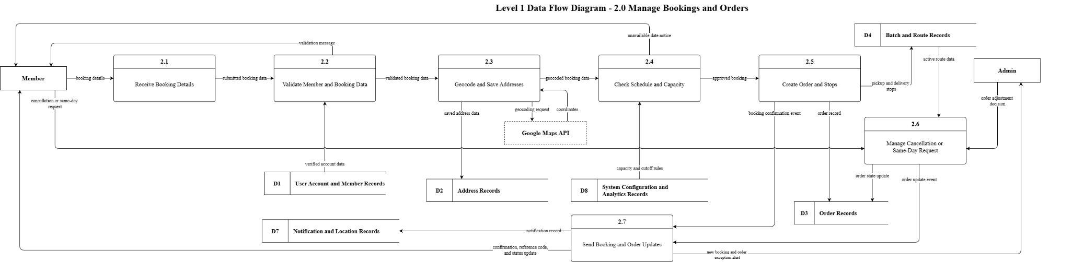
Figure 47. Proposed System Level 1 Data Flow Diagram – Manage Bookings and Orders
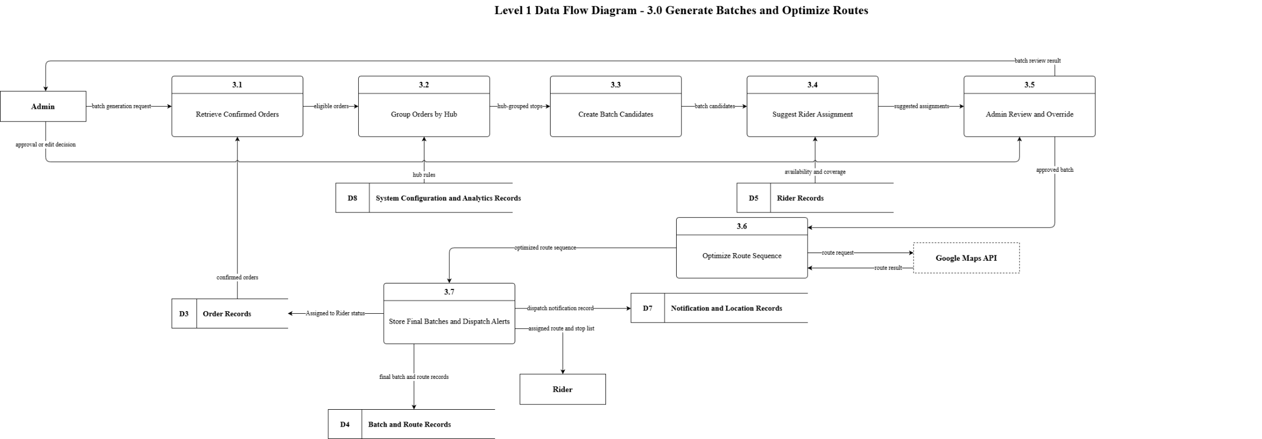
Figure 48. Proposed System Level 1 Data Flow Diagram – Generate Batches and Optimize Routes
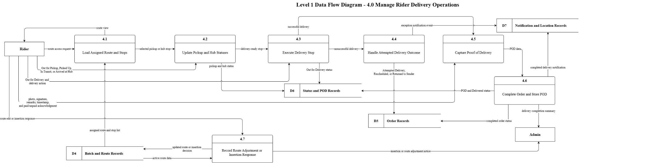
Figure 49. Proposed System Level 1 Data Flow Diagram – Manage Rider Delivery Operations
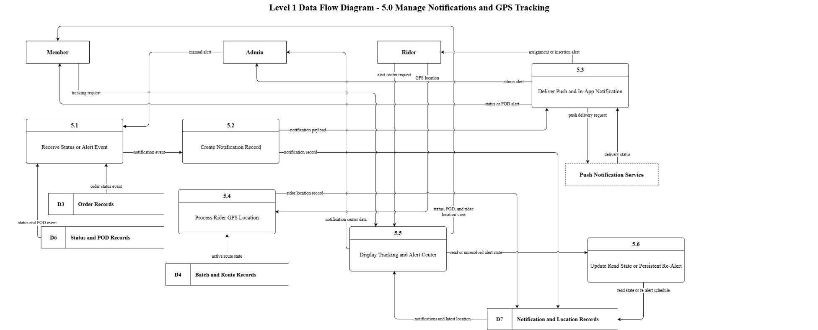
Figure 50. Proposed System Level 1 Data Flow Diagram – Manage Notifications and GPS Tracking
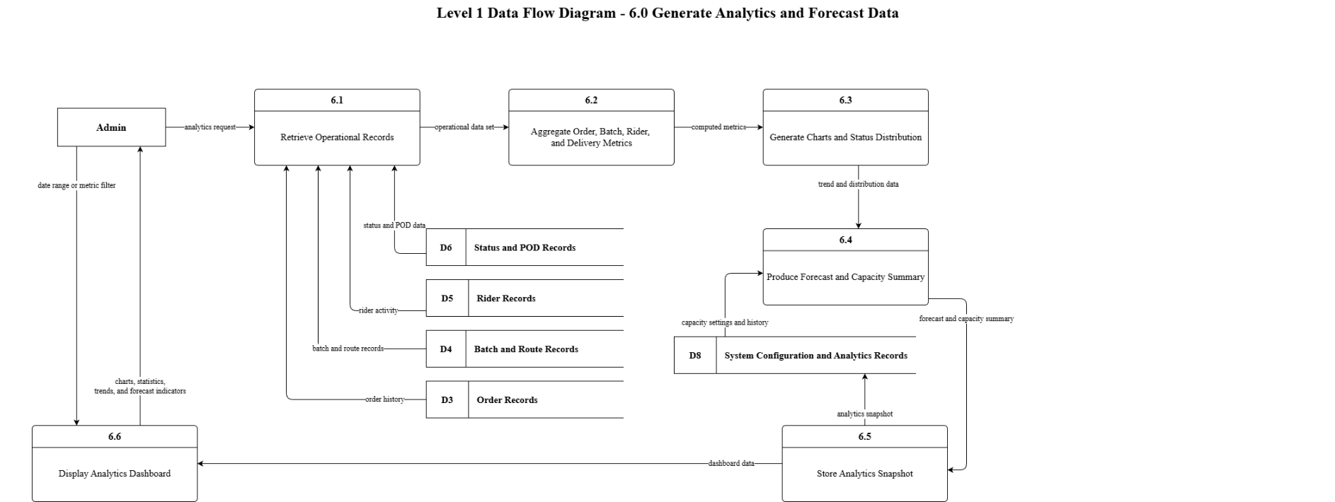
Figure 51. Proposed System Level 1 Data Flow Diagram – Generate Analytics and Forecast Data
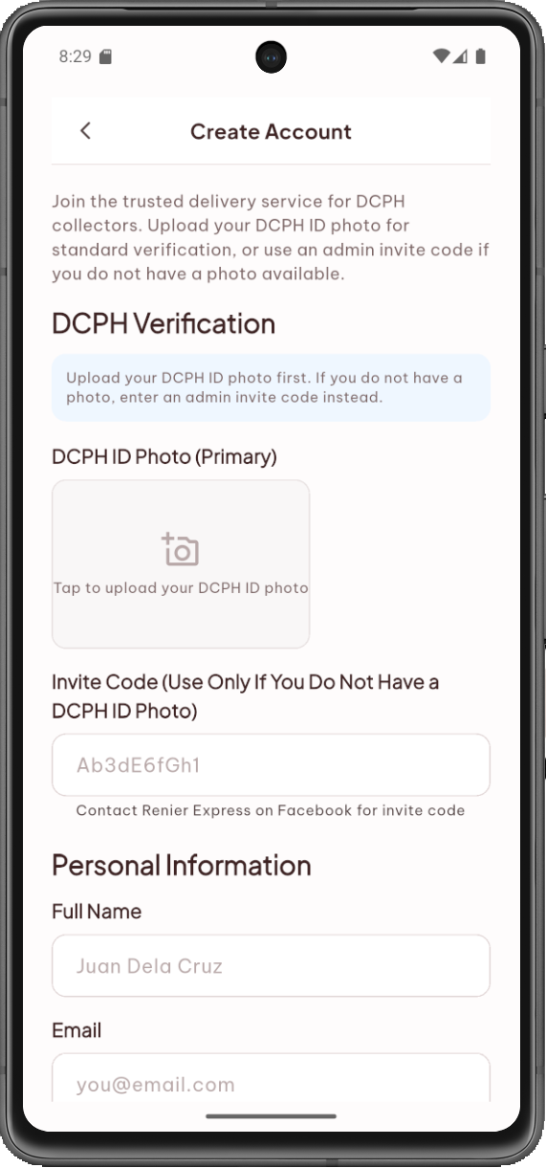
Figure 52. Member Registration Form
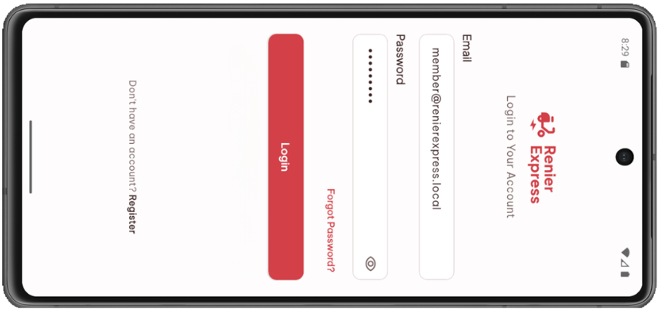
Figure 53. Login Screen
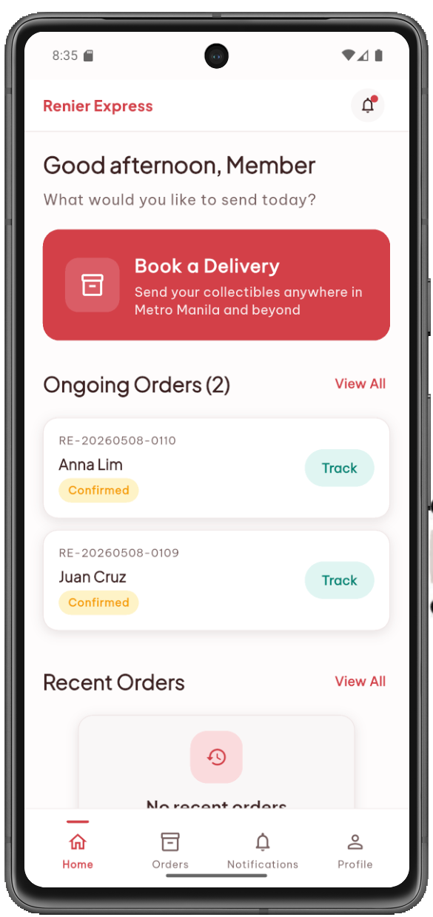
Figure 54. Member Home Dashboard
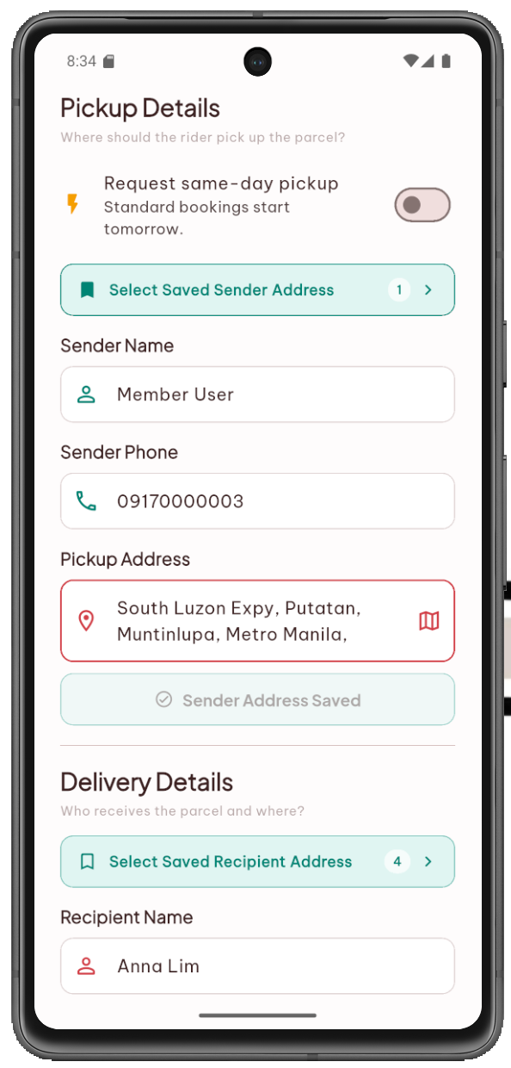
Figure 55 (a). Member Booking Form
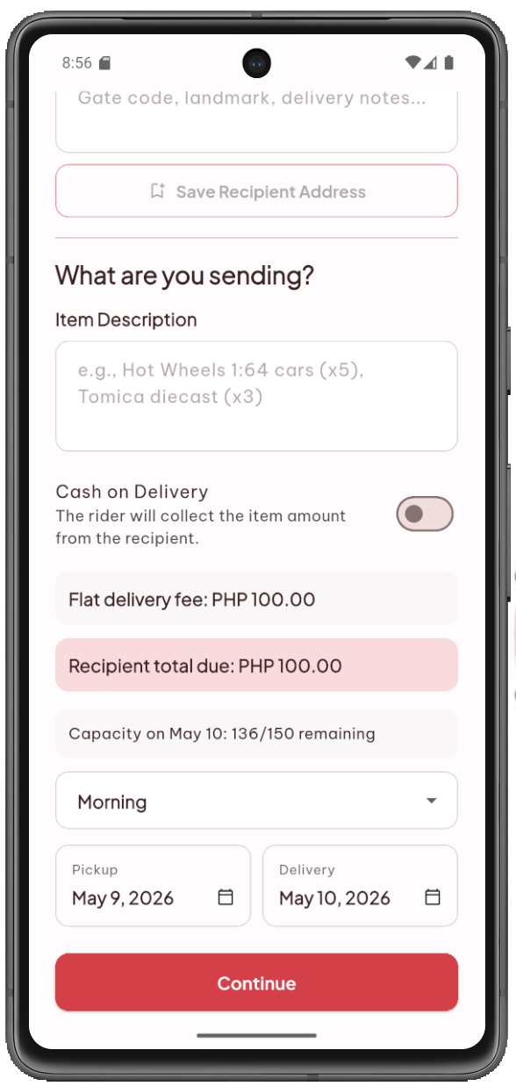
Figure 55 (b). Member Booking Form
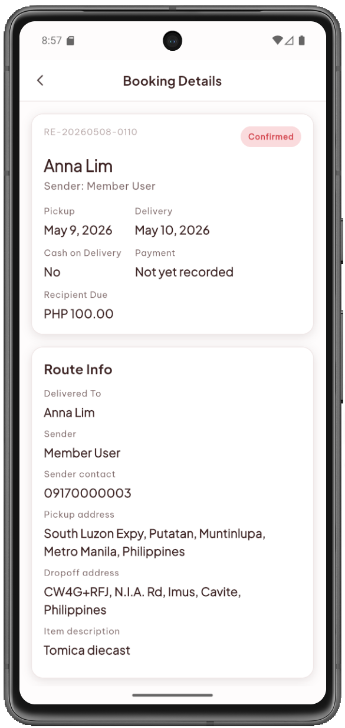
Figure 56 (a). Member Booking Details
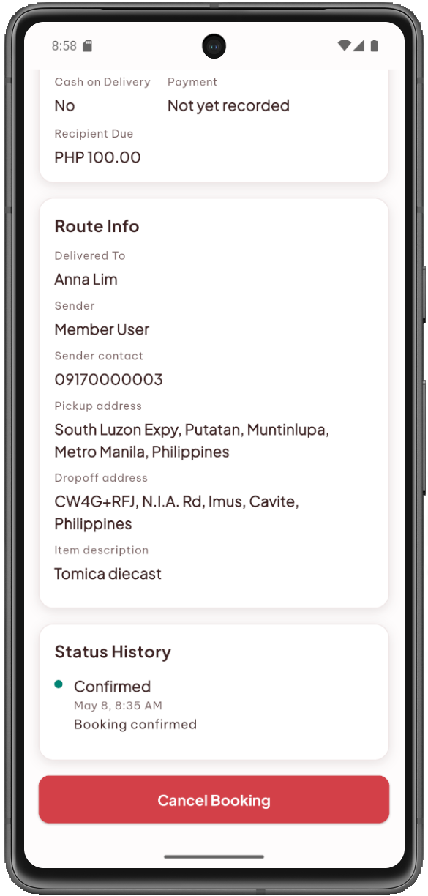
Figure 56 (b). Member Booking Details
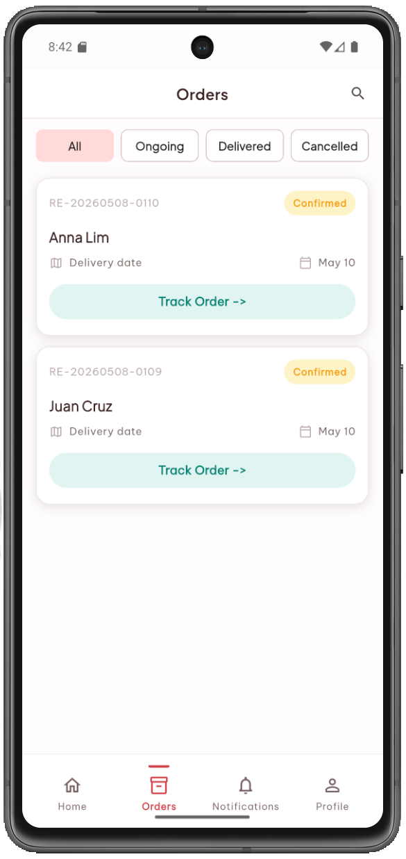
Figure 57. Member Orders Screen
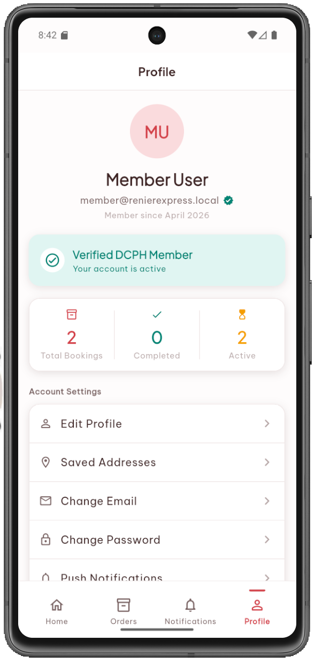
Figure 58. Member Profile Screen
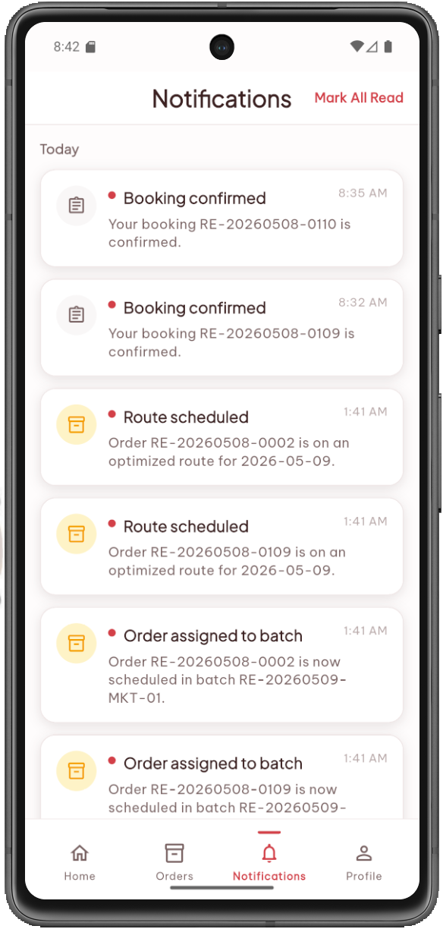
Figure 59. Member Notifications Screen
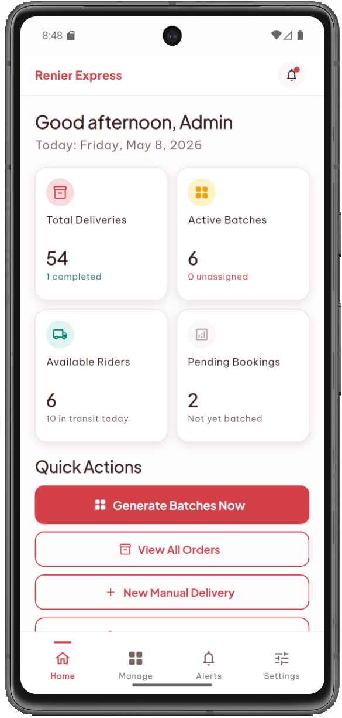
Figure 60. Admin Dashboard
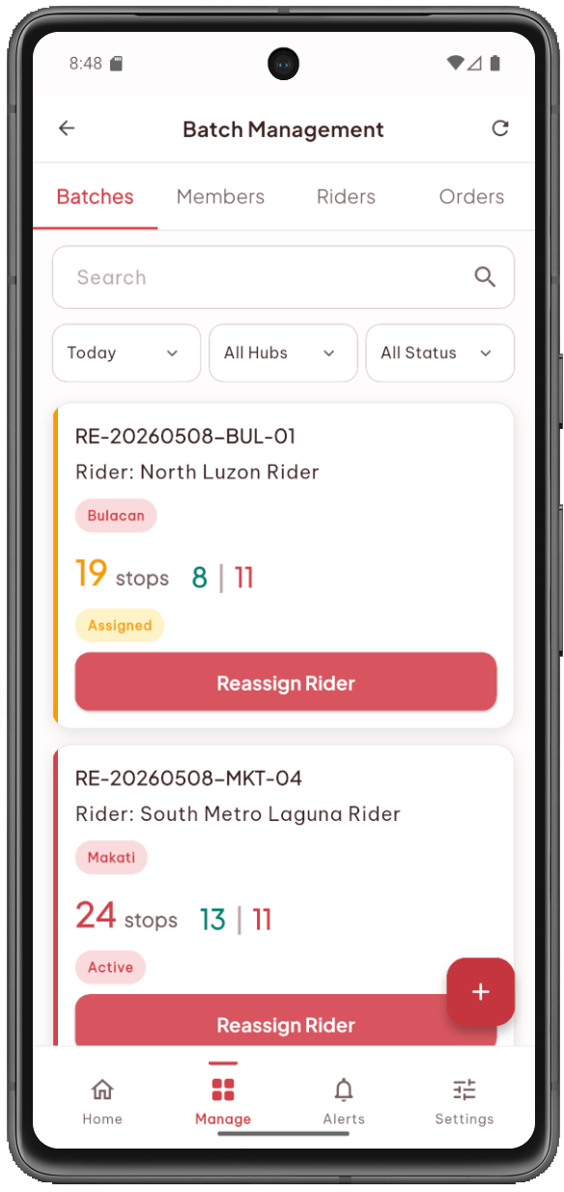
Figure 61. Batch Management Screen
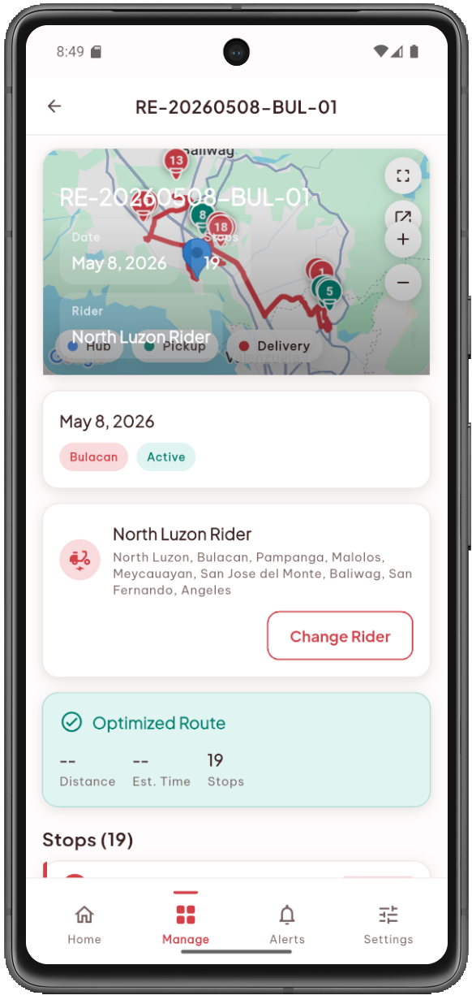
Figure 62 (a). Batch Detail Screen
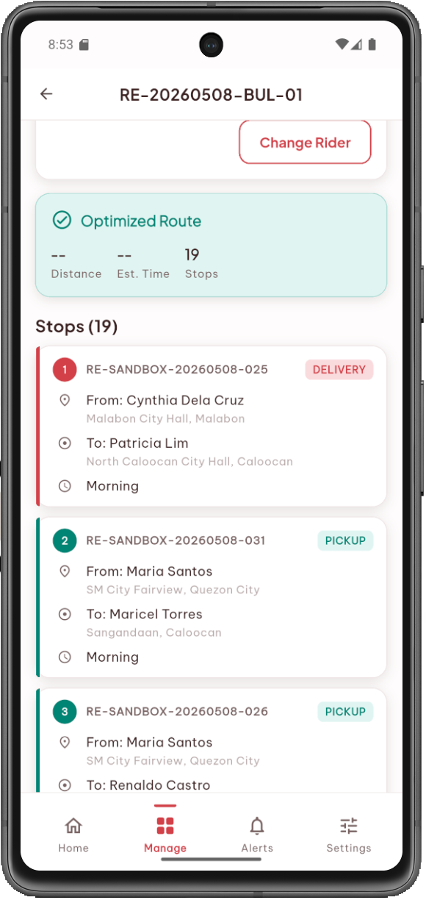
Figure 62 (b). Batch Detail Screen
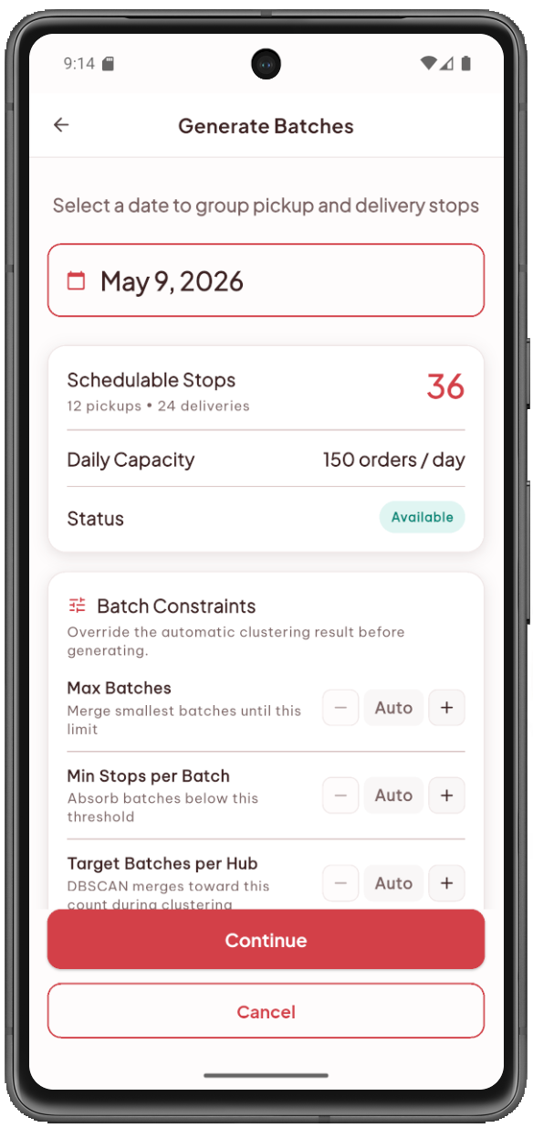
Figure 63. Generate Batches Screen
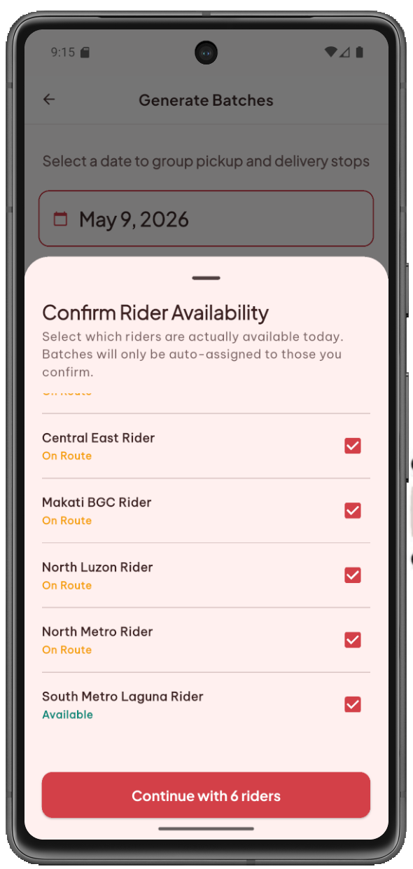
Figure 64. Confirm Rider Availability Screen
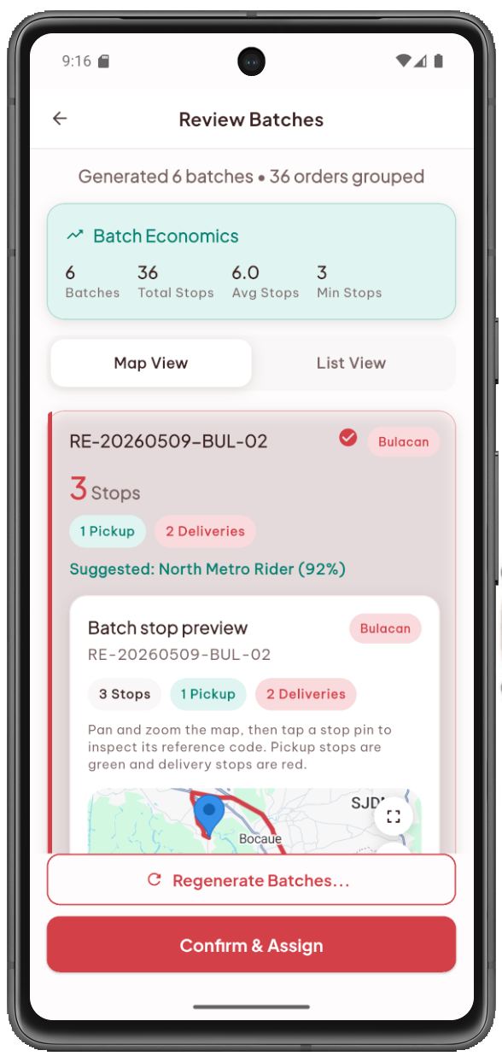
Figure 64 (a). Batch Generation Review Screen
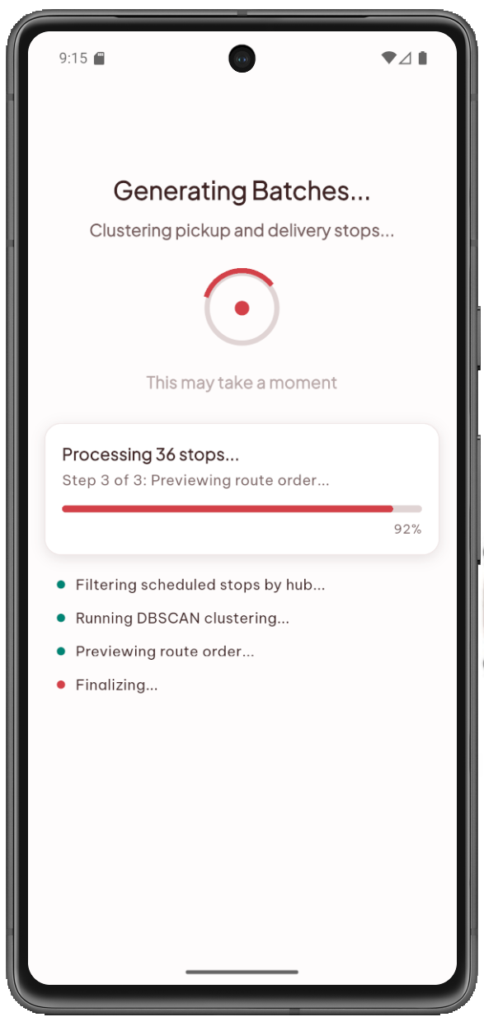
Figure 65. Generating Batches Screen
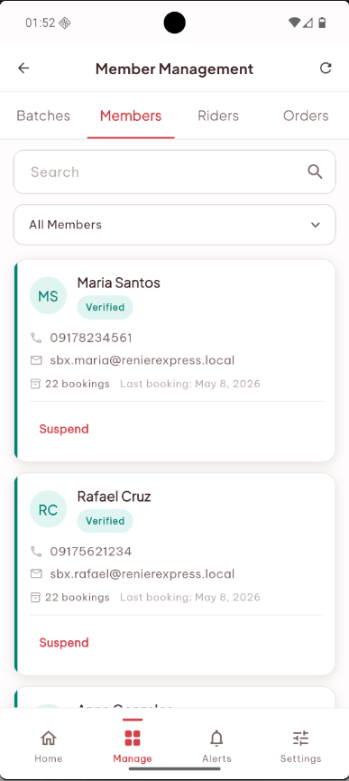
Figure 66. Member Management Screen
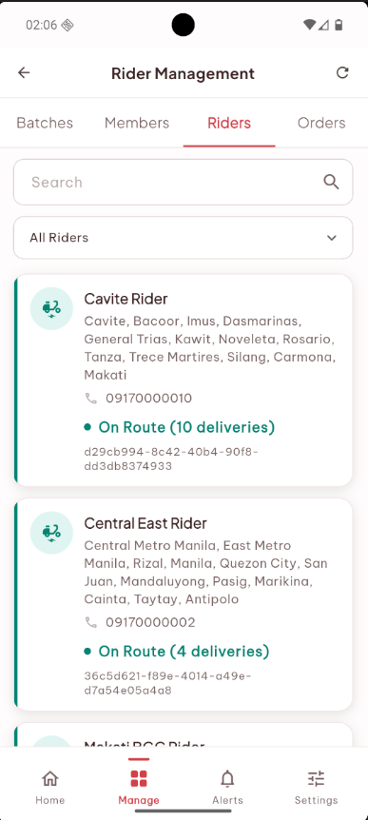
Figure 67. Rider Management Screen
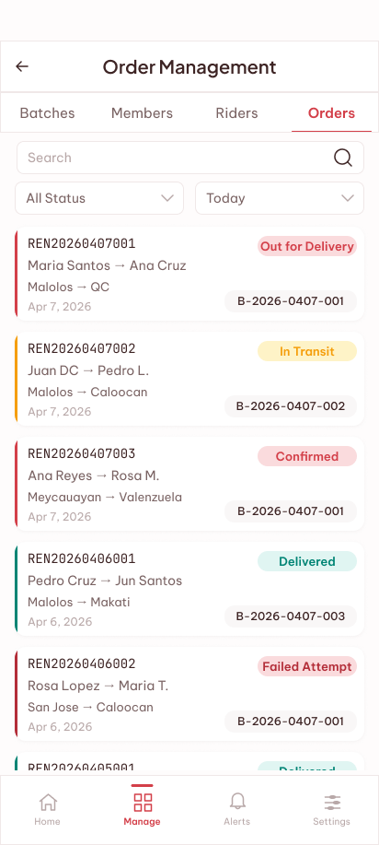
Figure 68. Order Management Screen
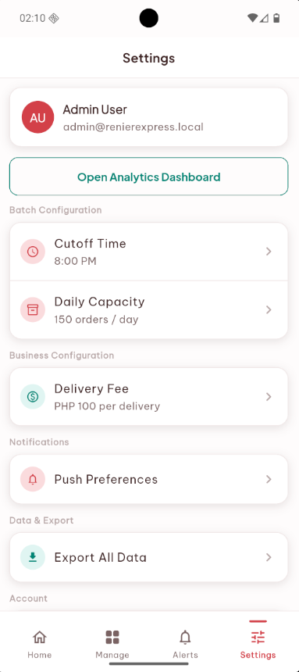
Figure 69. Settings Screen
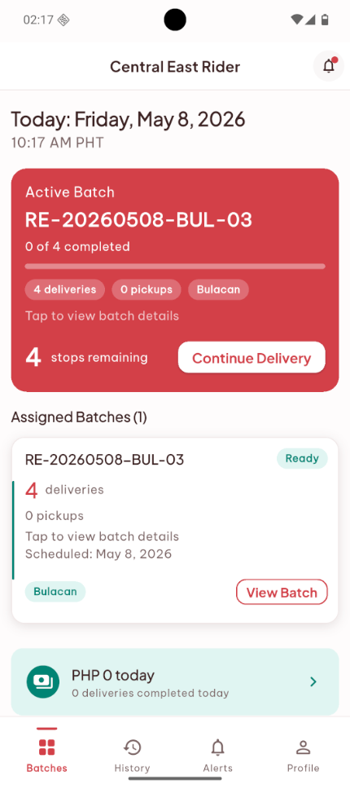
Figure 70. Today's Batches Screen
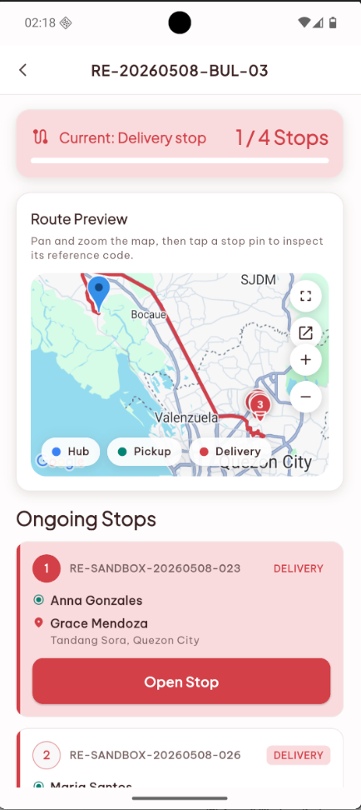
Figure 71. Route View Screen
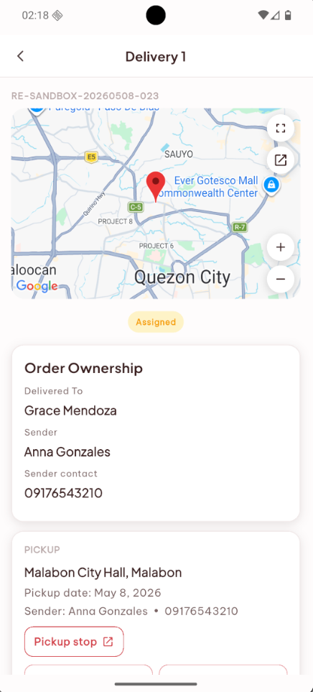
Figure 72. Delivery Execution Screen
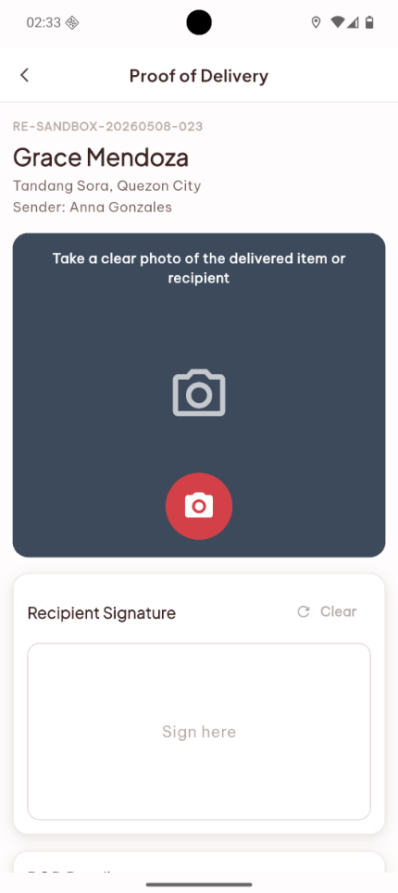
Figure 73. Proof of Delivery Capture Screen
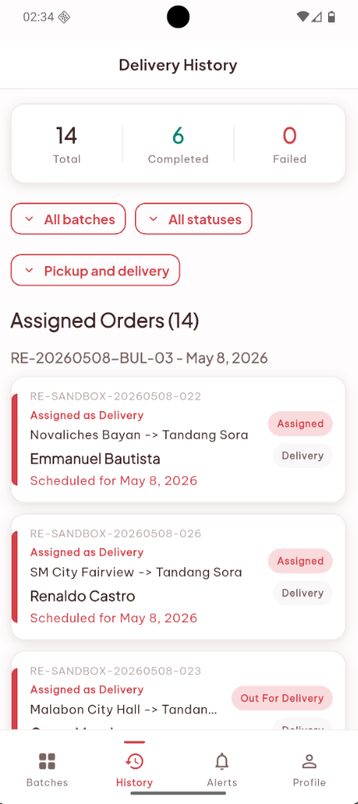
Figure 74. Delivery History Screen
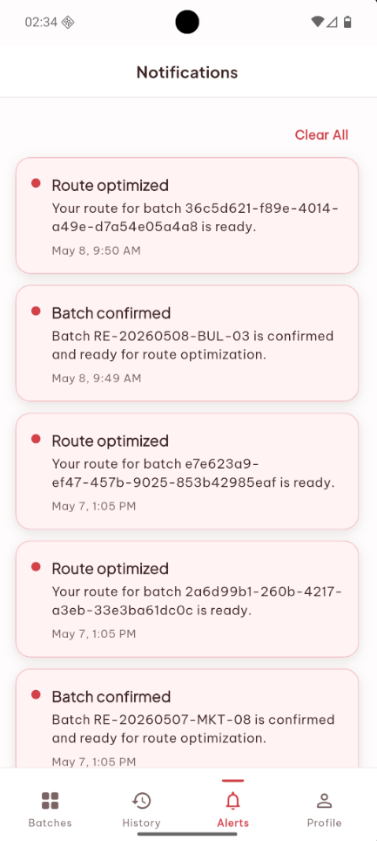
Figure 75. Rider Notifications Screen
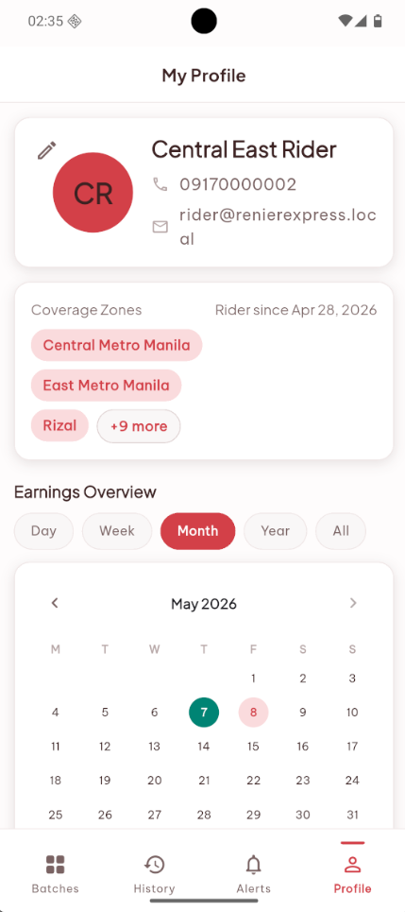
Figure 76. Rider Profile Screen
  - Implementation Plan
The proposed system will be deployed to the client through a structured three-phase rollout. In Phase 1, the proponents will conduct internal deployment and testing using a staging environment hosted on Railway and Supabase. This phase covers the setup of the Admin account, sample rider accounts, sample coverage zone configurations, and seed data for testing the booking, clustering, routing, and tracking pipeline. No real user accounts will be created in this phase. In Phase 2, the system will be released as a pilot to Mr. Alvarez and two to three selected riders using real delivery operations. This phase is intended to validate the system under actual operating conditions and to collect feedback before the expanded rollout. In Phase 3, the system will be made available to all eight riders and a controlled group of DCPH members. The AI components have model activation deferred until the data sufficiency threshold is met.
  - Implementation Results
The implementation is expected to produce tangible benefits across all three user roles. Mr. Alvarez will have a centralized view of all delivery bookings, batch compositions, rider assignments, and delivery statuses within a single application, which replaces the fragmented coordination that currently spans multiple group chats and screenshot archives. Members will have a structured booking interface with transparent status tracking across thirteen delivery milestones, replacing the informal process of messaging Renier to check on a parcel's location. Riders will receive a daily route with an optimized stop sequence and will submit status updates through the app rather than through group chat messages, which reduces reporting overhead and creates a persistent, timestamped delivery record automatically.

REFERENCES
- John Olsson, Daniel Hellström, and Henrik Pålsson. 2019. Framework of Last Mile Logistics Research: A Systematic Review of the Literature. Sustainability 11, 24 (December 2019), 7131. https://doi.org/10.3390/su11247131
- Nima Pourmohammadreza, Mohammad Reza Akbari Jokar, and Tom Van Woensel. 2025. Last-mile logistics with alternative delivery locations: A systematic literature review. Results in Engineering 25, (March 2025), 104085. https://doi.org/10.1016/j.rineng.2025.104085
- Ish Kumar and Chidambara. 2024. A systematic literature review and bibliometric analysis of last-mile E-commerce delivery in urban areas. Urban, Planning and Transport Research 12, 1 (December 2024), 2357577. https://doi.org/10.1080/21650020.2024.2357577
- 2024. E-commerce in the Philippines: Statistics report on e-commerce in the Philippines. Statista. Retrieved March 15, 2026 from https://www.statista.com/topics/6539/e-commerce-in-the-philippines/
- 2025. Leading concerns about using quick delivery apps in the Philippines as of August 2025. Rakuten Insight. Retrieved from https://www.statista.com/statistics/1623676/philippines-main-concerns-about-quick-delivery-apps/
- Nova Navo. 2024. Empowering Philippine MSMEs Through Digital Transformation. Institute for Small-Scale Industries. Retrieved March 15, 2026 from https://beta.entrepreneurship.org.ph/2024/09/26/empowering-philippine-msmes-through-digital-transformation/
- Wassen Am Mohammad, Yousef Nazih Diab, Adel Elomri, and Chefi Triki. 2023. Innovative solutions in last mile delivery: concepts, practices, challenges, and future directions. Supply Chain Forum: An International Journal 24, 2 (April 2023), 151–169. https://doi.org/10.1080/16258312.2023.2173488
- Shahbaz Khan, Rubee Singh, José Carlos Sá, Gilberto Santos, and Luís Pinto Ferreira. 2022. Modelling of Determinants of Logistics 4.0 Adoption: Insights from Developing Countries. Machines 10, 12 (December 2022), 1242. https://doi.org/10.3390/machines10121242
- Florian Hoppe, Willy Chang, Aadarsh Baijal, and Fock Wai Hoong. 2024. e-Conomy SEA 2024: Profits on the rise, harnessing SEA’s advantage. Bain & Company, Google, Temasek. Retrieved March 21, 2026 from https://www.bain.com/insights/e-conomy-sea-2024/
- MSMED Council and Department of Trade and Industry. 2024. Micro, Small, and Medium Enterprise Development Plan 2023-2028. Department of Trade and Industry. Retrieved from https://dtiwebfiles.s3.ap-southeast-1.amazonaws.com/BSMED/MSMED+Plan+2023-2028/MSMED+Plan+2023-2028_approved+07Nov2024.v2.pdf
- Yi Jiang, Jade R. Laranjo, and Milan Thomas. 2022. COVID-19 lockdown policy and heterogeneous responses of urban mobility: Evidence from the Philippines. PLOS ONE 17, 6 (June 2022), e0270555. https://doi.org/10.1371/journal.pone.0270555
- Gehana Lamug and Harold Abasolo. 2021. Operational Strategies of Online Food Delivery Businesses in Camarines Norte, Philippines. International Journal of Current Science Research and Review (August 2021). https://doi.org/10.47191/ijcsrr/V4-i8-14
- OECD. 2021. The Digital Transformation of SMEs. OECD Studies on SMEs and Entrepreneurship (February 2021). https://doi.org/10.1787/bdb9256a-en
- Hy Lam, Valerie Tang, and L Wong. 2024. Raising logistics performance to new levels through digital transformation. International Journal of Engineering Business Management 16, (December 2024), 18479790241231730. https://doi.org/10.1177/18479790241231730
- Jingjing Li, Yaohuiqiong Fang, and Na Tang. 2022. A cluster-based optimization framework for vehicle routing problem with workload balance. Computers & Industrial Engineering 169, (July 2022), 108221. https://doi.org/10.1016/j.cie.2022.108221
- Frédéric Didier, Laurent Perron, Sarah Mohajeri, Steven Agostino Gay, Thibaut Cuvelier, and Vincent Furnon. 2023. OR-Tools' Vehicle Routing Solver: a Generic Constraint-Programming Solver with Heuristic Search for Routing Problems. In Congrès de la Société française de recherche opérationnelle et d'aide à la décision (ROADEF).
- Atilla Wohllebe, Dirk-Siegfried Hübner, Uwe Radtke, and Szilárd Podruzsik. 2021. Mobile apps in retail: Effect of push notification frequency on app user behavior. Innovative Marketing 17, 2 (May 2021), 102–111. https://doi.org/10.21511/im.17(2).2021.10
- Xiaofang Lin, Abdullah Al Mamun, Qing Yang, and Mohammad Masukujjaman. 2023. Examining the effect of logistics service quality on customer satisfaction and re-use intention. PLOS ONE 18, 5 (May 2023), e0286382. https://doi.org/10.1371/journal.pone.0286382
- Martin Savelsbergh and Marlin W. Ulmer. 2024. Challenges and opportunities in crowdsourced delivery planning and operations—an update. Ann Oper Res 343, 2 (December 2024), 639–661. https://doi.org/10.1007/s10479-024-06249-1
- Jay Pabs. 2025. Last Mile Delivery Software: Transforming the Future of Fast, Accurate Deliveries. PhilNews.Ph, December 3. Retrieved from https://philnews.ph/2025/12/03/last-mile-delivery-software-transforming-the-future-of-fast-accurate-deliveries/
- Wilson Cordova, Cristina Teresa N. Lim, Harvey T. Ong, Hilario S. Caraan, Gil Antonio R. Dela Cruz, and Emmanuel Fernando C. Jimenez. 2025. Digital Innovation and Entrepreneurial Success in the Philippine MSME Sector: Challenges and Opportunities. ECONOMICS - Innovative and Economics Research Journal 13, 3 (2025), 69–82. https://doi.org/10.2478/eoik-2025-0056
- Ian Benedict Mia, Shieradel Jimenez, Raymund Habaradas, Jessica Jaye Ranieses, Cholo Javier, and Jelica Enriquez. 2024. Digital Technology Adoption Among Philippine Micro-, Small-, and Medium-Sized Enterprises: Barriers, Enablers & Challenges During COVID-19. Journal of Business, Ethics and Society 4, 1. https://doi.org/10.61781/4-1I2024/1bmlm
- Eleni Boumpa et al. 2023. A Review of the Vehicle Routing Problem and the Current Routing Services in Smart Cities. Analytics 2, 1 (2023), 1–16. https://doi.org/10.3390/analytics2010001
- Arif Ali Wani. 2024. Comprehensive analysis of clustering algorithms: exploring limitations and innovative solutions. PeerJ Computer Science 10, e2286 (2024). https://doi.org/10.7717/peerj-cs.2286
- Chiara Culotta, Constantin Blome, and Michael Henke. 2024. Theories of digital platforms for supply chain management: a systematic literature review. International Journal of Physical Distribution & Logistics Management 54, 5 (2024), 449–475. https://doi.org/10.1108/IJPDLM-01-2023-0016
- Samuel Baffoe Kwarteng and Poguda Aleksey Andreevich. 2024. Comparative Analysis of ARIMA, SARIMA and Prophet Model in Forecasting. Research & Development 5, 4 (2024), 110–120. https://doi.org/10.11648/j.rd.20240504.13
- Alexander Rokoss, Marius Syberg, Laura Tomidei, Christian Hülsing, Jochen Deuse, and Matthias Schmidt. 2024. Case study on delivery time determination using a machine learning approach in small batch production companies. Journal of Intelligent Manufacturing 35 (2024), 3937–3958. https://doi.org/10.1007/s10845-023-02290-2
- Chien-Chih Wang. 2025. Dynamic Dual-Phase Forecasting Model for New Product Demand Using Machine Learning and Statistical Control. Mathematics 13, 10 (2025), 1613. https://doi.org/10.3390/math13101613
- Labastida Prince, Simbulan Marvile, Estrella Chris John, Flores Wiljohn, and Criselle Centeno. 2024. Web-based ordering system for start-up business with forecasting. World Journal of Advanced Research and Reviews 22, 3 (2024), 357–368. https://doi.org/10.30574/wjarr.2024.22.3.1721
- Benzar Glen Grepon, Jc Margallo, Jonathan Maserin, and Rio Al-Di Dompol. 2023. RUI: A web-based road updates information system using Google Maps API. International Journal of Computing Sciences Research 7 (January 2023), 2253–2271. https://doi.org/10.25147/ijcsr.2017.001.1.158
- Jonathan Agoo, Renz Joshua Lanuza, Jonathan Lee, Paul Anthony Rivera, Neil Oliver Velasco, Marielet Guillermo, and Arvin Fernando. 2024. Geographic information system-based framework for sustainable small and medium-sized enterprise logistics operations. ISPRS International Journal of Geo-Information 14, 1 (2024), Article 1. https://doi.org/10.3390/ijgi14010001
- Arvin E. Mag-usara. 2022. Surigao river flood watch and warning app system. International Research Journal of Advanced Engineering and Science 7, 1 (2022). https://doi.org/10.51584/IJRIAS.2026.110100105
- Kvan Jazer Escalona, Jester Mackenzie Guinto, Cristian Jacob Eron, and Silas Flores. 2025. Mobile-based smart transport route optimization and hazard reporting system for San Juan. International Journal of Latest Technology in Engineering, Management & Applied Science 14, 9 (October 2025). https://doi.org/10.51583/IJLTEMAS.2025.1409000084
- Mary Joy P. Ladrillo, Sharmaine C. Cañezares, Aira Mae C. Ballais, Bryan R. Tupaz, Christian S. Castañares, Stephen P. G. Cajigas, Mark D. Garol, and Lorenzo I. Tolosa. 2025. Route optimization for blood bank visits in Tacloban City using the traveling salesman problem. International Journal of Research and Scientific Innovation 12, 15 (2025), 2414–2422. https://doi.org/10.51244/IJRSI.2025.1215PH000178
- Aldrin Navarro. 2023. Nextway: open source last mile delivery system for MSMEs. University of the Philippines Open University. https://api.repository.upou.edu.ph/api/core/bitstreams/8f55fbb9-bb7d-4550-a9dc-eeca7595cd2d/content
- Dharyll Prince Mariscal Abellana. 2023. Multivariate travel time forecasting in a traffic network using fuzzy cognitive mapping. In Proceedings of the 2023 IEEE World Conference on Applied Intelligence and Computing (AIC 2023). 485–490. https://doi.org/10.1109/AIC57670.2023.10263911
- John Philip Omol Echevarria and Peter John Berces Aranas. 2023. Forecasting the consumer price index in the regions of the Philippines using machine learning for time series models. Journal of Artificial Intelligence, Machine Learning and Neural Network 36 (September 2023), 11–22. https://doi.org/10.55529/jaimlnn.36.11.22
- Andrés Felipe León Villalba and Elsa Cristina González La Rotta. 2022. Clustering and heuristics algorithm for the vehicle routing problem with time windows. International Journal of Industrial Engineering Computations 13, 2 (2022), 165–184. https://doi.org/10.5267/j.ijiec.2021.12.002
- Antonios Balikos, Athanasios Pantopoulos, Athanasios Lois, Apostolis Xenakis, George Floros, Kostas Kolomvatsos, and Athanasios Ziliaskopoulos. 2025. Google’s VRP Free Algorithm Evaluation Study and its Use in Small and Medium Transportation Problems. In 2025 IEEE 45th International Conference on Distributed Computing Systems Workshops (ICDCSW), July 21, 2025. IEEE, Glasgow, United Kingdom, 432–438. https://doi.org/10.1109/ICDCSW63273.2025.00087
- Stevanus Putra Lesmana, Dina Hermawati, Maulina Mukaromah, Iqbal Ahmad Bukhari, and Norma Puspitasari. 2025. Machine Learning Implementation for E-commerce Delivery Delay Prediction Using XGBoost Algorithm. Green Engineering 2, 3 (July 2025), 46–57. https://doi.org/10.70062/greenengineering.v2i3.219
- Liang Guo, Weiguo Fang, Qiuhong Zhao, and Xu Wang. 2021. The hybrid PROPHET-SVR approach for forecasting product time series demand with seasonality. Computers & Industrial Engineering 161, (November 2021), 107598. https://doi.org/10.1016/j.cie.2021.107598
- Rob J. Hyndman and George Athanasopoulos. 2021. Forecasting: Principles and Practice (3rd ed.). OTexts, Melbourne, Australia. Retrieved April 10, 2026 from https://otexts.com/fpp3/
- Scott Silvey, Jinze Liu, and Yi Guo. 2024. Sample Size Requirements for Popular Classification Algorithms in Tabular Clinical Data: Empirical Study. Journal of Medical Internet Research 26 (December 2024), e60231. https://doi.org/10.2196/60231
- Nayan B. Ruparelia. 2010. Software development lifecycle models. SIGSOFT Softw. Eng. Notes 35, 3 (May 2010), 8–13. https://doi.org/10.1145/1764810.1764814
- John W. Creswell. 1994. Research Design: Qualitative, quantitative, and mixed methods approaches. Retrieved from https://www.ucg.ac.me/skladiste/blog_609332/objava_105202/fajlovi/Creswell.pdf

