*We have arranged for an optional SPECIAL DINNER for ACERT WORKSHOP participants at the*

*Award-winning WAGNER WINERY on Seneca Lake…and hope that you can join in for a wonderful evening!*

*Thanks to our sponsors….the price for this special event is now* ***$50/person***



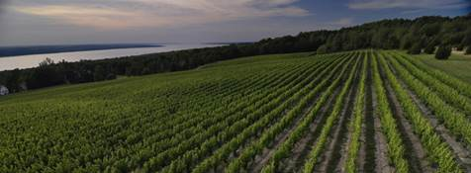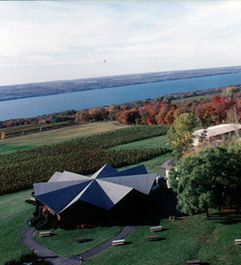

Wagner Winery is located eastern slope of Seneca Lake in the Finger Lakes Region of New York. Wagner is one of the Finger Lakes Region’s few estate wineries, which means that they grow all of the grapes used to produce their wine.

They cultivate 20 grape varieties on 250 acres, all adjacent to or within a few miles of the winery. Grape varieties under cultivation include: Riesling, Chardonnay, Gewürztraminer, Pinot Noir, Merlot, Cabernet Franc, Cabernet Sauvignon, Seyval Blanc, Melody, Vignoles, Vidal, Cayuga White, DeChaunac, Delaware and Niagara. They produce 50,000 cases of wine per year and have won numerous national awards.

The Wagner Valley Brewing Company is a small craft-brewery and has won the most prestigious of brewing awards, capturing numerous G.A.B.F., World Beer Cup and Tap New York medals.

<http://www.wagnervineyards.com>

**Our Wednesday DINNER AND VISIT includes:**

•         **Bus Transport** from Cornell to Winery and return to Ithaca (Hilton Garden Inn and Best Western University Inn)

•         **Wine and Beer Tasting and Appetizers at the Winery**

•         **Dinner Buffet** at the estate’s restaurant includes:

o   Garden Salad, bread and rolls

o   Garlic Roasted Potatoes

o   Rice Pilaf

o   Fire Roasted Vegetables

o   Shrimp Scampi

o   Top Sirloin of Beef with Mushroom Demi Glaze

o   Dessert: Mini Finger Pastries

o   (Cash Bar)

o   All gratuities

•         **Per Person: $50.00 all inclusive**

**PAYMENT Methods:**

**•** Checks should be made payable to “Cornell University.”

•          For Direct Bank Transfer payment instructions, please see Bank Transfer Instructions [Bank Transfer Instructions Link]

•          For Credit Card: Use the Cornell Business Services URL: <https://creditcard.cbs.cornell.edu/billing.aspx?eventid=8A7E5FC4-1ADC-40D6-943F-4601BFEE802B>   In the note section: add your name and “Optional Winery Dinner”

**Sponsors:  WE are truly appreciative of our SPONSORS for this event:**

**   **