Chapter 2
Slide : Theoretical Framework
- Technology Acceptance Model (TAM)
  - Ensures system is Useful and Easy to Use.
- Public Value Theory
  - Creates public value through better services and outcomes.
- Augmented Intelligence Model (AIM)
  - AI augments human decision-making; officials keep control.

Chapter 3

Slide : System Architecture & Core Technology
- Client Layer: Flutter app (Android & iOS).
- Application Layer:
  - NLP Module & Rule-Based Algorithm
  - Firebase Services
- Data Layer: Cloud Firestore database.
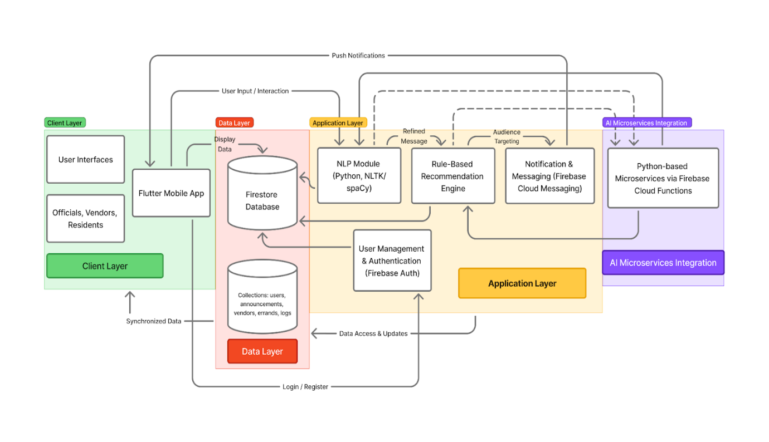

Slide : How the AI Works: Information Dissemination
- NLP Module: Refines message clarity and tone.
- Rule-Based Algorithm: Targets announcements to specific groups.
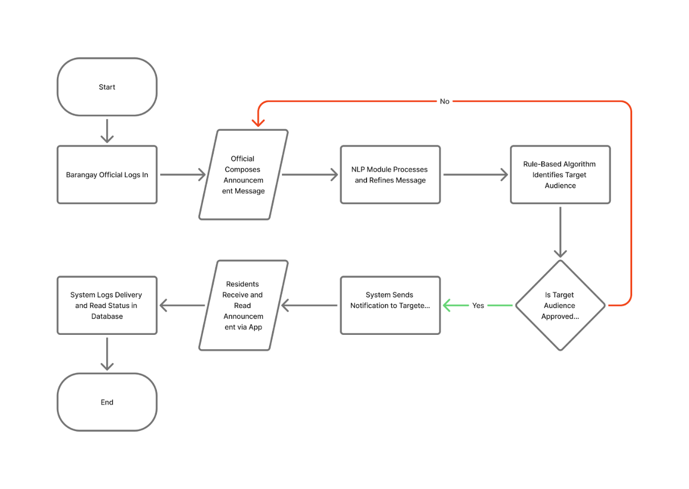

Slide : Digital Marketplace Flow
- Enables vendors to promote products digitally.
- Simple offline transactions (cash-on-delivery).
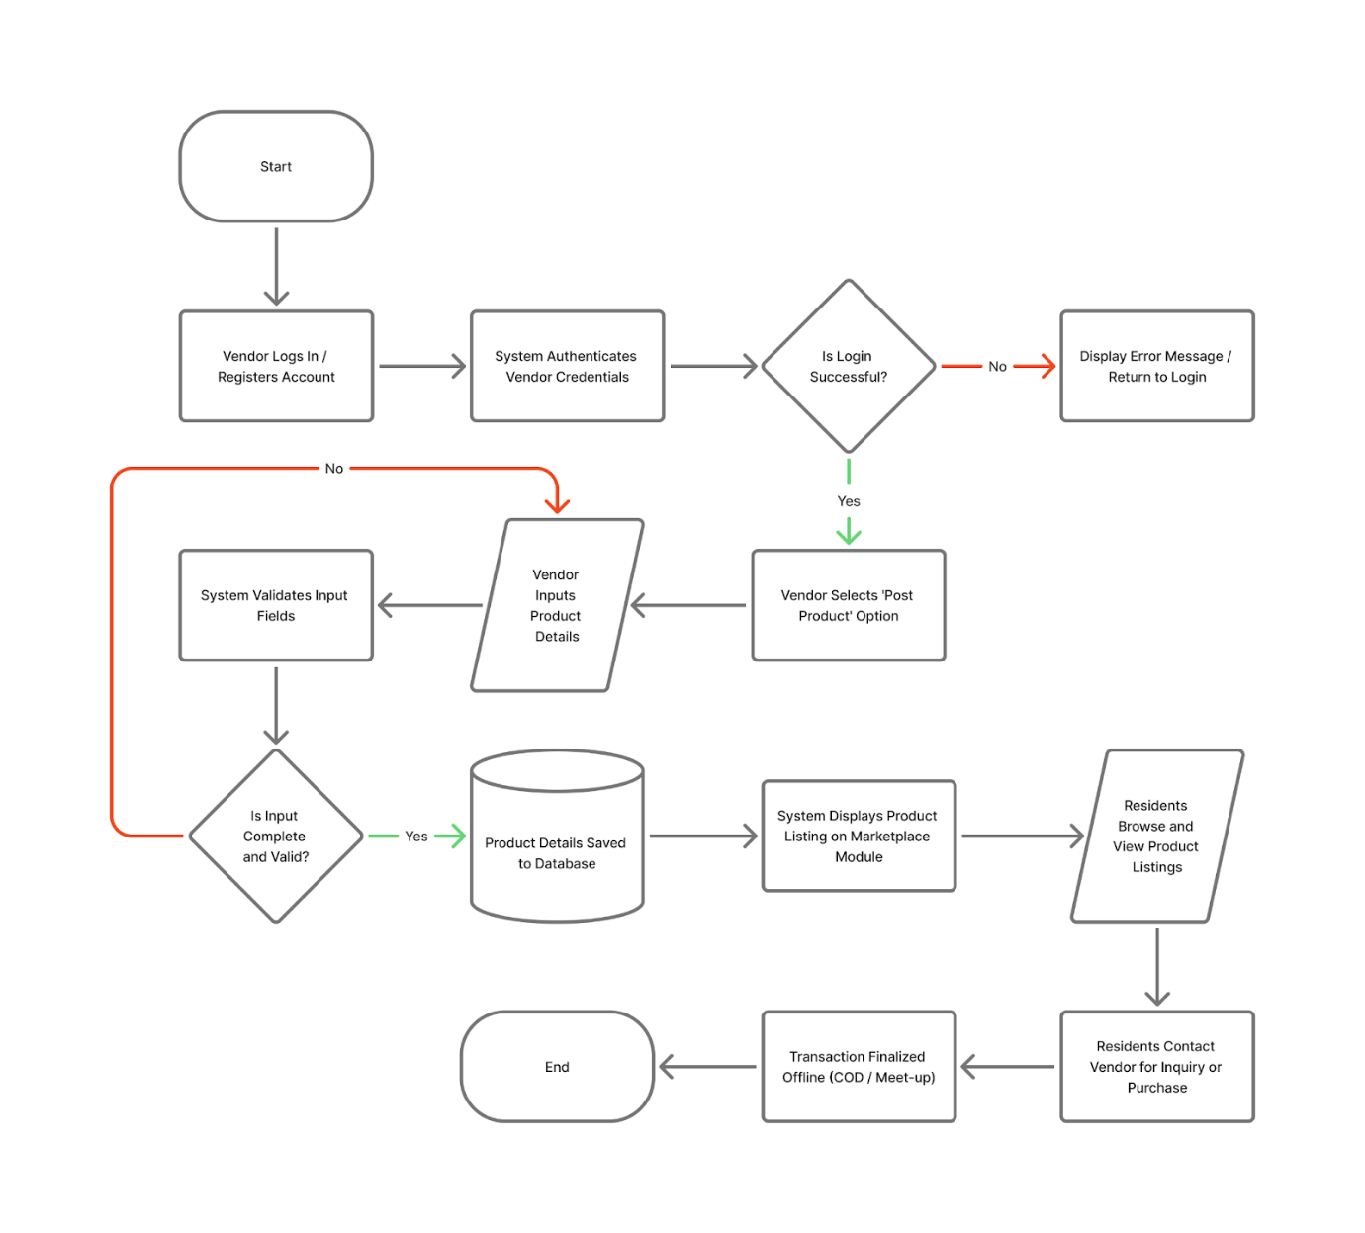

Slide : Community Cooperation Flow
- Facilitates peer-to-peer help and services.
- Promotes digital bayanihan.
