Lab ARP Final

1)

Systems IP: 10.23.1.189

Systems Mac: D0:8E:79:03:A5:8E

Subnet Mask: 255.255.0.0

Default Gateway router’s ip address: 10.23.0.1

2)  
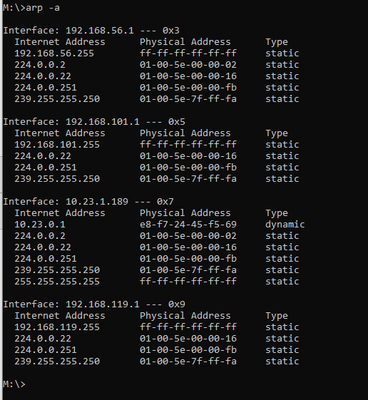

3)

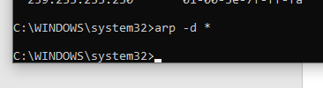

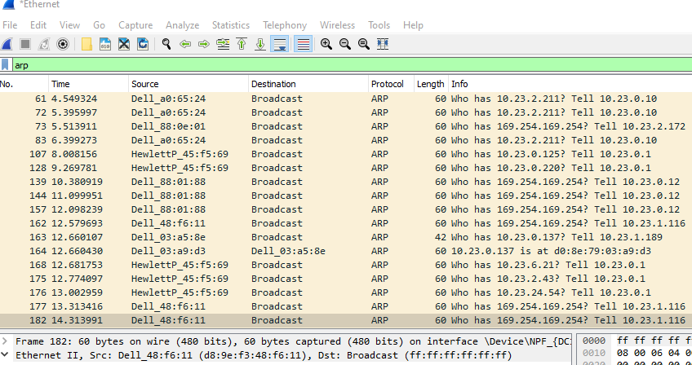

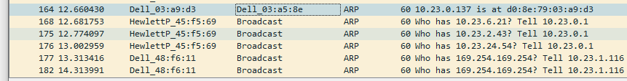

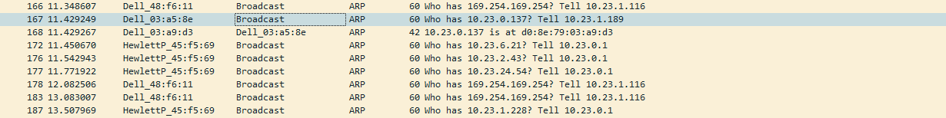

Source IP: 10.23.1.189  
Target IP: 10.23.0.137  
Source Mac: D0-8E-79-03-A5-8E

Target Mac: D0-8E-79-03-A9-D3

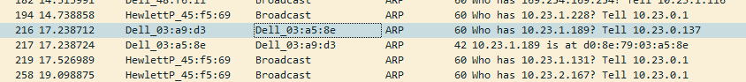

Target IP: 10.23.1.189  
Source IP: 10.23.0.137  
Target Mac: D0-8E-79-03-A5-8E

Source Mac: D0-8E-79-03-A9-D3



Source IP: 10.23.1.189  
Target IP: 10.23.0.137  
Source Mac: D0-8E-79-03-A5-8E

Target Mac: D0-8E-79-03-A9-D3

Client/Server



Target IP: 10.23.1.189  
Source IP: 10.23.0.137  
Target Mac: D0-8E-79-03-A5-8E

Source Mac: D0-8E-79-03-A9-D3

Server/Client

Source IP: 10.23.1.189  
Target IP: 155.138.5.178  
Source Mac: D0-8E-79-03-A5-8E

Target Mac: E8:F7:24:45:F5:69

Computer/Website

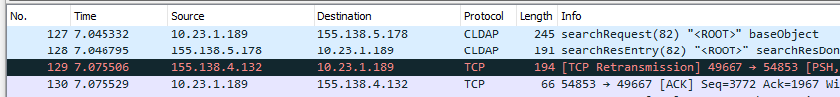



Target IP: 10.23.1.189  
Source IP: 155.138.5.178  
Target Mac: D0-8E-79-03-A5-8E

Source Mac: E8:F7:24:45:F5:69

Website/Computer