Justin Ganzak

2/9/2023

Lab 12:

1. What is the IP address of the HTTP client and the HTTP server?

Client: 10.23.1.43

Server: 128.119.245.12

1. What is the port number of the HTTP client?

56949

1. What is the port number of the HTTP server?

80

1. Identify the initial three messages (SYN, SYNACK, ACK) exchanged between the HTTP server and client to setup initial TCP connection. Take a screenshot of the messages.



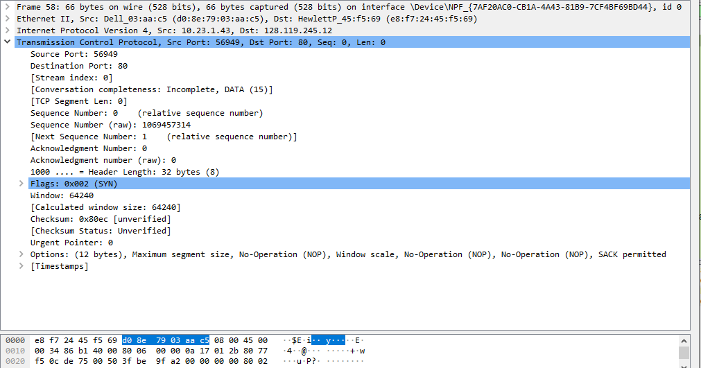

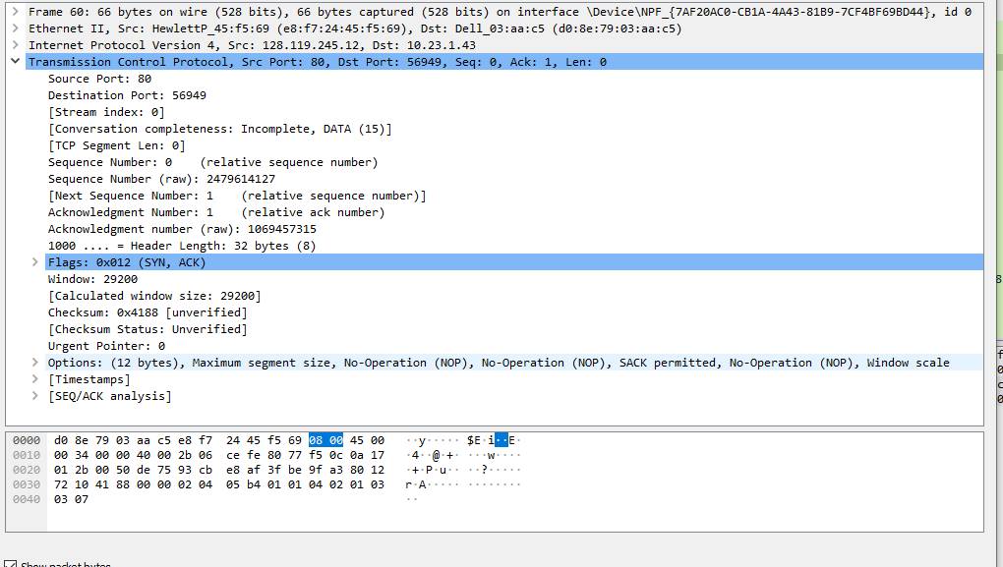

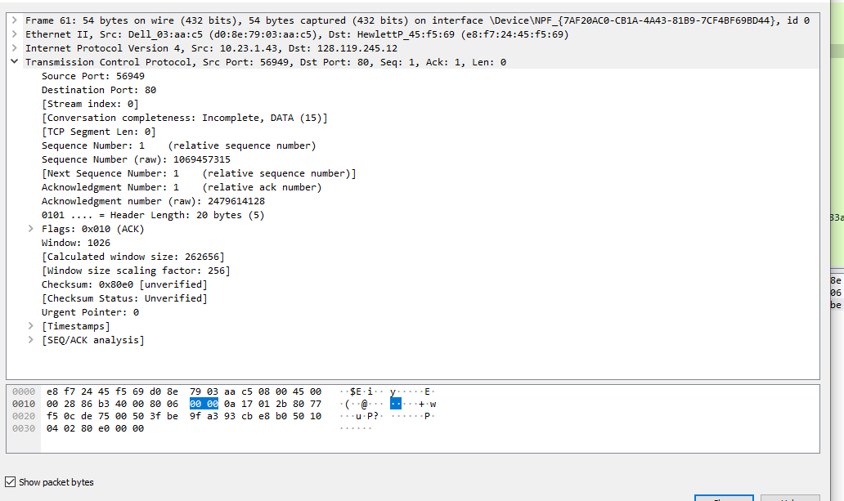

1. What is the initial sequence number used by the HTTP client?

1

1. What is the initial sequence number used by the HTTP Server?

1

1. What is the sequence number and acknowledgement number in the HTTP request?

1,1

1. What is the sequence number and acknowledgement number in the HTTP response?

1, 474