Justin Ganzak

Raymond Boon

Lab 14

1. Verify whether the client and server use TCP and that the port numbers match with the ones used in the program. Take screenshots at both the client and the server end.

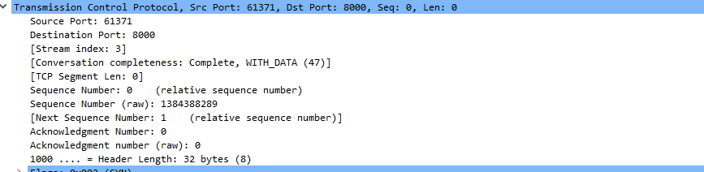

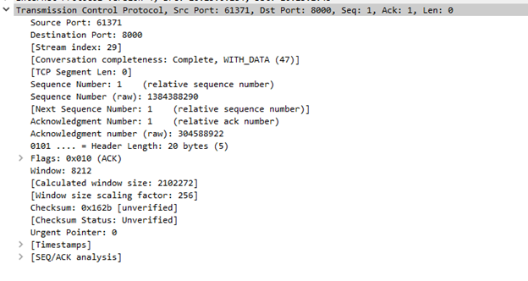

1. Verify whether the IP address used in the program match with the device's IP address. Screenshots of (a) ipconfig (b) Wireshark confirming the details.

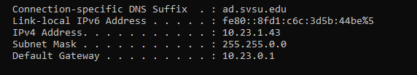



1. Screenshots of the TCP three-way handshake at both the client and the server's end.

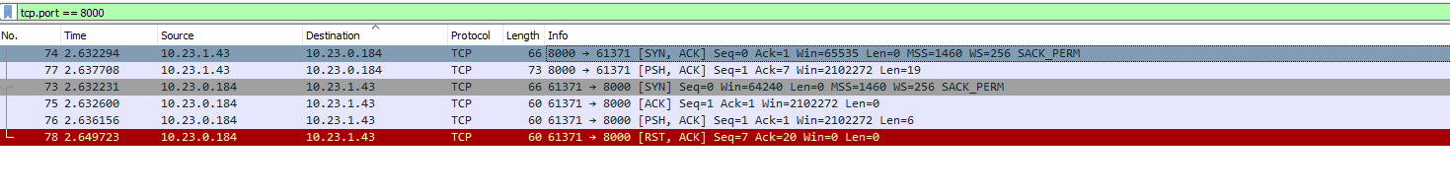

https://lh6.googleusercontent.com/T6IJjttqpX2bxnnb0MJ84CUz3RoSBjLLxz8rndRWb-QbD-rX7RGTLnPtbYGtAR2exW8Nxx49fDFbuaO5KgUeh6h2icxyeMqEebjYte5rzqFdnvsfYkpQaF9YHX8XYffwuTP2EQ8qIFB_aMnVdVVa-R0

1. Screenshots of the TCP data exchanged between the client and the server.

