Lab 9

Justin Ganzak

2/2/23

1. Are DHCP messages sent over UDP or TCP?

UDP

2.    What is the link-layer (e.g., Ethernet) address of your host?

  
3.    A host uses DHCP to obtain an IP address, among other things. But a host’s IP address is not confirmed until the end of the four-message exchange!  If the IP address is not set until the end of the four-message exchange, then what values are used in the IP datagrams in the four-message exchange?  For each of the four DHCP messages (Discover/Offer/Request/ACK DHCP), indicate the source and destination IP addresses that are carried in the encapsulating IP datagram.

Discover: source: 0.0.0.0, destination: 255.555.255.255

Offer: source: 10.23.0.1, destination: 10.23.1.43

Request: source: 0.0.0.0, destination: 255.255.255.255

ACK: source: 10.23.0.1, destination: 10.23.1.43

4.    What is the IP address of your DHCP server?

155.138.5.156

5.    What IP address is the DHCP server offering to your host in the DHCP Offer message?  Indicate which DHCP message contains the offered DHCP address.

10.23.0.1, Offer

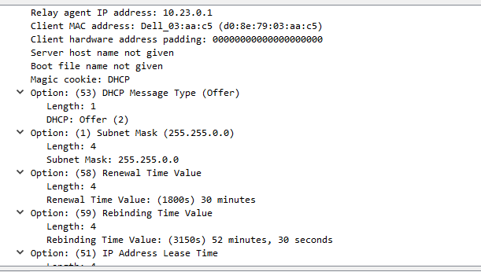  
6.    How long is the lease time in your experiment?

1 hour

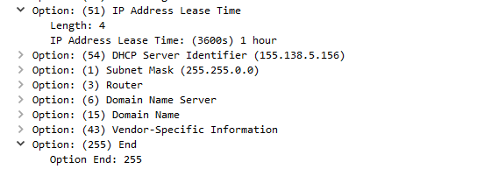

7.    List the network details/information provided by your DHCP server

