CIS 301

1/10/2023

Justin Ganzak

**Lab 1**

**Question**: What is the host name?  
**Answer**: gaia.cs.umass.edu\r\n

**Question**: What is the source port number and destination port number?  
**Answer**: Source port: 55728, Destination Port: 80  
  
**Question**: - What is the source IP address and destination IP address? Does the source IP address match with your device’s IP address? Verify. (Hint: use ipconfig to identify your device’s ip address. ) Take a screenshot of the result of ipconfig

**Answer:**   
Source IP: 10.23.1.43  
Destination IP: 128.119.245.12

Yes they match.  
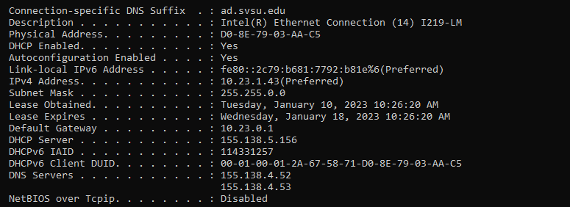

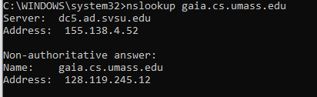

**Question:** What is the source MAC address and destination MAC address?

**Answer:** Source MAC: d0:8e:79:03:aa:c5  
 Destination MAC: e8:f7:24:45:f5:69

**Question:** Verify if the source MAC address matches with your device’s mac address. To do so, type ipconfig/all and identify the Physical address.

**Answer:**  Yes they match  
