Justin Ganzak

Lab 5

1. What is the server's IP address and port number?

10.23.2.165, 5000

1. What is the client's IP address port number?

10.23.2.18, 6115

1. At the client end, whose MAC address does (a)  source MAC address and (b) destination MAC address correspond to?

a) client

b) server

1. What is the transport layer protocol used at the client end? Hint: look for the transport layer protocol used in the client request.

Ack

1. What is the transport layer protocol used at the server's end? Hint: look for the transport layer protocol used in the server's response.

Syn

1. At the client end, take a screenshot of UDP request and the corresponding server's response.

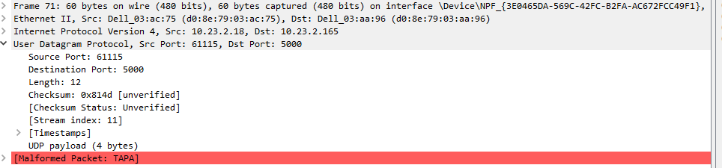

1. At the server's end, take a screenshot of client's UDP request and the corresponding server's response.

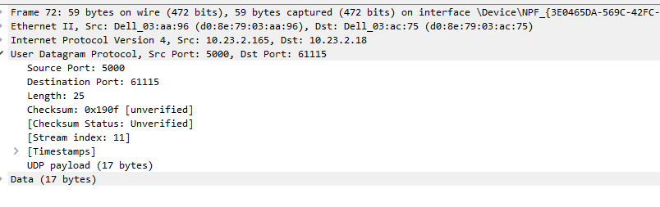

1. Can you identify the user input (i.e. radius) in the body of the client's UDP request? Attach the corresponding screenshot.

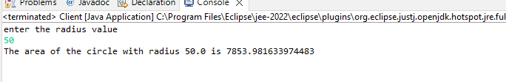

1. Can you identify the area in the body of the server's response? Attach the corresponding screenshot.

