Lab 8:

Justin Ganzak

1/31/2023

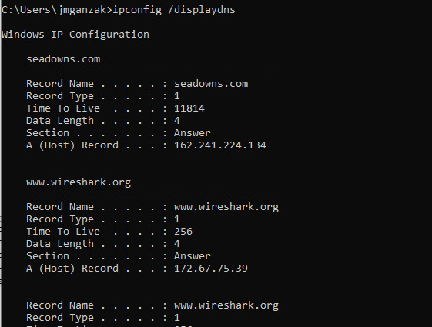

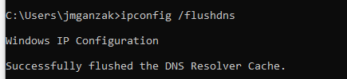

1. Locate the DNS query and response messages. Are they sent over UDP or TCP?

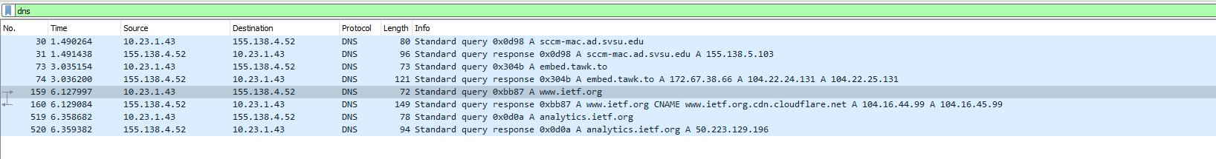

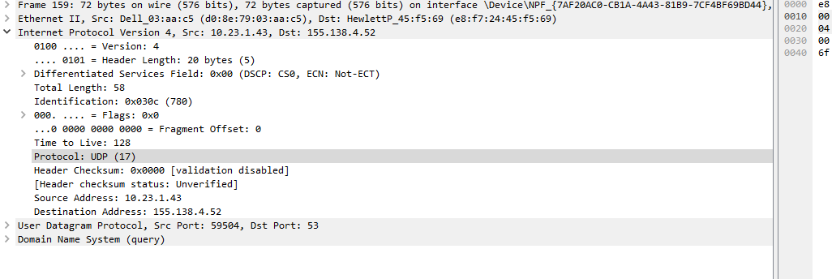

UDP

1. What is the destination port for the DNS query message? What is the source port of DNS response message?

Destination: 59504

Source: 53

3.    To what IP address is the DNS query message sent? Use ipconfig to determine the IP address of your local DNS server. Are these two IP addresses the same?

10.23.1.43

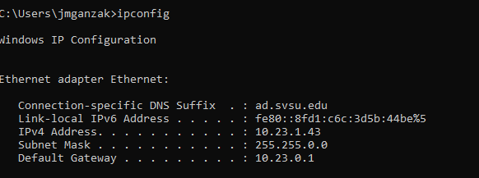

Yes they are the same

4.    Examine the DNS query message. Take a screenshot of the DNS query.

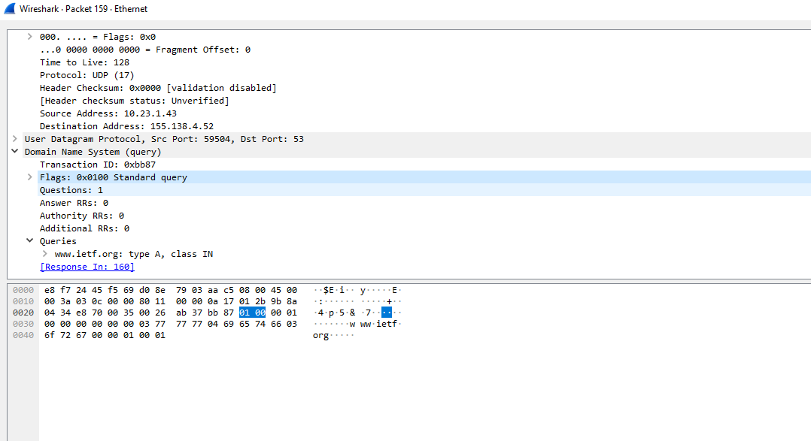

5.    Examine the DNS response message.  Take a screenshot of the DNS response.

