A figure div on the left
The figure on this page is a div. Its caption is the div’s last paragraph:
::: {#fig-groups .wrap-left width="35%"}
![](groups.png)
Scores by hours of practice in two groups.
:::

Result
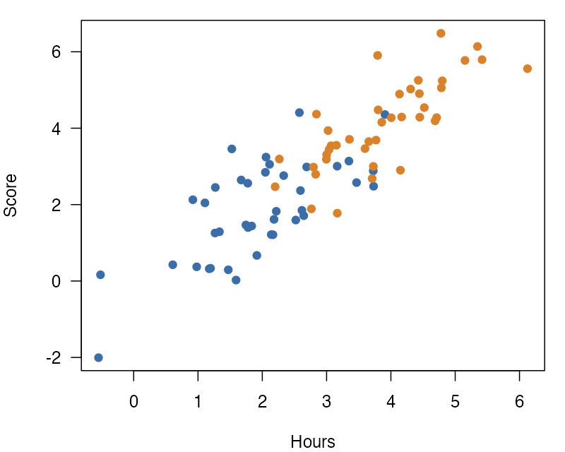
Figure 1: Scores by hours of practice in two groups.
Figure 1 shows each participant’s score against the hours that they practiced. Scores rose with practice in both groups, and the second group practiced more hours.
The class .wrap-left puts the figure on the left side of the text, so this text flows on its right. The figure is 35% of the text width, a little narrower than the default of 40%.
The div form puts the caption in its own paragraph, which is easier to read and edit when the caption is long. The figure keeps its number, so the text can point to it.

Next
A heading is not a paragraph, so wrapping stops before it.

