Customizing Print Templates:
Circulation
Handout
InnoU Online Course
Sierra



Copyright © 2014 by Innovative Interfaces, Inc.

This publication is supplied for the exclusive use of customers of Innovative Interfaces with the understanding that it shall not be shown or distributed to anyone outside of the customer's organization without the prior written permission of Innovative Interfaces. This publication may be copied only if the copies are for the exclusive use of staff members of libraries that have purchased the Innovative system.

Published May 2014

Customizing Print Templates: Circulation
InnoU Online Course

Introduction 4
Objectives of the class 4
Print Templates – what is it? 4
Important things to know about Print Templates 4
Print Templates “families” for notices 4
Printers 5
iReport software 5
Activate Print Templates for your Sierra system 5
Permissions 5
Turning on Print Templates in the Sierra Desktop Application 6
Sierra Desktop Application Settings 6
Export templates to your PC 6
Sierra Admin App User Account Settings 8
Demonstration of iReport 9
Open a template 9
Windows on screen 9
Report Inspector 10
Data Library in “Fields” 10
Report structure 10
Properties 11
Palette 11
Navigating in iReport 12
Preview 13
Exercises 14
Exercise 1 – Printed overdue notice 14
Page dimensions 14
Images 17
Static text 20
Date 22
Text fields 23
“Stretch with overflow” 26
Exercise 2 – Emailed overdue notice 28
Page dimensions 28
Images 28
Embedded URLs 30
Exercise 3 – Title Paging List 33
Import templates to the Sierra Desktop Application 40
Print/send notices with Print Templates 43
Documentation and Resources 44
Tell us what you think 44

Introduction

Objectives of the class
- Introduce Print Templates
- Set up Sierra to use Print Templates
- Edit templates using Jaspersoft iReport
- Understand how printing circulation notices with Print Templates works in the Sierra Desktop Application

Print Templates – what is it?
- The Print Templates feature allows you to customize many types of print output via the use of templates
  - Default (legacy) ways of printing any of these print jobs are still available
- Print Templates utilizes a third-party product that allows for a high level of customization of print output
- You can choose a method – Print Templates or default printing – for each user account and each output type separately (e.g. overdue notices or hold pickup notices)
  - It is still necessary to have Text of Circulation Notices entries and loan rule elements and circulation options completed so that the system knows a notice is required. Text number can’t be 0 or no notice will be printed.
  - This is required even if you will use static text in the template

Important things to know about Print Templates
- You cannot create new templates from scratch
  - Select a template that is most like the one you would like to have, export it and change it to suit your needs
- You cannot delete default (system-supplied) templates, or save edits with the default name (those that start with a leading underbar)
  - Customers who want to change a default template must export it, make the change, and import it with a new name
- Each output type has its own Data Library – a set of defined fields
  - You cannot add fields to the Data Library
  - New fields may be added in new releases
  - If new fields are added, old templates will continue to work but cannot take advantage of the new fields
  - If new fields are required, a template will have to be created from the new default

Print Templates “families” for notices
- Print Templates for notices are organized in “families”
- This allows different design of templates used for emailed vs printed notices, or notices in different languages
- The “family” is created or selected when you import new templates
- A family can consist of only one template, if no variation is required
- In the Notices function, you select which family to use, and the system will sort out individual templates based on:
  - language (for a multi-language system using the Preferred Language feature)
  - delivery method: Any, Print or Email

Printers
- A graphics-capable local printer is required for Print Templates
  - Print Templates print an image, not text
- Printer selection works the same way it does without Print Templates
  - Printer choices are controlled by the user account settings, e.g. Local Printer, Save to file, etc.
  - Emailed notices are queued to email

iReport software
- Jaspersoft iReport 4.0.2 is used to edit templates
- Download from CSDirect http://csdirect.iii.com/downloads/ireport.shtml
  - Make sure you select the correct version!
  - Ignore upgrade message shown when the program is opened
  - iReport 4.0.2 is not compatible with Windows 7 themes. To launch and use iReport, switch to the Windows Classic theme
- iReport is not used for printing, only for customizing templates
  - Printing is done from the Sierra Desktop Application, no additional software needed
- As an alternative, the .jrxml file for a print template could be edited in a text editor by those experienced with xml.

Activate Print Templates for your Sierra system
- Database Maintenance options (Admin Corner)
  - Enable Print Templates option – set to Yes
- This will make Print Templates available under Admin | Settings in the Sierra Desktop Application and in the Sierra User Settings in the Admin App, but each type of output still needs to be activated for a user account/login and output type

Permissions
- No authorization needed to print using Print Templates
- Enabling Print Templates for a user can be done via the Admin App or the Print Templates tab in the Sierra Desktop Application (Admin | Settings)
- To manage Print Templates (i.e. import/export, preview, rename and delete) a user requires the following:
  - Preview Print Templates (282)
  - Update Print Templates Tab (283)
  - Import/Export Print Templates (284)
  - Delete Print Templates (285)
- Save settings (176) may also be required

Turning on Print Templates in the Sierra Desktop Application

Sierra Desktop Application Settings
- Go to Admin | Settings | Print Templates tab
- Select Output Type Overdue Notice and check Use Print Templates

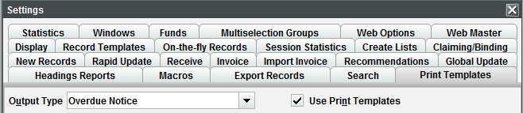

- The ability to turn this on requires the user have the appropriate permission assigned (Update Print Templates Tab (283)), as do the other functions in the tab
- There is one system default Print Template per circulation notice type. (Slips are different.) Default Print Templates can be identified by the leading underbars.
  - The default overdue template is named: _Overdue.
  - These default Print templates are the templates that cannot be deleted; they serve as a safety net. You use them as the basis for creating other templates, where content and dimensions can be changed entirely.

Export templates to your PC
- In order to customize templates we first have to export the default
- You can only export one template at a time:
  - Highlight the template you wish to export, for example _Overdue, and click Export
    - Format of the files is jrxml (Jaspersoft Report XML)
    - The jrxml file and any associated graphic file will be exported together
  - Select location where you want to store the template (we are going to use a folder on the desktop)
    - If you already have files in the directory you are exporting to, you can’t see them during export. The folder will appear empty, even if it isn’t, as in the screenshot below.
    - If you already have a file with the same name as the one you are exporting, it will be overwritten automatically
    - You should not enter a file name, the system takes care of that. Be aware that the name will probably not be the same as the template name in Sierra, although it happens to be for the overdue.
  - Click Choose a directory (=Save)

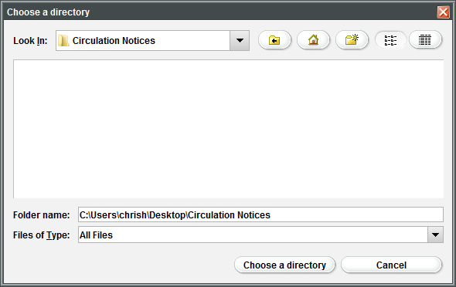

- Repeat the process for the Title Page List:
  - Select Output Type Title Page List and check Use Print Templates
  - Highlight the default template (_BibPageList) and click Export
  - Select location and store the template
  - You will see later that the name of the jrxml file is Title_Paging_List.jrxml, not _BibPageList.jrxml as you may expect
- When you are finished, click Save Settings, then OK

Sierra Admin App User Account Settings
- It is also possible to turn on Print Templates for a Sierra user account by editing that user’s Settings in the Sierra Admin App
- In the Admin App, you can set the user account to use Print Templates for a specific output type and you can set preferred templates and select template options

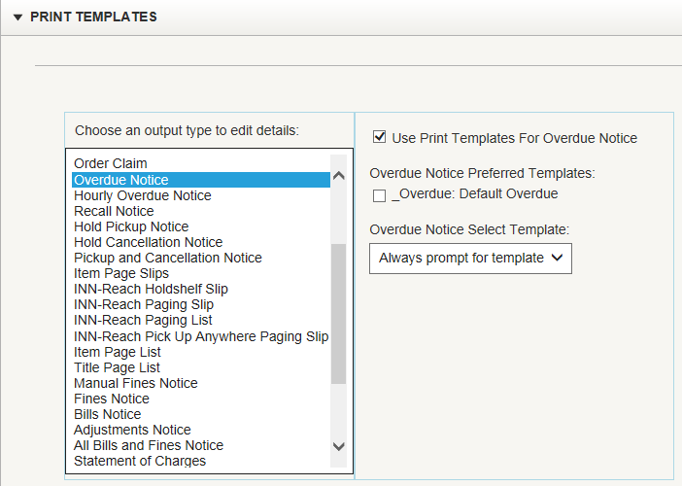

- This option can be useful if you need to change Print Templates Settings for many user accounts and do not want to log in to the Sierra Desktop Application with each individual account to do so
- In the Admin App, you cannot export, import, or preview templates

Demonstration of iReport
Jaspersoft iReport is a sophisticated software application with many features. We will only deal with those parts that have a direct impact on circulation templates.

Open a template
- Move to iReport
- When you open the iReport client for the first time, all you see on the screen is the Welcome Window and a couple of panes. You can close them and leave the screen empty.
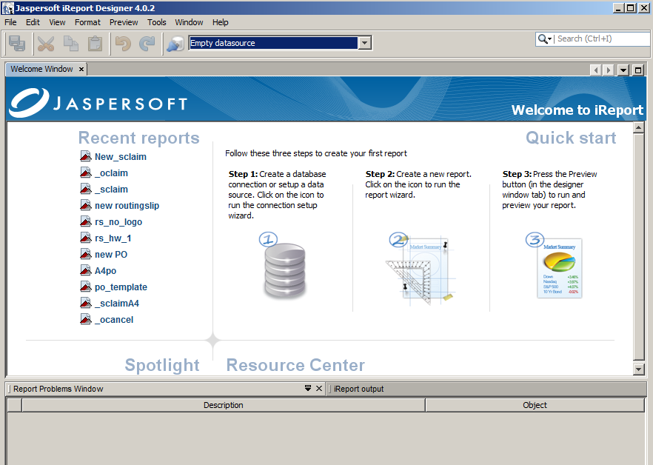

  - If you wish to get the default display back, use Window | Reset Windows

- Open the Overdue template that you have exported:
  - File | Open
- Display size can be changed in fixed steps, using the size tools

Windows on screen
- Once you open a file there are some new windows on the screen. Others are available in the Window menu. The windows can be resized, removed or moved in any order you like.

In iReport what you have in the file is called a “report.” But you will also see “document” or “template” used with the same meaning.

Report Inspector
- The Report Inspector on the left hand side shows the structure of the report you are working on, and it also contains the Data Library for the template.

Data Library in “Fields”
- Open the “Fields” folder to find all text fields available for the template type you are working with.
- For notices this is a mix of fields using record data, circulation parameter values and some generic information.
  - Remember that you can only use fields that are available in the Data Library.
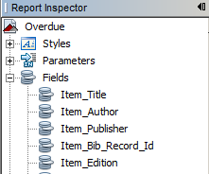

- To get more information about the fields:
  - Single click on a field to see a brief description appear in the Properties window on the right side of the screen
  - The Print Template Data Libraries pages in the Sierra WebHelp have detailed descriptions of each field (http://csdirect.iii.com/sierrahelp/Default.htm#sril_pt.html)
  - The Circulation Print Templates: Notices page on CSDirect includes a sample image of each default print template (http://csdirect.iii.com/documentation/pt_circnotices.shtml)

Report structure
- Each template is built on a similar structure. The content is organized in folders, representing different levels of the layout: Title, Page Header, etc.
- Click on the top level (the file name) directly underneath “Report Inspector,” to look at the properties of the entire template/report. “Overdue” is the name of the original template file and will display here for all templates based on this default.
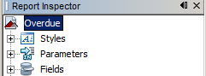

Properties
- Properties displays properties for the selected area.
- When we are at the top level we can, for example, see the width and the height of the document as a whole.

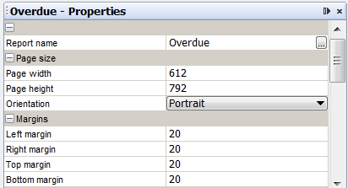

- The measurement unit in iReport is PostScript points (iReport says “pixels,” but it is not true pixels – this is important to know if you use an external converter).
  - Page size in Properties: width 612, height 792 PostScript points.
- Use a converter to calculate your own measurement to and from PostScript points, for example: http://www.unitconversion.org/unit_converter/typography.html
  - Convert the Page size (612x792 postscript points) to inches for example – it shows the default is a 8.5x11 inches page

Palette
- The Palette window provides access to all elements you can use in a report, and to some additional tools such as inserting current date and page numbers.

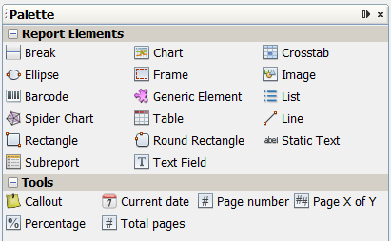

- There are many elements available in “Report Elements,” but our templates use only Static Text, Image and Text Field.
  - Note that the Text Fields we use are generally predefined and come from “Fields” in the Report Inspector

Navigating in iReport
- Text fields are represented by $F values in the document. In the report, click on a box that has a $F, for example Message_C.

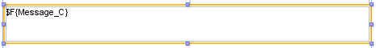

- The box is now selected and the focus in the Report Inspector has shifted – it opened a folder and highlighted the box representing the Text Field you selected.

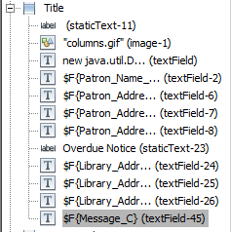

- In the Properties window you will see properties pertaining to the selected field (the size and position of its box, how it is formatted, etc.)

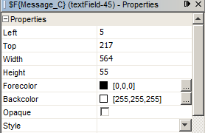

- Changes can be made in the Properties window, sometimes from menus, or directly in the document. There is also a toolbar with some shortcuts and additional options.
- In the Report Inspector you see the different elements as textField, staticText and image, with different symbols.
- The elements are grouped in folders, for example Title. In iReport this level is referred to as a band. In short, a band is an area with a specific purpose.
  - Click on a folder name (for example, Title) and see how Properties displays the very few values that control the band, basically the height.

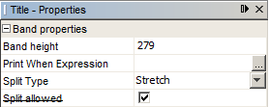

  - You can see the band layout in the report – look for watermarks. Gridlines crossing the margins mark the borders of each band, and the vertical ruler measures each band separately.

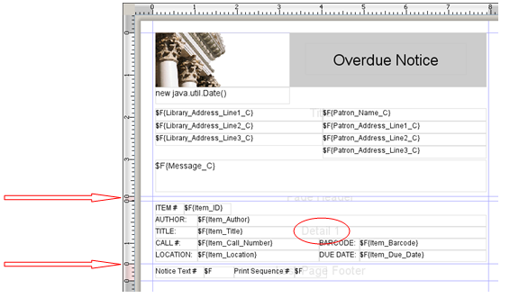

- The overdue template uses three bands: Title, Detail 1 and Last Page Footer. If you click on any of the other folders you will see that Properties normally shows 0 as band height.
- We will talk more about the use of each band when we work with the exercises.

Preview
- iReport offers preview in various formats – see the Preview menu. The default is Internal Preview. The other formats will also show an internal preview first, but will then open the report in the selected format, for example as a PDF or HTML page.
- To use preview, simply click on the Preview option on the toolbar above the report.

- You will now see the report as it will display when used. However, only static text, dates and images will display. Text Fields show as blank or with ‘null’ – iReport cannot foresee what the content should be.
- To get back to regular display, click on Designer.

Exercises
The first exercise will be to customize a template for printed overdues, followed by customization of a template for emailed overdues. After that we will work on a Title Paging List template.

Exercise 1 – Printed overdue notice

Page dimensions
- The first thing we will do is look at the dimensions of the page, and show how to change them if necessary.
- The default template is 8.5x11 inches (letter size). As we have seen in Properties this corresponds to 612x792 PostScript points (simplified to ‘pixels’ in the following).
- When you look at the report you can see that it does not display the full height of a page. It only shows the design. When the report is used for printing in Sierra some areas are used for dynamic content, primarily item data which will repeat as many times as there is room for on each page.
- The vertical and horizontal rulers can be used to check dimensions in a measurement that is more familiar than PostScript points.
  - By default they measure in inches. This can be changed from Tools | Options | iReport | General tab
  - Other options are “pixels” (i.e. points), centimeters or millimeters

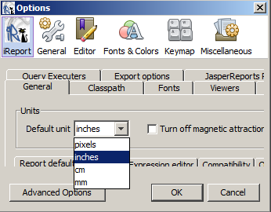

  - Note: changes are saved permanently, so your client will show whatever you saved last.

- The page size can be changed from Format | Page format. There are a number of predefined formats, e.g. Letter (default), A4, etc., or you can manually set dimensions.

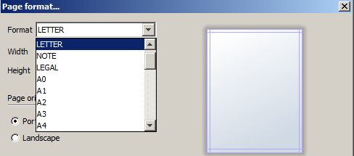

  - Change to A4
    - In the Format dropdown, select A4. Note that width and height change automatically. (The values are slightly different than usual – more precise. This is because iReport always measures in PostScript points, regardless of what the display format is.)
    - Click OK to view the change
    - Because A4 is narrower than the default size, many boxes will be too wide. In the report you can see that they continue across the right hand margin. You need to change the size of the boxes so they fit within the new format.

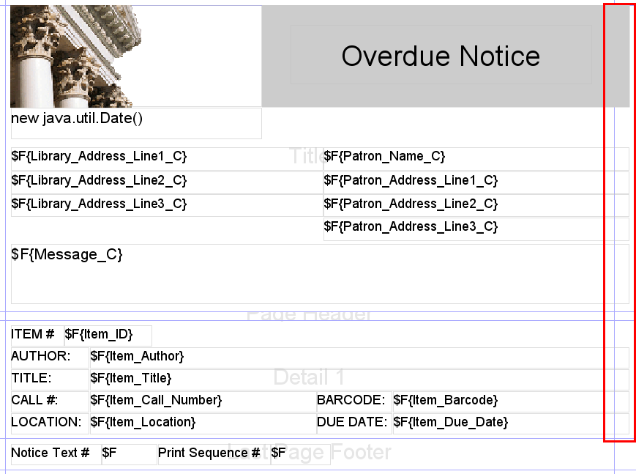

    - To select multiple boxes: hold down Ctrl and click on one box at a time to select the boxes that that are too wide. Then drag from the right to make them fit within the new page width.

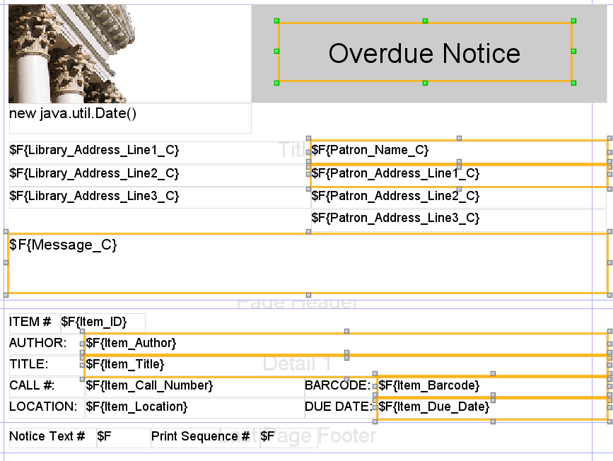

    - Ctrl-Z (Edit – Undo) can be used to start over if the boxes became too wide or too narrow after the first change.
  - Change to custom format
    - In Page format, change, for example, the height to 5 inches. If inches are not your familiar measurement the Height and Width dropdown can be used to change to something else.
    - Format will automatically change to Custom

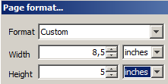

    - Press OK to view the change – if you didn’t change the width it will not be easy to spot. Make sure you are at top level, then check the Properties window. The height is now 360 ‘pixels.’

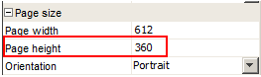

    - The current content in the report would fill more than one page – it uses approx. 6 inches (450 ‘pixels’). You can go to the Preview option and see the content is now spread over two pages.

- The page margins can be changed from the Properties window. Make sure you are at the top level in the Report Inspector:
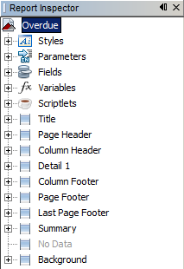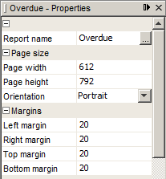

  - Alternatively you can do the same thing from Format | Page format | Margins, using another measurement unit like inches or cm.
- Next we will look at the notice upper area, the Title band. It contains information that prints only once, at the top of each notice – logo, date, patron and library addresses and the notice text.
  - The band height is 279 ‘pixels’ – approx 3.9 inches (9,8 cm)
  - Select the Title folder in Report Inspector to see the band height in ‘pixels’ in the Properties window
  - You can also look at the vertical ruler
- All types of elements are represented in this band: text fields, static text and image.

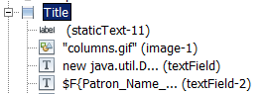

Images
- We start by looking at the image. We will replace the default with our own InnoU logo and resize the box so it fits the image size.
- Image files are not part of the template as such, but are connected to them via properties, which are different for printed and emailed notices. Images used on a printed notice have to be imported with the template. Therefore it must be in the same folder as the template when you import it into the Sierra Desktop Application.
- First click on the image so its box is highlighted. Then look at the Properties window.
- Look at the “Image properties” section (you may need to scroll down). You see the Image Expression: “columns.gif”
  - Note: Images must be either .gif or .jpg. Other formats (like .tiff, etc.) are not supported.
- There are several ways to change the source/name of an image. You can click on the name of the image in the image expression and type a new name – “columns.gif” in the example.
- Or you can click on the button next to the image name and get a pop up box where you can edit the name.

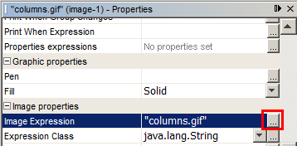

- Type the name of the new image file, putting double-quotes around it, e.g. "innoulogo.jpg"

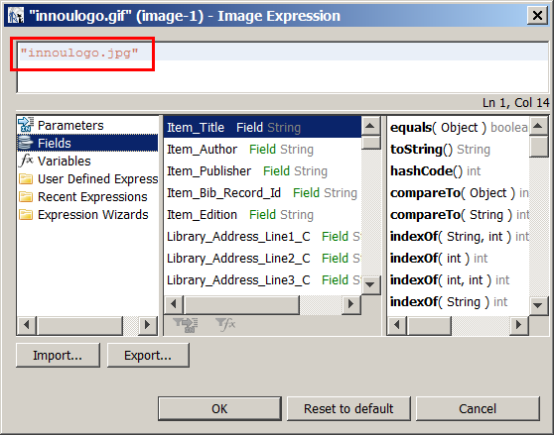

  - Note that the bottom section you will see here contains additional editing options which are not applicable to adding our new image
- Click OK if you used the popup window, or confirm the change with <Enter> if you typed directly in the Properties window. The image should refresh in a few seconds.
  - You may not see the new image until after you have saved the template, closed it and reopened.
  - If the new image doesn’t display, save with File | Save as…
  - Reminder: you cannot give a template the same name as a default in Sierra, e.g. _Overdue, so you should use Save as, to also give the jrxml file a different name.
  - Close the report, then open it again from File | Open Recent File and you should see the image display

If you insert a new image, rather than changing the source/name of an image that is already part of the template, you can find any graphic file on your PC, but you must then remove the “path.” Make sure that only the file name remains and is in quotes.
- In the Palette window click and drag Image onto the report. When you release you will get a dialog asking you to select an image file.
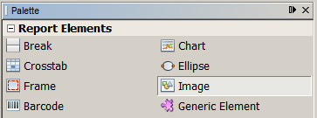
- Once you have selected a file, adjust the Image Expression in Properties to remove the “path”
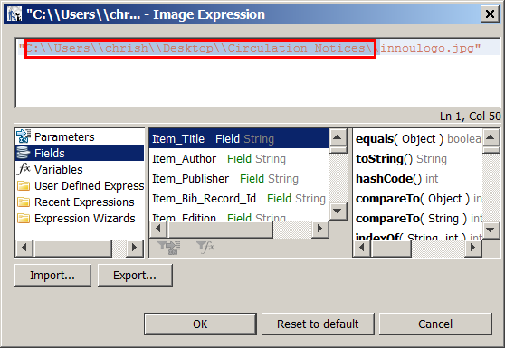

- The image box will not auto-resize based on the actual size of the image. We have to change the dimensions manually.
- Select the image box again, and in the Properties window move to the “Properties” section at the top (click on the plus sign if it is “closed”).
- Change the Width and Height to match the properties of your new image file

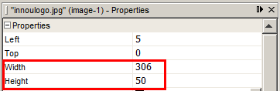

- Review the change on the screen. In our example the image will now stretch over the boxes next to it. We will correct this in the next exercise.

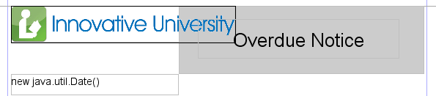

Static text
- The notice name is a static text that displays on a grey background. We will remove the background, change the text and move and resize the box.
- There are actually two static text boxes. The background is a separate box with no text, just background color. (If you look close you can see the text “Overdue Notice” is surrounded by a thin line, which is the box)
- Click in the grey area, but outside the notice name. The selection (yellow frame) should surround the whole grey area. (This is field staticText-11 in the ‘Title’ band)

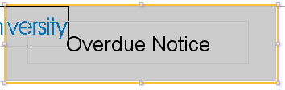

- Press Delete on your keyboard, and the grey will disappear but the text remain. (Use Ctrl-Z to undo if you selected the wrong area.)
  - Alternatively, use menu Edit | Delete, or right click and select Delete from the popup menu.
- Now double click on the notice name and you can edit the text.

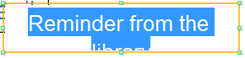

- In our example the box is a bit too large to fit next to the logo, and the whole text does not display in the original box.

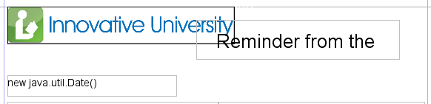

  - If the text is too long for the box it will not print in full. Only what you see will print.
- To fix this we will change the font size as well as the box size.
- We will first move the box below the image. Drag the box to approximately where you would like it to display.

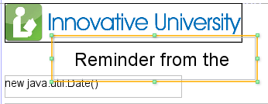

- Changing the font and/or the font size is easiest done from the dropdowns on the toolbar.

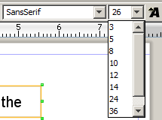

- Make sure the box is selected (highlighting the text is not necessary), then change the size from 26 to e.g. 22. (22 is not listed in the dropdown but you can type a value in the box to get the exact size you want and press <Enter> when done.)
  - A full font menu is offered in the Properties window (scroll down to the “Text properties” section)
  - Note about fonts: Circulation notices, due slips, and ecommerce receipts are limited to fonts that are universally understood by Java applications. For best results, use one of the five "logical fonts" recognized on the web: Serif, SansSerif, Monospaced, Dialog, or DialogInput.
- Now you can probably see the whole text, but the box may still overlap surrounding boxes.
  - If the box is too narrow make it wider so the whole text displays – click and drag on either side
- Change the height of the box so it is not overlapping the logo or the date field below. This time, try the Properties window:
  - Make sure box is selected, then in Properties change the Height element and use TAB or <Enter> (or click somewhere else) to have the change take effect.

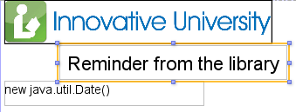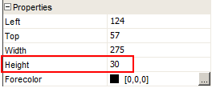

  - If necessary move the box up or down. You can use the <Up> or <Down> arrow keys on the keyboard for most exact result.
- Finally, we want to make sure the text is centered on the page, so we have to center the box. (The text within it is already centered.) This can be done easily from the Format menu. While the box is highlighted, click Format | Position | Center Horizontally.

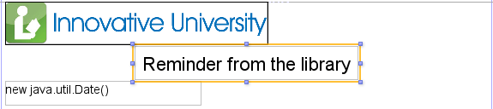

- To insert a new static text box, use the Palette window. Click and drag “Static Text” onto the template. We will demonstrate this a little later.

Date
- The following box in the Title band is used to generate today’s date (the sending date):
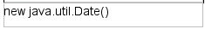

- It is a text field but not one from the Data Library. Instead it is using a standard java expression, i.e. it is not related to data from your Sierra server.
  - In the Palette, under Tools, the “Current date” element will produce a field like this.
  - If you are familiar with java you can create your own text fields, but still not extract data from Sierra unless it is already present in the Data Library
- The date format does not display in the box, but the default is month/day/year. To customize the format of the date:
- Select the box, right click and choose Field pattern.
  - Alternatively, in the Properties window, find Pattern in the “Text field properties” section. Click the symbol beside it to get a popup where you can select values.
- Under Category, Date is selected. Choose the desired date pattern from the Type menu and click Apply.
Dates for particular items within a notice (for example, item checkout dates and due dates, pickup by dates on circulation notices) are controlled by the date format on the Sierra server. They can be somewhat customized by the Helpdesk: display year as two or four digits; whether hours and minutes display. Service commitment at http://csdirect.iii.com/support/servcomm_form.php?id=447

Text fields
- All other text fields in the template come from the Data Library (‘$F’ fields).
  - In the Title and Last Page Footer bands you can only use fields that have _C at the end.
  - In the Detail 1 band you can NOT use fields that have _C at the end.
  - Which fields you can use in different bands is explained in the Sierra WebHelp (http://csdirect.iii.com/sierrahelp/Default.htm#sril_pt_odue.html)
  - The WebHelp uses the terms “body of the notice text,” “notice text,” “header,” and “footer.” In iReport this translates as:
“notice text” = Detail 1 band
“header and footer” = Title and Last Page Footer bands
- The name field $F{Patron_Name_C} displays the name on circulation notices as stored in the patron record. This is typically "Last name, First name." The Print Templates wiki includes a java expression you can use to restore the name display to "First name Last name" (http://csdirect.iii.com/lswiki/PrintTemplates/SharedPrintTemplatesCircNotices#Name_format_on_patron_notices
- The Detail 1 band is used for repeatable data, in this case item information. The total height of the document (the page size) will decide how many times the Detail band can repeat on each page. The default template lists 4 items on the first page, and 6 on the following page(s).
  - The height of the band itself is 107 ‘pixels’ – approx. 1.5 inches (3,8 cm). This is the space used to define information for one item. When notices are printed it will repeat for each item as will fit on the page.
  - Select the Detail 1 folder in Report Inspector to see the band height in ‘pixels’ in the Properties window, or look at the vertical ruler
- You see the text fields clearly when you look at fields in the Title and Detail 1 bands, with or without _C at the end. But in the Last Page Footer the definition of the text fields don’t display because the boxes are so small. You can only see “$F”
  - Expand a box to see the full field definition – highlight and drag one of the corners. Use Ctrl-Z to undo your change and resize to the original size.

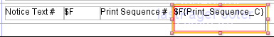

- As the name indicates, this band contains information that will only print at the bottom of the last page. In the default template the band is only 29 ‘pixels’ high (0.4 inches or 1 cm), allowing one row of text.

- We will delete the existing fields from the footer and add the field that shows the patron’s current charges (the amount in the “Money Owed” field). We will also add a static text box to have a label for the new field.
- To delete the existing fields, select one at a time and delete, or select all with Ctrl+click and delete.
- Now we have to find the new text field in the Fields folder in the Report Inspector.
  - The field we are looking for is Total_Patron_Fines. Since we want to have it in the Last Page Footer it has to exist as Total_Patron_Fines_C. In this case that is the only version there is. Scroll down towards the bottom of the list to find it.

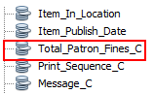

  - Other fields may exist in both versions, or only without _C.
    - Example of field with both versions: Bill_Total_Amount – end of list

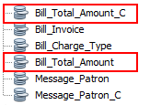

- Select Total_Patron_Fines_C from Fields:
  - Click on the field and drag it to somewhere on the right hand side of the Last Page Footer area.
  - This will create a box that you can move and resize as desired. The size of the box will decide how much information there is room for when the notice prints, so don’t make it too narrow.
  - If the new box goes outside the band area it will have a bright orange line around it, and there will be a warning triangle in one of the corners. If you hover anywhere over the box you will see a warning message display:

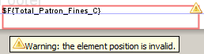

  - Move it to inside the band, but don’t worry too much about the position, you can fix it later.
- We will now add a label:
- In the Palette window, click and drag Static Text to where you want it. Click and drag to expand the text box.
- Place the static text box to the left of the new text field box. Double click inside the box and type in your text.

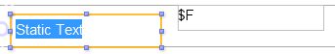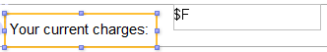

- When you add new boxes it’s difficult to get them exactly right from the beginning. We will use the tools iReport offers to make sure everything looks correct.
- To begin with, the font size is different than the other boxes, 10 instead of 12. Select both your new boxes with Ctrl+click and change the font size to 12. Use the dropdown on the toolbar.
- Deselect the two boxes (click somewhere else in the report), then select the static text box and adjust the width so it matches the text. All the text should display
    - Tip: Sometimes the full text doesn’t print in Sierra although it looks fine in iReport, so leave some blank space beside the text.

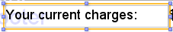

- Next we will move the text field box to the right hand side margin. Select the box and go to menu Format | Position | Align To Right Margin

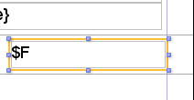

- You can now join the two new boxes by selecting both (Ctrl+click), then use menu Format – Position – Join Right.

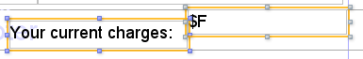

- Finally we will adjust the height and alignment of the new boxes so they match existing content. This can be done in several ways. We will use the Properties window:
  - Select one of the boxes in the Detail area (e.g. ITEM #) and check its properties. What you want to know is the height (Height = 20).
  - Change the height of the new boxes to be the same as the other boxes. It usually works best to change them one at a time, so select one and make the change, then the other. Confirm change with <Enter> or <Tab>.
  - You can also change the value in Top, which is the distance from the band top. This will align the boxes nicely. Change it to 5.

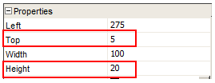

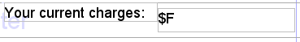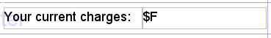

  - Do NOT change other values – the width and the position measured from the left hand side will be different for each box

“Stretch with overflow”
- To make sure that all content prints, instead of being truncated, you can use a function called Stretch with overflow. For example the notice text, if taken from the notice text file in Sierra, may vary in length depending on which level of overdue that prints.
  - The message in the default template, font size 14, allows for three lines of text
- To make the message “stretch”:
  - Select the Message_C box
  - In the Properties window, scroll down to the Text field properties section and check the box beside Stretch with overflow:

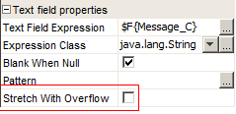

  - Note: stretching the message text may leave less space for item information on the first page.
- In the default template, Item_Title (in the Detail area) is set to stretch. If there are fields below the field you set to stretch, they should “float.” Otherwise long titles may make the following fields appear a bit out of sync with their labels, like this:

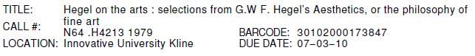

- In the Properties for the field you want to “float”, change the value in the Position Type dropdown to “Float” (in Properties section):

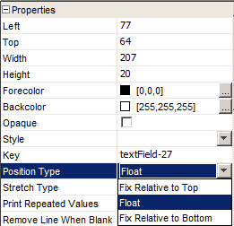

- In the default template that would be all the fields below Item_Title in the Detail band, static texts and text fields alike.
- The fields should then be correctly positioned on the notice, like this:

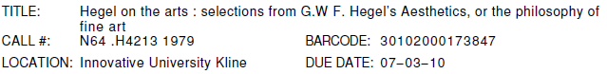

- If you prefer titles to be truncated instead, uncheck Stretch with overflow.
- When you are ready, save your new template with File | Save as… (Or just Save, if you saved it already.)

Exercise 2 – Emailed overdue notice
While it is not required to use a specific template for emailed notices it is necessary if you want to include an image, and may be useful also for other reasons. For example you have more space to work with since you are not limited to a particular paper size, and you can use color and special design in a way that is usually not possible for printed notices.

- You can start over with the _Overdue template again, or use the customized version you just saved. If you want to start with the customized version, save another copy of it: File | Save as…, and give it a different name.

Page dimensions
- When you customize a template to be used for emailed notices you are not limited to a particular size in the same way as you are with printed notices. There is no way to foresee exactly how different email readers will display the information, but there are some general tips you can follow.
- Because page height is not a worry in emails it can make sense to increase the height to avoid the gaps that are created with a page break. More space on a page means fewer pages are needed.
- With focus on the top level in the Report Inspector, change the Page height in the Properties window. You can for example make it something like 1000 pixels (which is approx 14 inches, or 35 cm).
  - Alternatively, if you want to change the height using a familiar measurement unit like inches or centimeters, go to Format | Page format.
- Because you have more space on an email “page” you can increase the band heights to give more room for additional information if desired.
- Be aware of how different email programs will handle design. For example, Gmail and many other webmail services will remove blank space and create a compact text. Outlook will keep design, and if the page height is given a very high value (e.g. 2000 ‘pixels’) it will make the page equally tall. The information in Last Page Footer may then print far below the item information (and probably be missed by the reader).
  - It may work better to not use Last Page Footer for emailed notices, and put the information in the Title band instead.

Images
Because of spam emails, many email servers may stop the download of images, and libraries might choose to not include images in emailed notices. However, adding an image can also make your notices more colorful and less anonymous, so it may be worth trying.

- As mentioned before, image files are not part of the template as such, but are connected to them via properties, which are different for printed and emailed notices.
- To add an image to an emailed notice, the image must be generally accessible over the web. The location where the images are stored must be accessible to the end patron when they receive their email notice. They cannot be stored on a local PC or behind a firewall.
  - The /screens directory on your Sierra server (where your WebPAC files exist) should normally be a good place to store the image(s)
- The link to the template is made via a complete URL, e.g. http://xtrain.iii.com/screens/innoulogo.jpg
- When importing the email template into Sierra, the image does not need to be imported.
- If you already have an image in the template you start with, it’s easier to delete that first, then start from scratch:
  - Highlight the image box and delete it.
- To add an image to the template:
  - In the Palette window click and drag Image onto the report.

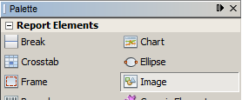

  - When you release you will get a dialog asking you to select an image file. Since we don’t want a local file here, Cancel at this point. This will leave a place-holder image.

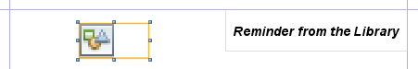

  - With the image selected, move to the “Image properties” section in Properties. Enter the URL of the image in double quotes in the Image Expression field (for example, “http://xtrain.iii.com/screens/innoulogo.jpg”).
    - It is easier if you use a popup window – click on the grey square beside the Image Expression field. Enter the image URL (in double quotes) in the box at the top. Click OK to save and close the popup.
  - Important: further down in “Image properties” check the box Is Lazy. (This has to do with the image being on a remote server.)

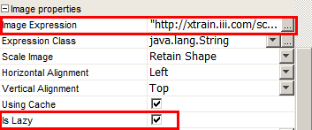

- Image scaling is not available in iReport, so the dimensions (in pixels) of images on notices should exactly match the dimensions of the original image files. Properties for the gif or jpg file show the dimensions:
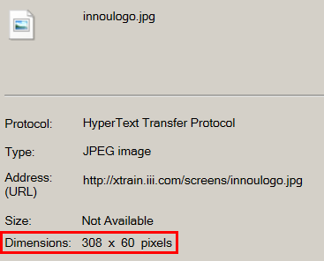

  - To find the dimensions, right click on the image in a browser and select Properties.
- Exact image dimensions and positions in pixels can then be specified in the element's properties, in the “Properties” section:

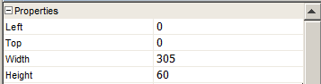

  - Setting Left and Top to 0 will place the image in the upper left corner
- The image should display in iReport.
- Elements cannot overlap or none of them will print properly, so you may have to adjust other boxes after the new image is added.

Embedded URLs
- Email notices can have live hyperlinks, for example a link to the login page in the WebPAC or Encore.
- To embed a live URL, you have to add a blank text field to the template.
- First decide where you want to place the link and make room for it. For example, we can place it in the Title band, below the notice text.
- To make room for it you can:
- Increase the size of the title band:
    - Highlight the Title folder in the Report Inspector.
    - In the Properties window, change the band height to something like 350. (You can adjust later.) The change will apply when you tab or click somewhere else.
- Move other content in the title band so that you create space within the band:
    - Select all date and address boxes by holding down Ctrl and clicking on them one at a time
    - Drag them upwards using the mouse, or use the <Up-arrow> on your keyboard to move them incrementally.
- In the Palette window, click on Text Field, drag it to where you want the hyperlink. When you release, a box will be created. The description is $F{Field}. Place it below the $F{Message_C} box and drag it so it extends across the page.

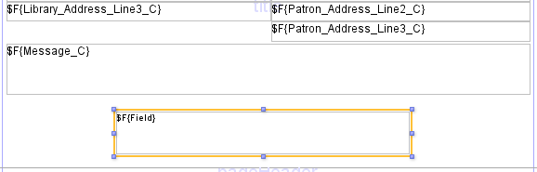

- Right click on the box and select Edit expression..
  - In the Expression editor, replace $F{Field} with the text you want to display in double quotes, e.g., "Login to your account"

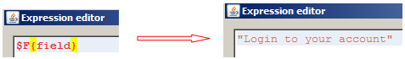

  - Click Apply to save
- Right click again, select Hyperlink
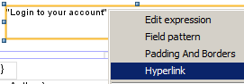

  - In the Hyperlink type dropdown, select Reference

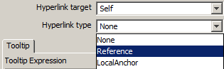

  - New tabs will appear below. In the Reference tab enter the URL in double quotes, e.g. “http://innou.iii.com/patroninfo”
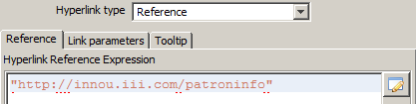

  - Click Close
- You can then, for example, make the font in the new box larger and bold, perhaps center it. Use the “Text properties” section in the Properties window

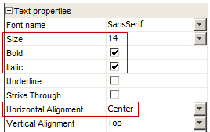

- If you want to give the text a different color, move to the “Properties” section and click on the button besides Forecolor and select a color.

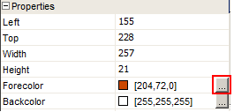

- You may want to center the box on the page and perhaps align it to the band bottom. Use options on the Format menu.
- Go back to adjust the height of the band if necessary.
- Make other changes as desired, then save the template. Remember to Save as… if you started with the default.
- The end result may look something like this:
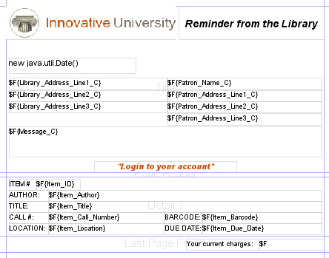

Exercise 3 – Title Paging List
- Open the Title_Paging_List template that you have exported
- The paging list is different in that it has less content and is meant for staff use only
- The default size is the same as the other notice templates
- The only bands used are Title and Detail. Other bands are 0 high or have some minimum value, but no fields.

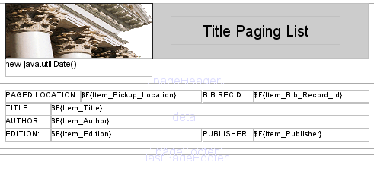

- The Title band only has an image, the notice name and a date field. Since this notice will only be used by staff you may want to remove the image, take out the grey background behind the text, and add some instructions for staff.
- Click on the image and delete it, and then click on the grey background and delete that
- Now click on the static text box (“Title Paging List”) and go to Format – Position – Center Horizontally
- You may also want to align the box to the top: Format – Align – Align To Top Margin
- To change the text, double click in the box and enter your own text. The top now looks something like this:

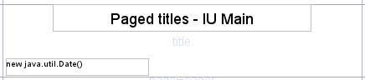

- You may want some sort of instructional text on the notice. The text set in Circulation Options can be used for this (that would be Text_Number_C). However, a static text may be an easier option.
  - Make room for a new box in the title band by moving the date box upwards. A quick way to place it immediately below the notice title:
    - Select both boxes (<Ctrl>+click)
    - Go to Format – Vertical Spacing – Remove Vert. Space. After the change you have some blank space in the ‘title’ area:

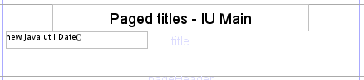

  - Now insert a Static Text box:
    - In the Palette window, find Static Text, click and drag to the report
    - Move the new box to below the date
    - Make sure it fits within the band (no red lines around). Move if necessary (use arrow keys on keyboard)
  - Double click in the new box to highlight the default text. Overwrite it with your own message.
  - If you wish to have more text, you can ‘Adapt to parent width’: Format | Size | Adapt to parent width
- Adjust font sizes and/or box sizes as necessary for the boxes in the title band, to make room for all the information you want. If you want text that is differently styled you need to put it in a separate box. You cannot use different styling within the same box.
- If you find you need to increase the band height, click on the Title folder in the Report Inspector and change the height in the Properties window. (The original height is 116)
- The end result may look something like this:

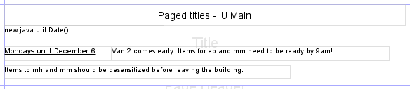

- The Detail band includes a number of fields to be printed for each paged title.
  - Note that if any item record fields are included on a Title Paging List they all come from the first attached item that is possible to page at the location being paged (for example, barcode). No item record fields are included in the default.
- You may want to print two columns instead of one in order to save paper. To do this you first have to change the Document properties:
  - Select the top level in the Report Inspector. In the Properties window, look at the “Columns” section. The Columns field is 1, change it to 2.

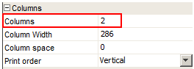

  - Tab or click somewhere else to see the change take effect. The column width is automatically adjusted to be half the page. It is now 286 ‘pixels.’ (Page width 612 divided by 2, minus margins: 20+20+286+286=612)
  - In the report you can see the columns clearly, the second column with stripes. (Columns only affect the Detail band)
- Next, in the Report Inspector, click on the Detail 1 folder. Check band properties in the Properties window: note that “Split allowed” is checked.

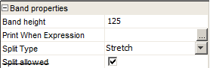

  - When split is allowed, what you define for the first column will repeat in subsequent columns when you print
- To make editing easier, increase the band height (to 200 for example)
- You now have to move all content to the first column and adjust the boxes so they don’t overflow into the second column, while there still has to be enough room to print the fields.
- Begin by considering if there are any fields you want to delete
  - Highlight box(es) and use <Delete> on your keyboard to delete unwanted fields.
- Do you need labels?
  - The label text may take up valuable space
- In our example we have deleted the Publisher field (label and text field) and deleted all labels (static text fields)

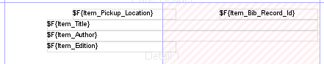

- All fields have to be in the first colum. If content overflows into the column on the right hand side it will overlap when the notice prints. Move remaining boxes to the left and rearrange them in logical order. Click and drag to move around boxes. Don’t worry too much about getting them positioned exactly right, there are tools you can use for that. You can also resize them later.
- After the first changes you may have something like this:

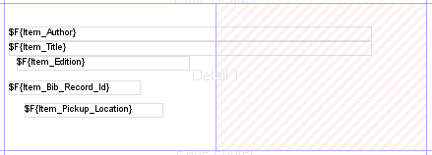

- If you want other fields, make room for them and insert from Fields in the Report Inspector. For example, you may want to have a call number and location.
  - Reminder: any item record fields come from the first attached item that is possible to page at the location being paged.
  - Call number is taken from the bibliographic record if there is none in the item
- When you add text fields from the Data Library in the Detail band they will appear with an accompanying Static Text field, containing the description of the field

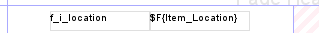

  - If you want a label for the new field you can simply use this Static Text box and change the text within it. Double click in the field to highlight the text and overwrite it. Or else, select the box and delete it.
- After adding a couple of new fields – without labels – we have something like this:

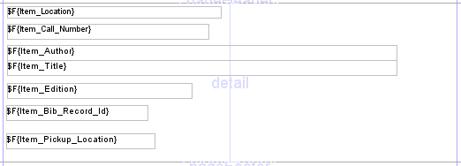

  - The new fields have font size 10, while the existing fields are 12. To save space you may want to use font size 10 in all fields. Select them all, and then use the font dropdown on the toolbar to change the size.
  - Tip: A quicker way to select all fields (than Ctrl+click on each box) is to use the Report Inspector. Click on first textField symbol, hold down Shift and click on the last textField symbol

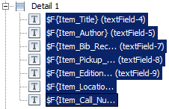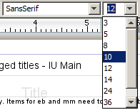

- Make sure fields are aligned and positioned properly:
  - Select the top box (Item_Location in the example), go to Format | Align | Align To Top Margin
  - Now, select all boxes in the Detail band, then go to Format | Position | Align To Left Margin. After the change they will be lined up on the left hand side:

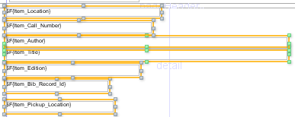

  - With all boxes still selected adjust the box width in Properties. The Width element will show <Differenct Values>. This is because the boxes have different widths. You should be able to change them all at the same time. Make them slightly narrower than the column width (which is 286).

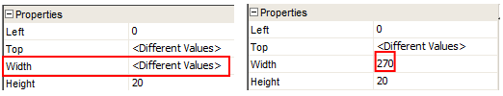

  - Tab away from the field to see the change.

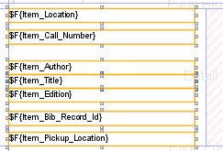

- Consider the height of the boxes, specifically the one used for the record title (Item_Title). If you have long titles that will not fit in the allotted space they can either be truncated or the template can be set to stretch to allow printing of the whole title. The default template uses “stretching.” (For title only, no other fields.)
  - Select the Item_Title box and in the Properties window move to the “Text field properties” section.
  - The checkbox beside Stretch With Overflow is checked. This will allow the field to stretch and print the full title.

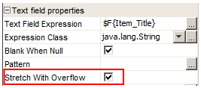

  - However, it may also cause the next line to be overprinted, if you have really long titles. If you don’t want that to happen, the fields below title should “float” (see more under “Stretch with overflow” above).
  - If you want the title to be truncated instead, uncheck the box.
- Fields that may not always have data can leave gaps on the notice, for example author and edition. To avoid this you can use the option to “Remove Line When Blank.” It’s a checkbox in the “Properties” section of the Properties window:

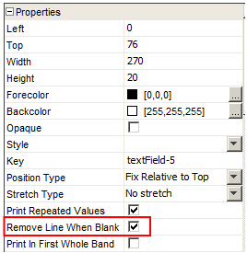

- The height of all boxes in the default template is 20, which allows for one line of text (font size 12) and some space around it.
  - Note: if you change the font size, it will not change the box height, i.e. the space allotted for each field. You may have to change the height as well to get the effect you are looking for. For example, if you change from 12 to 10 without changing the box height, you will still only see one line of text, but there will be a bit more distance between fields. Change the box height to e.g. 16 if the font size is 10.
- Check the height of any new boxes you added, and correct as necessary. If boxes overlap you can leave it like that. Then, select all boxes, then go to Format | Vertical Spacing | Remove Vert. Space
  - This will place all boxes next to each other.

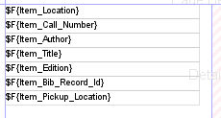

- Finally, adjust the height of the Detail band. (The original height is 101) Make it high enough so the last box doesn’t get red lines around it (showing it is outside of the band area). But be aware that any blank space below boxes will print as blank space before the next set of columns.
- With focus on the top level in the Report Inspector, check Print Order in Properties. This is in the “Columns” section.

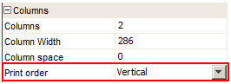

  - By default (as defined by iReport) it is Vertical, but can be changed to Horizontal
  - With “Vertical” the column on the left hand side of a page will be filled first before printing moves to the column on the right hand side. With “Horizontal” printing is left-right, left-right, etc.
- When you are finished save the template with Save as…

Import templates to the Sierra Desktop Application
- Import the new Print Template(s) via Admin | Settings | Print Templates
- Select Output Type (Overdue Notice) and click Import
  - You will then see the New Print Templates Attributes window:

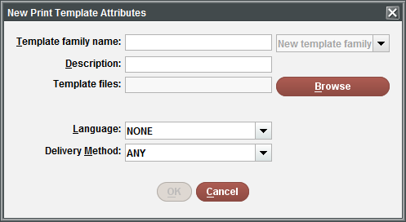

- Using “families” is mandatory for notices.
  - The “Template family name” will be used as the family name (can be up to 10 characters, no spaces)
  - The “Description” can be up to 25 characters, spaces permitted
  - There must be some content in name and description fields before OK becomes active.
- Browse is what you use to find your new template. Use it to find the template for printed overdues.
  - Select the jrxml file and the image file (if used) using Ctrl-click
  - Click Open in the dialog to confirm your choice
- If your library uses the Language Preference feature to send notices in multiple languages, select the appropriate language from the Language dropdown.
- In Delivery Method, select “printer”
  - Note: You can only have one template per delivery method/language combination in any one family.
- Click OK
- Import the template for emailed notices – no need to import any image this time.
  - Associate it with the same family – select from dropdown.
  - Delivery method = “email”
- With families you do not see the individual templates displayed in the list, just the family name and these will be in alphabetical order.

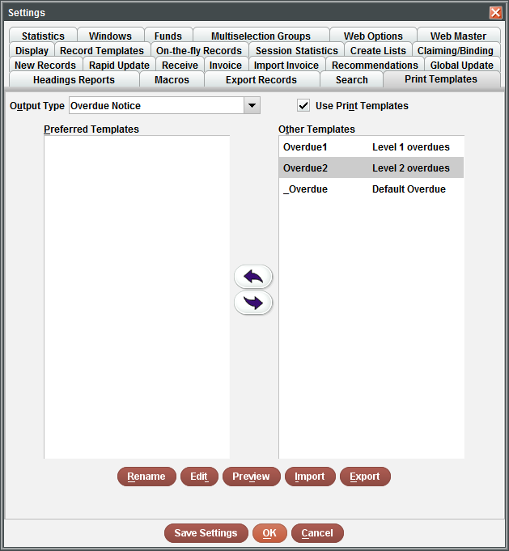

  - If a change is needed to the family name or description, highlight it and select the Rename button.
  - If you select Preview you will be prompted to select which template to view, if there is more than one in the family.
  - Preview serves two purposes: First of all, if you get an error message, the template won’t print when you try to use it. Also, it shows you what the template looks like in general – you don’t see all fields.
  - Edit gives you several options:
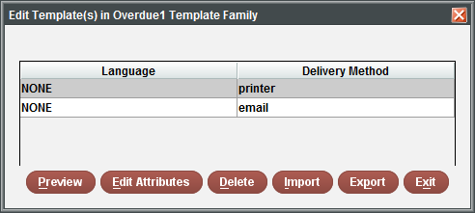

    - You can Preview, Import and Export from here
    - Edit Attributes allows you to change Language and Delivery Method settings for the selected template
    - This is the only place where you can Delete a template, for example if it failed to preview (if there is only one template, then not only will the template be deleted but the family also)
    - If you want to import a new template to replace an existing one, don’t delete it, just import the new one and if the delivery method and language are the same the system will ask if you want to replace it.

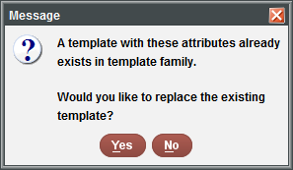

- If you have multiple templates (i.e. template families), those needed for this user account can be moved to the Preferred Templates area
- Change Output Type to Title Page List and import the new title paging list template
  - Create a new family for it
  - The Language option is not applicable to paging lists/slips – this feature only works for notices sent to patrons
  - There is no need to set Delivery Method, leave as ANY
- Don’t forget to preview the template
- Click Save Settings to save changes permanently for the login, then click OK

Print/send notices with Print Templates
- Move to Notices function
- Click New on the toolbar
  - Keep the default notice type: Overdue
  - Apart from selecting the template family you can make some other choices, like select Email Subject, Overdue Level and Status and change which address to use. But some options are grayed out: Include Telephone Number and Include Amount Owed. With Print Templates that kind of information should be included in the template.
  - The library can set up auto notices with Print Templates, if Auto Notices are enabled for the system
  - Click the Select Template button (or go directly to Prepare – it will prompt you to select the output template)

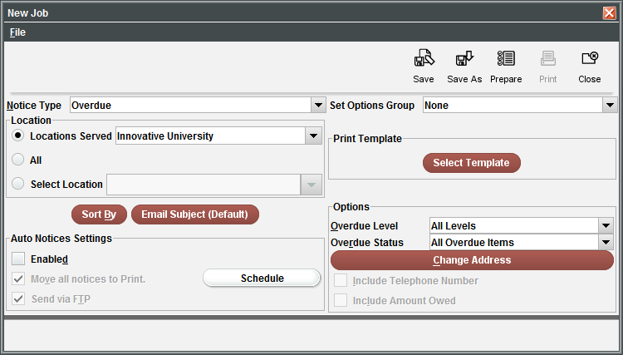

  - You will see the list of families (incl. the default template) – what you are selecting is the group of templates to be used. The system will sort out which specific template to use for printed or emailed notices and notices in different languages, as defined when you imported the customized templates.
  - Select your overdue family (highlight and click Select)

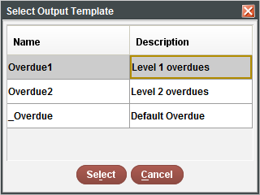

- Click Prepare on the toolbar
- You will be prompted to select a printer. This is the physical printer you normally print to, or it can be the Email printer or File Save if setting up an auto notice job.
- Review the list of notices to send – some will be to email, some to print. If the library has the telephone notification system and there are notices queued for TNS, those notices will not be affected by Print Templates.
  - When the system lists how many notices to send it uses the Circulation Option (Admin Corner) setting for 067> Notices: Where to print Item Info, where you defined how many items to print on each page with default notices. The output to Print Templates ignores this setting and will print as many as there is space for on each page.
- Send Notices to print and email

An error message such as Network error connecting to ncorrelator webservice is usually the result of a bad template. Check the following: Can you preview this template without errors? Will the default template work for these notices?

- Close the job and create a new one for the Title Paging List
- Prepare and print the paging list
- Review the results

Documentation and Resources
- Sierra WebHelp on
  - Printing with Print Templates
  - Creating Customized Print Templates
  - Print Templates Settings
  - Overdue Notice Data Library
  - Title Paging List Data Library
- Sierra Knowledge Base
  - Print Templates section
- Print Templates Wiki on CSDirect

Tell us what you think
- Connect to CSDirect to fill out evaluation
  - http://csdirect.iii.com/contact/feedback_innou.php
- Check out other classes at:
  - http://innou.webex.com

