**CS 4730-5730**

**Artificial Neural Networks**

**Assignment 2 (200 pts.)**

Date: 3-10-2020

Due: 3-13-2020 by 5 pm

**Calculate the following:**

**1.** g(x,y,z**) =** 2x^2*y^3 + 5*cos(x)^2 *z+ 4*exp(-2x)+z^3

**a)** ∇gi(x,y,z) for i = x,y, and z

**2.** f(x,y,z) = 2*exp(y^3)*x^5 + 3*sin(x^2)*cos(y^3) *z^4+ 6*exp(-3x^2)*z^2

**a)** ∇fi(x,y,z) for i = x,y, and z

**b)** J(g,f), Jacobian

**3.** h(x,y,z) = 2*exp(y^3)*x^5 + 3*sin(x^2)*cos(y^3) *z^4+ 6*exp(-3x^2)*z^2

**a)** ∇hi(x,y,z) for i = x,y, and z

**4.** E(x,y,z) = 6y*exp(z^2)*x^3 + 3*sin(4xy)*cos(5xz) *z^2+ 7*exp(-3x^2*y)*z^5

**a)** ∇Ei(x,y,z) for i = x,y, and z

**b)** J(h,E) , Jacobian

**5.** C(x,y,z) = 5z*exp(x^2)*y^2 + 5*sin(5xyx)*sin(5xz+2y) *y^2*x+ 3*exp(-3x^2*y+z)*y^4

**a)** ∇Ci(x,y,z) for i = x,y, and z

**b)** J(C,h,E) , Jacobian

**Given:** The ANNs below.

**6. Find:**

**a)** The input vector  **x** (make sure the dimension is labeled) **b)** thehidden weight matrix, **W_0 c)** the hidden layer vector, **u_0,1 d)** the hidden layer weight matrix, **W_1,2 e)** the output vector, **y f)** Write a piece of code to calculate the forward propagation of the network below **g)** Calculate the error vector for the system. **x** =[1 0 1 1] and **y** = [0 1 0].

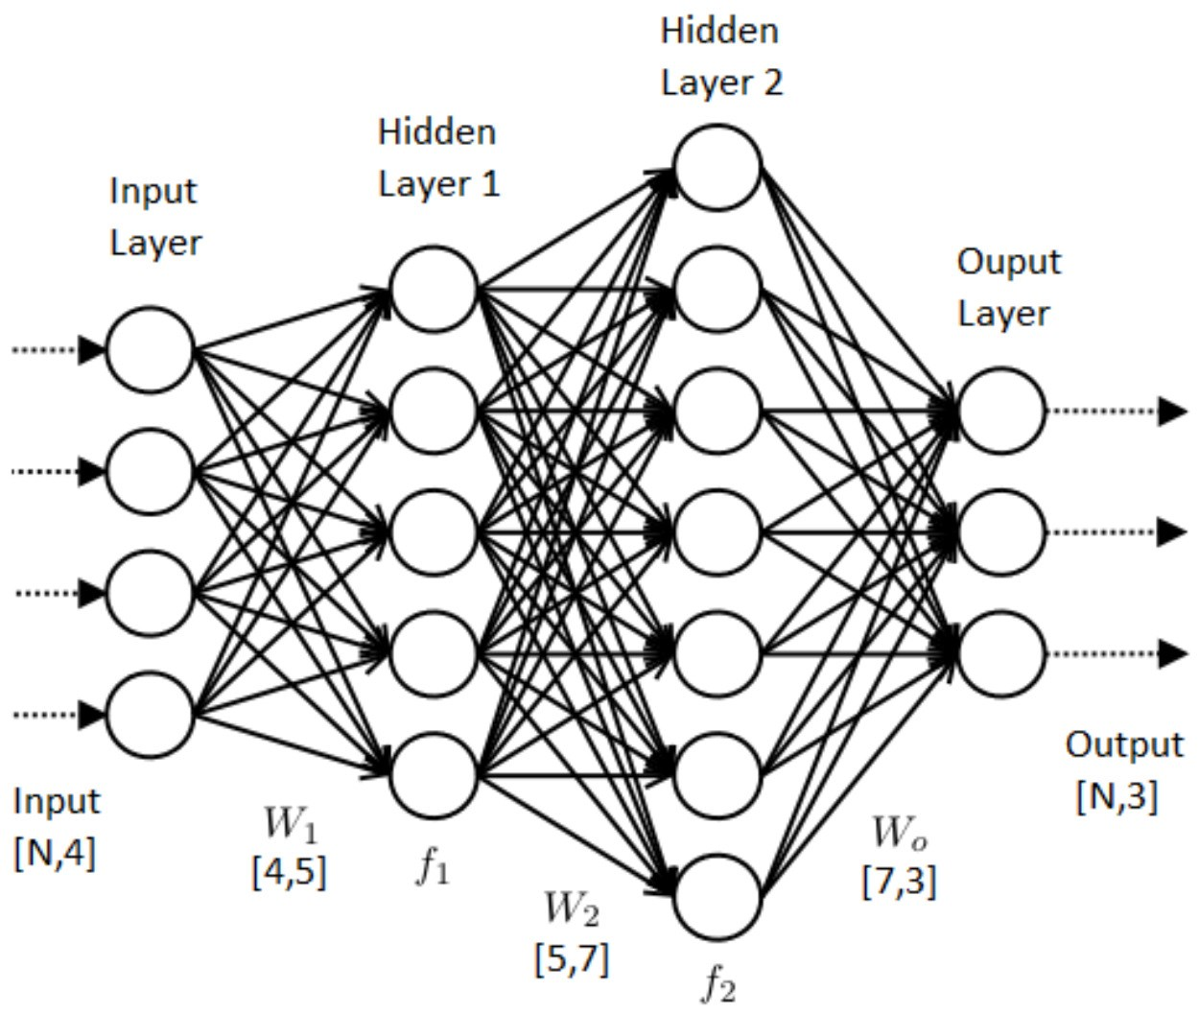

**7. Find:**

**a)** The input vector  **x** (make sure the dimension is labeled) **b)** thehidden weight matrix, **W_0 c)** the hidden layer vectors, **u_0,1,2 d)** the hidden layer weight matrix, **W_1,2,3 e)** the output vector, **y f)** Write a piece of code to calculate the forward propagation of the network below **g)** Calculate the error vector for the system. **x** = [ 1 0 1] and y = 1

