Jeff Stokes
12/07/2020
HPC & Embedded Systems
Final
Discussion/results

The code took a lengthy amount of time to fully run, taking over 20 minutes to finish running. As expected, most of the time was spent running the trials and experiments, of which running process 2 (the SMD system) took the longest. Initially more nodes were used for running the system, but due to the computation time the amount was eventually reduced from 200 (which took long enough that I opted to break out of the compiling), to 120, and eventually 110. Process 3’s time results took surprisingly little time on my CPU (Intel i5-7400), but that is likely due to the low number of coupled compartments. There could be some error in placement on starting the timer in the SIR model, requiring the starting point to be put at the beginning of the function, prior to variable initialization, rather than immediately before calculations begin.

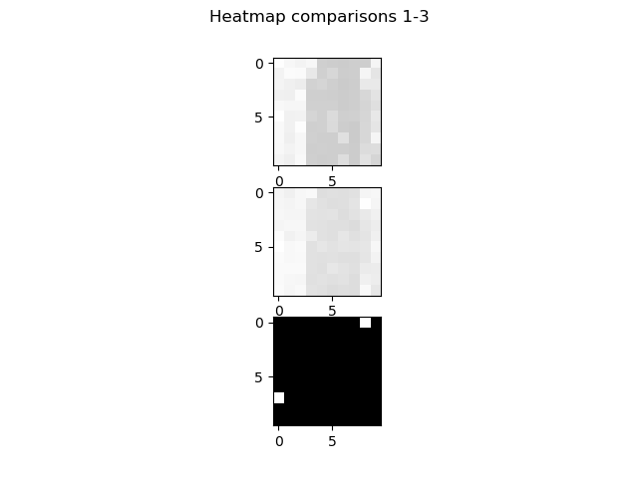
Heatmap comparisons:

RGB Image from Heatmap (Scaled up):

Mean process time comparisons:
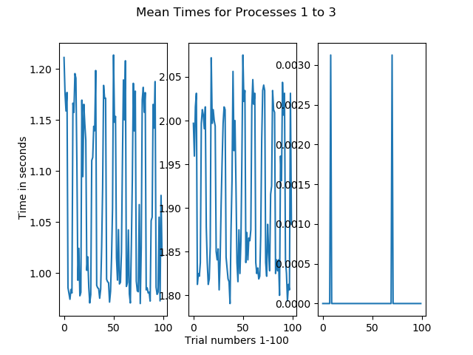

Standard deviation vs mean time:
