Jeff Stokes
HPC and Embedded Systems
Midterm

Scatterplot:
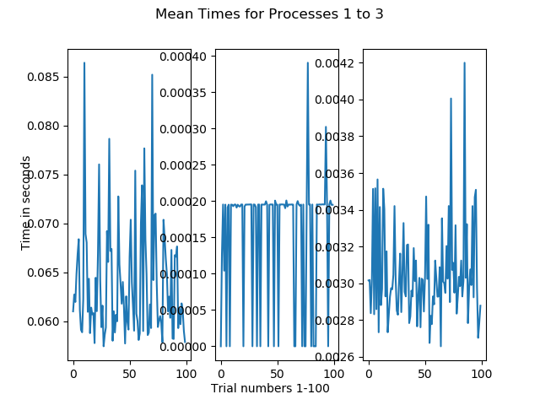

Heat maps:

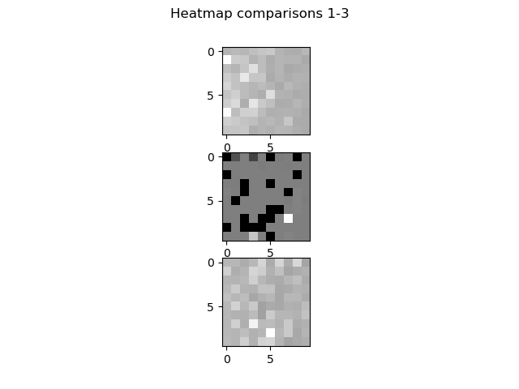
RGB Image(scaled up):

Histogram comparison:
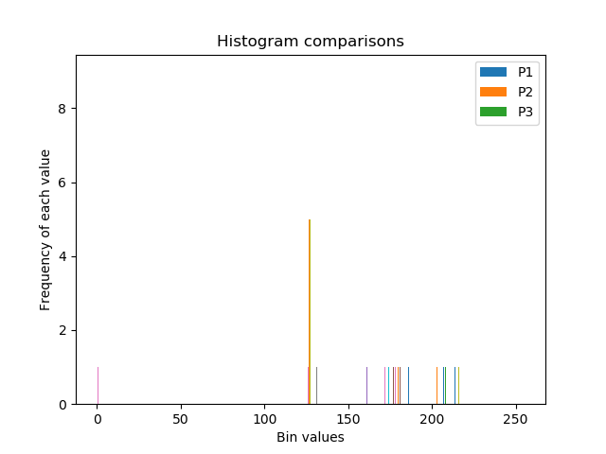
Standard deviation and comparison to mean:
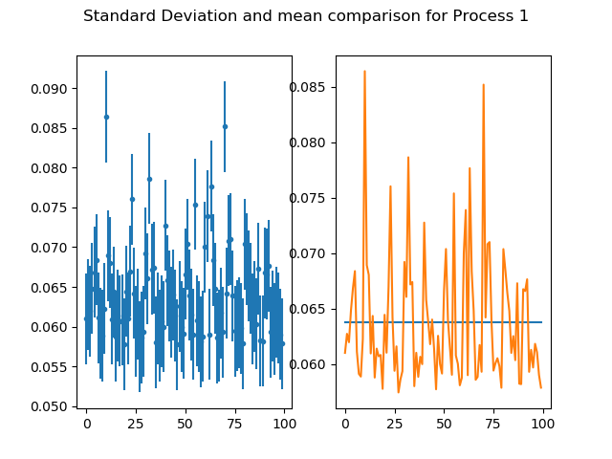
Process 1:
Process 2:
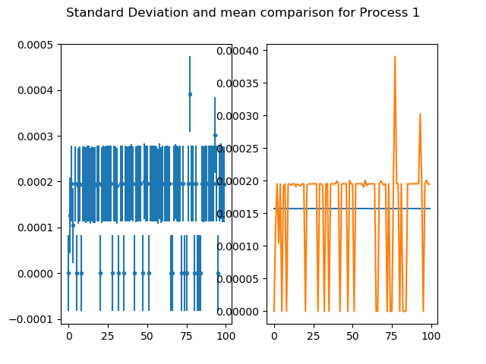
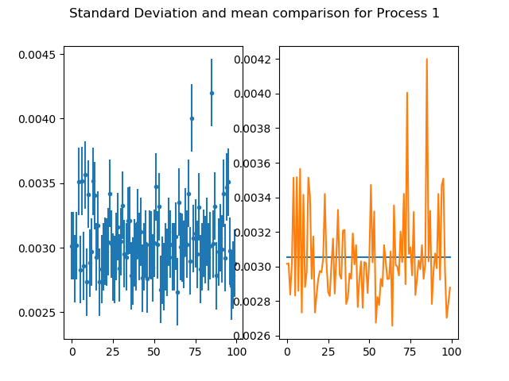
Process 3:

