**AN ANDROID BASED APPLICATION IN ACQUIRING PASSENGER’S FEEDBACK ON A SPECIFIC PUBLIC TRANSPORTATION**

A Capstone Project

Presented to the Faculty of the

Department of Computer and Information Sciences

University of San Carlos

Cebu City, Philippines

In Partial Fulfilment

of the Requirements for the Degree

BACHELOR OF SCIENCE IN INFORMATION COMMUNICATIONS TECHNOLOGY

By

JOHN MARK M. AMIT

JOSE MARIA A. GULA

ALEC JOB A. MELCHOR

VANVAN YBAÑEZ

CHRISTIAN V. MADERAZO

Faculty Adviser

September 22, 2016

**ABSTRACT**

Uncorrected and careless public vehicle drivers who commit misconduct nowadays greatly affect the population of passengers especially students and employees in urbanized areas. This uncontrolled issue affects public transport quality and reputation. Convenient and reliable public transportation for the people is an essential part of everyday living nowadays. Gathering feedback from passengers and analyzing the gathered data is the purpose of this project. After entering the plate numbers of the public vehicle passengers who have the application are able to submit positive and negative feedback on the public vehicle they are in depending on the type of vehicle. Passengers can also submit their opinions and comments if they want to. Passengers can see all records of public vehicles, the number of their positive and negative feedback statistically. After gathering and analyzing the positive and negative feedback, the records of a public vehicle will be shown statistically to all users of the application. This will inform the users or passengers of the current public vehicle records and raise awareness to misconduct of public vehicle drivers. A disadvantage to this study is when a public vehicle changes its driver making the new driver carry the reputation of the past driver if that driver made numerous misconducts. The results could to lead to the awareness of the driver or the operator of the public vehicle if their records contain numerous negative feedbacks. The results can also be used by traffic enforcement authorities to discipline public vehicle drivers with bad records.

**TABLE OF CONTENTS**

**ABSTRACT ......................................................................................................... ii**

**TABLE OF CONTENTS...................................................................................... iii**

**LIST OF FIGURES ............................................................................................. iv**

**LIST OF TABLES .................................................................................................v**

**CHAPTER 1 INTRODUCTION .............................................................................1**

**1.1 Rationale of the Study........................................................................1**

**1.2 Statement of the Problem...................................................................2**

**1.2.1 General Objective .................................................................2**

**1.2.2 Specific Objectives ..............................................................2**

**1.3 Significance of the Study...................................................................3**

**1.4 Scope and Limitations .......................................................................4**

**CHAPTER 2 RELATED SYSTEMS......................................................................5**

**CHAPTER 3 TECHNICAL BACKGROUND............................................…........13**

**CHAPTER 4 DESIGN AND METHODOLOGY...................................................15**

**4.1Conceptual Framework.....................................................................15**

**4.2 Analysis and Design.........................................................................16**

**4.2.1 Use-Case Diagram ………………………..………….……….16**

**4.2.2 Entity Relationship Diagram ………………………………..18**

**4.3 Development Model ...........................................................…...........19**

**4.4 Development Approach ...................................................................20**

**4.5 Software Development Tools ..........................................................22**

**4.6 Project Management.........................................................................22**

**4.6.1 Schedule and Timeline.......................................................22**

**4.6.2 Responsibilities...................................................................23**

**4.6.3 Budget and Cost Management...........................................23**

**4.7 Verification, Validating and Testing................................................24**

**REFERENCES…………………………………....…………………………………...25**

**CURRICULUM VITAE**

**LIST OF FIGURES**

**Figure 1: Swimlane Diagram for Passenger Feedback System……...…..….15**

**Figure 2: Use Case Diagram for Passenger Feedback System..…...…...…..16**

**Figure 3: Entity Relationship Diagram for Passenger Feedback System….18**

**Figure 4: Waterfall Methodology for Passenger Feedback System………...19**

**LIST OF TABLES**

**Table 1: Use Case Main Functionalities and it’s description ………….….....17**

**Table 2: Software Development Tools …………………………………………..22**

**Table 3: Schedule and Timeline ………………………………………...………...22**

**Table 4: Responsibilities ………………………………………………...…………23**

**Table 5: Budget and Cost Management …………………………………………23**

**CHAPTER 1**

**INTRODUCTION**

**1.1 Rationale of the Study**

Nowadays in our public transportation, drivers who violate traffic rules and perform misconduct to passengers are seldom corrected and disciplined by law enforcement. These issues lead to reduced public transportation reputation for the people and also tourists from foreign places. With these issues disregarded and ignored, drivers will continue to cause problems to public transport that will affect public transportation quality greatly. Passengers have a freedom to give a feedback of the driver while they are travelling in their desired places they want to go. Their feedback is important for the driver’s performance that records their positive and negative actions. Through their records the passenger will know and evaluate their performance of the driver to know that they will be safe in their trip. It will be a great impression for the tourist that visits in our country that they ensure to be safe for viewing and evaluating the records of the driver and avoid suspicious act. Through this drivers may know with their performance that evaluated by the passengers and given a time to improve their behavior and driving skills.

This capstone proposal aims to develop a mobile application that gathers positive and negative feedback inputted from people who commute in urban places. By creating accounts, users can evaluate a certain public vehicle based on its performance and the data gathered from the feedback of the users are shown statistically. With this statistics users may distinguish the positive and negative feedback from the passengers. It helps the user to know that they are safe in their trip.

Upon completion, recorded specific violations and actions gathered by this system will be available to all users of this application. Data gathered from users will benefit responsible law enforcement authorities to act and impose discipline to responsible drivers whose vehicles have numerous negative feedbacks. Moreover, this system can improve the tourism here in Cebu City and other cities that will adopt in this system.

**1.2 Statement of the Problem**

As commuters or passengers there are numerous events in which we encounter misbehaviour and undesirable actions from public vehicle drivers. Verbal complaints and feedback on these issues have little corrective effect. Leading to no immediate actions intended to correct or improve the situation.

**1.2.1 General Objective**

The main objective of this project is to design and develop an android application that gathers the feedback of the passengers in public transportation.

**1.2.2 Specific Objectives**

This project intends to:

* Acquire the feedback of the passengers with their travel experience in a public transportation.
* Analyze the feedback of the passengers.
* Develop an android application.
* Test and evaluate the android application.

**1.3 Significance of the Study**

This project on Feedback System will benefit the following:

**Passengers**. With this system, the passengers can voice out with their feelings that they like to reach but can’t reach out with the driver because he is driving. Foreign passengers can also check the driver’s profile if he is trustworthy enough to transport them in their specific destination.

**Operator**. The operator will evaluate of the driver’s attitude and to decide if the driver can still drive or not.

**Driver**. Through this system, the driver may acknowledge of the passenger’s feedback for having a time to evaluate his driving skills and behavioural acts. It will may good for them to know their limitations and skills of driving, it will be a great help for them to improve their skills and giving a time to change their attitude.

**Other Researchers.** Researchers may vary their ideas by observing and evaluate this system to develop an idea to apply for their upcoming research study.

**1.4 Scope and Limitation**

**Scope**

Passenger’s Feedback system is only for the passengers that uses for any designated public transportation that are registered in the system. The system can write comments and evaluate the driver’s performance which can view in their profile statistics of the selected driver. Within the system driver can view with the complaints of the passenger that rides his vehicle.

**Limitation**

The system can’t evaluate the validity of the comments from the passengers whether it’s true or not. Only the passengers that have internet connection are allowed to complain and suggest of any designated public transportation. The system can only accommodate for a specific number of comments that consume in a day. The system can’t determine if the complaint of the passenger is a passenger of the designated public transportation.

**CHAPTER 2**

**RELATED SYSTEMS**

Customer Feedback is defined as “a marketing term that describes the process of obtaining a customer’s opinion about a business, product or service” (Beard, 2014). In addition, It can help to identify problem areas and strengths, and generate ideas for service improvements (Wirtz, Tambayah, & Matilla, 2010). Though a feedback can be a positive or negative. “Customer feedback is so important because it provides marketers and business owners with insight that they can use to improve their business, products and/or overall customer experience” (Beard, 2014). The companies usually collect feedback from the customers. The feedback can take many forms, including on-site customer complains, calls to toll-free customer-response phone numbers, and customer comment cards (Sampson, 1998). On the other hand, Customer feedback system helps an organization to put in place a continuous customer feedback monitoring process and in particular, this system relates to an instant Customer Feedback System of receiving, storing, and delivering customer comments, including qualitative and quantitative feedback, over a communication network such as the Internet (,2016). Companies that are known for their tradition in using customer feedback share two important features: 1. They use customer feedback to drive organizational change. 2. They support the customer-feedback process by a strong and centralized function. Their customer-satisfaction measurement system is based on validated customer-satisfaction drivers. Their excellent use of customer feedback takes a combination of strong individuals, exceptional teamwork, and relentless executive leadership (Newhouse,1997).

**Improving service quality in public transportation systems using automated customer feedback**

One of the existing researches focusing on public transportation feedback is the Transportation Research Part E: Logistics and Transportation Review (Stelzer, Englert, Hörold, & Mayas, 2016). It highlights the approach to include customer feedback into transport operations and analyze the effects of customer feedback on service quality. In this research the need for standardized automated information exchange between travellers and transportation company is evaluated to improve the service quality of public transport. Therefore the needs and expectations of transportation companies and travellers are defined and the usage of a novel approach for bidirectional information and communication systems in public transport is proposed.

**Designing a mobile system for public safety using open crime data and crowdsourcing**

In the UbiComp ‘14 Adjunct publication pages 67-70 it is highlighted that exploring ways to improve public safety of the society by using open crime data and crowdsourcing (Huang, Wang, & White, 2014). The results suggest that both time of day and type of location significantly affect people's sharing decisions. These insights change our system to force people to report safety related information timely.

**An Empirical Study of Social Capital in Participation in Online Crowdsourcing**

Online crowdsourcing has become a new innovation business model through the Internet. This paper studied the motives of the use of online crowdsourcing and the social capital in its community. The results show that learning, direct compensation, self-marketing and social motives are causes to activate the participation in outsourcing activities. (Peng & Zhang, 2009)

**Online crowdsourcing subjective image quality assessment**

With the random design on large graphs, it is specifically suitable for large scale crowdsourcing researches on the Internet. To make it more practical toward this intention, it is necessary to develop online algorithms to deal with successive or streaming data (Xu, Huang, & Yao, 2012).

**Online Crowd sourcing in the Public Sector: How to Design Open Government Platforms**

This study finds that internet-based crowdsourcing have changed how government bodies operate. It allows new voluntary problem solving and quality check processes nowadays. This study investigates if crowdsourcing platforms can be applied in the government. Results also show that crowdsourcing can somehow produce interest among the people that may serve as a source of reliable input. (Koch, Füller, & Brunswicker, 2011)

**Causes of customer dissatisfaction studies of public transport by the critical incident method**

This study focuses on customer dissatisfaction by targeting the source of the dissatisfaction and complaints. This study gathered data from written complaints and customer interviews. Concludes that quality drawbacks are in most cases frequent. Suggests that driver related aspects should be included. (Edvardsson,1998)

**Real-time feedback methods for gait rehabilitation through a mobile platform**

Computing and data acquisition has become a very important part of everyday life. From reading emails on cell phones, to kids playing with motion sensing game consoles, we are surrounded with sensors and mobile devices. As the availability of powerful mobile computing devices expands, the road is paved for applications in previously limited environments. Rehabilitative devices are emerging that embrace these mobile advances. Research has explored the use of smartphones in rehabilitation as a means to process data and provide feedback in conjunction with established rehabilitative methods. Smartphones, combined with sensor embedded insoles, provide a powerful tool for the clinician in gathering data and may act as a standalone training technique. Schmidt, M. G. (2013).

**The Digitization of Word of Mouth: Promise and Challenges of Online Feedback Mechanisms**

Online feedback mechanisms utilize multiple communication capabilities of the Internet to create large-scale, word-of-mouth networks. Best known as a technology for building trust and promoting cooperation in online marketplaces, such as eBay, these mechanisms are effective to have a much wider impact on organizations. Their growing popularity has potentially important goals for a wide range of management activities such as brand building, customer acquisition and retention, product development, and quality assurance. (Dellarocas, 2003)

**Modifying driver behaviour with passenger feedback**

A feedback program was utilized to help drivers improve their safety behaviour based on the idea that precise types of driver error result from probability traps as defined by Fuller [Journal of Applied Behaviour Analysis, 24 (1991) 73]. Two drivers and their single respective passengers participated. For each driver, repeated in-car observations were made of four unsafe driving behaviours. Two of these were sequentially targeted in the behavioural interruption that involved the passengers providing informational feedback to their driver. Both drivers showed a marked improvement across the targeted behaviours. The study demonstrated the application of behaviour analysis to the traffic domain and the efficacy of individual feedback as a behavioural tool for positive behaviour modification. (Hutton, Sibley, Harper, & Hunt, 2001)

**System and method for providing a unified customer feedback solution**

A method for providing a system for allowing businesses to manage substantially all of their customer relations and feedback on a computer network via a Customer Feedback System. This method allows to gather the customer feedbacks and to provide high quality customer service using a computer transmission medium. The Customer Feedback System resides on a web server and is used to solicit customer feedback and provide customer support and other information to a business’s customers via the internet. In this system the feedback of the customer is essential for providing various aspects of customers relations as well as strong support for security, customizability, and optimal performance. (Ruge ,Negovan, & Pisani, 2007)

**Opinion mining of customer feedback data on the web**

As people leave on the Web their opinions on products and services they have used, it has become important to develop methods of (semi-)automatically classifying and gauging them. The task of analyzing such data, collectively called customer feedback data, is known as opinion mining. Opinion mining consists of several steps, and multiple techniques have been proposed for each step. In this paper, we survey and analyze various techniques that have been developed for the key tasks of opinion mining. On the basis of our survey and analysis of the techniques, we provide an overall picture of what is involved in developing a software system for opinion mining. (Lee, Jeong, & Lee, 2008)

**System for monitoring vehicle efficiency and vehicle and driver performance**

A commercial vehicle fleet management system which integrates a vehicle on-board computer, a precise positioning system, and communication system to provide automated calculating and reporting of jurisdictional fuel taxes, road use taxes, vehicle registration fees. It is to be used in conjunction with miles traveled, gas mileage, and a database stored in memory which contains information such as jurisdictional boundaries to correlate vehicle path with border crossing events as vehicle crosses jurisdictional borders, thereby automating the calculation and reporting of fuel tax appointment among various jurisdictions may likewise be computed and reported. It employs position information and geographical database information to calculate and automate vehicle operator logs, operator payroll, hours on service compliance. In this system the position of the vehicle is shown in the satellite to monitor its path and the drivers performance is evaluated accordingly. (Jenkins , 2001)

**Vehicle driver performance monitoring system**

Driver performance monitoring system is generally directed to an onboard computer system for operation on a designated host vehicle. More specifically, the vehicle driver performance monitoring system is an onboard computer system which has in place the hardware and software means to sense various vehicle operation parameters, characterize the driving habits of the current driver based on those parameters with respect to various specific determinants,  In this system it monitors the driving performance to control the driving habits and preserve the health and safety of the occupants of other automobiles. (Ousbornen, 1996)

**System and method for driver performance improvement**

A system is adapted to assess information incoming to a vehicle operator, to prioritize the information based upon a number of conditions relating to the vehicle operation, the operating environment, the activity of the operator and the physical condition of the operator, and to provide to the operator the most pertinent information for the given set of conditions. As used throughout this specification, the terms vehicle operator and driver are used interchangeably and each are used to refer to the person operating the vehicle in the manner in which the vehicle is intended to be operated. This system monitors various data sources, including the vehicle operation, the operating environment, the activity and condition of the operator, over  a period of operation and records the operator’s performance. The performance may be compared with accepted good practices, and a report may be provided to the operator indicating how the operator's performance compares with the accepted good practices and with the operator's previous driving performance and habitual behavior. The system may record operator performance over a number of periods of operation, and provide comparisons of operator performance from period to period. (Douros, 2005)

**System and method for driver performance improvement**

A system is adapted to assess information incoming to a vehicle operator, to prioritize the information based upon a number of conditions relating to the vehicle operation, the operating environment, the activity of the operator and the physical condition of the operator, and to provide to the operator the most pertinent information for the given set of conditions. As used throughout this specification, the terms vehicle operator and driver are used interchangeably and each are used to refer to the person operating the vehicle in the manner in which the vehicle is intended to be operated. This system monitors various data sources, including the vehicle operation, the operating environment, the activity and condition of the operator, over  a period of operation and records the operator’s performance. The performance may be compared with accepted good practices, and a report may be provided to the operator indicating how the operator's performance compares with the accepted good practices and with the operator's previous driving performance and habitual behavior. The system may record operator performance over a number of periods of operation, and provide comparisons of operator performance from period to period. (Douros, 2005)

**CHAPTER 3**

**Technical Background**

This chapter deliberates and presents the important features and tools that relevant in this study.

**Android Operating System**.

Android is a mobile operating system developed by Google. It is used by several smartphones and tablets. It is an open source, meaning developers can modify and customize the OS for each phone. (Christensson, 2016). This mobile application is planned for this research to developed Android OS to offer the most widely used smartphones.

**Android Studio**

Android Studio is the official Integrated Development Environment (IDE) for Android platform development. This Android Studio is a mandatory used for this research to developed Android app. It offers more features that will enhance productivity when building Android apps, such as a flexible Gradle-based build system, fast and feature-rich emulator and a unified environment where you can develop for all android devices.

**Mobile Photo Sharing**

Photo sharing is the publishing or transfer of user’s digital photos online. Photo-sharing websites offer services such as uploading and sharing photos. This function is provided through both websites and applications that facilitate the upload and display of images. (Aichner, 2015). The user can view photos of a certain person who shares his/her taken photo to the application and websites.

**User Profiling**

A user profile is a visual display of personal data related with a specific user, or a customized desktop environment. It refers therefore to the plain digital representation of a person’s identity and can also be reflected as the computer representation of a user model. It is also a record of user specific statistics that define the user’s working environment.

**Statistical** **Analysis: Bar Graph**

A statistical Analysis which implies the bar graph that shown of the driver records which reflect of his performance by reported of the passengers riding in his public transportation during the travel. It will tabulate statistically the number of reports that receive in a day.

**Statistical Analysis: Pie Chart**

The statistical numerical proportion of the drivers performance can be shown on a pie chart or a circle chart. The positive and negative feedbacks are shown in slices of the pie chart and the arc of each slice is proportional to the quantity it represents.

**Follow Feature**

Passengers or users of this application can follow drivers to stay updated and tuned in the activities and records of a driver.

**CHAPTER 4**

**DESIGN AND METHODOLOGY**

**4.1. Conceptual Framework**

In this horizontal swimlane diagram there are two major lanes: the passenger and system lane. The passenger lane breaks down into three lanes starting with the process in which the passenger chooses the vehicle type, view feedback history and view recent news. In the second sub-lane in the passenger lane there are two processes: view vehicle records and search vehicle plate number, after the passenger selects the choose starting process.

In the third sub-lane in the passenger lane it consists of the add feedback and follow vehicle process after the passenger selects the view vehicle records process. In the system lane, the system will do the process of identifying positive and negative feedback from the add feedback process of the passenger. After the process of identifying the feedback the system will store the positive and negative feedback separately.

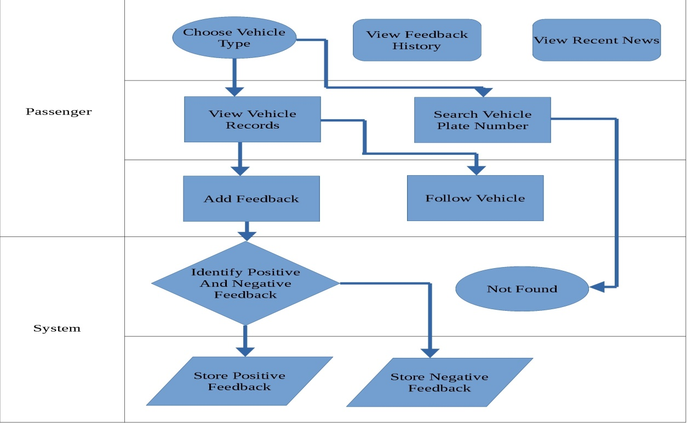**Figure 1 -** Swimlane Diagram for Passenger Feedback System

**4.2 Analysis and Design**

**4.2.1 Use-Case Diagram**

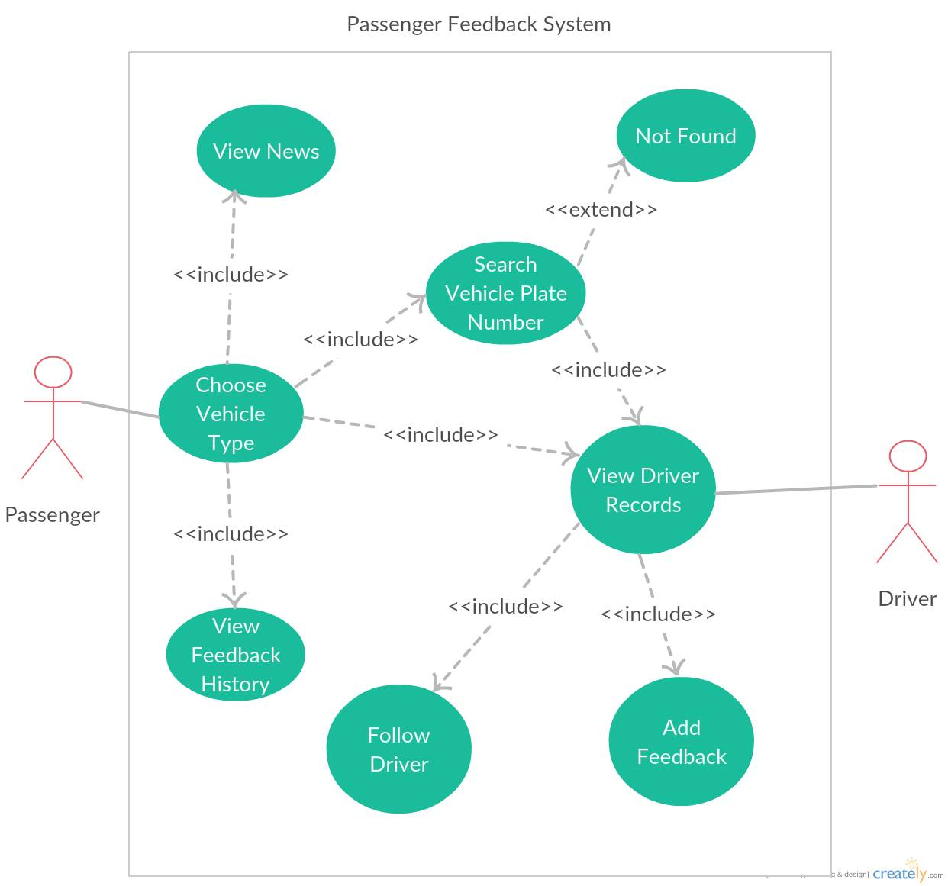**Figure 2 –** Use Case Diagram for Passenger Feedback System

|  |  |
| --- | --- |
| **Case** | **Description** |
| 1.) Choose Vehicle Type | The passenger can choose a vehicle type (Taxi, Bus, Jeep,& Van). |
| 2.) View News | The passenger can view the recent news within its local city through RSS Feed. |
| 3.) View Feedback History | The passenger can view all the feedbacks he/she added to the vehicle. |
| 4.) Search Vehicle Plate Number | The passenger can search vehicle plate number vary on its vehicle type. |
| 5.) Not Found | If the passenger inputs invalid vehicle plate number or vehicle number does not exist. |
| 6.) View Vehicle Records | The passenger can view the vehicle records so he/she will be aware of what kind of vehicle he/she is riding. |
| 7.) Follow Vehicle | The passenger can follow the vehicle he/she can view the recent feedbacks of the other people within the passenger’s profile. |
| 8.)Add Feedback | The passenger can add a feedback to a specific vehicle whether it’s positive or negative. |

**Table 1 –** Use Case Main Functionalities and it’s description

**4.2.2 Entity Relationship Diagram**

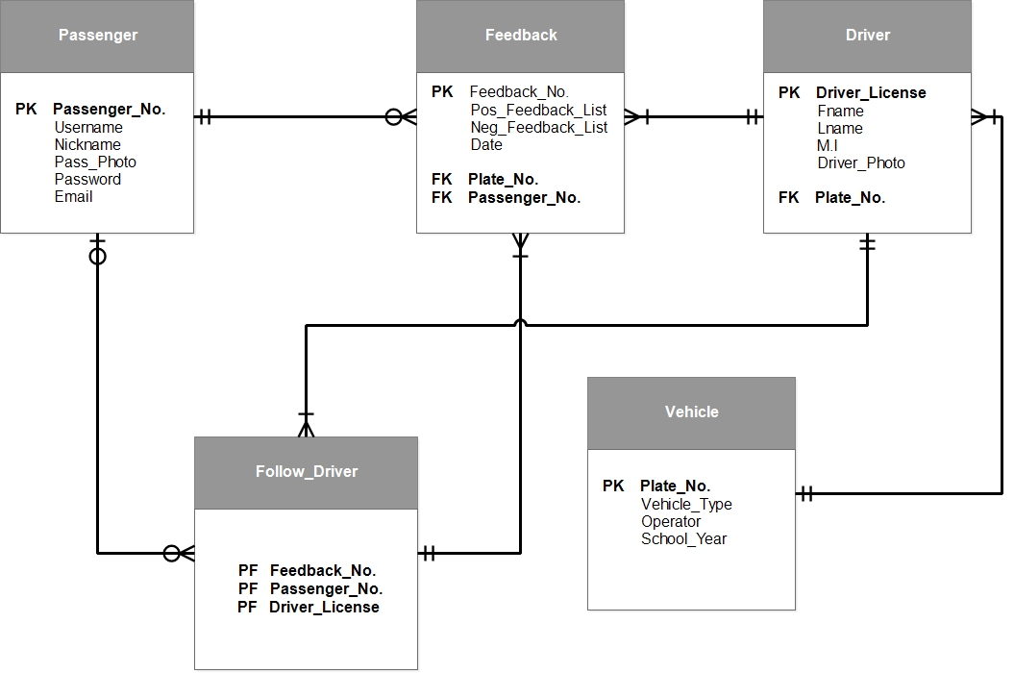

**Figure 3 –** Entity Relationship Diagram for Passenger Feedback System

**4.3. Development Model**

The researchers chose the Waterfall Methodology because it gave a direction to the linear - sequential life cycle. It allows for departmentalization and control. A schedule can be set with deadlines for each stage of development and a product can proceed through the development process model phases one by one.

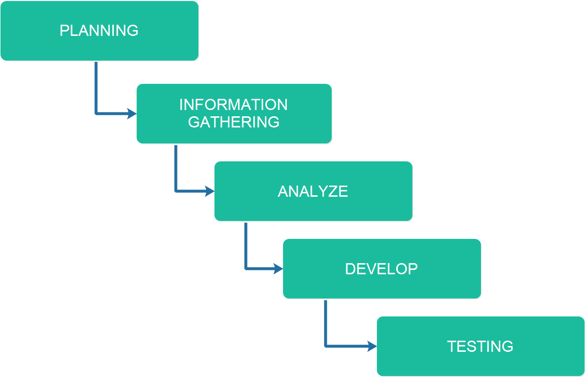

**Figure 4 –** Waterfall Methodology for Passenger Feedback System

**Development 1. Planning**

This is where the researchers create brainstorming for constructing an idea of startup system. This is the phase where the researchers decided a system.

**Development 2. Information Gathering**

The Information Gathering is where the researcher’s research for the related system to get some thoughts that can acquire to be used in the development of the system.

**Development 3. Analyze**

The gathered information were analyzed and evaluated the documents that contains information for the development of the system.

**Development 4. Develop**

The researchers started the coding of the back – end and the front – end. This is where the researchers develop the system’s functionalities and modules as stated in the documents.

**Development 5. Testing**

This is where the developers tested and evaluated the system. The developers gave comments and recommendations to the researchers for revision purposes. If there are bugs and errors encountered, it can be identified easily and would be corrected immediately.

**4.4. Development Approaches**

Planning is the process of thinking where the researchers create brainstorming for deciding a startup system and to achieve a desired goal. UI Design phase, thinking and creating design drafts for the system that are suitable of the expected outcome from the researchers and it will be evaluated to determine the effectiveness and uses of the system then produce documents that are appropriate for developing the system. The implementation will follow for providing functionalities and modules of the system that are needed to be applied. Then will develop and test the system where we put all of this given phases that produce a good quality output.

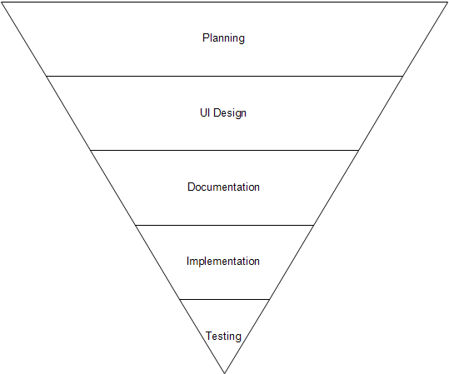

**Figure 4 –** Top-down Model for Passenger Feedback System

**4.5. Software Development Tools**

|  |  |  |  |
| --- | --- | --- | --- |
| **Name** | Version | Source | Use |
| Android Studio | 2.1 | https://developer.android.com/studio.com | System’s Framework |
| Vysor | 1.2.9 | http://www.vysor.io/ | Displays Android phone in a window on the computer |
| JAVA | JAVA 7 | https://java.com/ | Language used to code the system |
| JAVA SE Development Kit | 8 | http://www.oracle.com | Develop and deploy Java applications |
| XAMMP | 5.5.38 | https://www.apachefriends.org/index.html | For Database Connectivity |
| SQLite | 3.14.2 | https://www.sqlite.org/ | For Database Implementation |

**Table 2 –** Software Development Tools for Passenger Feedback System

**4.6 Project Management**

**4.6.1 Schedule and Timeline**

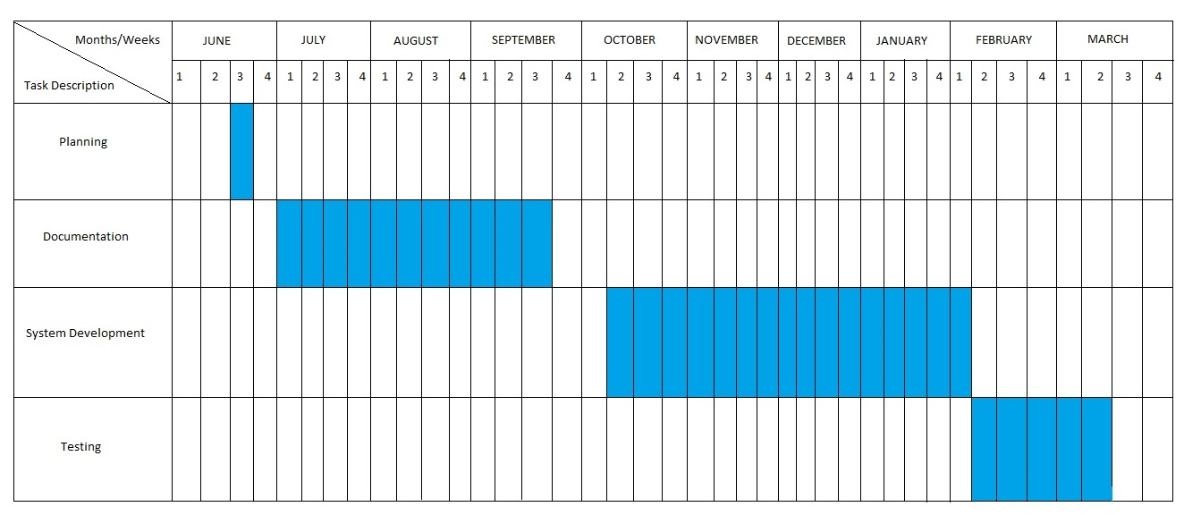

**Table 3 –** Schedule and Timeline for Passenger Feedback System

**4.6.2 Responsibilities**

This table shows the responsibilities and tasks for each of the member.

|  |  |  |  |
| --- | --- | --- | --- |
|  |  | **ESTIMATED** | |
| **TASK** | **ASSIGNEE** | **START DATE** | **FINISH DATE** |
| Documentation | Amit, Gula,  Melchor,  Ybañez | 01-Jul | 30-Sep |
| Android System UI Design | Amit  Melchor | 15-Aug | 19-Aug |
| Web-Admin Webpage UI Design | Amit  Gula | Nov | Nov |
| Database Implementation | Amit  Ybañez | Nov | Nov |
| Web-Admin Development: Front-End | Amit,  Melchor,  Ybañez | Nov | Nov |
| Web-Admin Development: Back-End | Amit,  Gula,  Melchor | Nov | Dec |
| Android Application Development: Front-End | Amit,  Melchor | Dec | Dec |
| Android Application Development: Back-End | Amit, Gula,  Melchor,  Ybañez | Dec | Jan |

**Table 4 –** Responsibilities for Passenger Feedback System

**4.6.3 Budget and Cost Management**

|  |  |
| --- | --- |
| **ITEM** | **COST** |
| TRAVEL COST | 5000 |
| PRINTING & FEES | 2000 |
| BOND PAPERS | 500 |
| OTHER MISCELLANEOUS | 1500 |
| TOTAL | 9000 |

**Table 5 –** Budget and Cost Management for Passenger Feedback System

**4.7. Verification, Validation and Testing**

The IT Professionals is the one who will take a look to verify if the system has been accomplished to its requirements, to confirm if the system is totally working and to test if the system is ready to execute.

Black-box testing is a method of software testing that examines the functionality of an application without peering into its internal structures or workings. In this event the one we will give a test is the proponents. The proponents are the one who is most familiar and aware of the system. Each module and functionalities is tested to see errors and bugs of the system.

User Acceptance Testing is also known as beta testing, application testing or end user testing. It consists of a set of test steps, which verify if specific requirements are working for the user. In this case we let our client test our system to assure the proposed functionalities and modules are properly executed.

**REFERENCES**

1. ) Beard, R. (2014, September 29). 6 reasons why customer feedback is important to your business. Retrieved July 13, 2016, from <http://blog.clientheartbeat.com/why-customer-feedback-is-important/>
2. ) Indian applicant files patent application for instant customer feedback system and method thereof. (2016, Feb 16). Indian Patents News Retrieved from [http://search.proquest.com.ezproxy.usc.edu.ph/docview/1765327253?acc ountid=50192](http://search.proquest.com.ezproxy.usc.edu.ph/docview/1765327253?accountid=50192)
3. ) Newhouse, B. (1997). Customer feedback as a catalyst for change. Strategy & Leadership, 25(3), 60. Retrieved from [http://search.proquest.com.ezproxy.usc.edu.ph/docview/194373951?acco untid=50192](http://search.proquest.com.ezproxy.usc.edu.ph/docview/194373951?accountid=50192)
4. ) Wirtz, J., Tambyah, S. K., & Mattila, A. S. (2010). Organizational learning from customer feedback received by service employees. Journal of Service Management, 21(3), 363-387. d oi:http://dx.doi.org/10.1108/09564231011050814
5. ) Sampson, S. E. (1998). Gathering customer feedback via the internet: Instruments and prospects. Industrial Management & Data Systems, 98(2), 71-82. Retrieved from [http://search.proquest.com.ezproxy.usc.edu.ph/docview/234921157?acco untid=50192](http://search.proquest.com.ezproxy.usc.edu.ph/docview/234921157?accountid=50192)
6. ) Stelzer, A., Englert, F., Hörold, S., & Mayas, C. (2016). Improving service quality in public transportation systems using automated customer feedback. Transportation Research Part E: Logistics and Transportation Review, 89, 259–271. doi:10.1016/j.tre.2015.05.010
7. ) Huang, Y., Wang, Y., & White, C. (2014). Designing a mobile system for public safety using open crime data and crowdsourcing. . doi:10.1145/2638728.2638762
8. ) Peng, L., & Zhang, M. (2009). An empirical study of social capital in participation in online Crowdsourcing. . doi:10.1109/ICEEE.2010.5660804
9. ) Xu, Q., Huang, Q., & Yao, Y. (2012). Online crowdsourcing subjective I mage quality assessment. . doi:10.1145/2393347.2393400

10.) Koch, G., Füller, J., & Brunswicker, S. (2011). Online Crowdsourcing in the public sector: How to design open government platforms. In Online Communities and Social Computing (pp. 203–212). doi:10.1007/978-3- 642-21796-8_22

1. ) Edvardsson, B. (1998). Causes of customer dissatisfaction - studies of public transport by the critical-incident method. Managing Service Quality: An International Journal, 8(3), 189–197. doi:10.1108/09604529810215675
2. ) Schmidt, M. G. (2013). Real-time feedback methods for gait rehabilitation through a mobile platform (Order No. 1535101). Available from ProQuest Dissertations & Theses Global. (1324127826). Retrieved from [http://search.proquest.com.ezproxy.usc.edu.ph/docview/1324127826?acc ountid=50192](http://search.proquest.com.ezproxy.usc.edu.ph/docview/1324127826?accountid=50192)
3. ) Dellarocas, C. (2003). The Digitization of word of mouth: Promise and challenges of online feedback mechanisms. Management Science, 49(10), 1407–1424. doi:10.1287/mnsc.49.10.1407.17308
4. ) Hutton, K. A., Sibley, C. G., Harper, D. N., & Hunt, M. (2001). Modifying driver behaviour with passenger feedback. Transportation Research Part F: Traffic Psychology and Behaviour, 4(4), 257–269. doi:10.1016/S1369- 8478(01)00027-4
5. ) Ruge, D., Negovan, M., & Pisani, R. (2005). U.S. Patent Application No. 11/207,219.

16.) Lee, D., Jeong, O. R., & Lee, S. G. (2008, January). Opinion mining of customer feedback data on the web. In Proceedings of the 2nd international conference on Ubiquitous information management and communication (pp. 230-235). ACM.

1. ) Jenkins, P. C., Deal, D. V., Cuthbertson, T. G., Morton, J. W., Smith, A. D., Hoy, D. R., & Egeberg, G. W. (2001). U.S. Patent No. 6,253,129. Washington, DC: U.S. Patent and Trademark Office.
2. ) Ousborne, J. (1996). U.S. Patent No. 5,499,182. Washington, DC: U.S. Patent and Trademark Office.
3. ) Douros, K., Gardner, J. L., Gardner, R. M., Hurwitz, J. B., Leivian, R. H., Nagel, J., ... & Wood, C. A. (2005). U.S. Patent No. 6,909,947. Washington, DC: U.S. Patent and Trademark Office.

20.) Wallin Andreassen, T. (1995). (Dis)satisfaction with public services: The case of public transportation. Journal of Services Marketing, 9(5), 30–41. doi:10.1108/08876049510100290