**PUBLIC VECHICLE COMPLAINT MANAGEMENT SYSTEM**

A Capstone Project

Presented to the Faculty of the

Department of Computer and Information Sciences

University of San Carlos

Cebu City, Philippines

In Partial Fulfillment

of the Requirements for the Degree

BACHELOR OF SCIENCE IN INFORMATION COMMUNICATIONS TECHNOLOGY

By

JOHN MARK M. AMIT

JOSE MARIA A. GULA

ALEC JOB A. MELCHOR

VANVAN YBAÑEZ

CHRISTIAN V. MADERAZO

Faculty Adviser

October 14, 2016

**ABSTRACT**

As public transportation vehicles are rapidly increasing, uncorrected and careless public vehicle drivers who commit misconduct nowadays greatly affect the population of commuters and fellow drivers. This uncontrolled issue affects public transport quality and reputation. Convenient and reliable public transport for the people is an essential part of everyday living. The purpose of this project is to make a public vehicle complaint system that gathers the complaint of the people that are involved in a public vehicle incident or witnessed a misconduct behavior of that public vehicle through a mobile application. The complaint fields will be based on the survey of the public’s common public vehicle violation and LTO’s common violations list. The gathered data or the records will be seen statistically by the operators and responsible authorities through a web application to evaluate or take action to the public vehicle driver. The results could lead to the awareness of the public vehicle operators if their records contain numerous complaint or negative feedbacks. The results can also be generated to a report in order to keep a hard copy and make it as evidence.

**TABLE OF CONTENTS**

**ABSTRACT ......................................................................................................... ii**

**TABLE OF CONTENTS...................................................................................... iii**

**LIST OF FIGURES ............................................................................................. iv**

**LIST OF TABLES .................................................................................................v**

**CHAPTER 1 INTRODUCTION .............................................................................1**

**1.1 Rationale of the Study........................................................................1**

**1.2 Statement of the Problem...................................................................2**

**1.2.1 General Objective .................................................................2**

**1.2.2 Specific Objectives ..............................................................2**

**1.3 Significance of the Study...................................................................2**

**1.4 Scope and Limitations .......................................................................3**

**1.4.1 Scope …………………………………………………………….3**

**1.4.2 Limitations ………………………………………………………3**

**CHAPTER 2 RELATED SYSTEMS......................................................................4**

**CHAPTER 3 TECHNICAL BACKGROUND............................................…........12**

**CHAPTER 4 DESIGN AND METHODOLOGY...................................................13**

**4.1Conceptual Framework.....................................................................13**

**4.2 Analysis and Design.........................................................................14**

**4.2.1 System Flow …………………………..…….…………………14**

**4.2.2 Use-Case Diagram ………………………..………….……….15**

**4.2.3 Entity Relationship Diagram ………………………………..17**

**4.3 Development Model ...........................................................…...........18**

**4.4 Development Approach ...................................................................20**

**4.5 Software Development Tools ..........................................................21**

**4.6 Project Management.........................................................................22**

**4.6.1 Schedule and Timeline.......................................................22**

**4.6.2 Responsibilities...................................................................22**

**4.6.3 Budget and Cost Management...........................................23**

**4.7 Verification, Validating and Testing..................…...........................23**

**REFERENCES…………………………………....…………………………………...24**

**LIST OF FIGURES**

**Figure 1: Conceptual Framework ..………………………………………..…..…13**

**Figure 2: System Flow……...…...……...…………………………………………..14**

**Figure 3: Use-Case Diagram………………………………………………..……...15**

**Figure 4: Entity Relationship Diagram …..……………………………….……...17**

**Figure 5: Waterfall Model ……………………………………………………..…...18**

**Figure 6: Top-down Model ………………………………………………………...20**

**LIST OF TABLES**

**Table 1: Use Case Main Functionalities and it’s description ………….….....16**

**Table 2: Software Development Tools …………………………………………..21**

**Table 3: Schedule and Timeline ………………………………………...………...22**

**Table 4: Responsibilities ………………………………………………...…………22**

**Table 5: Budget and Cost Management …………………………………………23**

**CHAPTER 1**

**INTRODUCTION**

* 1. **Rationale of the Study**

Public transportation are commonly used here in the Philippines and issues about it are rampant. There are numerous public vehicle drivers violate traffic rules and perform misconduct to either his passengers or the crowds that are nearby. Obviously, each and every incidence is not reported directly to the police. These issues lead to reduced public transportation reputation for the people and also tourists from foreign places. With these issues disregarded and ignored, drivers will continue to cause problems to public transport that will affect the public transportation quality greatly which can also affect the tourism of the country. Social media is mostly used to hear the complaints of the people that are involved in a public transport vehicle incident which is not due process. It can only make several people aware of that public vehicle. However, there are also good experiences of the commuters with the public transport vehicle services. The complaints of the people are important so the responsible authorities can take immediate action about the incident depends on its nature.

Collection of data using crowdsourcing is popular method to get the complaints or negative feedback from the end-user. Crowdsourcing will be used by the system to collect complaints from the commuters and the people involved in an incident that could also be used to determine the rating of that public transport through an android application. In addition, the data gathered will be obtained by the operators through a web application. Data gathered from the mobile application users will benefit responsible law enforcement authorities to act and impose discipline to responsible public vehicle drivers that has numerous complaints from the commuters or any people involved in that incident. Moreover, this system can improve the tourism here in Cebu City and other cities that will adopt in this system.

**1.2 Statement of the Problem**

There are numerous events in which they encounter misbehavior and undesirable actions from public vehicle drivers be it commuters or passengers and fellow drivers. Verbal complaints and feedback on these issues have little corrective effect. Leading to no immediate actions intended to correct or improve the situation.

**1.2.1 General Objective**

The main objective of this project is to develop a public vehicle complaint management system.

**1.2.2 Specific Objectives**

This project intends to:

1. Determine common complaints and violations regarding public vehicles.
2. Design a mobile-based complaint submission.
3. Design a complaint handling web application.
4. Develop a public vehicle complaint management system.
5. Test and evaluate the system.

**1.3 Significance of the Study**

This project will benefit the following:

**Complainant**. With this system, the people can easily give complain to that public vehicle without getting a form from a traffic officer or going to a government site.

**Operator.** The operator can easily assess the public vehicle driver whether the driver will be replaced or not.

**LTFRB and LTO**. These government agencies can do anything with the information or records shown in the system whether they will reveal it to the public via news or take action to those operators that its public vehicle has many negative feedbacks or complaints.

**Other Researchers**. Researchers may vary their ideas by observing and evaluate this system to develop an idea and to apply for their upcoming research study.

**1.4 Scope and Limitation**

**1.4.1 Scope**

The system allows the complainant to add a complaint to a certain vehicle using a mobile phone. The operator can manage vehicles and drivers, view complaint records submitted to the database and can generate it to a report. The system allows and LTFRB (super admin) can view the overall records of the complaint. Moreover, LTO and LTFRB can view and manage the operators of the system.

**1.4.2 Limitations**

Only android smartphones can run this application and smartphones without internet connection cannot submit complaints. Only common violations and common public complaints are listed in the system.

**CHAPTER 2**

**RELATED SYSTEMS**

Customer Feedback is defined as “a marketing term that describes the process of obtaining a customer’s opinion about a business, product or service” (Beard, 2014). In addition, It can help to identify problem areas and strengths, and generate ideas for service improvements (Wirtz, Tambayah, & Matilla, 2010). Though a feedback can be a positive or negative. “Customer feedback is so important because it provides marketers and business owners with insight that they can use to improve their business, products and/or overall customer experience” (Beard, 2014). The companies usually collect feedback from the customers. The feedback can take many forms, including on-site customer complains, calls to toll-free customer-response phone numbers, and customer comment cards (Sampson, 1998). On the other hand, Customer feedback system helps an organization to put in place a continuous customer feedback monitoring process and in particular, this system relates to an instant Customer Feedback System of receiving, storing, and delivering customer comments, including qualitative and quantitative feedback, over a communication network such as the Internet (,2016). Companies that are known for their tradition in using customer feedback share two important features: 1. They use customer feedback to drive organizational change. 2. They support the customer-feedback process by a strong and centralized function. Their customer-satisfaction measurement system is based on validated customer-satisfaction drivers. Their excellent use of customer feedback takes a combination of strong individuals, exceptional teamwork, and relentless executive leadership (Newhouse,1997).

**Improving service quality in public transportation systems using automated customer feedback**

One of the existing researches focusing on public transportation feedback is the Transportation Research Part E: Logistics and Transportation Review (Stelzer, Englert, Hörold, & Mayas, 2016). It highlights the approach to include customer feedback into transport operations and analyze the effects of customer feedback on service quality. In this research the need for standardized automated information exchange between travellers and transportation company is evaluated to improve the service quality of public transport. Therefore the needs and expectations of transportation companies and travellers are defined and the usage of a novel approach for bidirectional information and communication systems in public transport is proposed.

**Designing a mobile system for public safety using open crime data and crowdsourcing**

In the UbiComp ‘14 Adjunct publication pages 67-70 it is highlighted that exploring ways to improve public safety of the society by using open crime data and crowdsourcing (Huang, Wang, & White, 2014). The results suggest that both time of day and type of location significantly affect people's sharing decisions. These insights change our system to force people to report safety related information timely.

**An Empirical Study of Social Capital in Participation in Online Crowdsourcing**

Online crowdsourcing has become a new innovation business model through the Internet. This paper studied the motives of the use of online crowdsourcing and the social capital in its community. The results show that learning, direct compensation, self-marketing and social motives are causes to activate the participation in outsourcing activities. (Peng & Zhang, 2009)

**Online crowdsourcing subjective image quality assessment**

With the random design on large graphs, it is specifically suitable for large scale crowdsourcing researches on the Internet. To make it more practical toward this intention, it is necessary to develop online algorithms to deal with successive or streaming data (Xu, Huang, & Yao, 2012).

**Online Crowd sourcing in the Public Sector: How to Design Open Government Platforms**

This study finds that internet-based crowdsourcing have changed how government bodies operate. It allows new voluntary problem solving and quality check processes nowadays. This study investigates if crowdsourcing platforms can be applied in the government. Results also show that crowdsourcing can somehow produce interest among the people that may serve as a source of reliable input. (Koch, Füller, & Brunswicker, 2011)

**Causes of customer dissatisfaction studies of public transport by the critical incident method**

This study focuses on customer dissatisfaction by targeting the source of the dissatisfaction and complaints. This study gathered data from written complaints and customer interviews. Concludes that quality drawbacks are in most cases frequent. Suggests that driver related aspects should be included. (Edvardsson,1998)

**Real-time feedback methods for gait rehabilitation through a mobile platform**

Computing and data acquisition has become a very important part of everyday life. From reading emails on cell phones, to kids playing with motion sensing game consoles, we are surrounded with sensors and mobile devices. As the availability of powerful mobile computing devices expands, the road is paved for applications in previously limited environments. Rehabilitative devices are emerging that embrace these mobile advances. Research has explored the use of smartphones in rehabilitation as a means to process data and provide feedback in conjunction with established rehabilitative methods. Smartphones, combined with sensor embedded insoles, provide a powerful tool for the clinician in gathering data and may act as a standalone training technique. Schmidt, M. G. (2013).

**The Digitization of Word of Mouth: Promise and Challenges of Online Feedback Mechanisms**

Online feedback mechanisms utilize multiple communication capabilities of the Internet to create large-scale, word-of-mouth networks. Best known as a technology for building trust and promoting cooperation in online marketplaces, such as eBay, these mechanisms are effective to have a much wider impact on organizations. Their growing popularity has potentially important goals for a wide range of management activities such as brand building, customer acquisition and retention, product development, and quality assurance. (Dellarocas, 2003)

**Modifying driver behaviour with passenger feedback**

A feedback program was utilized to help drivers improve their safety behaviour based on the idea that precise types of driver error result from probability traps as defined by Fuller [Journal of Applied Behaviour Analysis, 24 (1991) 73]. Two drivers and their single respective passengers participated. For each driver, repeated in-car observations were made of four unsafe driving behaviours. Two of these were sequentially targeted in the behavioural interruption that involved the passengers providing informational feedback to their driver. Both drivers showed a marked improvement across the targeted behaviours. The study demonstrated the application of behaviour analysis to the traffic domain and the efficacy of individual feedback as a behavioural tool for positive behaviour modification. (Hutton, Sibley, Harper, & Hunt, 2001)

**System and method for providing a unified customer feedback solution**

A method for providing a system for allowing businesses to manage substantially all of their customer relations and feedback on a computer network via a Customer Feedback System. This method allows to gather the customer feedbacks and to provide high quality customer service using a computer transmission medium. The Customer Feedback System resides on a web server and is used to solicit customer feedback and provide customer support and other information to a business’s customers via the internet. In this system the feedback of the customer is essential for providing various aspects of customers relations as well as strong support for security, customizability, and optimal performance. (Ruge ,Negovan, & Pisani, 2007)

**Opinion mining of customer feedback data on the web**

As people leave on the Web their opinions on products and services they have used, it has become important to develop methods of (semi-)automatically classifying and gauging them. The task of analyzing such data, collectively called customer feedback data, is known as opinion mining. Opinion mining consists of several steps, and multiple techniques have been proposed for each step. In this paper, we survey and analyze various techniques that have been developed for the key tasks of opinion mining. On the basis of our survey and analysis of the techniques, we provide an overall picture of what is involved in developing a software system for opinion mining. (Lee, Jeong, & Lee, 2008)

**System for monitoring vehicle efficiency and vehicle and driver performance**

A commercial vehicle fleet management system which integrates a vehicle on-board computer, a precise positioning system, and communication system to provide automated calculating and reporting of jurisdictional fuel taxes, road use taxes, vehicle registration fees. It is to be used in conjunction with miles traveled, gas mileage, and a database stored in memory which contains information such as jurisdictional boundaries to correlate vehicle path with border crossing events as vehicle crosses jurisdictional borders, thereby automating the calculation and reporting of fuel tax appointment among various jurisdictions may likewise be computed and reported. It employs position information and geographical database information to calculate and automate vehicle operator logs, operator payroll, hours on service compliance. In this system the position of the vehicle is shown in the satellite to monitor its path and the drivers performance is evaluated accordingly. (Jenkins , 2001)

**Vehicle driver performance monitoring system**

Driver performance monitoring system is generally directed to an onboard computer system for operation on a designated host vehicle. More specifically, the vehicle driver performance monitoring system is an onboard computer system which has in place the hardware and software means to sense various vehicle operation parameters, characterize the driving habits of the current driver based on those parameters with respect to various specific determinants,  In this system it monitors the driving performance to control the driving habits and preserve the health and safety of the occupants of other automobiles. (Ousbornen, 1996)

**System and method for driver performance improvement**

A system is adapted to assess information incoming to a vehicle operator, to prioritize the information based upon a number of conditions relating to the vehicle operation, the operating environment, the activity of the operator and the physical condition of the operator, and to provide to the operator the most pertinent information for the given set of conditions. As used throughout this specification, the terms vehicle operator and driver are used interchangeably and each are used to refer to the person operating the vehicle in the manner in which the vehicle is intended to be operated. This system monitors various data sources, including the vehicle operation, the operating environment, the activity and condition of the operator, over  a period of operation and records the operator’s performance. The performance may be compared with accepted good practices, and a report may be provided to the operator indicating how the operator's performance compares with the accepted good practices and with the operator's previous driving performance and habitual behavior. The system may record operator performance over a number of periods of operation, and provide comparisons of operator performance from period to period. (Douros, 2005)

**LTO’s COMMON VIOLATIONS**

**Ordinance no. 172**

Art. VI, Sec 1(a) Driving w/ indecent attire

Art VI, Sec 1(b) Stereo ban

Art VI, Sec 1(c) Smoking ban

Art VI, Sec 1(d) DTS No Entry

Art VI, Sec 1(e) DTS No U-Turn

Art VI, Sec 1(f) DTS Go Signal

Art VI, Sec 1(g) DTS Stop Signal

Art VI, Sec 1(h) Crossing Solid Line

Art VI, Sec 1(i) DTS Left Turn

Art VI, Sec 1(j) U-Turn in Business Intersection

Art VI, Sec 1(k) Driving Left

Art VI, Sec 1(l) Parallel Parking Opposite Direction

Art VI, Sec 1(m) Parking on Sidewalk

Art VI, Sec 1(n) Parking at Sidewalk

Art VI, Sec 1(o) Parking at Intersection

Art VI, Sec 1(p) Double Parking on cross walk

Art VI, Sec 1(q) Parking on PUJ Stop

Art VI, Sec 1(r) Defective tail light/ brake light

Art VI, Sec 1(t) Defective Head light

Art VI, Sec 1(u) Obstruction due disabled vehicle

Art VI, Sec 1(v) No crash helmet

Art VI, Sec 1(w) Disobedience to traffic enforcers

Art VI, Sec 1(x) Disobeying Flag ceremony

Art VI, Sec 1(y) Loading sand and gravel w/o cover

Art VI, Sec 1(z) Double back ride tricycle

**Ordinance. No. 299-97**

Not driving in the designated lane

**Chapter 3**

**TECHNICAL BACKGROUND**

**Web application**

**Laravel.** A free open source PHP web framework that is intended for the development of web applications following model-view-controller (MVC) architectural pattern. Many inbuilt functions and infrastructure to access database, migrations, models and testing.

**MySQL**. Is a relational database management system. MySQL is a popular choice of database use in web applications, and is a central component of the widely used LAMP open source web application software stack. LAMP is an acronym for “GNU/Linux, Apache, MySQL, Perl/PHP/Python”.

**Bootstrap**. Is the most popular HTML, CSS, and JavaScript framework for developing responsive, mobile-first web sites.

**Mobile Application**

**Android Operating System.** Is a mobile operating system developed by Google. It is used by several smartphones and tablets. It is an open source, meaning developers can modify and customize the OS for each phone. (Christensson, 2016).

**Android Studio**. Is the official Integrated Development Environment (IDE) for Android platform development. It offers more features that will enhance productivity when building Android apps, such as a flexible Gradle-based build system, fast and feature-rich emulator and a unified environment.

**Global Positioning System.** is a series of satellites owned by the US government that broadcasts signals that **GPS** receivers on the surface of the planet can use to determine position through triangulation.

**CHAPTER 4**

**DESIGN AND METHODOLOGY**

**4.1 Conceptual Framework**

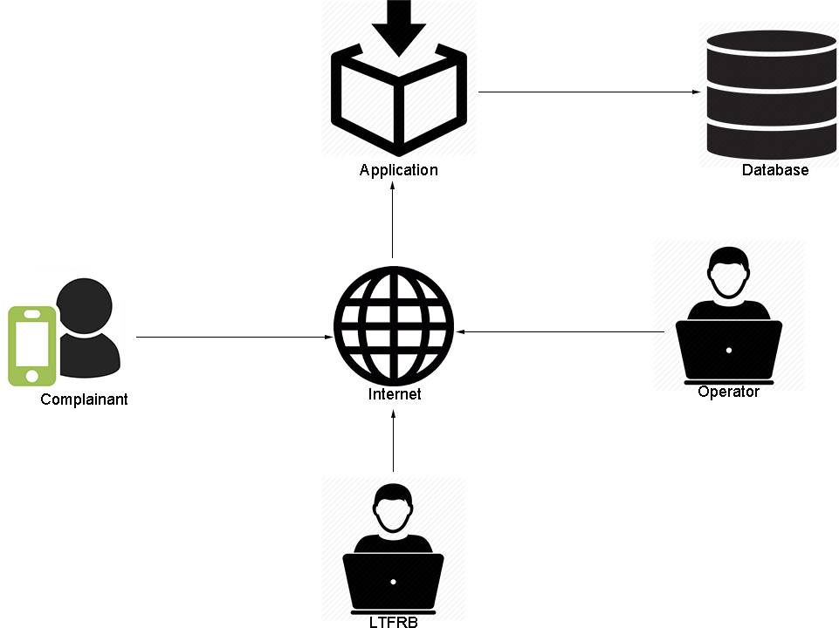

**Figure 1 -** *Public Vehicle Complaint Management Conceptual Framework*

**4.2 Analysis and Design**

VIEW OVERALL RECORDS

VERIFIED COMPLAINTS

GENERATE REPORT

MANAGE OPERATORS

DATABASE

OPERATOR

MANAGE VEHICLE DRIVER

MANAGE VEHICLES

VIEW RECORDS

LTFRB

**4.2.1 System Flow**

**Figure 2 -** *Public Vehicle Complaint Management System Flow*

FILTER VEHICLE W/ AND W/O OPERATOR

ADD COMPLAINT

INPUT INFORMATION REQUIRED

COMPLAINANT

**4.2.2 Use-Case Diagram**

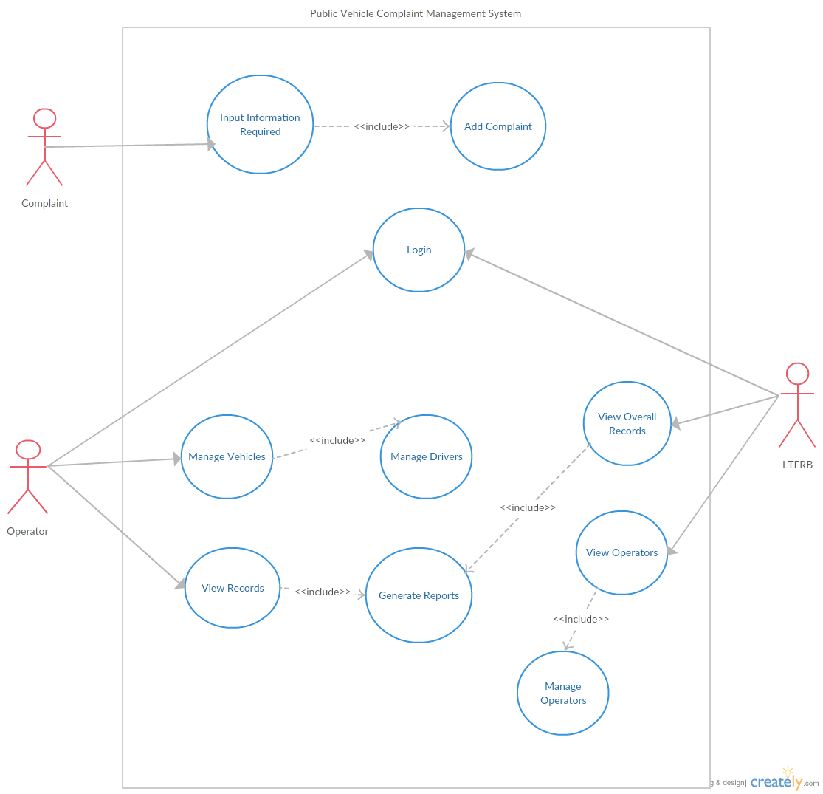**Figure 3 –** *Use Case Diagram for Public Vehicle Complaint Management System*

**Table 1 - Use-Case List of Flows**

|  |  |  |
| --- | --- | --- |
| **Use Case Name** | **Description** | **Actor** |
| Input Information Required | When the application starts, the user needs to fill-up all the required fields. | Complainant |
| Add Complaint | The user can add a complaint based on common LTO violations and common public complaints based on a survey. |
| Manage Vehicles | The operator can add and delete vehicles | Operator |
| Manage Drivers | The operator can add, remove and edit drivers in the system. |
| View Records | The operators can view their vehicle’s verified complaints. |
| Generate Reports | The operators and LTFRB can generate statistical reports from the verified complaints. | Operator, LTFRB |
| Log In | The operators and the LTFRB can log in with their assigned accounts. |
| View Overall Records | The LTFRB can view all the vehicle records: vehicles with operators and those without operators | LTFRB |
| View Operators | The LTFRB can view existing public vehicle operators |
| Manage Operators | The LTFRB can add, delete and update existing operators |

**4.2.3 Entity Relationship Diagram**

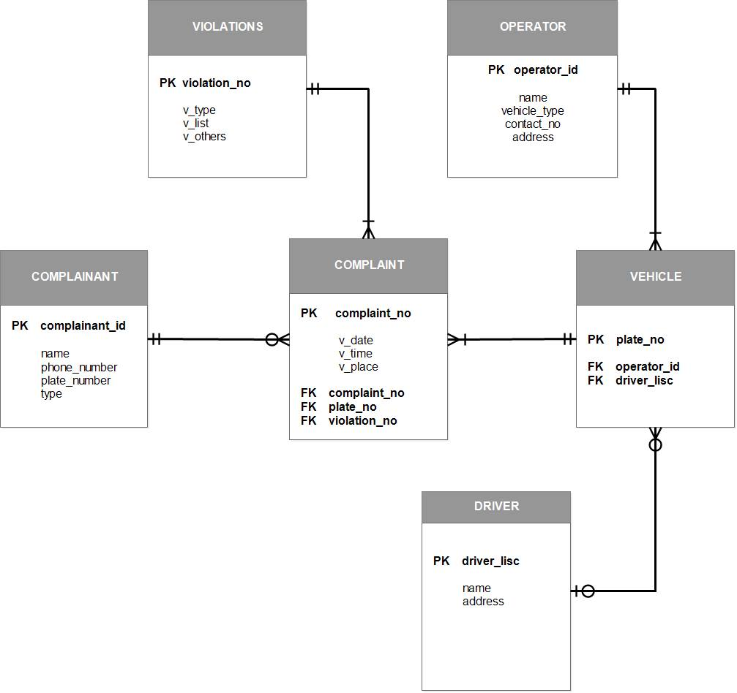

**Figure 4 –** *Entity Relationship Diagram for Public Vehicle Complaint Management System*

**4.3. Development Model**

The researcher has chosen the Waterfall Methodology because it gave a direction to the linear - sequential life cycle. It allows for departmentalization and control. A schedule can be set with deadlines for each stage of development and a product can proceed through the development process model phases one by one.

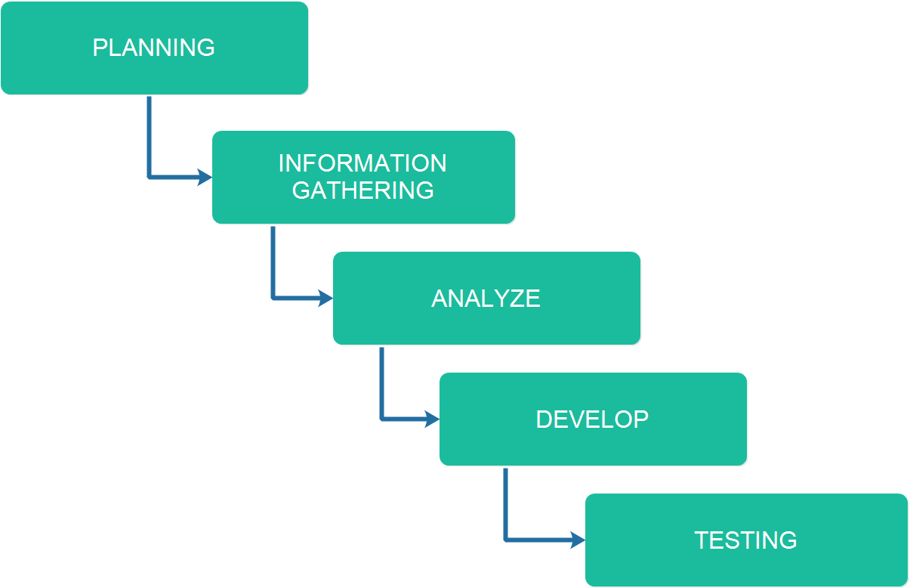

**Figure 5 –** *Waterfall Methodology for Public Vehicle Complaint Management*

*System*

**Development 1. Planning**

This is where the researchers brainstorm for building an idea of a startup system. The researchers also picture out the design of the system by using their combined ideas.

**Development 2. Information Gathering**

The Information Gathering is where the researchers will search for the related system that supports in the development of the system. In this way, the researchers will get some ideas from the related systems and will be implemented in the system when in development method.

**Development 3. Analyze**

The gathered information will be analyzed and evaluated from the document for the development of the system. This is where the researchers will make the system flowchart.

**Development 4. Develop**

The researchers will start the coding of the back – end and the front – end. This is where the researchers develop the system’s functionalities and modules as stated in the documents.

**Development 5. Testing**

This is where the developers will test and evaluate the system. The developers will provide comments and recommendations to the researchers for revision purposes. If there are bugs and errors bump into, it will be identify easily and will be revise and change immediately.

**4.4. Development Approaches**

The approach used in this system is the top-down. The developers started with the user-interface design of the system. After the user-interface design the main modules will be started which are complaint and report modules.

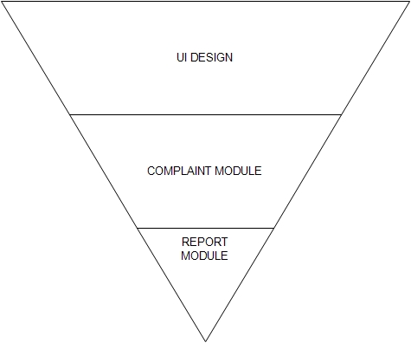

**Figure 6 –** *Top-down Model for Public Vehicle Complaint Management System*

The researchers used the top-down approach. UI Design is the base part of the triangle so that the researchers can view the full picture of the system. Followed by the complaint module which will be the android application of the system. After that followed by report module which will be used by the admin and super admin through a web application.

**4.5. Software Development Tools**

|  |  |  |  |
| --- | --- | --- | --- |
| **Name** | Version | Source | Use |
| Android Studio | 2.1 | https://developer.android.com/studio.com | System’s IDE |
| Vysor | 1.2.9 | http://www.vysor.io/ | Displays Android phone in a window on the computer. |
| JAVA | JAVA 7 | https://java.com/ | Language used to code the system. |
| JAVA SE Development Kit | 8 | http://www.oracle.com | Develop and deploy Java applications. |
| XAMMP | 5.5.38 | https://www.apachefriends.org/index.html | For Database Connectivity. |
| Laravel | 4.1 | https://laravel.com/ | Back – End Framework |
| phpMyAdmin | 4.6.4 | https://www.phpmyadmin.net/ | For Database Implementation |
| Bootstrap | 3.3.7 | http://getbootstrap.com/ | Front – End Framework |

**Table 2 –** *Software Development Tools for Public Vehicle Complaint Management System*

The tools shown in table 2 will be used in developing the system which composed of web application tools and mobile application tools.

**4.6 Project Management**

**4.6.1 Schedule and Timeline**

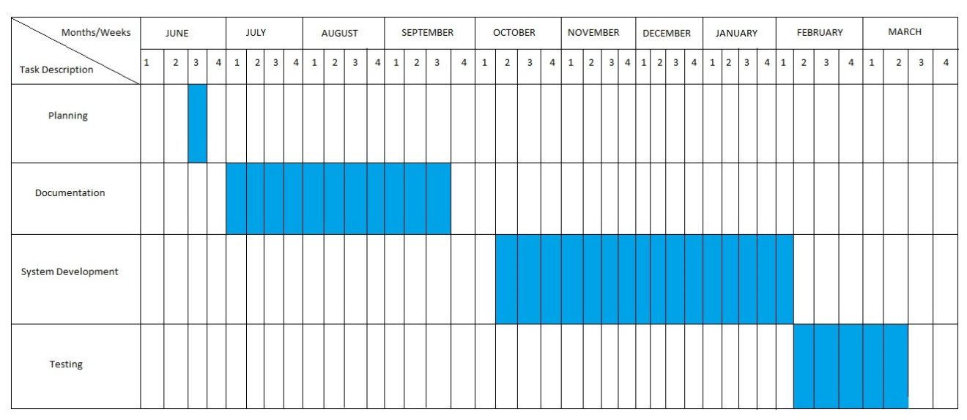

**Table 3 –** *Schedule and Timeline for Public Vehicle Complaint Management System*

**4.6.2 Responsibilities**

This table shows the responsibilities and tasks for each of the member.

|  |  |  |  |
| --- | --- | --- | --- |
|  |  | **ESTIMATED** | |
| **TASK** | **ASSIGNEE** | **START DATE** | **FINISH DATE** |
| Documentation | Amit, Gula,  Melchor,  Ybañez | 01-Jul | 30-Sep |
| Android System UI Design | Amit  Melchor | 15-Aug | 19-Aug |
| Web-Admin Webpage UI Design | Amit  Gula | Nov | Nov |
| Database Implementation | Amit  Ybañez | Nov | Nov |
| Android Application Development: Front-End | Amit,  Melchor, | Nov | Nov |
| Android Application Development: Back-End | Amit, Gula,  Melchor,  Ybañez | Nov | Dec |
| Web-Admin Development: Front-End | Amit,  Melchor,  Ybañez | Dec | Dec |
| Web-Admin Development: Back-End | Amit, Gula,  Melchor, | Dec | Jan |

**Table 4 –** Responsibilities for Public Vehicle Complaint Management System

**4.6.3 Budget and Cost Management**

|  |  |
| --- | --- |
| **ITEM** | **COST** |
| **Printing Fees** |  |
| Black & White (1x200 pages) | 200 |
| Colored (5x50 pages) | 250 |
| **Travel Cost** | 1000 |
| **Miscellaneous** | 600 |
| **Total Amount** | **2,050** |

**Table 5 –** *Budget and Cost Management for Public Vehicle Complaint Management System*

**4.7. Verification, Validation and Testing**

The IT Professionals is the one who will take a look to verify if the system has been accomplished to its requirements, to confirm if the system is totally working and to test if the system is ready to execute.

Black-box testing is a method of software testing that examines the functionality of an application without peering into its internal structures or workings. In this event the one we will give a test is the proponents. The proponents are the one who is most familiar and aware of the system. Each module and functionalities is tested to see errors and bugs of the system.

User Acceptance Testing is also known as beta testing, application testing or end user testing. It consists of a set of test steps, which verify if specific requirements are working for the user. In this case we let our client test our system to assure the proposed functionalities and modules are properly executed.

**REFERENCES**

Beard, R. (2014, September 29). 6 reasons why customer feedback is important to your business. Retrieved July 13, 2016, from <http://blog.clientheartbeat.com/why-customer-feedback-is-important/>

Indian applicant files patent application for instant customer feedback system and method thereof. (2016, Feb 16). Indian Patents News Retrieved from [http://search.proquest.com.ezproxy.usc.edu.ph/docview/1765327253?acc ountid=50192](http://search.proquest.com.ezproxy.usc.edu.ph/docview/1765327253?accountid=50192)

Newhouse, B. (1997). Customer feedback as a catalyst for change. Strategy & Leadership, 25(3), 60. Retrieved from [http://search.proquest.com.ezproxy.usc.edu.ph/docview/194373951?acco untid=50192](http://search.proquest.com.ezproxy.usc.edu.ph/docview/194373951?accountid=50192)

Wirtz, J., Tambyah, S. K., & Mattila, A. S. (2010). Organizational learning from customer feedback received by service employees. Journal of Service Management, 21(3), 363-387. d oi:http://dx.doi.org/10.1108/09564231011050814

Sampson, S. E. (1998). Gathering customer feedback via the internet: Instruments and prospects. Industrial Management & Data Systems, 98(2), 71-82. Retrieved from [http://search.proquest.com.ezproxy.usc.edu.ph/docview/234921157?acco untid=50192](http://search.proquest.com.ezproxy.usc.edu.ph/docview/234921157?accountid=50192)

Stelzer, A., Englert, F., Hörold, S., & Mayas, C. (2016). Improving service quality in public transportation systems using automated customer feedback. Transportation Research Part E: Logistics and Transportation Review, 89, 259–271. doi:10.1016/j.tre.2015.05.010

Huang, Y., Wang, Y., & White, C. (2014). Designing a mobile system for public safety using open crime data and crowdsourcing. . doi:10.1145/2638728.2638762

Peng, L., & Zhang, M. (2009). An empirical study of social capital in participation in online Crowdsourcing. . doi:10.1109/ICEEE.2010.5660804

Xu, Q., Huang, Q., & Yao, Y. (2012). Online crowdsourcing subjective I mage quality assessment. . doi:10.1145/2393347.2393400

Koch, G., Füller, J., & Brunswicker, S. (2011). Online Crowdsourcing in the public sector: How to design open government platforms. In Online Communities and Social Computing (pp. 203–212). doi:10.1007/978-3- 642-21796-8_22

Edvardsson, B. (1998). Causes of customer dissatisfaction - studies of public transport by the critical-incident method. Managing Service Quality: An International Journal, 8(3), 189–197. doi:10.1108/09604529810215675

Schmidt, M. G. (2013). Real-time feedback methods for gait rehabilitation through a mobile platform (Order No. 1535101). Available from ProQuest Dissertations & Theses Global. (1324127826). Retrieved from [http://search.proquest.com.ezproxy.usc.edu.ph/docview/1324127826?acc ountid=50192](http://search.proquest.com.ezproxy.usc.edu.ph/docview/1324127826?accountid=50192)

Dellarocas, C. (2003). The Digitization of word of mouth: Promise and challenges of online feedback mechanisms. Management Science, 49(10), 1407–1424. doi:10.1287/mnsc.49.10.1407.17308

Hutton, K. A., Sibley, C. G., Harper, D. N., & Hunt, M. (2001). Modifying driver behaviour with passenger feedback. Transportation Research Part F: Traffic Psychology and Behaviour, 4(4), 257–269. doi:10.1016/S1369- 8478(01)00027-4

Ruge, D., Negovan, M., & Pisani, R. (2005). U.S. Patent Application No. 11/207,219.

Lee, D., Jeong, O. R., & Lee, S. G. (2008, January). Opinion mining of customer feedback data on the web. In Proceedings of the 2nd international conference on Ubiquitous information management and communication (pp. 230-235). ACM.

Jenkins, P. C., Deal, D. V., Cuthbertson, T. G., Morton, J. W., Smith, A. D., Hoy, D. R., & Egeberg, G. W. (2001). U.S. Patent No. 6,253,129. Washington, DC: U.S. Patent and Trademark Office.

Ousborne, J. (1996). U.S. Patent No. 5,499,182. Washington, DC: U.S. Patent and Trademark Office.

Douros, K., Gardner, J. L., Gardner, R. M., Hurwitz, J. B., Leivian, R. H., Nagel, J., ... & Wood, C. A. (2005). U.S. Patent No. 6,909,947. Washington, DC: U.S. Patent and Trademark Office.

Wallin Andreassen, T. (1995). (Dis)satisfaction with public services: The case of public transportation. Journal of Services Marketing, 9(5), 30–41. doi:10.1108/08876049510100290