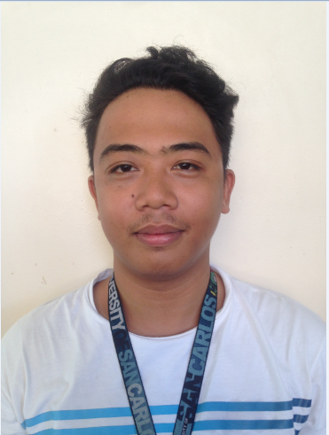**APPLICANT/CANDIDATE RESUME**

CONTACT INFORMATION

Name: Vanvan Ybanez

Address: Basak, Lapu - Lapu City

Cellphone number: 09152088579

Email address: vanvanex13@gmail.com

PERSONAL INFORMATION

Date of Birth: March 13, 1996

Age: 20

Citizenship/Nationality: Filipino

Gender: Male

Marital Status: Single

Language proficiency: English, Tagalog, Cebuano

Computer PMS and Software skills:Web Development

EDUCATIONAL BACKGROUND

Education Level

2012-Present

University of San Carlos – Talamban Campus

Tertiary

2008-2012

Advance Institute of Technology

Secondary

2002-2008

Advance Institute of Technology

Elementary

STRENGTHS/TRAITS & SKILLS

1. Fast Learner
2. Hard working
3. Ethical

TECHNICAL SKILLS

* Knowledgeable in basic troubleshooting and networking configurations.

CAREER OBJECTIVES

To develop and explore more to enhance my skills and knowledge in this field.

WORK EXPERIENCE

April – June 2016 Data Scrapping - Networking

OJT Student

References

1. Jason Kennith C.Pinote

Career Ambassador

The Results Companies

Contact No. 09222144455

1. Kent Anthony D. Ardiente

SME/Immediate Supervisor

TechMahindra Vcustomer

Contact No. 09063148055/09336154753

1. Daphne Leah A. Sabang

Professor

University of San Carlos

Contact No. 09325605890