**CHAPTER 1**

**INTRODUCTION**

* 1. **Rationale of the Study**

Public transportation are commonly used here in the Philippines and issues about it are rampant. There are numerous public vehicle drivers violate traffic rules and perform misconduct to either his passengers or the crowds that are nearby. Obviously, each and every incidence is not reported directly to the police. These issues lead to reduced public transportation reputation for the people and also tourists from foreign places. With these issues disregarded and ignored, drivers will continue to cause problems to public transport that will affect the public transportation quality greatly which can also affect the tourism of the country. Social media is mostly used to hear the complaints of the people that are involved in a public transport vehicle incident which is not due process. It can only make several people aware of that public vehicle. However, there are also good experiences of the commuters with the public transport vehicle services. The complaints of the people are important so the responsible authorities can take immediate action about the incident depends on its nature.

Collection of data using crowdsourcing is a popular method to get the complaints or negative feedback from the end-user. Crowdsourcing will be used by the system to collect complaints from the commuters and the people involved in an incident that could also be used to determine the rating of that public transport through an android application. In addition, the data gathered will be obtained by the operators through a web application. Data gathered from the mobile application users will benefit responsible law enforcement authorities to act and impose discipline to responsible public vehicle drivers that has numerous complaints from the commuters or any people involved in that incident. Moreover, this system can improve the tourism here in Cebu City and other cities that will adopt in this system.

**1.2 Statement of the Problem**

There are numerous events in which they encounter misbehavior and undesirable actions from public vehicle drivers be it commuters or passengers and fellow drivers. Verbal complaints and feedback on these issues have little corrective effect. Leading to no immediate actions intended to correct or improve the situation.

**1.2.1 General Objective**

The main objective of this project is to develop a public vehicle complaint management system.

**1.2.2 Specific Objectives**

This project intends to:

1. Determine common complaints and violations regarding public vehicles.
2. Design a mobile-based complaint submission.
3. Design a complaint handling web application.
4. Develop a public vehicle complaint management system.
5. Test and evaluate the system.

**1.3 Significance of the Study**

This project will benefit the following:

**Complainant**. With this system, the people can easily give complain to that public vehicle without getting a form from a traffic officer or going to a government site.

**Operator.** The operator can easily assess the public vehicle driver whether the driver will be replaced or not.

**LTFRB and LTO**. These government agencies can do anything with the information or records shown in the system whether they will reveal it to the public via news or take action to those operators that its public vehicle has many negative feedbacks or complaints.

**Other Researchers**. Researchers may vary their ideas by observing and evaluate this system to develop an idea and to apply for their upcoming research study.

**1.4 Scope and Limitation**

**1.4.1 Scope**

The system allows the complainant to add a complaint to a certain vehicle using a mobile phone. The admin (operator) can manage vehicles and drivers, view complaint records submitted to the database and can generate it to a report. The system allows super admin (LTFRB or LTO) can view the overall records of the complaint. Moreover, super admin can view and manage the operators of the system. In addition, both can verify the complaints.

**1.4.2 Limitations**

Only android smartphones can run this application and smartphones without internet connection cannot submit complaints. Only common LTO violations and common public complaints are listed in the system.

**CHAPTER 2**

**RELATED SYSTEMS**

These are the references used by the researchers in developing the system.

Customer Feedback is defined as “a marketing term that describes the process of obtaining a customer’s opinion about a business, product or service” (Beard, 2014). In addition, It can help to identify problem areas and strengths, and generate ideas for service improvements (Wirtz, Tambayah, & Matilla, 2010). Though a feedback can be a positive or negative. “Customer feedback is so important because it provides marketers and business owners with insight that they can use to improve their business, products and/or overall customer experience” (Beard, 2014). The companies usually collect feedback from the customers. The feedback can take many forms, including on-site customer complains, calls to toll-free customer-response phone numbers, and customer comment cards (Sampson, 1998). On the other hand, Customer feedback system helps an organization to put in place a continuous customer feedback monitoring process and in particular, this system relates to an instant Customer Feedback System of receiving, storing, and delivering customer comments, including qualitative and quantitative feedback, over a communication network such as the Internet (,2016). Companies that are known for their tradition in using customer feedback share two important features: 1. They use customer feedback to drive organizational change. 2. They support the customer-feedback process by a strong and centralized function. Their customer-satisfaction measurement system is based on validated customer-satisfaction drivers. Their excellent use of customer feedback takes a combination of strong individuals, exceptional teamwork, and relentless executive leadership (Newhouse,1997).

**Improving service quality in public transportation systems using automated customer feedback**

One of the existing researches focusing on public transportation feedback is the Transportation Research Part E: Logistics and Transportation Review (Stelzer, Englert, Hörold, & Mayas, 2016). It highlights the approach to include customer feedback into transport operations and analyze the effects of customer feedback on service quality. In this research the need for standardized automated information exchange between travellers and transportation company is evaluated to improve the service quality of public transport. Therefore the needs and expectations of transportation companies and travellers are defined and the usage of a novel approach for bidirectional information and communication systems in public transport is proposed.

**Designing a mobile system for public safety using open crime data and crowdsourcing**

In the UbiComp ‘14 Adjunct publication pages 67-70 it is highlighted that exploring ways to improve public safety of the society by using open crime data and crowdsourcing (Huang, Wang, & White, 2014). The results suggest that both time of day and type of location significantly affect people's sharing decisions. These insights change our system to force people to report safety related information timely.

**An Empirical Study of Social Capital in Participation in Online Crowdsourcing**

Online crowdsourcing has become a new innovation business model through the Internet. This paper studied the motives of the use of online crowdsourcing and the social capital in its community. The results show that learning, direct compensation, self-marketing and social motives are causes to activate the participation in outsourcing activities. (Peng & Zhang, 2009)

**Online crowdsourcing subjective image quality assessment**

With the random design on large graphs, it is specifically suitable for large scale crowdsourcing researches on the Internet. To make it more practical toward this intention, it is necessary to develop online algorithms to deal with successive or streaming data (Xu, Huang, & Yao, 2012).

**Online Crowd sourcing in the Public Sector: How to Design Open Government Platforms**

This study finds that internet-based crowdsourcing have changed how government bodies operate. It allows new voluntary problem solving and quality check processes nowadays. This study investigates if crowdsourcing platforms can be applied in the government. Results also show that crowdsourcing can somehow produce interest among the people that may serve as a source of reliable input. (Koch, Füller, & Brunswicker, 2011)

**Causes of customer dissatisfaction studies of public transport by the critical incident method**

This study focuses on customer dissatisfaction by targeting the source of the dissatisfaction and complaints. This study gathered data from written complaints and customer interviews. Concludes that quality drawbacks are in most cases frequent. Suggests that driver related aspects should be included. (Edvardsson,1998)

**Real-time feedback methods for gait rehabilitation through a mobile platform**

Computing and data acquisition has become a very important part of everyday life. From reading emails on cell phones, to kids playing with motion sensing game consoles, we are surrounded with sensors and mobile devices. As the availability of powerful mobile computing devices expands, the road is paved for applications in previously limited environments. Rehabilitative devices are emerging that embrace these mobile advances. Research has explored the use of smartphones in rehabilitation as a means to process data and provide feedback in conjunction with established rehabilitative methods. Smartphones, combined with sensor embedded insoles, provide a powerful tool for the clinician in gathering data and may act as a standalone training technique. Schmidt, M. G. (2013).

**The Digitization of Word of Mouth: Promise and Challenges of Online Feedback Mechanisms**

Online feedback mechanisms utilize multiple communication capabilities of the Internet to create large-scale, word-of-mouth networks. Best known as a technology for building trust and promoting cooperation in online marketplaces, such as eBay, these mechanisms are effective to have a much wider impact on organizations. Their growing popularity has potentially important goals for a wide range of management activities such as brand building, customer acquisition and retention, product development, and quality assurance. (Dellarocas, 2003)

**Modifying driver behaviour with passenger feedback**

A feedback program was utilized to help drivers improve their safety behaviour based on the idea that precise types of driver error result from probability traps as defined by Fuller [Journal of Applied Behaviour Analysis, 24 (1991) 73]. Two drivers and their single respective passengers participated. For each driver, repeated in-car observations were made of four unsafe driving behaviours. Two of these were sequentially targeted in the behavioural interruption that involved the passengers providing informational feedback to their driver. Both drivers showed a marked improvement across the targeted behaviours. The study demonstrated the application of behaviour analysis to the traffic domain and the efficacy of individual feedback as a behavioural tool for positive behaviour modification. (Hutton, Sibley, Harper, & Hunt, 2001)

**System and method for providing a unified customer feedback solution**

A method for providing a system for allowing businesses to manage substantially all of their customer relations and feedback on a computer network via a Customer Feedback System. This method allows to gather the customer feedbacks and to provide high quality customer service using a computer transmission medium. The Customer Feedback System resides on a web server and is used to solicit customer feedback and provide customer support and other information to a business’s customers via the internet. In this system the feedback of the customer is essential for providing various aspects of customers relations as well as strong support for security, customizability, and optimal performance. (Ruge ,Negovan, & Pisani, 2007)

**Opinion mining of customer feedback data on the web**

As people leave on the Web their opinions on products and services they have used, it has become important to develop methods of (semi-)automatically classifying and gauging them. The task of analyzing such data, collectively called customer feedback data, is known as opinion mining. Opinion mining consists of several steps, and multiple techniques have been proposed for each step. In this paper, we survey and analyze various techniques that have been developed for the key tasks of opinion mining. On the basis of our survey and analysis of the techniques, we provide an overall picture of what is involved in developing a software system for opinion mining. (Lee, Jeong, & Lee, 2008)

**System for monitoring vehicle efficiency and vehicle and driver performance**

A commercial vehicle fleet management system which integrates a vehicle on-board computer, a precise positioning system, and communication system to provide automated calculating and reporting of jurisdictional fuel taxes, road use taxes, vehicle registration fees. It is to be used in conjunction with miles traveled, gas mileage, and a database stored in memory which contains information such as jurisdictional boundaries to correlate vehicle path with border crossing events as vehicle crosses jurisdictional borders, thereby automating the calculation and reporting of fuel tax appointment among various jurisdictions may likewise be computed and reported. It employs position information and geographical database information to calculate and automate vehicle operator logs, operator payroll, hours on service compliance. In this system the position of the vehicle is shown in the satellite to monitor its path and the drivers performance is evaluated accordingly. (Jenkins , 2001)

**Vehicle driver performance monitoring system**

Driver performance monitoring system is generally directed to an onboard computer system for operation on a designated host vehicle. More specifically, the vehicle driver performance monitoring system is an onboard computer system which has in place the hardware and software means to sense various vehicle operation parameters, characterize the driving habits of the current driver based on those parameters with respect to various specific determinants,  In this system it monitors the driving performance to control the driving habits and preserve the health and safety of the occupants of other automobiles. (Ousbornen, 1996)

**System and method for driver performance improvement**

A system is adapted to assess information incoming to a vehicle operator, to prioritize the information based upon a number of conditions relating to the vehicle operation, the operating environment, the activity of the operator and the physical condition of the operator, and to provide to the operator the most pertinent information for the given set of conditions. As used throughout this specification, the terms vehicle operator and driver are used interchangeably and each are used to refer to the person operating the vehicle in the manner in which the vehicle is intended to be operated. This system monitors various data sources, including the vehicle operation, the operating environment, the activity and condition of the operator, over  a period of operation and records the operator’s performance. The performance may be compared with accepted good practices, and a report may be provided to the operator indicating how the operator's performance compares with the accepted good practices and with the operator's previous driving performance and habitual behavior. The system may record operator performance over a number of periods of operation, and provide comparisons of operator performance from period to period. (Douros, 2005)

**LTO’s COMMON VIOLATIONS**

**Ordinance no. 172**

Art. VI, Sec 1(a) Driving w/ indecent attire

Art VI, Sec 1(b) Stereo ban

Art VI, Sec 1(c) Smoking ban

Art VI, Sec 1(d) DTS No Entry

Art VI, Sec 1(e) DTS No U-Turn

Art VI, Sec 1(f) DTS Go Signal

Art VI, Sec 1(g) DTS Stop Signal

Art VI, Sec 1(h) Crossing Solid Line

Art VI, Sec 1(i) DTS Left Turn

Art VI, Sec 1(j) U-Turn in Business Intersection

Art VI, Sec 1(k) Driving Left

Art VI, Sec 1(l) Parallel Parking Opposite Direction

Art VI, Sec 1(m) Parking on Sidewalk

Art VI, Sec 1(n) Parking at Sidewalk

Art VI, Sec 1(o) Parking at Intersection

Art VI, Sec 1(p) Double Parking on cross walk

Art VI, Sec 1(q) Parking on PUJ Stop

Art VI, Sec 1(r) Defective tail light/ brake light

Art VI, Sec 1(t) Defective Head light

Art VI, Sec 1(u) Obstruction due disabled vehicle

Art VI, Sec 1(v) No crash helmet

Art VI, Sec 1(w) Disobedience to traffic enforcers

Art VI, Sec 1(x) Disobeying Flag ceremony

Art VI, Sec 1(y) Loading sand and gravel w/o cover

Art VI, Sec 1(z) Double back ride tricycle

**Ordinance. No. 299-97**

Not driving in the designated lane

**Chapter 3**

**TECHNICAL BACKGROUND**

These are the technical terms used by the developers in developing the system.

**Web application**

**CodeIgniter.** is a powerful PHP framework with a very small footprint, built for developers who need a simple and elegant toolkit to create full-featured web applications.

**MySQL**. Is a relational database management system. MySQL is a popular choice of database use in web applications, and is a central component of the widely used LAMP open source web application software stack. LAMP is an acronym for “GNU/Linux, Apache, MySQL, Perl/PHP/Python”.

**Bootstrap**. Is the most popular HTML, CSS, and JavaScript framework for developing responsive, mobile-first web sites.

**Percentage**. One of the most frequent ways to represent statistics is by percentage. Percent simply means "per hundred" and the symbol used to express percentage is %.

**Percentage Change**. Percent increase and percent decrease are measures of percent change, which is the extent to which a variable gains or loses intensity, magnitude, extent, or value. The figures are arrived at by comparing the initial (or before) and final (or after) quantities according to a specific formula.

**Mobile Application**

**Android Operating System.** Is a mobile operating system developed by Google. It is used by several smartphones and tablets. It is an open source, meaning developers can modify and customize the OS for each phone. (Christensson, 2016).

**Android Studio**. Is the official Integrated Development Environment (IDE) for Android platform development. It offers more features that will enhance productivity when building Android apps, such as a flexible Gradle-based build system, fast and feature-rich emulator and a unified environment.**Global Positioning System.** is a series of satellites owned by the US government that broadcasts signals that **GPS** receivers on the surface of the planet can use to determine position through triangulation.

**CHAPTER 4**

**DESIGN AND METHODOLOGY**

**4.1 Conceptual Framework**

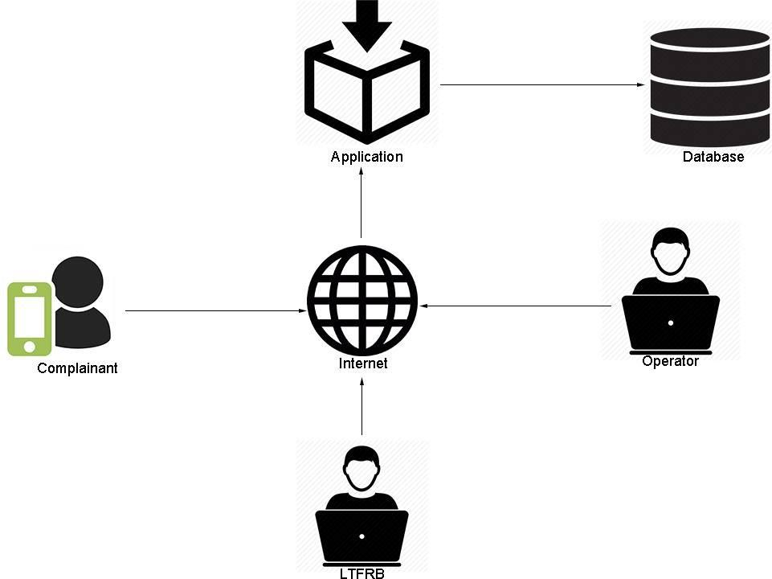

**Figure 4.1 -** *Public Vehicle Complaint Management Conceptual Framework*

**4.2 Analysis and Design**

**4.2.1 System Flow**

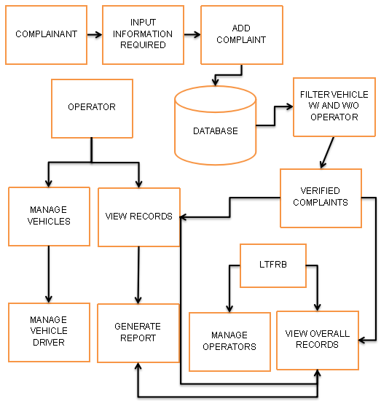

**Figure 4.2.1 -** *Public Vehicle Complaint Management System Flow*

**4.2.2 Use-Case Diagram**

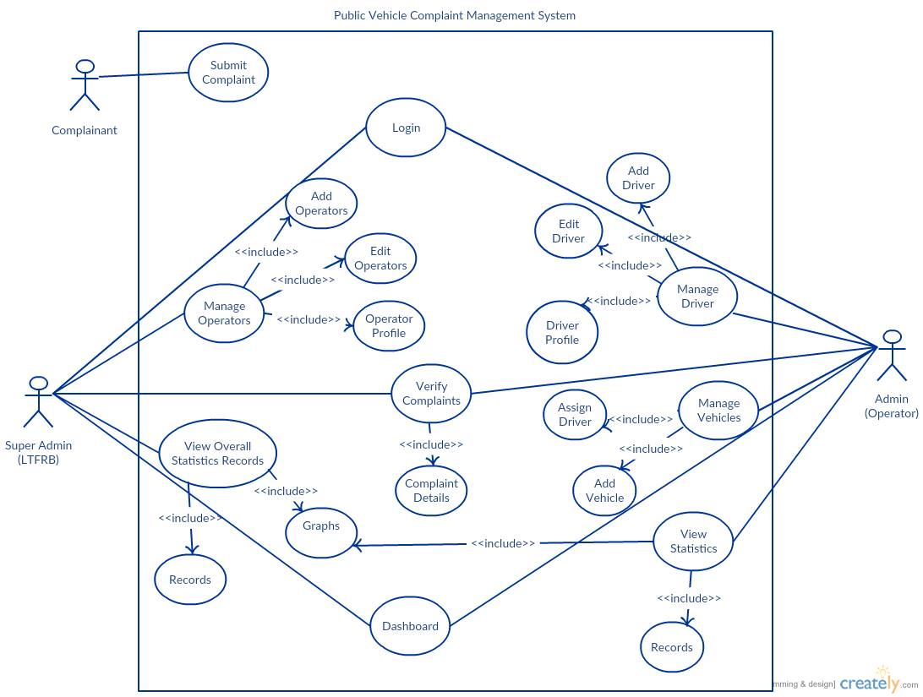

**Figure 4.2.2 –** *Use Case Diagram for Public Vehicle Complaint Management System*

**Table 4.2.2. - Use-Case List of Flows**

|  |  |
| --- | --- |
| **Web Application** | |
| **Use-Case Number** | 01 |
| **Use-Case Name** | Login |
| **Actor** | Super Admin/Admin |
| **Flow** | The user can log in with their assigned accounts by pressing the login button. |
| **Use-Case Number** | 02 |
| **Use-Case Name** | Manage Operators |
| **Actor** | Super Admin |
| **Flow** | The user can add, delete, update existing operators and search operators within the table. Moreover, by clicking the operator name it will direct to operators’ profile. |
| **Use-Case Number** | 03 |
| **Use-Case Name** | Add Operators |
| **Actor** | Super Admin |
| **Flow** | The user can add operators and can save it by clicking the submit button. |
| **Use-Case Number** | 04 |
| **Use-Case Name** | Edit Operators |
| **Actor** | Super Admin |
| **Flow** | The user can edit operators and can update it by clicking the update button. |
| **Use-Case Number** | 05 |
| **Use-Case Name** | Verify Complaints |
| **Actor** | Super Admin/Admin |
| **Flow** | The user can verify the complaints by clicking the verify button. Moreover, the user can delete and view the complaint’s full info. |
| **Use-Case Number** | 06 |
| **Use-Case Name** | Complaint Details |
| **Actor** | Super Admin/Admin |
| **Flow** | The user can view the full info here. In addition, the user can verify and delete the complaints here. |
| **Use-Case Number** | 07 |
| **Use-Case Name** | View Statistics: Records |
| **Actor** | Super Admin |
| **Flow** | The user can view the overall interpreted data from the verified complaints here. |
| **Use-Case Number** | 08 |
| **Use-Case Name** | View Statistics: Graphs |
| **Actor** | Super Admin/Admin |
| **Flow** | The user can view the generated reports from the verified complaints. |
| **Use-Case Number** | 09 |
| **Use-Case Name** | Dashboard |
| **Actor** | Super Admin |
| **Flow** | The user can see the number of unverified complaints, operators and registered vehicles in the system. Moreover, The user can view the generated report which is filtered by time , most complained operators, and the most complained places. In Addition, the user can view the latest complaints and can verify, view info, and delete within the dashboard. Lastly, the user can go to the operators’ profile if the operators’ name is clicked from the verified complaints. |
| **Use-Case Number** | 10 |
| **Use-Case Name** | Operator Profile |
| **Actor** | Super Admin |
| **Flow** | The user can view the operator’s profile and can edit the operator if changes are made by clicking the edit button. |
| **Use-Case Number** | 11 |
| **Use-Case Name** | Manage Driver |
| **Actor** | Admin |
| **Flow** | The user can add, delete, update existing drivers and search drivers within the table. Moreover, by clicking the license number it will direct to driver’s profile. |
| **Use-Case Number** | 12 |
| **Use-Case Name** | Add Driver |
| **Actor** | Admin |
| **Flow** | The user can add drivers and can save it by clicking the submit button. |
| **Use-Case Number** | 13 |
| **Use-Case Name** | Edit Driver |
| **Actor** | Admin |
| **Flow** | The user can edit the driver’s details and can update it by clicking the update button. |
| **Use-Case Number** | 14 |
| **Use-Case Name** | Manage Vehicles |
| **Actor** | Admin |
| **Flow** | The user can add, delete, view vehicles and assign/un-assign driver to the vehicles. Moreover, the user can search vehicle’s info within the search box. |
| **Use-Case Number** | 15 |
| **Use-Case Name** | Assign Driver |
| **Actor** | Admin |
| **Flow** | The user can delete, view vehicles and assign a driver to a un-assigned vehicle. In addition, the user can search vehicle info within the search box. |
| **Use-Case Number** | 16 |
| **Use-Case Name** | View Statistics: Records |
| **Actor** | Admin |
| **Flow** | The user can view the overall interpreted data from the verified complaints of the current operator login-ed here. |
| **Use-Case Number** | 17 |
| **Use-Case Name** | Dashboard |
| **Actor** | Admin |
| **Flow** | The user can see the number of unverified complaints, drivers and unassigned vehicles in the system. Moreover, The user can view the generated report which is filtered by time , most complained vehicles, and the most complained places. In Addition, the user can view the latest complaints and can verify, view info, and delete within the dashboard. |
| **Use-Case Number** | 18 |
| **Use-Case Name** | Driver Profile |
| **Actor** | Admin |
| **Flow** | The user can view the driver’s profile and can edit the driver if changes are made by clicking the edit button. |
| **Mobile** | |
| **Use-Case Number** | 01 |
| **Use-Case Name** | Submit Complaint |
| **Actor** | Complainant |
| **Flow** | The user can submit complaint by inputting the required details and by ticking the checkbox. |

**4.2.3 Entity Relationship Diagram**

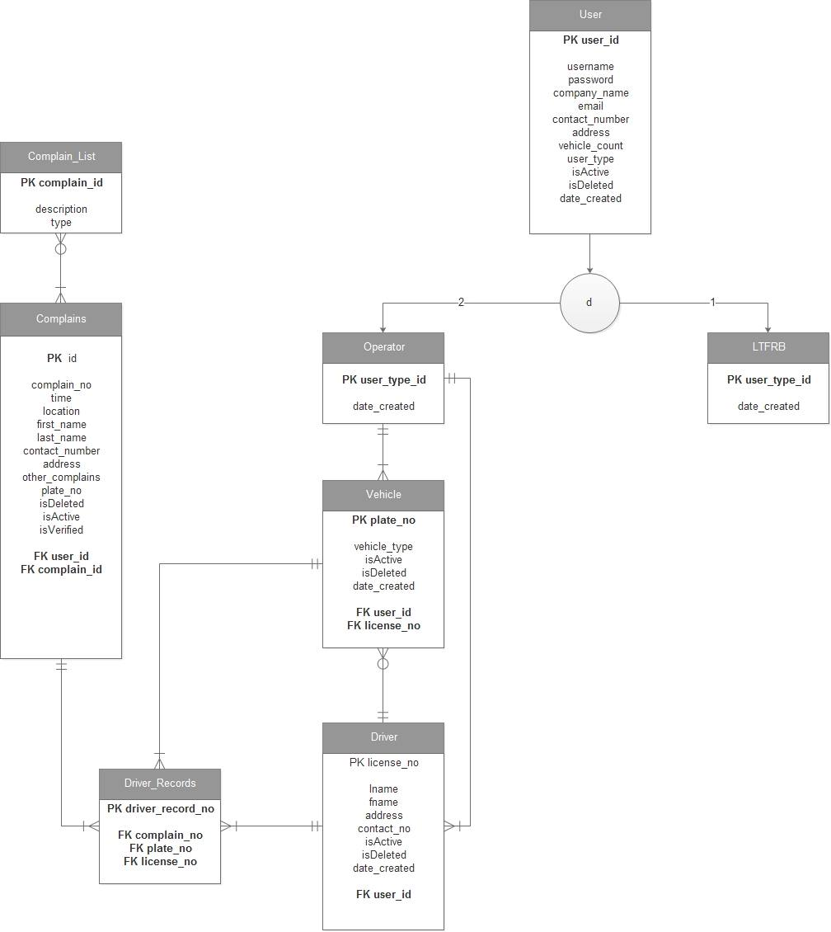

**Figure 4.2.3 –** *Entity Relationship Diagram for Public Vehicle Complaint Management System*

**4.3. Development Model**

The researcher has chosen the Waterfall Methodology because it gave a direction to the linear - sequential life cycle. It allows for departmentalization and control. A schedule can be set with deadlines for each stage of development and a product can proceed through the development process model phases one by one.

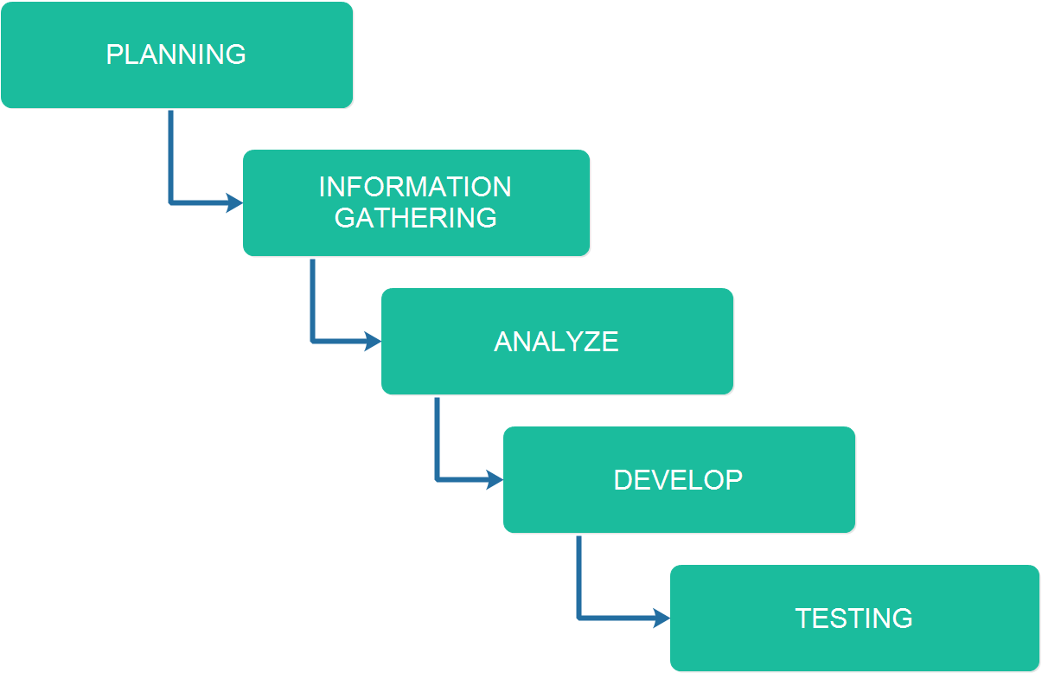

**Figure 4.3.1 –** *Waterfall Methodology for Public Vehicle Complaint Management*

*System*

**Development 1. Planning**

This is where the developers brainstorm for building an idea of a startup system. The researchers also picture out the design of the system by using their combined ideas.

**Development 2. Information Gathering**

The Information Gathering is where the developers has been searching for the related system that supports in the development of the system. With this, the developers have already gotten some ideas from the related systems and has been implemented in the system.

**Development 3. Analyze**

The gathered information has been analyzed and evaluated from the document for the development of the system. This is where the developers has already made the system flowchart.

**Development 4. Develop**

The developers have been starting the coding of the back – end and the front – end. This is where the researchers develop the system’s functionalities and modules as stated in the documents.

**Development 5. Testing**

This is where the developers has been testing and evaluating the system. The developers has provided comments and recommendations to the users for revision purposes. If there are bugs and errors bump into, it will be identified easily and will be revise and change immediately.

**4.4. Development Approaches**

The approach used in this system is the top-down. The developers started with the user-interface design of the system. After the user-interface design the main modules will be started which are complaint and report modules.

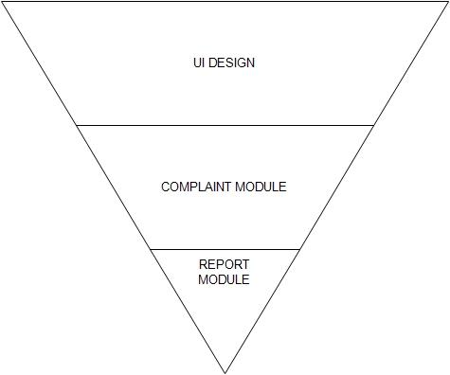

**Figure 4.4.1 –** *Top-down Model for Public Vehicle Complaint Management System*

The researchers used the top-down approach. UI Design is the base part of the triangle so that the researchers can view the full picture of the system. Followed by the complaint module which will be the android application of the system. After that followed by report module which will be used by the admin and super admin through a web application.

**4.5. Software Development Tools**

|  |  |  |  |
| --- | --- | --- | --- |
| **Name** | Version | Source | Use |
| Android Studio | 2.1 | https://developer.android.com/studio.com | Android IDE |
| ChartJS | 2.4.0 | http://www.chartjs.org | Graph Presentation |
| JAVA | JAVA 7 | https://java.com/ | Language used to code the system. |
| JAVA SE Development Kit | 8 | http://www.oracle.com | Develop and deploy Java applications. |
| XAMMP | 5.5.38 | https://www.apachefriends.org/index.html | For Database Connectivity. |
| Codeigniter | 3.1.3 | https://codeigniter.com | Back – End Framework |
| phpMyAdmin | 4.6.4 | https://www.phpmyadmin.net/ | For Database Implementation |
| Bootstrap | 3.3.7 | http://getbootstrap.com/ | Front – End Framework |
| Datatables | 1.10.13 | https://datatables.net | Web tables |

**Table 4.5.1 –** *Software Development Tools for Public Vehicle Complaint Management System*

The tools shown in table 2 has been used in developing the system which composed of web application tools and mobile application tools.

**4.6 Project Management**

**Table 4.6.1 Schedule and Timeline**

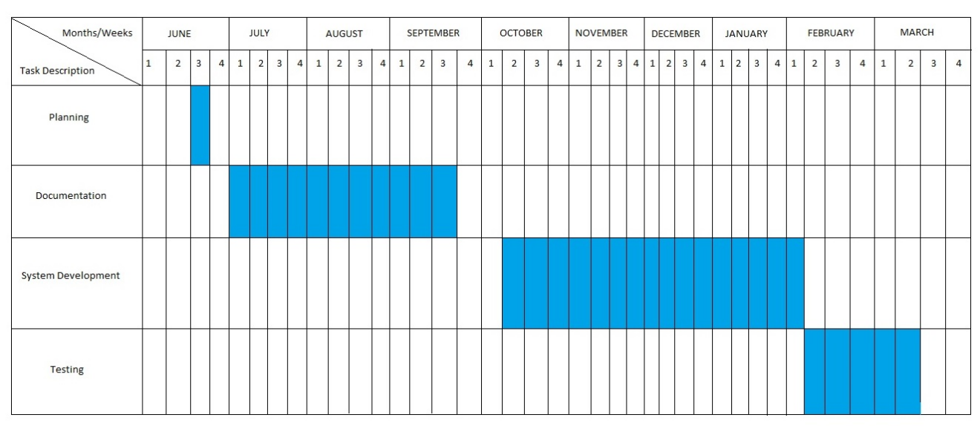

**4.6.2 Responsibilities**

This table shows the responsibilities and tasks for each of the member.

|  |  |  |
| --- | --- | --- |
| **APPLICATION** | **TASK** | **ASSIGNEE** |
|  | Documentation | Amit  Gula  Melchor  Ybañez |
|  | Database Implementation | Amit  Ybañez |
|  | **FUNCTIONS** |  |
| Android | Insert Complaint | Gula  Melchor |
|  | Retrieve GPS Location |
|  | Android User Interface | Melchor |
| Web | Web User Interface | Amit |
|  | Login | Ybañez |
|  | Verfy Complaints |
|  | Manage Vehicles |
|  | Manage Operators | Amit |
|  | Manage Drivers |
|  | Statistics |
|  | Users profile |
|  | Assign Driver | Gula |
|  | Dashboard | Amit  Gula  Melchor  Ybañez |

**Table 4.6.2 –** Responsibilities for Public Vehicle Complaint Management System

**4.6.3 Budget and Cost Management**

|  |  |
| --- | --- |
| **ITEM** | **COST** |
| **Printing Fees** |  |
| Black & White (1x200 pages) | 200 |
| Colored (5x50 pages) | 250 |
| **Travel Cost** | 1000 |
| **Miscellaneous** | 600 |
| **Total Amount** | **2,050** |

**Table 4.6.3 –** *Budget and Cost Management for Public Vehicle Complaint Management System*

**4.7. Verification, Validation and Testing**

The IT Professionals is the one who will take a look to verify if the system has been accomplished to its requirements, to confirm if the system is totally working and to test if the system is ready to execute.

Black-box testing is a method of software testing that examines the functionality of an application without peering into its internal structures or workings. In this event the one we will give a test is the proponents. The proponents are the one who is most familiar and aware of the system. Each module and functionalities is tested to see errors and bugs of the system.

User Acceptance Testing is also known as beta testing, application testing or end user testing. It consists of a set of test steps, which verify if specific requirements are working for the user. We let our client test our system to assure the proposed functionalities and modules are properly executed.

**CHAPTER 5**

**RESULT AND ANALYSIS**

**Specific Objective 1: Determine common complaints and violations regarding public vehicles**

**Figure 5.1 Survey Results Interpretation**

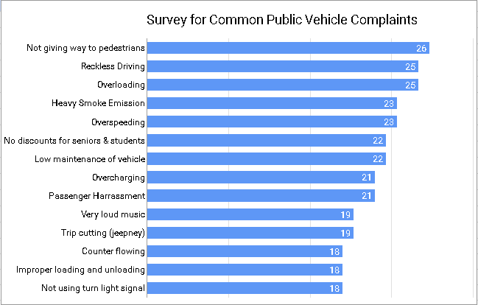

Figure 5.1 is the Bar Graph presentation of the result of the survey conducted by the researchers to 30 respondents. The researchers only selected the top 10 common public vehicle complaints to be used in the complaint submission.

**Specific Objective 2: Design a mobile-based complaint submission**

The researchers achieved the second objective by designing a mobile application, the applications capabilities include:

* Get city location of complainant.
* Get personal information of complainant
* Submit complaint(s) to a vehicle by vehicle plate number.

**Specific Objective 3: Design a complaint handling web application.**

The researchers achieved the third specific objective by:

* Creating a module that verifies complaints received from the mobile application.
* Creating a super admin (LTFRB) module that manages operators and verifies complaints.
* Creating an admin (operator) module that verifies the complaints of its public vehicles. The admin (operator) module can also manage the drivers and vehicles.

**Specific Objective 4: Develop a public vehicle complaint management system.**

**Systems Capability**

* The system is capable of sending public vehicle complaints from an android device.
* The system can manage public vehicle complaints received from complainants.
* The system can manage the complaints of public vehicle with operators and without operators.
* The system can manage the complaint data of public vehicles and their drivers.
* The system can generate statistical data based from the gathered complaints.

**Major Modules**

The proposed system has the following major modules:

* Mobile-based public vehicle complaint submission application:
  + Submit complaints - a module that enables the user to submit public vehicle complaints together with the personal information of the complainant.
  + Get city location - a module that can get the current city location of the complainant when he/she submits a complaint from a mobile device.
* Public vehicle complaint handling web application:
  + Manage complaints of public vehicle operators - a module that enables the admin to manage complaints of public vehicles with operators.
  + Manage complaints of public vehicles without operators - a module that enables the admin to manage complaints of public vehicles without operators.
  + Manage drivers of public vehicles - a module that enables the operator to manage their public vehicle drivers with numerous complaints.
  + Manage Operators - a module that enables LTFRB authorities to manage operators of public vehicles.

**Specific Objective 5: Test and Evaluate the System**

**5.1 Verification (Black Box Testing)**

The Public Vehicle Complaint Management System was tested from January 30, 2017 – January 31, 2017 by the following testers:

John Mark Amit

Jose Maria Gula

Alec Job Melchor

Vanvan Ybañez

Mary Kris Villacrucis

After executing a test, the decision is defined according to the following rules:

Acceptable – The test sheet is set to "Acceptable" status if the actual result meets the expected result.

Not Acceptable - The test sheet is set to "Not Acceptable" status if the actual result does not meet the expected result.

**Figure 5.1.1 Android Application Black Box Testing**

Figure 5.1.1 shows the black box testing results of the android submit complaint test case module. There were 9 test cases and all the results were acceptable meaning that the android application is acceptable.

See Appendix F for Detailed and Sample Test Cases (Black Box Testing)

**Figure 5.1.2 Web Application Black Box Testing**

Figure 5.1.2 is the interpretation of the web application black box testing. The testing consisted of 154 test cases and all the test case results were all acceptable.

**5.2 Validation (User Acceptance Testing)**

The Public Vehicle Complaint Management System was from February 2, 2017 to February 6, 2017 by 30 randomly selected respondents.

Average Score Interpretation:

4.1 – 5.0 = Very Acceptable

3.1 – 4.0 = Acceptable

2.1 – 3.0 = Moderately Acceptable

1.0 – 2.0 = Not Acceptable

**Table 5.2.1 User Acceptance Testing results**

|  |  |
| --- | --- |
|  | Average |
| Functionality | 4.1 |
| Reliability | 4.0 |
| Usability | 4.3 |
| Efficiency | 4.2 |
| Maintainability | 4.2 |
| Support and Manuals | 4.2 |

Table 5.2.1 represents the average ratings of each acceptance test categories. Based on the results the functionality of the system 4.1 is very acceptable meaning its functionalities have met the specific objectives. The system got an average of 4.0 on the reliability category which means the system is reliable. The systems usability got a average of 4.3 which means very acceptable and the system can be used easily. The systems efficiency got an average of 4.2 which means the systems efficiency is very acceptable so the systems processes are efficient. The systems maintainability got an average of 4.2 which means the systems maintainability is very acceptable and the system can easily be maintained. The systems support and manuals got an average of 4.2 that is very acceptable so the support and manuals can be understood easily.

**Figure 5.2.2 User Acceptance results graph**

Average Rating: 4.2

Interpretation: Very Acceptable

**CHAPTER 6**

**CONCLUSION AND RECOMMENDATION**

**6.1 Conclusion**

From the design phase until the system had been tested, the researches have come up with the following conclusions:

The developed Public Complaint Management system has met its required objectives. The system demonstrates the possibility of sending public vehicle complaints on an android device that will be received and verified by operators and government transportation authorities. By using the system the verified complaints received by the operators and the LTFRB authorities will be beneficial to the public.

**6.2 Recommendation**

For future researchers, a good recommendation is the implementing of a real-time mobile application to web application connectivity. Another good recommendation would be the implementation of a good file hosting feature for seamless submission of complaints.

**GLOSSARY**

* LTFRB(Land Transportation Franchising and Regulatory Board) - is an agency of the Philippine government under the Department of Transportation responsible for promulgating, administering, enforcing, and monitoring compliance of policies, laws, and regulations of public land transportation services.
* Operators – managers who own public transport vehicles usually one type (e.g. taxi or jeepney)
* Violations(Common/LTO) – these are actions commited by public vehicle drivers when driving.
* Crowd sourcing - the practice of obtaining information or input into a task or project by enlisting the services of a large number of people, either paid or unpaid, typically via the Internet.
* CodeIgniter - is a powerful PHP framework with a very small footprint, built for developers who need a simple and elegant toolkit to create full-featured web applications.
* MySQL - Is a relational database management system. MySQL is a popular choice of database use in web applications, and is a central component of the widely used LAMP open source web application software stack. LAMP is an acronym for “GNU/Linux, Apache, MySQL, Perl/PHP/Python”.
* Bootstrap - Is the most popular HTML, CSS, and JavaScript framework for developing responsive, mobile-first web sites.
* Android Operating System. Is a mobile operating system developed by Google. It is used by several smartphones and tablets. It is an open source, meaning developers can modify and customize the OS for each phone. (Christensson, 2016).
* Android Studio. Is the official Integrated Development Environment (IDE) for Android platform development. It offers more features that will enhance productivity when building Android apps, such as a flexible Gradle-based build system, fast and feature-rich emulator and a unified environment.

**BIBLIOGRAPHY**

**WEB ARTICLE**

1. Beard, R. (2014, September 29). 6 reasons why customer feedback is important to your business. Retrieved July 13, 2016, from <http://blog.clientheartbeat.com/why-customer-feedback-is-important/>

2. Indian applicant files patent application for instant customer feedback system and method thereof. (2016, Feb 16). Indian Patents News Retrieved from [http://search.proquest.com.ezproxy.usc.edu.ph/docview/1765327253?acc ountid=50192](http://search.proquest.com.ezproxy.usc.edu.ph/docview/1765327253?accountid=50192)

3. Newhouse, B. (1997). Customer feedback as a catalyst for change. Strategy & Leadership, 25(3), 60. Retrieved from [http://search.proquest.com.ezproxy.usc.edu.ph/docview/194373951?acco untid=50192](http://search.proquest.com.ezproxy.usc.edu.ph/docview/194373951?accountid=50192)

4. Wirtz, J., Tambyah, S. K., & Mattila, A. S. (2010). Organizational learning from customer feedback received by service employees. Journal of Service Management, 21(3), 363-387. d oi:http://dx.doi.org/10.1108/09564231011050814

5. Sampson, S. E. (1998). Gathering customer feedback via the internet: Instruments and prospects. Industrial Management & Data Systems, 98(2), 71-82. Retrieved from [http://search.proquest.com.ezproxy.usc.edu.ph/docview/234921157?acco untid=50192](http://search.proquest.com.ezproxy.usc.edu.ph/docview/234921157?accountid=50192)

6. Stelzer, A., Englert, F., Hörold, S., & Mayas, C. (2016). Improving service quality in public transportation systems using automated customer feedback. Transportation Research Part E: Logistics and Transportation Review, 89, 259–271. doi:10.1016/j.tre.2015.05.010

7. Huang, Y., Wang, Y., & White, C. (2014). Designing a mobile system for public safety using open crime data and crowdsourcing. . doi:10.1145/2638728.2638762

8. Peng, L., & Zhang, M. (2009). An empirical study of social capital in participation in online Crowdsourcing. . doi:10.1109/ICEEE.2010.5660804

9. Xu, Q., Huang, Q., & Yao, Y. (2012). Online crowdsourcing subjective I mage quality assessment. . doi:10.1145/2393347.2393400

10. Koch, G., Füller, J., & Brunswicker, S. (2011). Online Crowdsourcing in the public sector: How to design open government platforms. In Online Communities and Social Computing (pp. 203–212). doi:10.1007/978-3- 642-21796-8_22

11. Edvardsson, B. (1998). Causes of customer dissatisfaction - studies of public transport by the critical-incident method. Managing Service Quality: An International Journal, 8(3), 189–197. doi:10.1108/09604529810215675

12. Schmidt, M. G. (2013). Real-time feedback methods for gait rehabilitation through a mobile platform (Order No. 1535101). Available from ProQuest Dissertations & Theses Global. (1324127826). Retrieved from [http://search.proquest.com.ezproxy.usc.edu.ph/docview/1324127826?acc ountid=50192](http://search.proquest.com.ezproxy.usc.edu.ph/docview/1324127826?accountid=50192)

13. Dellarocas, C. (2003). The Digitization of word of mouth: Promise and challenges of online feedback mechanisms. Management Science, 49(10), 1407–1424. doi:10.1287/mnsc.49.10.1407.17308

14. Hutton, K. A., Sibley, C. G., Harper, D. N., & Hunt, M. (2001). Modifying driver behaviour with passenger feedback. Transportation Research Part F: Traffic Psychology and Behaviour, 4(4), 257–269. doi:10.1016/S1369- 8478(01)00027-4

15. Ruge, D., Negovan, M., & Pisani, R. (2005). U.S. Patent Application No. 11/207,219.

16. Lee, D., Jeong, O. R., & Lee, S. G. (2008, January). Opinion mining of customer feedback data on the web. In Proceedings of the 2nd international conference on Ubiquitous information management and communication (pp. 230-235). ACM.

17. Jenkins, P. C., Deal, D. V., Cuthbertson, T. G., Morton, J. W., Smith, A. D., Hoy, D. R., & Egeberg, G. W. (2001). U.S. Patent No. 6,253,129. Washington, DC: U.S. Patent and Trademark Office.

18. Ousborne, J. (1996). U.S. Patent No. 5,499,182. Washington, DC: U.S. Patent and Trademark Office.

19. Douros, K., Gardner, J. L., Gardner, R. M., Hurwitz, J. B., Leivian, R. H., Nagel, J., ... & Wood, C. A. (2005). U.S. Patent No. 6,909,947. Washington, DC: U.S. Patent and Trademark Office.

20. Wallin Andreassen, T. (1995). (Dis)satisfaction with public services: The        case of public transportation. Journal of Services Marketing, 9(5), 30–41. doi:10.1108/08876049510100290