**USER MANUAL**

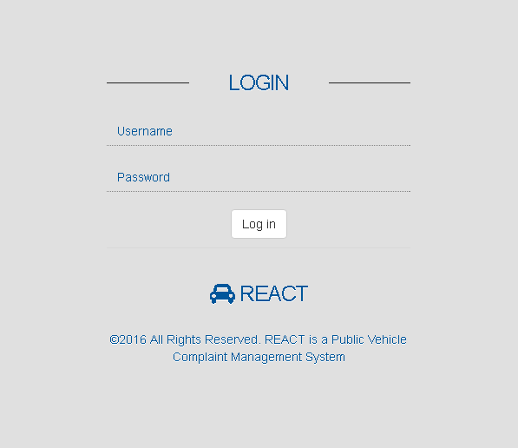LOGIN PAGE

Admin:

Username: admin

Password: admin

Operator:

Username: 21vision

Password: asd123

ADMIN DASHBOARD

1

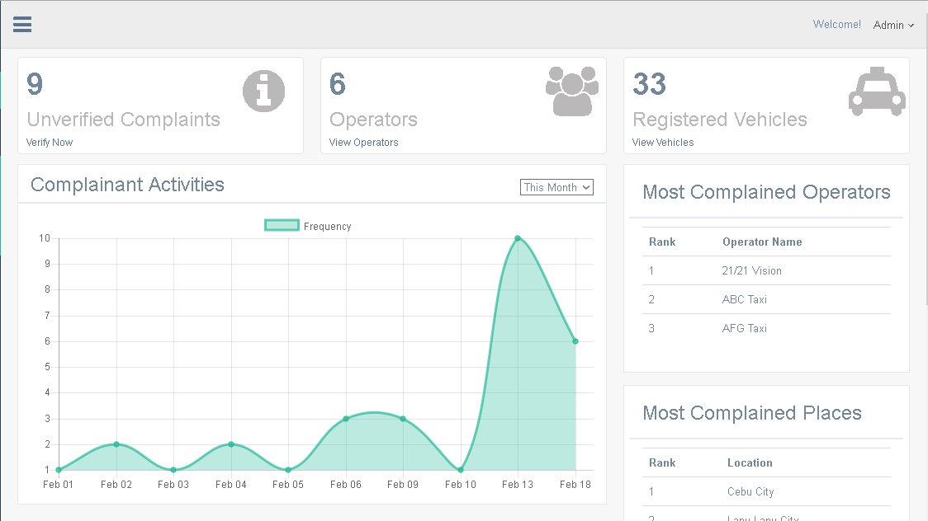

1. Displays unverified complaints of vehicles without operators, click to manage unverified complaints.

2. Displays all registered operators in the system, click to manage operators.

3. Displays all registered vehicles of operators.

4. Displays graphical complaint frequency by month, week and day.

5. Displays the most complained public vehicle operators.

6. Displays the locations with the most public vehicle complaints.

ADMIN SIDE NAVIGATION PANEL

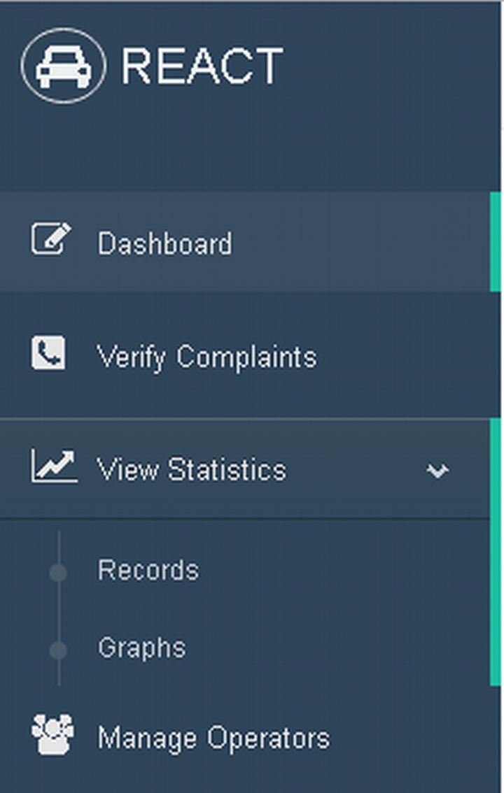

**1**

**2**

**3**

**4**

**5**

**6**

1. Dashboard Tab – Click to display dash board page (default).

2. Verify Complaints Tab – Click to displays verify complaints page.

3. View Statistics Tab – Click to Show the drop-down tabs: Records and Graphs tab.

4. Records tab – Click to display complaint records in detailed statistical interpretation.

5. Graphs tab – Click to displays detailed statistical graph representation of complaints.

6. Manage Operators – Click to displays manage operators page to manage all existing operators.

ADMIN VERIFY COMPLAINTS

**2**

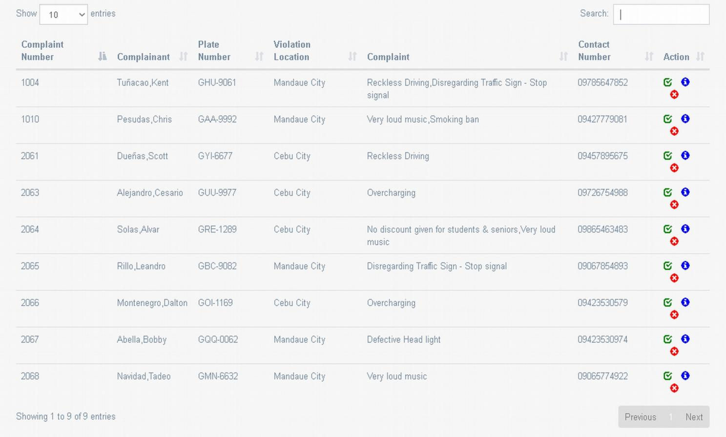1. Click to choose desired number of entries

**5**

**6**

**1**

**3**

**4**

**7**

2. Type in to search complaint data

3. Click to go to previous table page.

4. Click to verify complaint.

5. Click to delete unverified complaint.

6. Click to show complaint information.

7. Click to go to next table page.

ADMIN COMPLAINT DETAILS

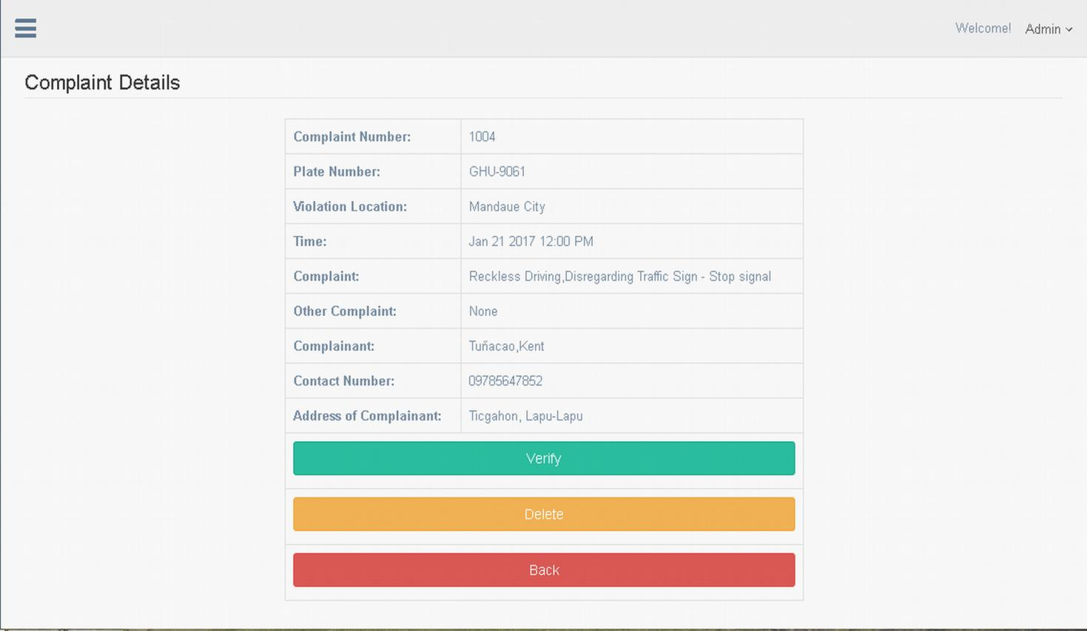1. Click to verify unverified complaint.

**1**

**2**

**3**

2. Click to delete unverified complaint.

3. Click to return to previous page (Verify Complaints page)

ADMIN VIEW STATISTICS: RECORDS

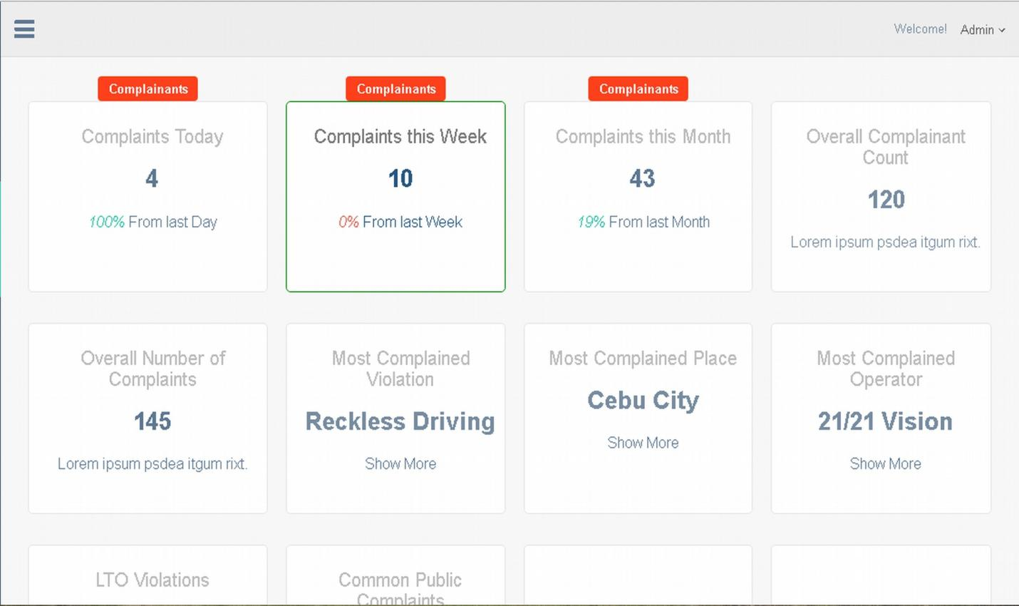1. Click label to display number of complaints/complainants today.

**7**

**1**

**2**

**5**

**4**

**8**

**3**

**6**

2. Click label to display number of complaints/complainants this week.

3. Click label to display number of complaints/complainants this month.

4. Displays the total number of complainants.

5. Displays the total number of complaints received.

6. Displays the most complained Violation.

7. Displays the most complained city location.

8. Displays the most complained public vehicle operator.

ADMIN VIEW STATISTICS: GRAPHS

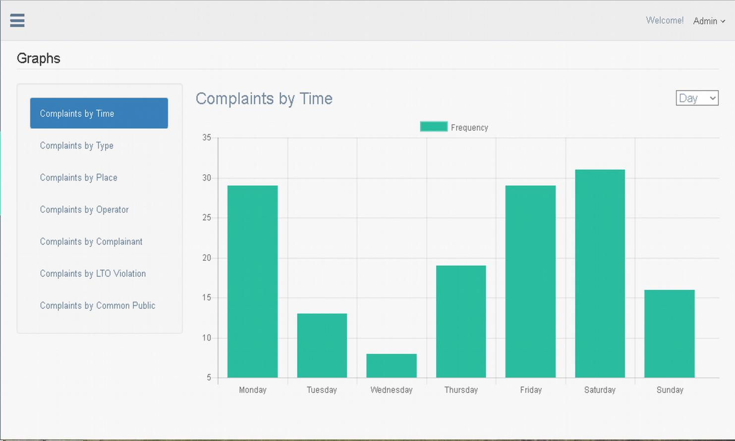1. Click to show complaints by time graph (default)

**1**

**2**

**3**

**4**

**5**

**6**

**7**

**8**

2. Click to show complaints by type graph.

3. Click to show complaints by place graph.

4. Click to show complaints by operator graph.

5. Click to show complaints by complainant graph.

6. Click to show complaints by LTO violation graph.

7. Click to show complaints by common public violations graph.

8. Click to manipulate graph by day, hour and month.

ADMIN MANAGE OPERATORS

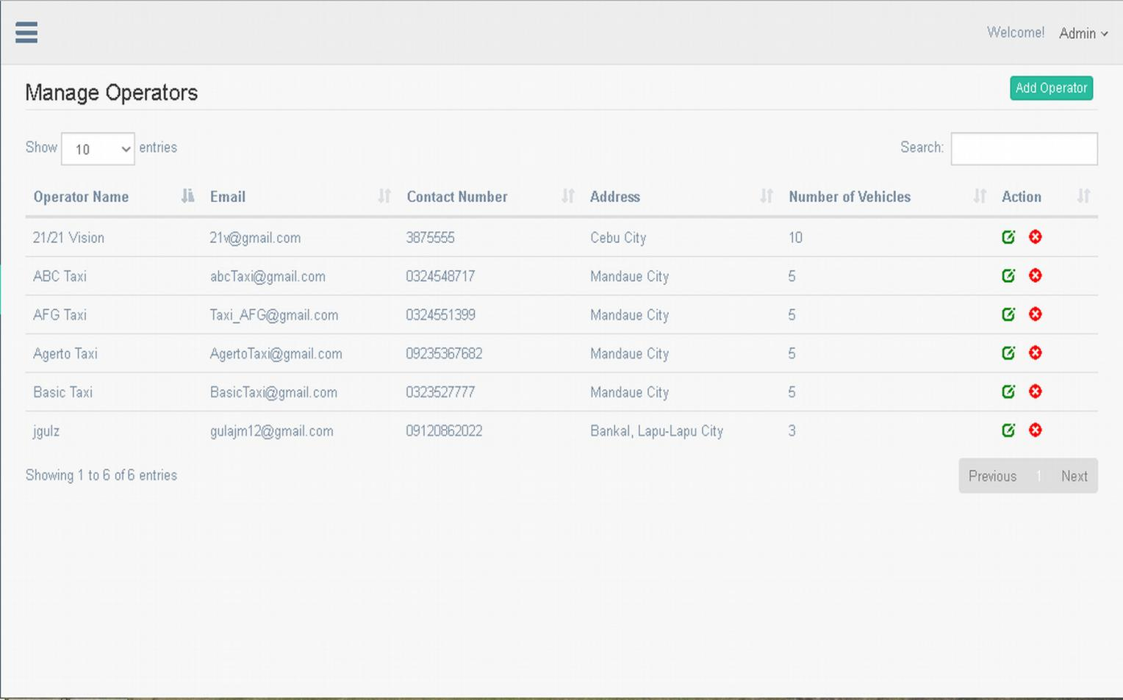1. Click to choose desired number of entries.

**1**

**4**

**5**

**2**

**6**

**7**

**3**

2. Click to add new operator.

3. Type to search desired operator data.

4. Click to edit operator.

5. Click to delete operator.

6. Click to go to previous table page.

7. Click to go to next table page.

ADMIN EDIT OPERATOR

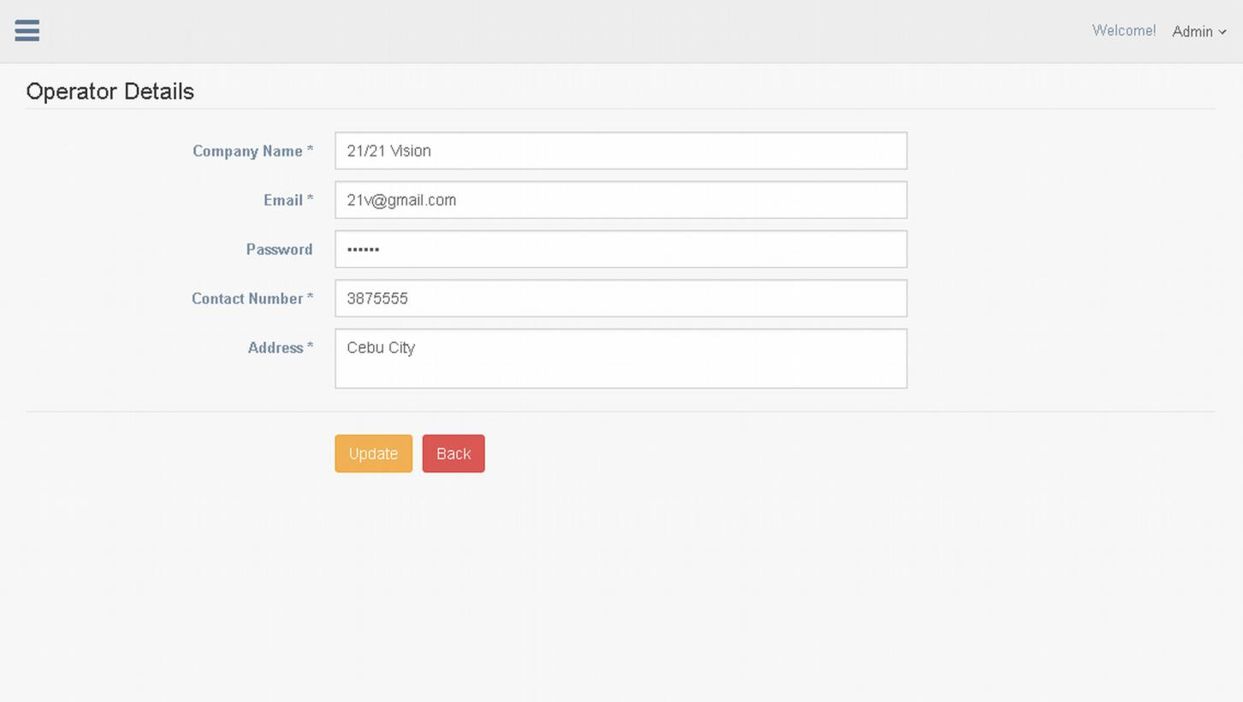1. Click to update operator details.

**1**

**2**

2. Click to go back to previous page. (Manage operators)