**USER MANUAL**

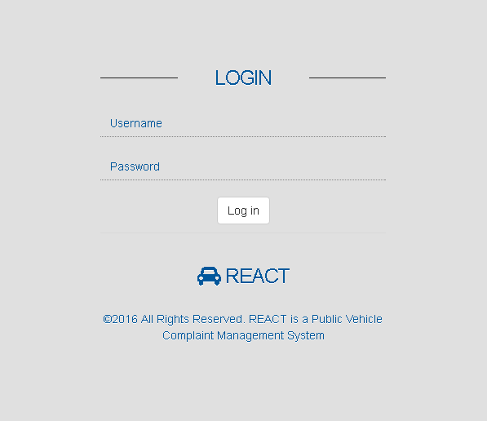LOGIN PAGE

1. Username Field

2. Password Field

3. Login Button

Admin:

Username: admin

Password: admin

Operator:

Username: 21vision

Password: asd123

ADMIN DASHBOARD

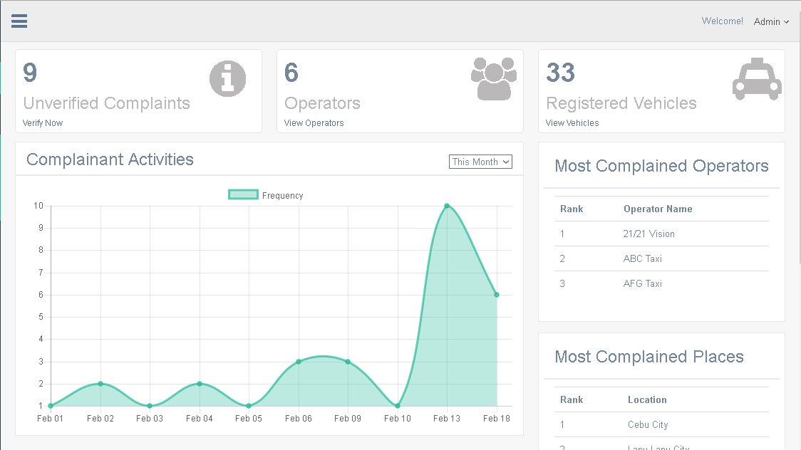

1. Displays unverified complaints of vehicles without operators, click to manage unverified complaints.

2. Displays all registered operators in the system, click to manage operators.

3. Displays all registered vehicles of operators.

4. Displays graphical complaint frequency by month, week and day.

5. Displays the most complained public vehicle operators.

6. Displays the locations with the most public vehicle complaints.

ADMIN SIDE NAVIGATION PANEL

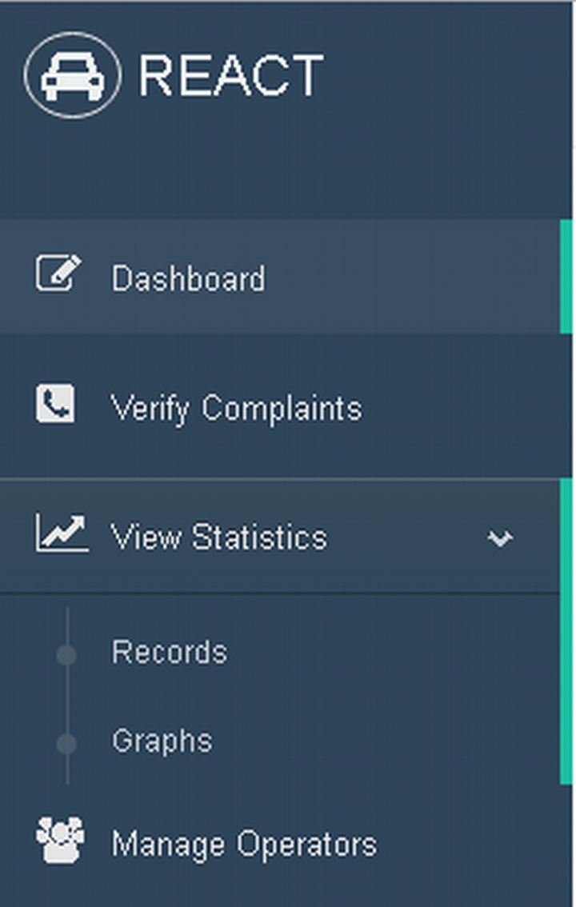

1. Dashboard Tab – Click to display dash board page (default).

2. Verify Complaints Tab – Click to displays verify complaints page.

3. View Statistics Tab – Click to Show the drop-down tabs: Records and Graphs tab.

4. Records tab – Click to display complaint records in detailed statistical interpretation.

5. Graphs tab – Click to displays detailed statistical graph representation of complaints.

6. Manage Operators – Click to displays manage operators page to manage all existing operators.

ADMIN VERIFY COMPLAINTS

