**Computer Programming**

**Experiment 2: Decision Making & Looping (Chapter 4)**

|  |  |
| --- | --- |
| **Class:** |  |
| **ID:** |  |
| **Name:** |  |

1. **Goal**

* Understand the flow control of a C program
* Grasp relational operators and expressions
* Understand, code, and debug decision-making structures (*if-else*, *switch*)
* Understand, code, and debug looping structures (*while*, *do-while, for*)

1. **Requirements**

Please finish your experiment independently. You could use Integrated Development Evironments (IDE), such as CodeBlocks, Microsoft Visual C++, gcc, and Apple XCode. Write out a full program, fix any bugs, and make sure your code is runnable.

1. **Contents**
2. Page 176, Application Program 4.1: Girder Intersection – If-Else Control Structure.
3. Page 179, Application Program 4.2: Area Calculation – For Loop
4. Page 183, Application Program 4.4: Temperature Unit Conversions –Loop and If-Else Control Structure
5. Page 185, Application Program 4.5: Simulation
6. Page 187, Application Program 4.6: Engineering Economics – Nested For Loops
7. Page 191, Application Program 4.7: Solving a Quadratic Equation – If-Else Control Structure (Numerical Method Example)
8. Input an arbitrary number *n*, do the following calculation: *∑n!=1!+2!+3!+4!+5!+…+n!*
9. Get all prime numbers between *100* and *200*.
10. Write three programs to display the following output:

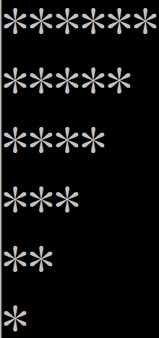 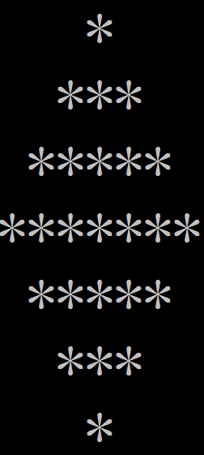 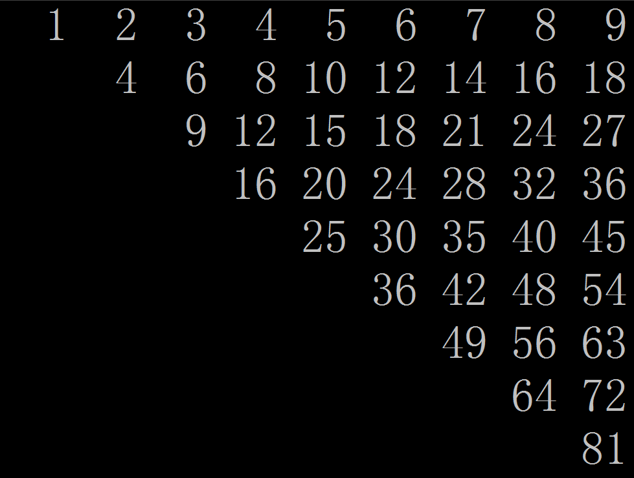

1. **Results & Analysis**

Please describe the IDE you used, list the source code of your program, present your input and output, and analyze your results and the issues you encounter.

(Do not change the above contents. Please provide your answers below.)