**Name of Organization: AKAdeMiX Dance Crew Date: 2/25/2015**

**Total Requested: $8,745.43 Funding Round: Rolling Round III**

**Number of Active Members: 20**

**Number of Meetings/Practices and Events a Month: 12 practices a month**

**General Purpose of the Organization (Brief description including history of the group and past achievements)**

Founded in Spring 2010, AKAdeMiX Dance Crew is a hip-hop dance crew at the University of Virginia highlighting diversity in talent and ethnicity. Our goal is to spread awareness of hip-hop dancing around Grounds as well as to showcase UVa talent at a variety of dance competitions. We have been invited to numerous showcases as well as competitions, many of which we have won.

**How do these requested expenses support the mission of the organization and its day to day activities?**

The requested expenses would allow AKAdeMiX to compete in World of Dance Dallas. This is the largest urban dance event that competes across America and the rest of the globe, showcasing the world's best dance troupes to hundreds of thousands of spectators. It is an extremely prestigious event and we are overjoyed to have qualified as competitors. As a club sport, being able to attend represents competing at the peak of what we do. This is the best opportunity we have ever had to show what the UVa hip-hop dance community has to offer in front the largest dance audience.

**What would you do if your organization did not receive these funds or received less than requested?**

If we do not receive enough funds and the cost per person is too high we will be unable to compete at World of Dance. SAF is our primary, and at the moment only, source of funding and if the amount granted is not enough, we will have to look for alternative means of funding.

**What are your other funding resources?**

We have no other funding resources.

**What are the items for this event or activity that are not eligible for funding and their total amounts?**

There are no items for this event that are not eligible for funding.

**Will any of these events or activities charge a fee for attendance or result in a profit for the organization? *If yes, what is the price and expected profit?***

No

**Items Requested for Funding:**

|  |  |  |  |  |  |
| --- | --- | --- | --- | --- | --- |
| **Name of Item** | **Purpose/Event** | **Quantity** | **Price** | **Total Amount Requested** | **Total Amount Approved (Leave blank)** |
| **Airfare** | **To get to Dallas** | **20** | **$231.20** | **$4,624.00** |  |
| **Hotel** | **Housing for crew** | **4** | **$414.63 per room $103.66 per person** | **$2,073.15** |  |
| **Rental Vehicles** | **To travel to venue / workshops / around Dallas** | **4** | **$387.04 per vehicle for $77.41 per person** | **$1,548.28 for the four days** |  |
| **Competition Fees** | **Required to compete** | **20** | **$25.00** | **$450.00** |  |

On my honor, the requested items and information accurately represent the needs of the organization. *(sign electronically)*

**Yilin Liu**

List below: Links to Invoices and Price Quotes

<http://i.imgur.com/lj3QF3v.png> - Airfare

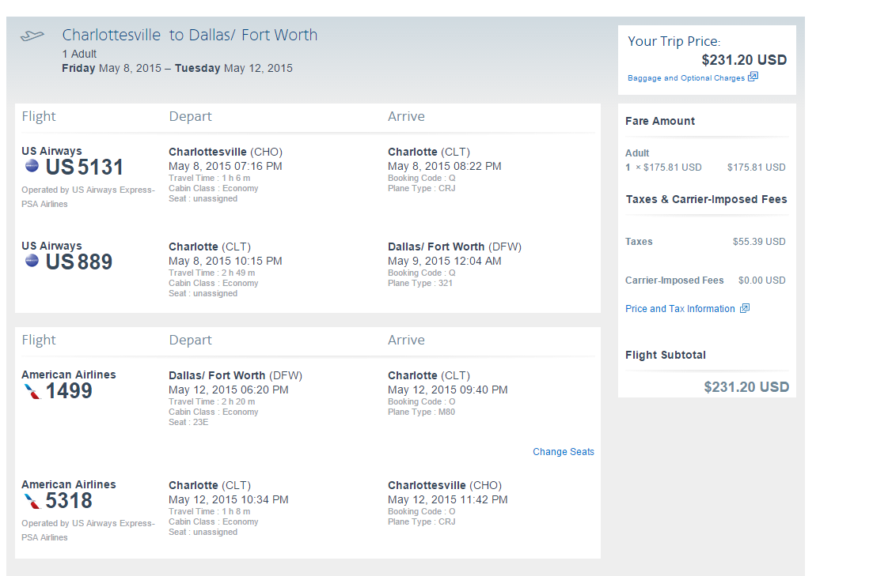

<http://i.imgur.com/pX6n0cS.png> - Hotel

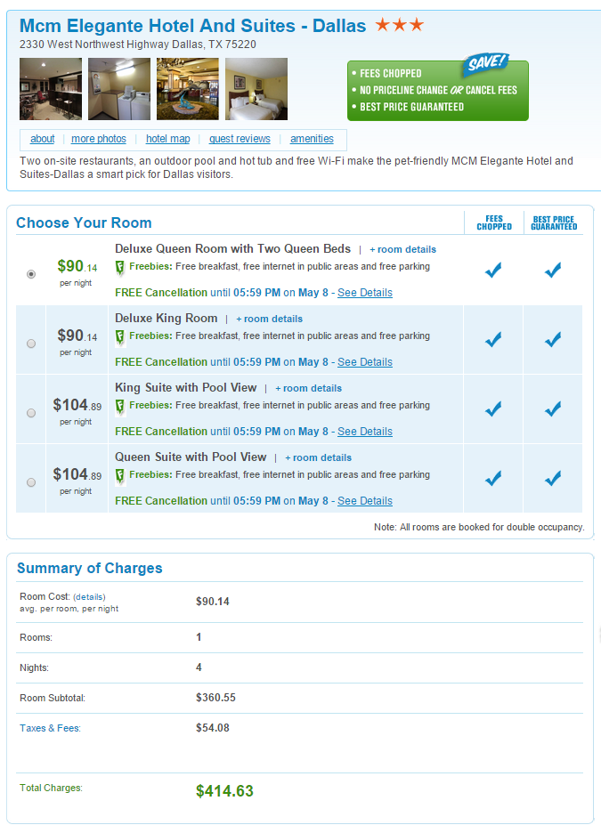

<http://i.imgur.com/6wh0wKK.png> - Rental Vehicles

