**ERD/Data Modeling – 30 Points Total**

Answer the questions on the following page with respect to this ERD of a simple real estate company.

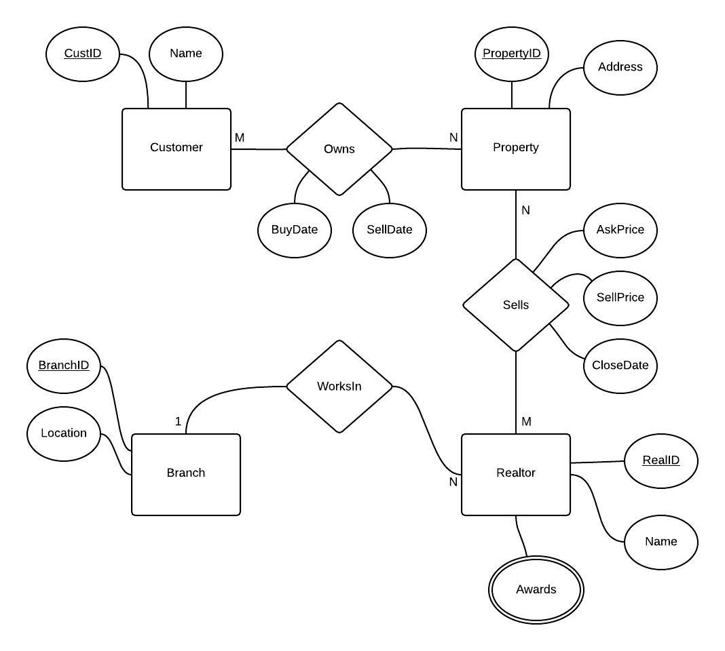

1. Over time, can the same **Property** be owned by different **Customers**? Why or why not?  
   (4 pts)

Yes, the Ownership entity has buy and sell dates as attributes.

1. Does the model support a team of **Realtors** sharing in the sale of a **Property**? Why or why not?  
    (4 pts)

Yes, the Realtor Property relationship is M:N or ‘many to many.’

1. Can the history of a **Realtor** moving from one **Branch** to another be captured? Why or why not?  
   (4 pts)

No, there is no date attribute in either the Realtor or Branch entities.

1. Can a **Customer** own several **Properties**? Why or why not?  
   (4 pts)

Yes, the relationship between the Customers and Property is M:N or ‘many to many.’

1. Are all **Realtors** the winner of multiple **Awards**? Why or why not?  
   (4pts)

No, the Awards only means that a Realtor may have multiple awards.

1. Transform the ERD into a relational schema using well structured relations that satisfy the requirements of the Third Normal Form (3NF). Use the following notation:  
   (10 pts)  
     
   **Relation( KeyAtttibute, Attribute, ForeignKey**)  
   Underline key attributes.  
   Indicate foreign keys as **RED**

Customer(CustID, Name)

Owns(BuyDate, SellDate, **CustID**, **PropertyID**)

Property(PropertyID, Address)

Sells(AskPrice, SellPrice, CloseDate, **RealID**, **PropertyID**)

Realtor(RealID, Name)

Awards(**RealID**, Awards)

Branch(BranchID, Location)