HERALD!



Send your current estimated time of arrival (ETA) to your destination via SMS automatically.

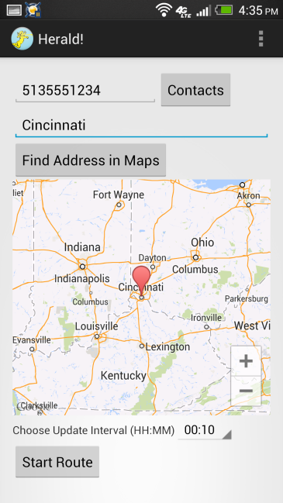Herald! will allow you to provide your friends and family with real-time travel updates without texting and driving. With the power of Google Maps, Herald! finds your current location and the ETA to your destination and updates a person of your choice on your trip.

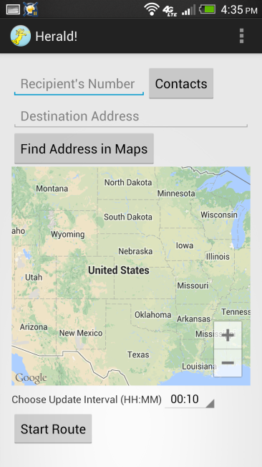 Herald!’s UI is simple and easy to use. Simply enter the number of the person you want to receive updates, the address of your destination, select the time interval between updates and hit “Start Route”. Also, you can use the “Find Address in Maps” button to verify Google Maps found the correct address.

Developed by: Connor Pike and Jacob Holbrook