**Herald!**

**Specifications Document**

**Ver. 1.0**

**Application Name:**

System Metaphor:

Sends your current estimated time of arrival (ETA) to your destination via SMS.

Authors: Connor Pike, Jacob Holbrook

**Use Case Diagram:**

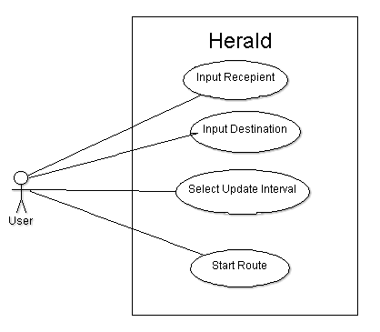

**User Stories:**

Pre-alpha Release 0.1:

* Users want to select recipient via phone number and contacts
* <filler text>

Pre-alpha Release 0.2:

* <filler text>
* <filler text>