**Herald!**

**Specifications Document**

**Ver. 1.0**

**Application Name:**

System Metaphor:

Sends your current estimated time of arrival (ETA) to your destination via SMS.

Authors: Connor Pike, Jacob Holbrook

**Use Case Diagram:**

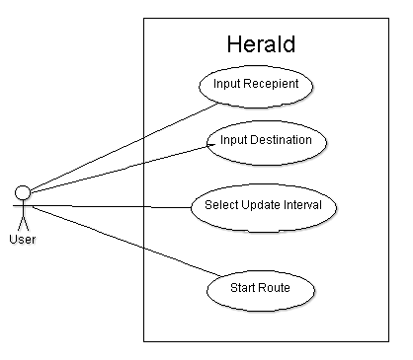

**User Stories:**

Pre-alpha Release 0.1:

* Users want to select recipient via phone number or email (interface with Contacts)
* <filler text>

Pre-alpha Release 0.2:

Alpha Release 0.1:

* Users want to select destination via Google Maps.
* <filler text>

**Test Plan:**

|  |  |  |  |
| --- | --- | --- | --- |
| Test Id | Description | Expected Results | Actual Results |
| 001 | Precondition: contacts exist, Recipient Field is empty, A contact is selected | The contacts number populate the Recipient field |  |
| 002 | Precondtion: contacts exist, Recipient Field is empty  The user attempts to enter something other than a phone number in the recipient field | Nothing is entered |  |
| 003 | Precondition: the Destination field is empty  User enters address of destination into google maps | The address destination populates the destination field. |  |