CS 255 System Design Document

UML Diagrams

UML Use Case Diagram
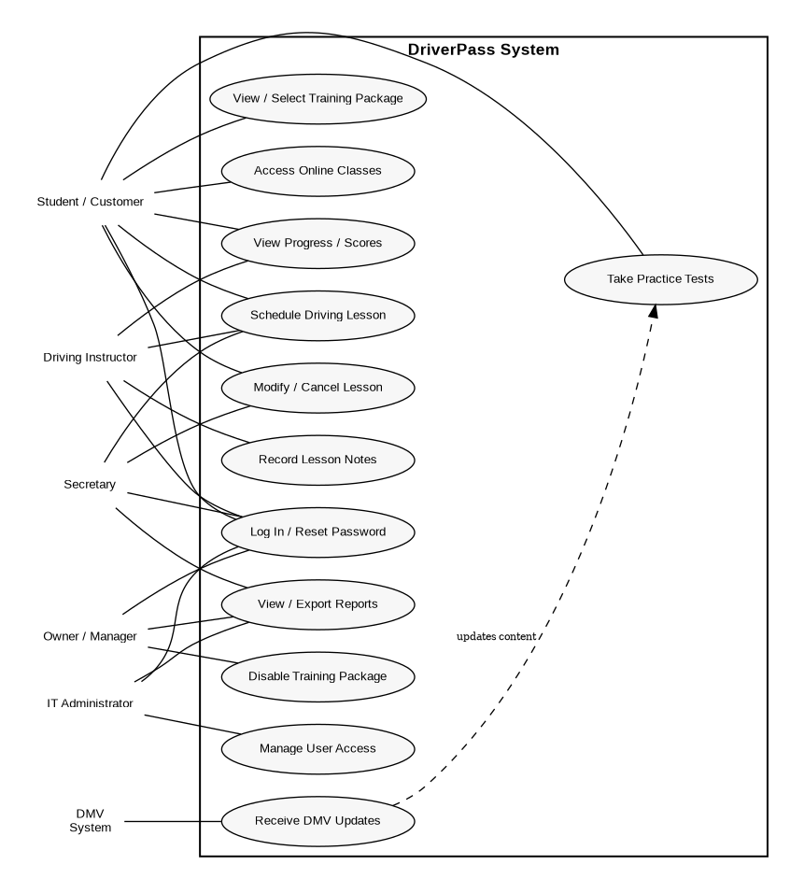

Figure 1. DriverPass UML use case diagram.

UML Activity Diagrams
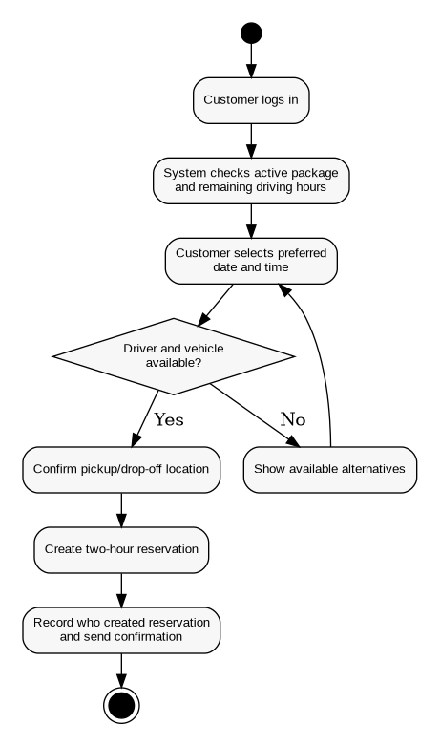
Activity Diagram 1: Schedule Driving Lesson
Activity Diagram 2: Take Practice Test

UML Sequence Diagram
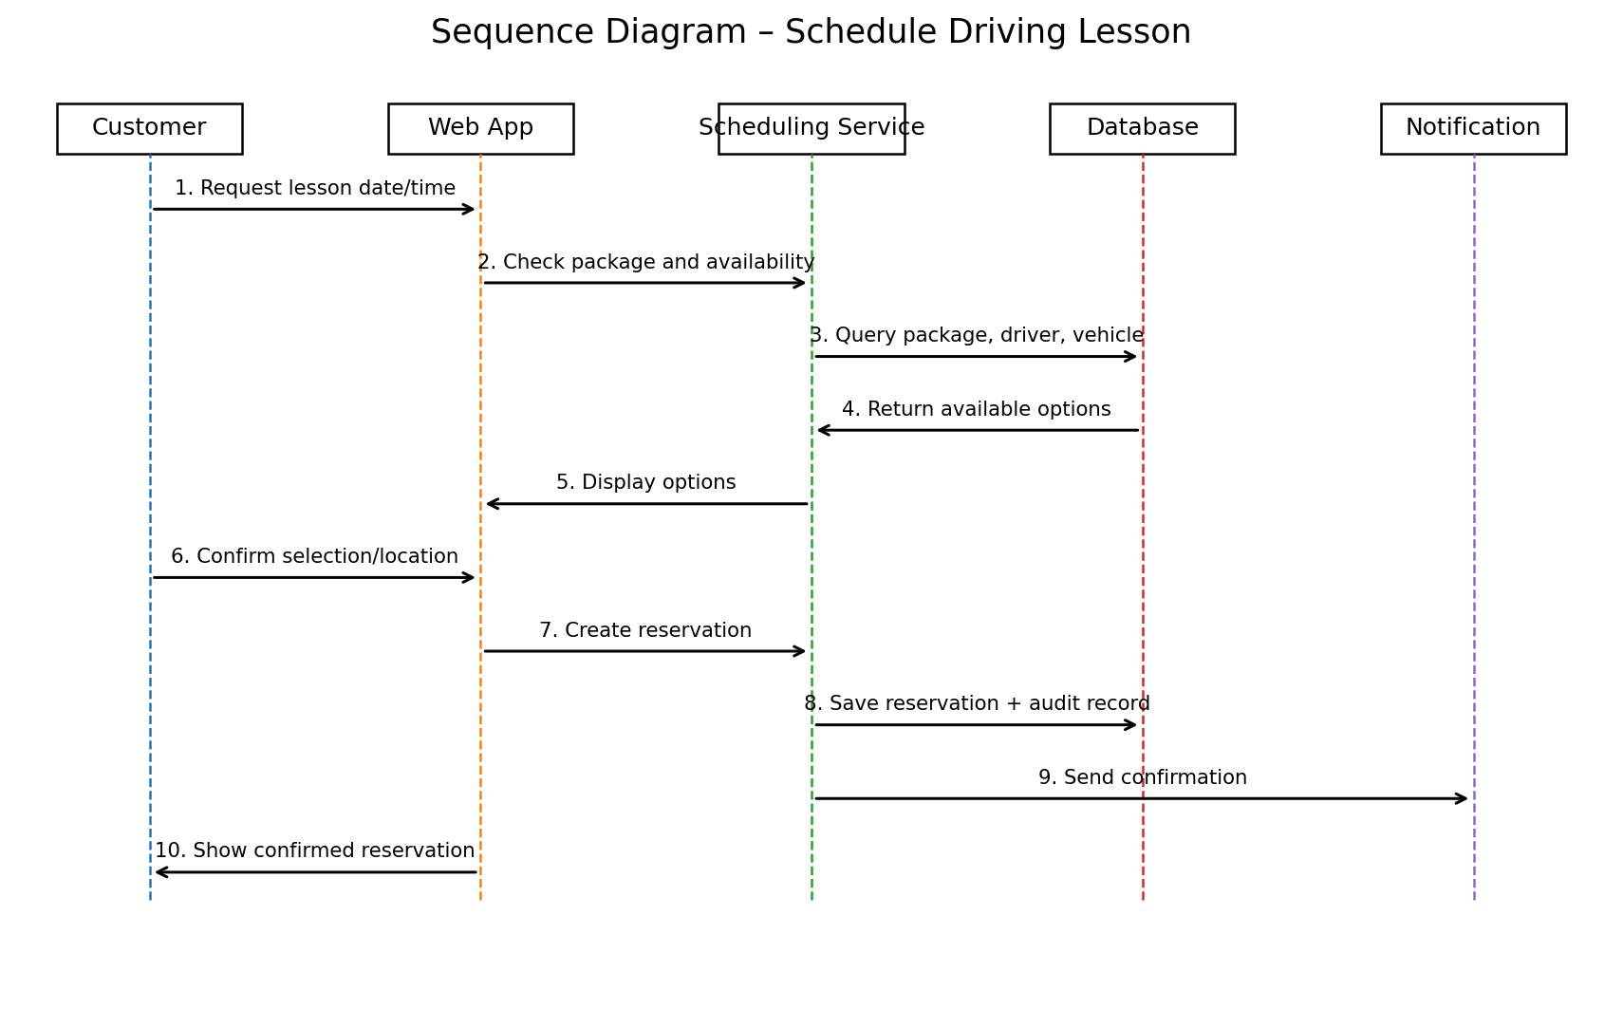

Figure 4. Sequence diagram for scheduling a driving lesson.

UML Class Diagram
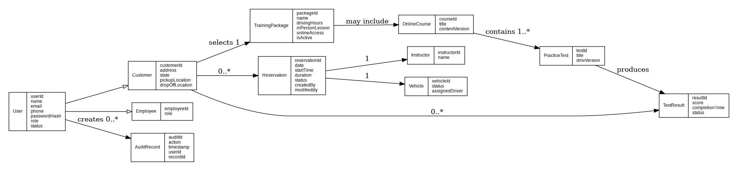

Figure 5. DriverPass UML class diagram.

Technical Requirements
The DriverPass system should be implemented as a secure, web-based application so customers and employees can access it from standard computers and mobile devices. The client does not require specialized end-user hardware; users need an internet-connected device with a current web browser. DriverPass staff will also need reliable office internet access and standard workstations for scheduling, account administration, and reporting.
Software requirements include a responsive web interface, an application layer that enforces scheduling and package rules, and a relational database for customer accounts, training packages, reservations, vehicles, instructors, practice tests, scores, and audit history. The system should support role-based permissions for customers, the secretary, instructors, the owner/manager, and the IT administrator. Password-reset capability, account blocking, encrypted network connections, secure password storage, and protected handling of customer/payment information are required. Reports should be viewable in the system and exportable to a format that can be opened in spreadsheet software such as Excel.
The infrastructure should use a centrally hosted server environment, preferably cloud-hosted, with routine backups, recovery procedures, monitoring, and enough capacity to support concurrent web and mobile access. All changes to live records must occur while connected to the central system so DriverPass does not create conflicting or duplicate copies of data. The system should also provide an integration point for DMV rule, policy, and sample-question updates so training content can remain current.
Development and design tools include Lucidchart for UML modeling, a modern integrated development environment for implementation, source control for version management, database administration tools, and automated/manual testing tools. The design should remain modular so future releases can add or remove training modules or packages; in the initial release, authorized management users can disable a package so new customers cannot select it.

