IST 263 Project Milestone 3 – Site Media
Name: Jie Mi
Description:
My website, “Better Call Jie Mi,” is inspired by the humorous “Better Call Saul” advertisements from the
television series Better Call Saul. In real life, whenever my friends—especially international Chinese
students and Chinese immigrants in Syracuse—run into a strange or difficult problem, I am often the
first person they think of calling. That is why I decided to create “Better Call Jie Mi.”

Since Ms. Gao, who previously assisted Chinese students at SU’s international student center, left, my
friends joke that I have unofficially taken over many of the unusual problems she used to encounter. All
services are unofficial and available exclusively to friends of Jie Mi. (Overall it is just a funny and
nonsense website
URL to Images on Github:
Login to github.com and navigate to your images folder for the project. Copy the url and paste it here.

Example Site Media Entries
Media Thumbnails | Page | Usage Rights | Citation (if applicable)
 | Home Page | Creative Commons License
Video: https://youtu.be/pQN-pnXPaVg | About Page | NA
 | Home Page | I own this image

NOTE: You need to legally use all your images. The options for usage writes should be: I own this, creative commons, free stock, or some other way you legally use the image. Embedded content gets the NA (not applicable).

Your turn! Enter your images below. FYI – the images you find need to be quite large to look good on your website. If the image you find is tiny, keep looking.
Media Thumbnails | Page | Usage Rights | Citation (if applicable)
https://v.douyin.com/Shj_rcF_VcQ/ 9@9.com :4pm | Home Page | Open Use for Content Creaters | Music Open To use
https://v.douyin.com/jGU5pvznJFI/ 3@3.com :4pm | 1 | Open Use for Content Creaters | Music Open To use
https://v.douyin.com/XCygKD5G8hI/ 1@9.com :0pm | 2 | Open Use for Content Creaters | Music Open To use
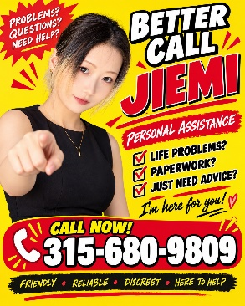 | Home Page | I own this image， thx chatgpt
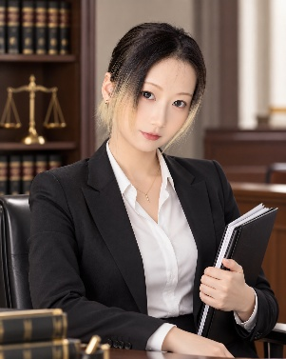 | 2 | I own this image， thx chatgpt
 | 1 | I own this image， thx chatgpt
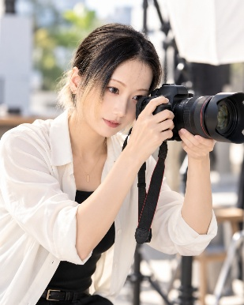 | 1 | I own this image， thx chatgpt
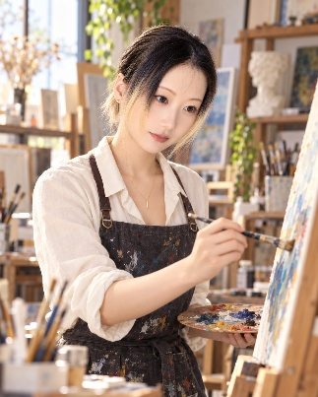 | 1 | I own this image， thx chatgpt
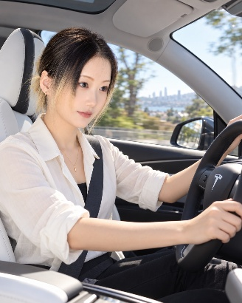 | 2 | I own this image， thx chatgpt
 | 1 | I own this image， thx chatgpt
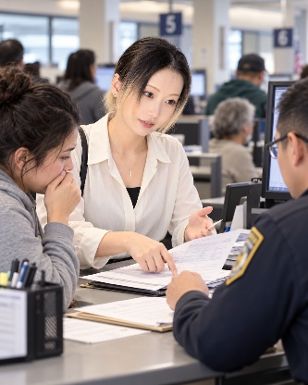 | 2 | I own this image， thx chatgpt
 | 2 | I own this image， thx chatgpt
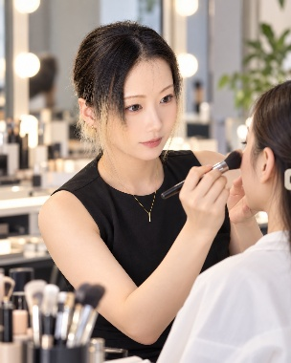 | 1 | I own this image， thx chatgpt
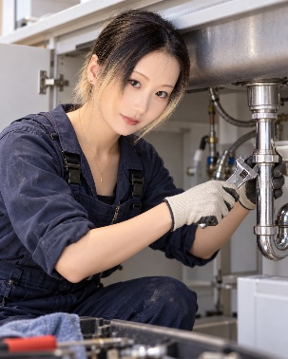 | 2 | I own this image， thx chatgpt

