
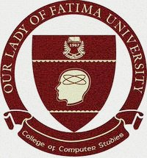
OUR LADY OF FATIMA UNIVERSITY
Km 23, Sumulong Highway, Bgy. Sta. Cruz, Antipolo City
COLLEGE OF COMPUTER STUDIES

March 11, 2026

DR. ALICIA Q. TABLIZO, LPT, RPm
Program Head, College of Arts and Sciences,
OLFU – Antipolo City

Dear Dr. Tablizo:

Greetings!

In partial fulfillment of the requirements for the subject Capstone 1, the students enrolled are required to conduct a company visit, leading to the preparation, documentation and presentation of the research study on a topic of Capstone importance.

The aim of the said study is to prepare the students as well as to expose them in actual application of Capstone.

In this regard, I would like to request your good office to allow our students to conduct an interview at your department.

Any favor accorded will be highly appreciated and would mean that your company is one with us in helping students strengthen our education.

Rest assured that all information gathered will be treated with utmost confidentiality and will be used for classroom discussion only.

Hoping for your favorable action.

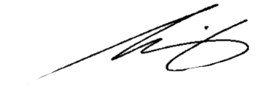
Very truly yours, Group Members:
John Michael C. Felix
REYNOLD A. DELIZO, MSIT Jaymee Alyssa R. Santos
Professor, College of Computer Studies Ronnel O. Ignacio
Hazel Ann F. Asuncion

Noted by:

BENJAMIN B. GANDEZA, MIT, DIT(c)
Program Head, College of Computer Studies

