***CASE 1***

Files and terminal:

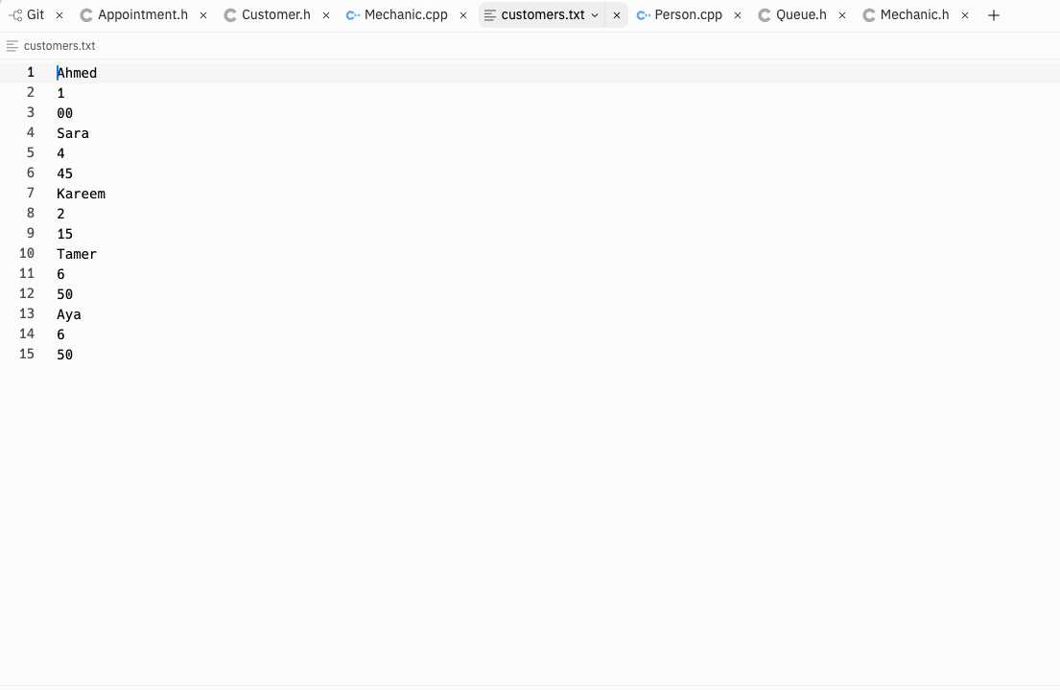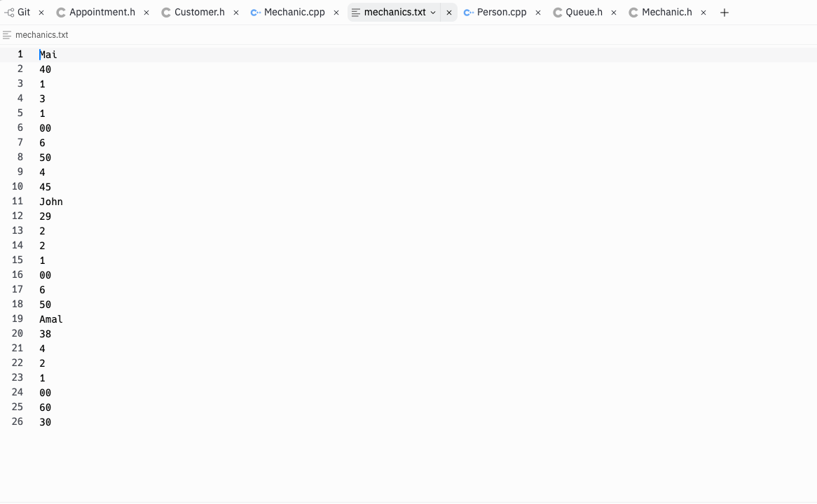

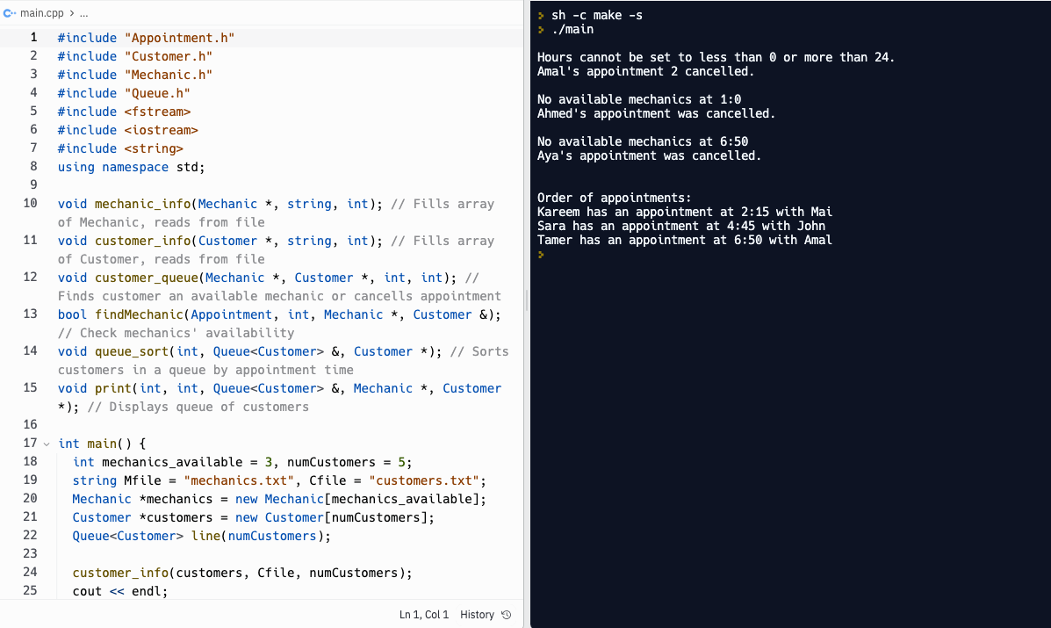

Explanation:

* Amal’s second appointment was set to 60:30🡪 program cancelled her appointment.
* All mechanics were unavailable at 1:00🡪 Ahmed’s appointment was cancelled.
* John and Mai weren’t available at 6:50, but Amal was, so Tamer’s appointment was recorded.
* Since Tamer registered his appointment first, Aya, who also wanted to register at 6:50, had her appointment cancelled.
* Then the terminal displayed all customers who didn’t have their appointments cancelled times in order.

***CASE 2***

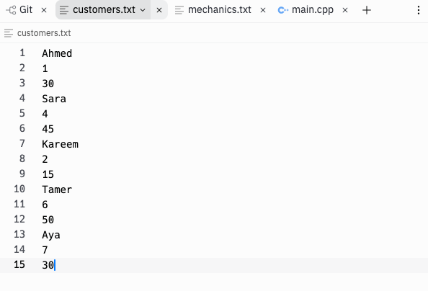Files and terminal:

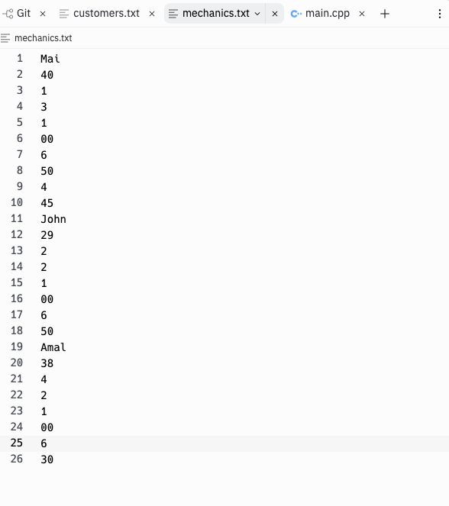

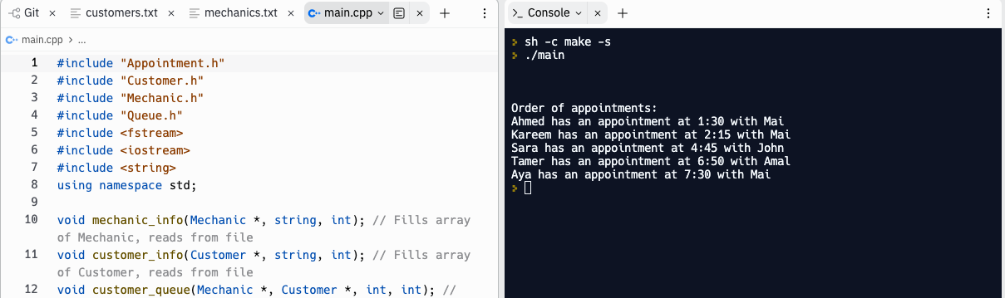

Explanation:

* Corrected Amal’s 60:30 appointment to 6:30 🡪 error no longer displayed
* Changed Ahmed’s appointment to 1:30🡪 error no longer displayed
* Changed Aya’s appointment to 7:30🡪 error no longer displayed
* Now terminal prints all 5 customers’ appointments in order