State of the Student Housing Market
New-supply cohort · National scope
Prepared for Subtext Living · June 18, 2026 · Data as of 2026-06-01
This report covers 130 purpose-built student housing buildings delivered between 2023 and 2026, each over 100 beds and within one mile of campus, across 31 Subtext-30 and Pursuit markets. Data as of 2026-06-01. Rent uses stabilized buildings (occupancy at least 85%); occupancy and prelease use all operating buildings; the whole-market benchmark is the full tracked market from the dashboard.

Executive Summary
This cohort covers 130 purpose-built student-housing buildings delivered 2023 through 2026, all over 100 beds and within a mile of campus, across 31 Subtext-30 and Pursuit markets (75,337 beds, 9,123 units, as of June 1, 2026). The headline is a durable new-product premium. On the June anchor, stabilized new supply rents at about $1,386 per bed in the 2026 delivery year versus $1,085 for the whole tracked market, a premium of roughly $300 per bed, or 28%. That gap has held remarkably steady: it was 31% for 2024 deliveries and 28% for both 2025 and 2026. New product is not pricing itself out of the market, it is holding a consistent spread above it.
Demand is keeping pace with the rent. Stabilized 2023 and 2024 vintages are running 95-97% occupied, and 2026 deliveries are preleasing at about 78%, essentially in line with the whole market (77.4%) despite the premium and despite being unproven product. Rent growth has cooled, though. Same-store June rent rose only 1.1% year over year (2026 vs 2025) across the cohort, well below the 3.2% logged on the October anchor a year earlier. New supply can still command its premium, but it is no longer pushing rate hard on top of it.
The product itself is changing in three visible ways. Floor plans are getting larger on a per-bed basis (2026 deliveries average 388 SF per bed versus roughly 350 for 2023-2025), driven by a heavier mix of 2x2 (407 SF/bed) and 1x1 (437 SF/bed) plans and fewer compact studios. Parity, beds matched one-to-one with private baths, is declining as a share of beds, from 88.5% in 2023 to 73.7% in 2026, with shared-bath non-parity layouts taking the difference. And amenities are tilting hard toward wellness: sauna, yoga, cold plunge and hot tub are now the most common emerging features, while pet amenities are fading and smart fitness remains the least adopted category (36%).
Bottom line. New supply holds a steady 28% rent premium over the whole market with prelease in line with it, so the pricing model works; the strategic question for Subtext is product, not price, specifically whether to follow the drift toward larger, lower-parity plans and a wellness-led amenity package or to protect the higher rent-per-bed of compact, full-parity layouts.

Trends at a Glance

Cohort by delivery vintage
The new-supply cohort broken out by delivery year. Occupancy of 0 marks 2026 product still in lease-up.
Vintage | Bldgs | Beds | Rent/Bed | Occ | Prelease | SF/Bed | Parity%
2023 | 43 | 23,279 | $1,336 | 96% | 78% | 354 | 88%
2024 | 32 | 20,091 | $1,436 | 95% | 77% | 350 | 85%
2025 | 25 | 14,756 | $1,467 | 93% | 79% | 346 | 75%
2026 | 30 | 17,211 | $1,362 | lease-up | 78% | 388 | 74%

Cohort vs whole market, by year
New-supply cohort performance against the whole tracked market, June anchor.
Year | New Rent/Bed | Market Rent/Bed | Premium | New Occ | New Prelease
2024 | $1,363 | $1,041 | +30.9% | 92% | 83%
2025 | $1,358 | $1,061 | +28.0% | 93% | 84%
2026 | $1,386 | $1,085 | +27.7% | 95% | 78%

Key time series
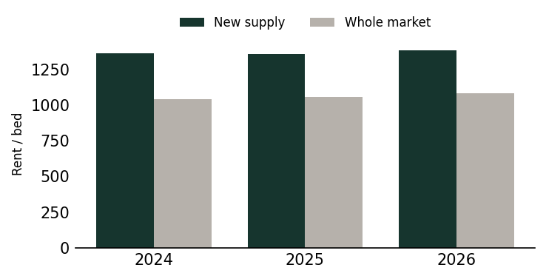
Rent per bed: new supply vs the whole market, by year. The premium holds across vintages.
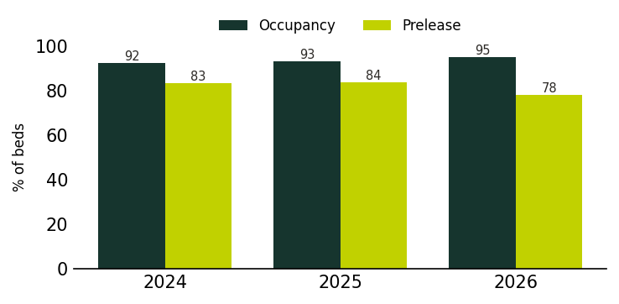
Cohort occupancy and prelease by year (June anchor). Demand keeps pace with the premium.
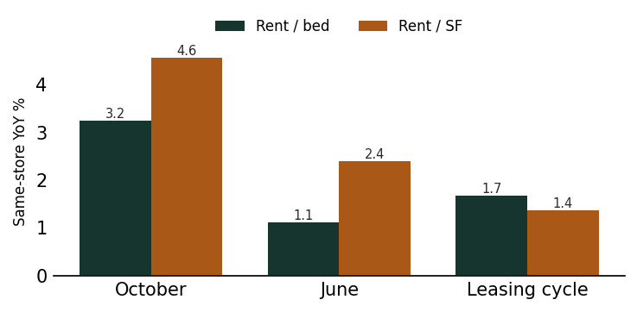
Same-store rent growth by anchor. Momentum has cooled toward the June read.
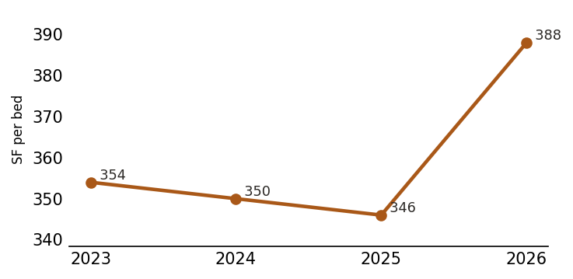
Average square feet per bed by delivery vintage. 2026 product steps up in size.

1. Pricing & Position vs the Market
New supply prices well above the broader market and has stayed there. Using the June anchor (both series June-aligned), stabilized cohort rent runs $1,363 per bed for 2024 deliveries, $1,358 for 2025, and $1,386 for 2026, against whole-market benchmarks of $1,041, $1,061, and $1,085. That is a premium of $322 (31%), $297 (28%), and $301 (28%) by year. The premium is a genuine new-product spread, not a market-wide rent level, and it has been stable across three delivery years even as more supply came online.
Demand supports the rate. Stabilized vintages are full: 2023 deliveries sit at 96.5% occupancy and 2024 at 94.9% on the latest read. The 2026 cohort is preleasing at about 78%, almost identical to the whole market at 77.4%, which says renters are willing to pay the premium without a prelease penalty. Across all operating buildings the blended occupancy of 73.3% looks soft, but that is diluted by 2026 lease-up product that is not yet occupied; the stabilized read is the cleaner signal.
What has changed is the pace of rent growth, not the level. Same-store June rent grew only 1.1% year over year (2026 vs 2025) and 2.4% on a per-SF basis, down sharply from the 3.2% rent and 4.6% SF growth recorded on the October 2025 anchor. The 2025 vintage in particular shows almost no same-store rent movement (+0.2%) while still adding SF. The read for Subtext: the premium is bankable, but underwriting fresh deliveries on continued 3%+ trade-outs is aggressive given where same-store growth has landed.

2. What's Being Built, by Vintage
The unit mix is shifting away from the smallest, highest rent-per-bed product. Studios fell from 8.7% of beds in 2023 deliveries to 7.2% (2024), 5.2% (2025) and just 2.4% (2026). The 4BR remains the workhorse, holding the largest bed share in every vintage and peaking at 52.1% in 2024 before settling near 45% in 2026. 1BR share is volatile but ticked up to 7.8% in 2026, its high across the cohort. The net effect is a product getting slightly more share-friendly (more beds in multi-bed units) at the unit level while still leaning on the 4-bed box.
Floor plans are getting bigger per bed. Stabilized 2023-2025 vintages cluster around 346-354 SF per bed, but 2026 deliveries jump to 388 SF per bed in the latest read. The driver is plan mix, not bigger bedrooms in the same plans: 2026 carries more 2x2 (407 SF/bed, $1,457) and 1x1 (437 SF/bed, $1,727) inventory plus a set of oversized plans (3x2.5 at 500 SF/bed, 4x4.5 at 505 SF/bed). The 4x4, still the single largest layout at 5,980 beds, stays compact at 328 SF/bed and $1,302. Blended rate per SF actually fell in 2026 (about $3.51 latest vs $4.24 for 2025 deliveries), consistent with more square footage per bed at a roughly flat per-bed rent.
The trajectory points to larger, more apartment-style product. Developers are adding space and 1BR/2BR options rather than pushing more compact 4x4 beds, even though the compact beds carry the better rate per SF. If the market is rewarding space, the design question for Subtext is where the efficient frontier sits: how much SF per bed renters will actually pay for before per-bed rent flattens, which is exactly what the 2026 numbers start to show.
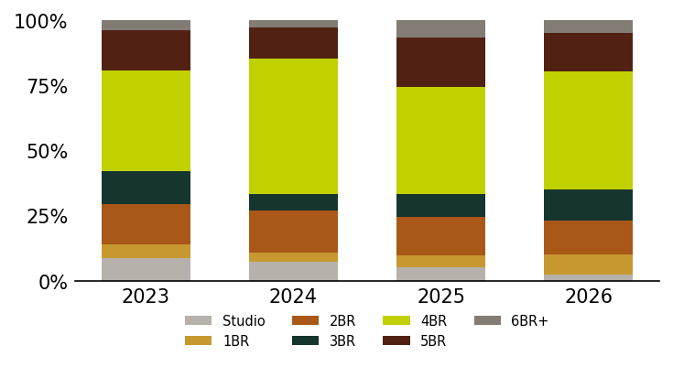
Bed mix by delivery vintage. Studios shrink and large plans hold as the cohort ages.

3. Parity & Layout Economics
Parity is in clear decline. Beds with a private bath (parity, studios included) fell from 88.5% of the cohort in 2023 to 85.2% (2024), 75.2% (2025) and 73.7% (2026). Shared-bath non-parity layouts picked up most of the difference, rising from 10.0% to a peak of 24.5% in 2025 before easing to 18.7% in 2026, with bath-heavy plans accounting for the small remainder. So roughly a quarter of recent beds now share baths, a real shift from the near-universal private-bath product of 2023.
Per-bed pricing power is uneven across layouts, and it does not simply reward more baths. The small private-bedroom plans carry the top rents: 1x1 runs $1,727-$2,009 per bed across vintages and studios $1,463-$1,979, both well above any shared plan. Among the larger configurations, the 2x2 (about $1,400-$1,463) and 3x3 (about $1,347-$1,499) consistently out-earn the 4x4 ($1,248-$1,437) and 5x5 ($1,211-$1,483) on a per-bed basis. The 4x4, the most-built large plan, sits at the lower end of per-bed rent precisely because its compact bedrooms (around 320-330 SF/bed) maximize bed count per unit. In other words, bed density trades against per-bed rate.
Where the pricing power sits: smaller-headcount, private-bath plans (studio, 1x1, 2x2) capture the highest per-bed rent, while the high-density 4x4/5x5 product wins on total beds and revenue per unit but not per bed. The drift toward more non-parity beds is a cost and yield play, not a rent play; shared-bath beds price below parity in most vintages (2023 non-parity $1,236 vs parity $1,351). For Subtext, the choice is explicit: full-parity compact product protects rate per bed, while leaning into shared baths and bigger units chases total beds and construction efficiency at a lower per-bed rent.
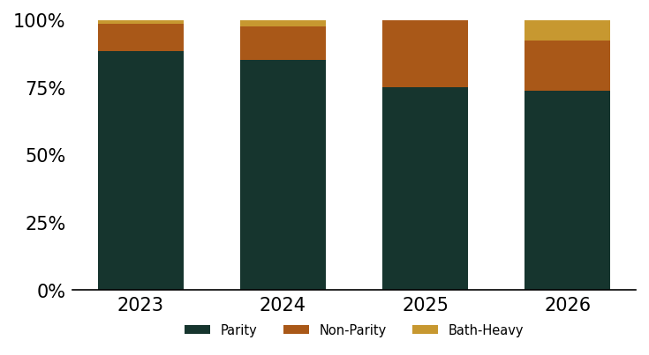
Parity (private bath, studios included) vs shared-bath beds by vintage.
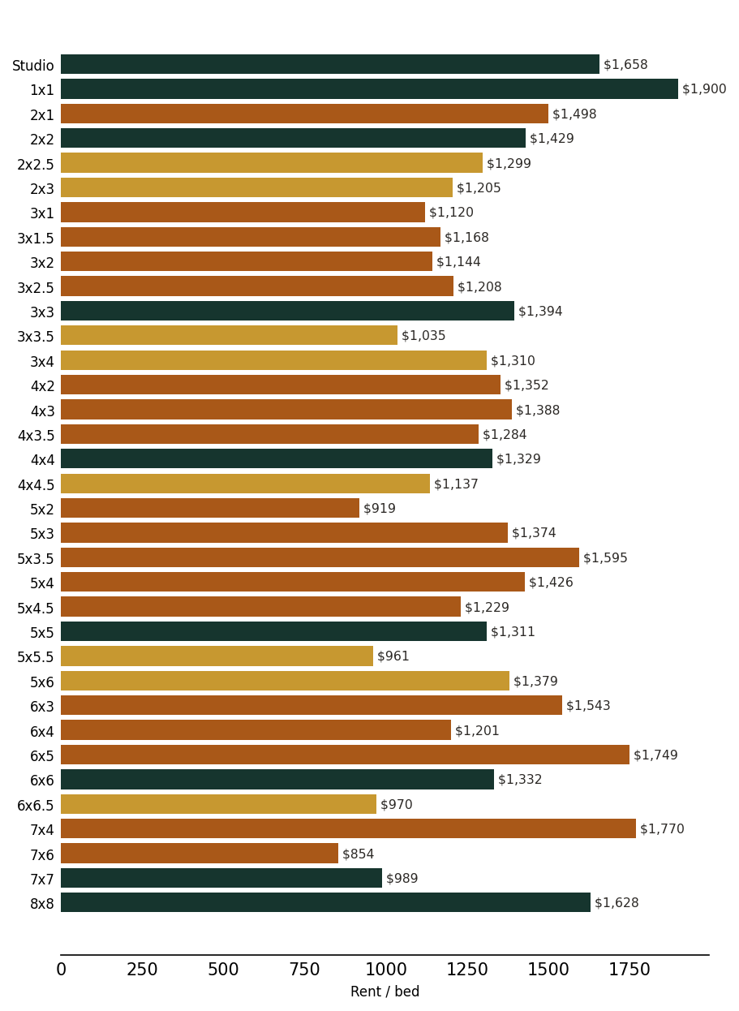
Rent per bed by layout (BRxBA). Small private-bath plans carry the top per-bed rent.

4. Amenities & Emerging Trends
Five categories are now effectively table stakes across the 130 buildings: access technology (75%), outdoor space (72%), convenience services (70%), coffee/F&B (69%) and wellness (66%). Entertainment (64%), mobility (59%) and pet (58%) form a second tier. Novel features appear in about half (49%), and smart fitness is the clear laggard at 36%, the only category present in barely a third of buildings. Buildings average 10.5 distinct emerging amenities each, so the differentiation game is now about which extras, not how many.
The adoption curve by delivery year shows wellness as the real mover. Wellness rose from 53% of 2023 deliveries to 69% (2024), 68% (2025) and 80% (2026), the steepest climb of any category and now the most common feature in the newest product. Novel amenities jumped from a steady 44% in 2023-2025 to 67% in 2026, the other standout. Access technology crept up to 80%. Moving the other way: pet amenities fell from 63% (2023) to 47% (2026) and mobility softened, suggesting some early-cycle features are being cut as developers reallocate amenity budget toward wellness and signature novel features.
The top emerging amenities confirm the wellness tilt. Sauna leads (21 buildings, 16%), followed by yoga studio (19, 15%) and bike storage (19, 15%), then dog park (13, 10%), coffee bar (12, 9%) and keyless entry (10, 8%). The wellness frontier runs deeper: hot tub (9), cold plunge (7), tanning bed (6), spa with sauna (4). The novel/experiential frontier is where buildings are trying to stand out: poolside jumbotron (8), golf simulator (5), pickleball court (5), sky lounge (4). For Subtext, sauna and yoga are fast becoming expected in premium new product, while cold plunge, golf sims and pickleball are still rare enough to differentiate.
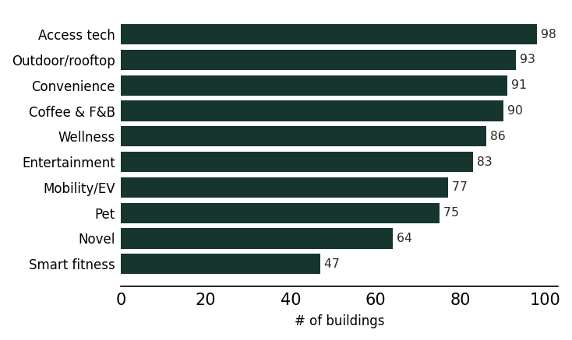
Emerging amenity categories by count of buildings (of 130 scraped).
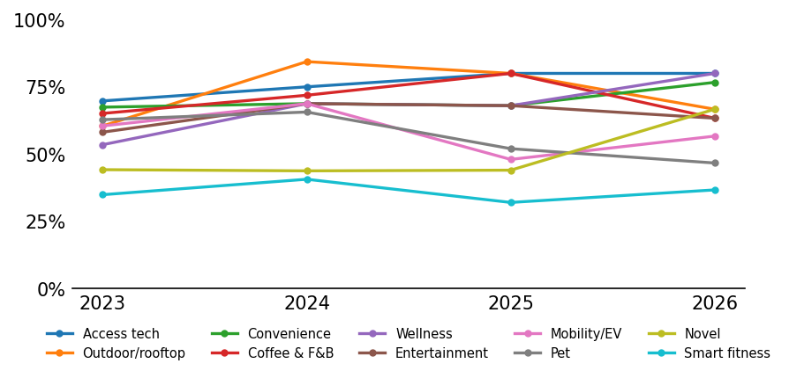
Amenity-category adoption by delivery year. Wellness is the steepest climber.
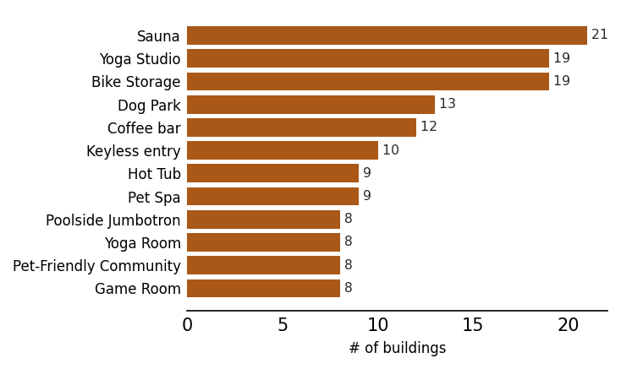
Most common specific emerging amenities across the cohort.

5. Fees & Bill-Backs
Fee norms are consistent across the cohort. The median application fee is $50 (n=49) and the median admin fee is $150 (n=45). Parking is a billed add-on at 62% of buildings and pet fees apply at 56%, so paid parking is now the majority practice and just over half of buildings monetize pets even as pet amenities themselves are being trimmed from newer deliveries.
Utility bill-backs are the largest cost residents carry beyond rent. RUBS (ratio utility billing) is in place at 64% of buildings, and trash is included in rent at only 33%, meaning most residents are billed back for trash on top of utilities. Conservice is the dominant biller (27 buildings), with ClearCharge a distant second (10) and SimpleBills, WhiteSky and Entrata appearing in single buildings. The practical takeaway: a resident in a typical building pays the quoted bed rent plus RUBS utilities and trash, likely paid parking, and a pet fee if applicable, so the effective all-in cost sits meaningfully above the headline per-bed rate, and the premium reads larger to residents than the rent comparison alone suggests.
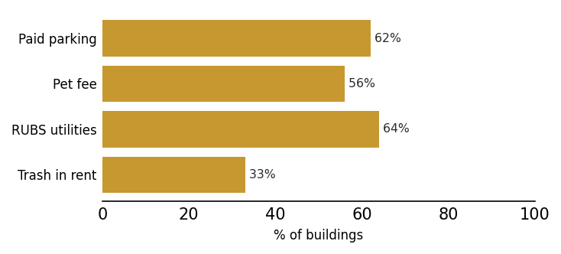
Cost practices: share of buildings charging for parking and pets, billing utilities via RUBS, and including trash.

6. Subtext-30 vs Pursuit
The two cohorts overlap (15 markets are in both; the Subtext-30 set spans 27 markets and 117 buildings, Pursuit spans 19 markets and 88 buildings), so the comparison is about emphasis rather than two separate universes. On pricing, blended rents are nearly identical ($1,387/bed S30 vs $1,384/bed Pursuit), but the premium over the local whole market is wider in Subtext-30 markets: 27-30% across vintages versus 24-28% in Pursuit. Subtext-30 markets carry the bigger headline rents, including the highest-rent markets in the set (Colorado Boulder near $2,129, Michigan around $2,049, Pittsburgh $1,737).
Rent momentum favors Subtext-30. Same-store June rent grew 1.1% in S30 versus only 0.4% in Pursuit, and the October-anchor gap was wider still (3.3% vs 2.1%). Pursuit-only markets are softer on recent rent traction. On composition, Pursuit deliveries swung harder on parity, dropping to 70% parity in the 2025 vintage (vs 77% for S30) before snapping back to 79% in 2026, while S30 held a steadier high-70s parity level; Pursuit also builds slightly more compact (347 SF/bed blended vs 354 for S30).
On amenities the two are close. Subtext-30 buildings carry marginally more emerging amenities (10.7 vs 10.2 per building) and lead slightly on novel features (51% vs 44%), consistent with more premium, differentiated product in those markets. Pursuit edges ahead only on smart fitness (39% vs 37%). Wellness adoption is essentially the same (66% vs 64%). Net: Subtext-30 markets are the higher-rent, higher-premium, better rent-growth, more amenity-rich segment, while Pursuit-only markets price a touch tighter to their local market and have shown weaker recent rent traction.
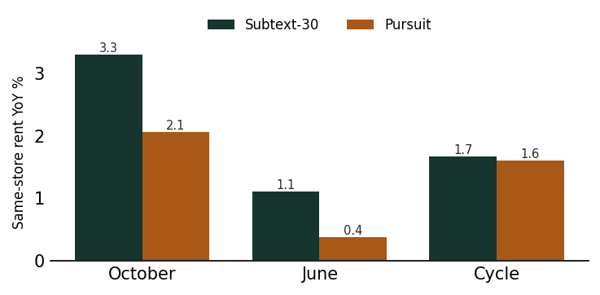
Same-store rent growth, Subtext-30 vs Pursuit, by anchor. S30 holds more momentum.

What to Watch
- Same-store rent growth has cooled to about 1% on the June anchor (0.4% in Pursuit). Underwrite new deliveries on a flat-to-low-single-digit trade-out, not the 3%+ seen on the October 2025 read.
- The 28% premium has held across three delivery years and prelease tracks the whole market. The pricing model is proven; the open question is product, not rate.
- Parity has fallen from 88.5% (2023) to 73.7% (2026) while parity/private-bath beds still earn the rent premium. Decide deliberately whether shared-bath beds are a yield/cost play worth the lower per-bed rent in each specific market.
- Per-bed rent is highest in studio/1x1/2x2 and lowest in the high-density 4x4. The 2026 move toward larger SF per bed flattened per-SF rent. Find the SF-per-bed point where renters stop paying more per bed before designing up.
- Wellness (sauna, yoga, cold plunge) is now expected in premium product (80% of 2026 deliveries). Treat sauna and yoga as table stakes; use cold plunge, golf sim and pickleball, still rare, as the differentiators.
- Pet amenities are being cut (63% to 47%) even as pet fees stay common (56%). Confirm whether dropping pet amenities hurts lease velocity in pet-heavy markets before trimming them from a Subtext program.
- All-in resident cost runs well above headline rent: RUBS at 64% of buildings, trash included at only 33%, paid parking at 62%, plus a $50 application and $150 admin median. Model the effective all-in figure when positioning against the market, not just bed rent.

Data Appendix: New Supply by Market
Market | Bldgs | Beds | Rent/Bed | Occ | Prelease
University of Texas at Austin | 8 | 6,820 | $1,595 | 91% | 87%
Florida State University | 9 | 6,785 | $1,297 | 59% | 76%
University of Tennessee | 7 | 5,325 | $1,345 | 75% | 86%
Georgia Institute of Technology | 7 | 4,753 | $1,410 | 89% | 73%
University of Central Florida | 7 | 4,671 | $1,193 | 68% | 72%
University of Wisconsin Madison | 6 | 4,474 | $1,493 | 60% | 70%
University of Florida | 7 | 4,005 | $1,364 | 99% | 92%
Indiana University Bloomington | 6 | 3,661 | $1,175 | 89% | 68%
University of South Carolina | 5 | 3,190 | $1,214 | 52% | 91%
Texas A&M University | 4 | 2,756 | $1,428 | 65% | 75%
University of Maryland College Park | 4 | 2,646 | $1,405 | 99% | -
University of Michigan | 5 | 2,362 | $2,049 | 65% | 71%
Ohio State University | 6 | 2,097 | $1,453 | 82% | 95%
Penn State | 4 | 2,093 | $1,518 | 97% | 94%
Arizona State University | 3 | 2,083 | $1,371 | 0% | 50%
University of Georgia | 5 | 2,050 | $1,215 | 95% | 84%
University of South Florida | 3 | 1,934 | $1,378 | 99% | 75%
University of California San Diego | 7 | 1,867 | $1,465 | 74% | -
Auburn University | 4 | 1,771 | $1,367 | 53% | 90%
Purdue University | 3 | 1,534 | $1,548 | 99% | -
University of Arizona | 2 | 1,396 | $1,384 | 88% | -
University of Arkansas | 2 | 1,259 | $1,044 | 46% | 74%
Clemson University | 3 | 1,222 | $1,272 | 40% | 84%
University of Kentucky | 2 | 928 | $1,304 | 30% | 86%
University of Illinois at Urbana-Champaign | 3 | 912 | $1,187 | 71% | 94%
University of Mississippi | 2 | 852 | $1,167 | 0% | 94%
University of Colorado Boulder | 2 | 665 | $2,129 | 31% | -
University of Pittsburgh | 1 | 593 | $1,737 | 99% | 86%
Louisiana State University | 1 | 293 | $1,170 | 95% | -
University of North Carolina at Chapel Hill | 1 | 244 | $1,529 | 100% | 86%
University of Alabama | 1 | 96 | $1,200 | 100% | 86%

Methodology & Sources
Cohort: purpose-built student housing delivered 2023 through 2026, over 100 beds, within one mile of campus, across the Subtext-30 and Pursuit market sets. Rent is bed-weighted from stabilized buildings (occupancy at least 85%); occupancy and prelease use all operating buildings. Year-over-year figures are same-store. The whole-market benchmark is the full tracked market from the dashboard. Amenity and fee data is scraped from each property's official website only.
Data coverage: Coverage is strong: 130 buildings across 31 markets with full unit-mix, parity, layout, amenity and fee data; rent is bed-weighted from stabilized buildings (occ >= 85%) while occupancy and prelease use all operating buildings. Caveats: 2026 deliveries are mostly in lease-up, so their occupancy and latest SF-per-bed figures are provisional and the June anchor is the cleaner read; fee medians rest on smaller samples (application n=49, admin n=45); and S30 and Pursuit cohorts overlap, so they are not independent comparisons.

