Data summary

OCTRI-BERD Workshop

2019-07-18

Table of Contents

library(tidyverse)

## Warning: package 'ggplot2' was built under R version 3.5.2

## Warning: package 'tibble' was built under R version 3.5.2

## Warning: package 'tidyr' was built under R version 3.5.2

## Warning: package 'purrr' was built under R version 3.5.2

## Warning: package 'dplyr' was built under R version 3.5.2

## Warning: package 'stringr' was built under R version 3.5.2

## Warning: package 'forcats' was built under R version 3.5.2

library(knitr)

## Warning: package 'knitr' was built under R version 3.5.2

library(kableExtra)

## Warning: package 'kableExtra' was built under R version 3.5.2

**Data**: Fisher’s (or Anderson’s) Iris data set.

# Petal Widths

## Figure

Scatterplot of petal widths vs. length by species type

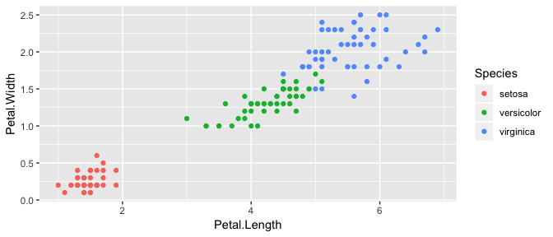

## Summary statistics

The following table summarizes petal widths by species type:

kable(table_petal_width, digits=1,  
 format="markdown")

|  |  |  |  |
| --- | --- | --- | --- |
| Species | mean | SD | median |
| setosa | 0.2 | 0.1 | 0.2 |
| versicolor | 1.3 | 0.2 | 1.3 |
| virginica | 2.0 | 0.3 | 2.0 |