**Simple Stock Application**

**Overview:**

This application allows users to select a symbol for a publicly traded company via a user interface created from ember-cli. Data pertaining to all publicly traded symbols is stored in the Google Firebase database (https://console.firebase.google.com/project/companies-3c329/database/data). It is imported into the front-end application via a Firebase Adapter in Ember.

Our application uses a spring boot back-end web-service. The web-service is used to secure price history data for a selected stock symbol from yahoo finance. Once the price history data is secured, the average of high, low, open and close prices is calculated, the resulting data is relayed to the front end application (in JSON), where the average prices are displayed in a chart.

**GitHub Repositories**

Java code for the web-service can be secured from the ‘simpleStockService’ repository, using this URL (<https://github.com/jmirand26/simpleStockService.git>)

Code for the front-end application created using ember-cli can be secured from the ‘simpleStockFrontEnd’ repository, using this URL (<https://github.com/jmirand26/simpleStockFrontEnd.git>)

**Running the Application**

* Download the src code available at the repositories mentioned above at the following locations (you can download the code anywhere you wish, I will be using these directories for demonstration purposes)
* Download the Java web-service code under ~\workspace\
* Download the ember-cli code under ~\ember_projects\simple-stock\
* Open up a command window and navigate to the ember-cli working directory; type ‘ ember server’; this should start up the ember server
* An executable jar for the Java web-service application is available under ~\workspace\target\; open up another command window and navigate to this directory; type ‘java -jar stockappwebsvc-0.1.0.jar --server.port = 8090’

*Note: It usually starts the web-service at port 8080, but this port was not available to me, so I used 8090, please use 8090, or you will have to modify the URL for the ember-cli application under (~\ember_projects\simple-stock\app\routes\quote.js) to reflect port 8080 (*[*http://localhost:8080/stockhistory/*](http://localhost:8080/stockhistory/)*)*

* Once you have successfully started the spring boot web-server –AND-- the ember server by following the steps mentioned above, open up two browser windows (preferably in chrome). Entering this URL in one window should display the JSON file returned by the back-end web-service to the ember front-end application (<http://localhost:8090/stockhistory/GOOGL>). The stock symbol in this case is GOOGL

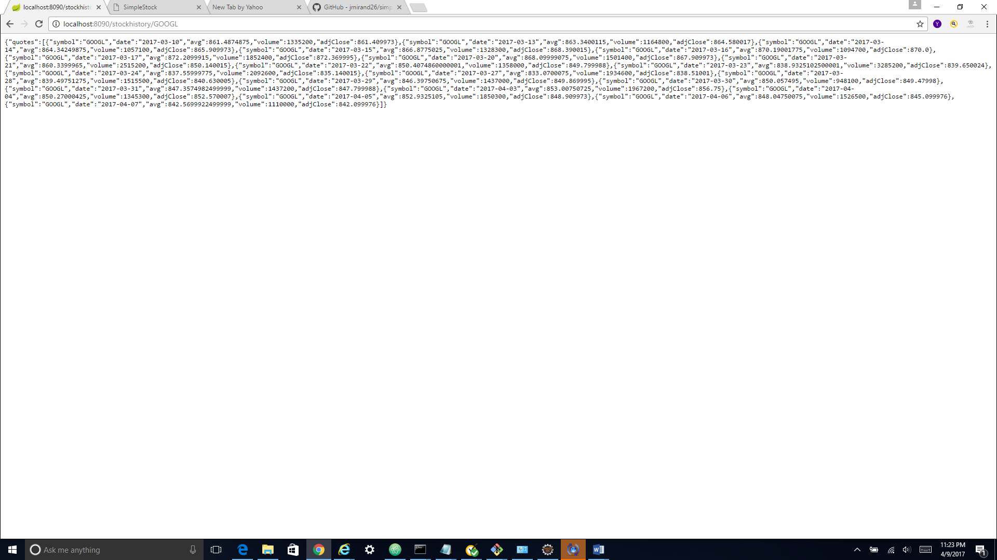

* Enter this URL in the other browser window (<http://localhost:4200/stock>). This page may take a little while to load as it uploads data for all 7000 publicly traded stocks. Search by company name and click on the symbol link on the far right hand side of the screen to display the average price history chart for that symbol

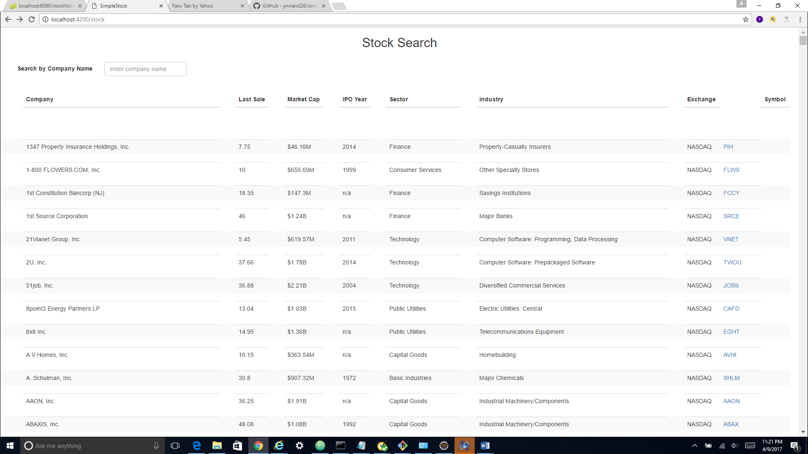

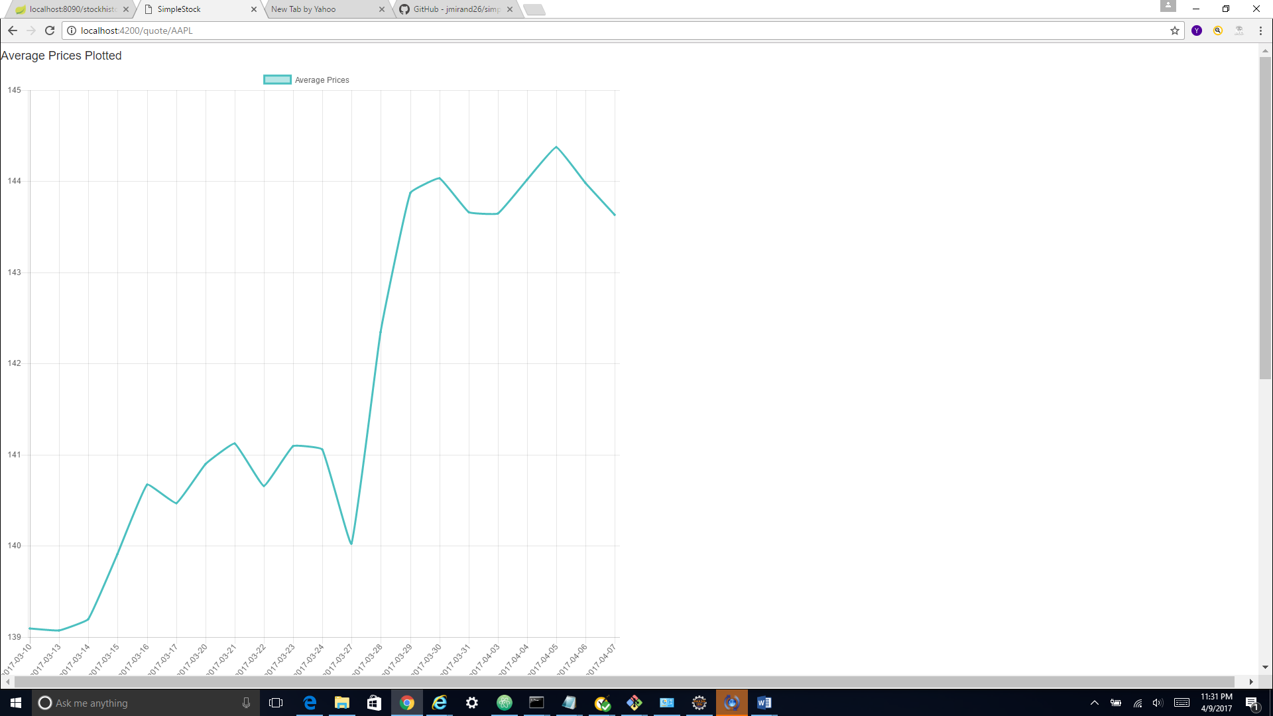

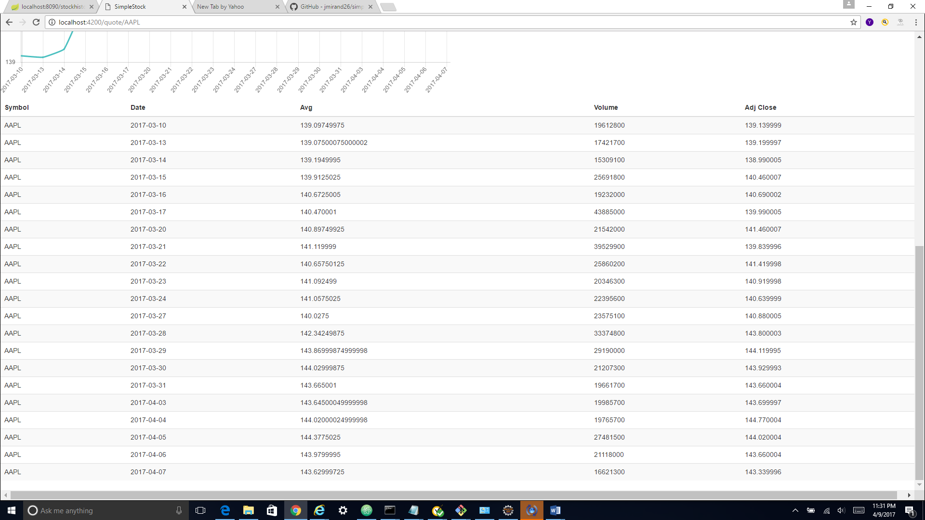

**Dependencies and Compiling the Java Web-services code**

* I used Eclipse Neon – 3 as my IDE, I got the IDE for Java EE developers (http://www.eclipse.org/downloads/packages/release/Neon/3.RC3)
* Please install MAVEN on your application and set the MAVEN_HOME attribute in your environment variables (https://maven.apache.org/download.cgi)
* Spring boot requires the Java 1.8 version to be installed, set the JAVA_HOME environment variable
* Once you have downloaded the src code to your eclipse workspace, you will need to modify the build-path to point to your installation of java. To do this, follow these steps in your IDE:
* Right-click on JRE System Library[jre1.8.0_121] in the Package Explorer > Build Path > Remove from Build Path
* Then right click on Maven Dependencies > Build Path > Configure Build Path > Under the ‘Libraries’ tab, select ‘Add Library’ > JRE System Library > Next > Keep the default option selected ‘Workspace default JRE (jre 1.8.0_121)’ > Finish > Apply > OK
* Then right click on the pom.xml file > Run As > Run Configurations > Under ‘Maven Build’ in the explorer, say ‘New’ > Under the ‘Main’ tab, enter ‘package’ in the ‘Goals’ field > Apply > Close
* Again right click on the pom.xml file > Run As > Maven Build

*Note: If the ‘Goals’ field is empty at this stage, re-enter ‘package’ > Apply > Run*

* This should build the .jar file, it should be available under the ~\workspace\target\ directory in your workspace

**Dependencies and Compiling the Ember-cli code**

* I installed the following add-ons on Ember
* Ember-cli-sass
* Ember-cli-bourbon
* Ember-font-awesome
* Ember-bootstrap
* Ember-cli-chart
* Ember-cli-filter-component
* Once you download the ember project files to your working directory (~\ember_projects\simple-stock\) open a command window and navigate to this directory. Run ‘npm install ‘ and then ‘bower install’ without any parameters

Refrences:

* <https://spring.io/guides/gs/rest-service/>
* <https://www.learnhowtoprogram.com/javascript/ember-js/ember-data-and-firebase>
* <https://www.emberscreencasts.com/posts/46-bar-charts-with-ember-cli-chart>
* <https://www.npmjs.com/package/ember-cli-filter-component>