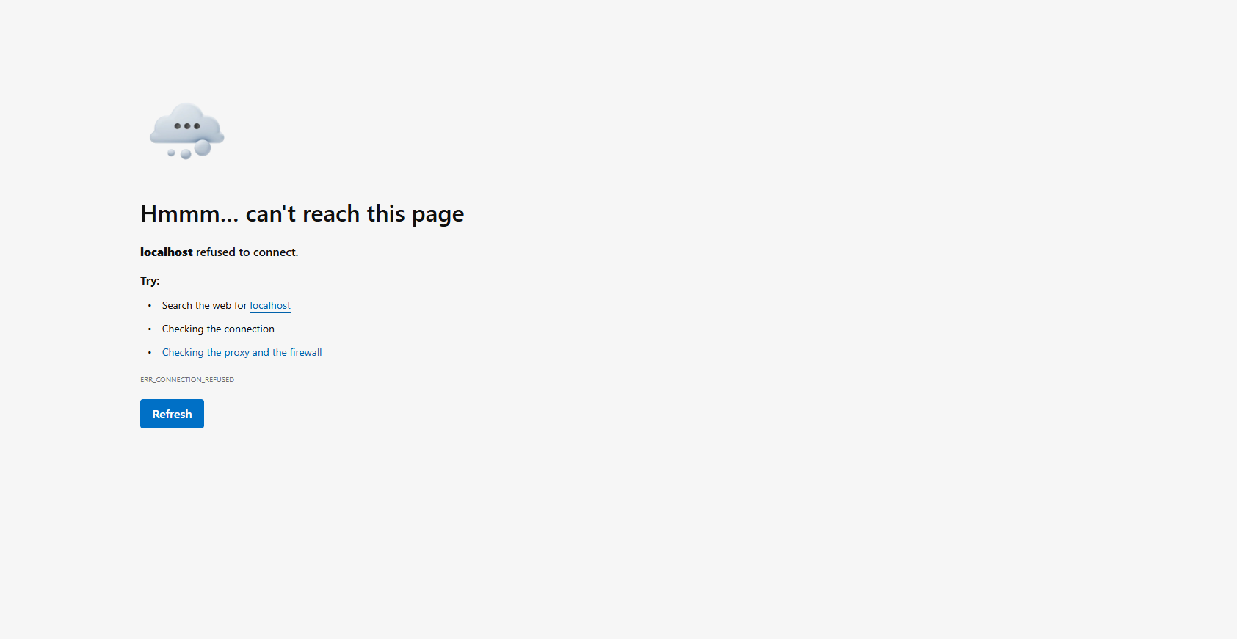
- This error occurred when I attempted to copy and paste the local link into my browser at first.
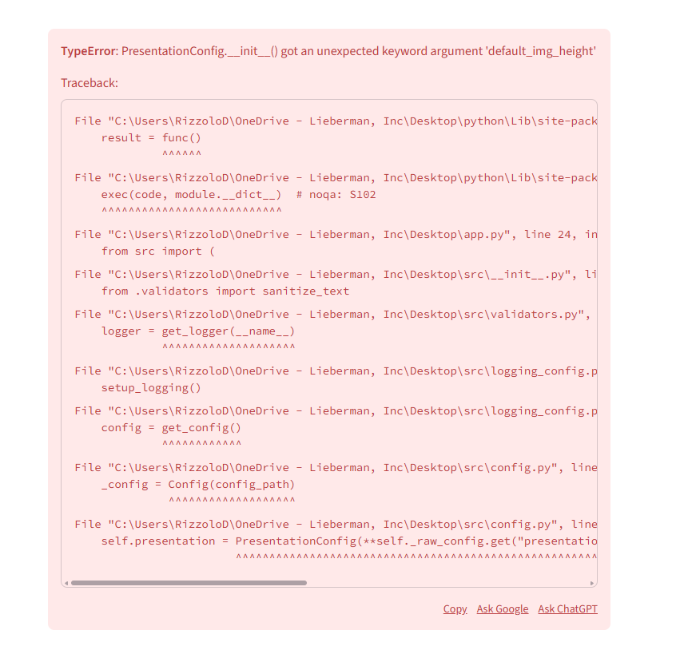
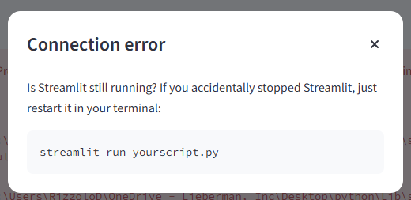
- These errors appeared in the Streamlit browser tab, when I went to access the stimupop module. I was unable to move forward in the testing process, or manuver around the module after these errors appeared.

