Feedback on StimuPop

Getting Started: Opening the program

- In the User Guide step 3, update this instruction: “Double-click 'StimuPop.exe' to launch the application”

- It would be helpful to add clarifying instructions that you need to ctlr and click on the local link http://localhost:8501 to get it to open in the browser window.

- Whenever I first try to open the link in my browser, I get the following error message (below). However, if I hit continue, exit the window, and then Ctrl-click again on the link, it opens perfectly fine. Is that something that can be fixed?
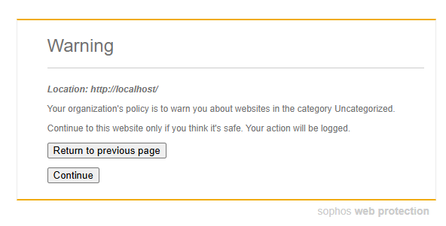
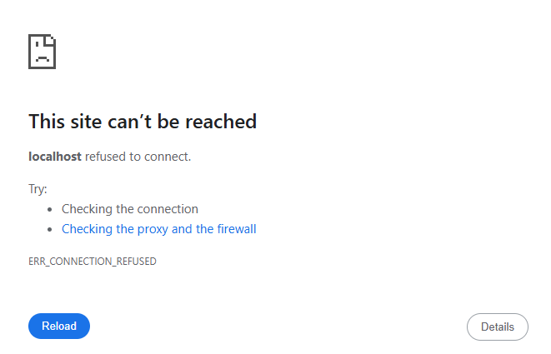

Using StimuPop

- In the User Guide step 1, update this instruction: “Double-click 'StimuPop.exe' to launch the application”

- When I first tried to upload the test files I created, this error in red font appeared on both files. But then I closed out of the application altogether and went back in, and the same files uploaded perfectly fine.
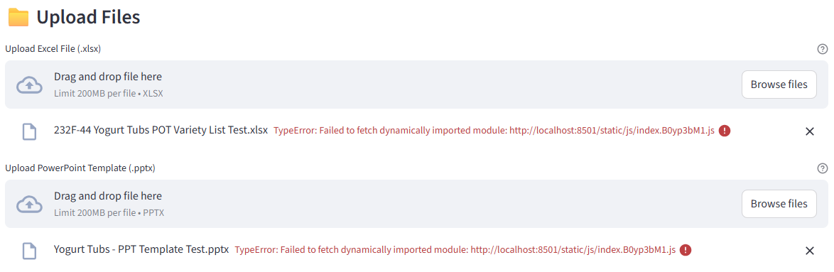

- In the User Guide, I would clarify that the “Per-Column Formatting” options under the advanced settings are only available when using Blank Mode.

- Is the “Layout Position (Blank mode)” only applicable to the Blank Mode, or is it also usable with the Template Placeholders mode? On screen, it has (Blank mode), but this section also appears when I’m on Template Placeholder mode. Perhaps remove the (Blank mode) from on-screen.
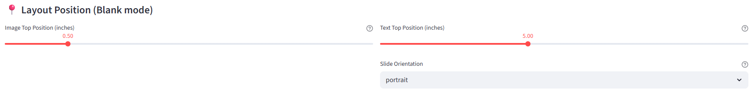

- The first time I clicked generate presentation, this error popped up (see below), but when I opened it in the newer version, it ran without any issues.
