Low-Mg Carbonate XRD data analysis, 0-100% range calcite

John M. Jaeger

May 24, 2017

## code description

This code is designed to import and analyze X-ray diffraction data collected at the University of Florida on a Rigaku Ultima IV diffractometer. The data are from carbonate mineral standards created to calibrate the diffractometer to provide quantitative measures of low- and high-Mg calcite. The general approach follows: Sepulcre, S., Durand, N., and Bard, E., 2009, Global and Planetary Change: Global And Planetary Change, v. 66, p. 1–9, doi: 10.1016/j.gloplacha.2008.07.008.

This code analyzes a full range of calcite/aragonite mixtures, with assumed values used for 100% calcite and 100% aragonite mixtures. These assumed values are used to better constrain polynomial fit.

Code generated by: John M. Jaeger Associate Professor 241 Williamson Hall P.O. Box 112120 Dept. of Geological Sciences University of Florida Gainesville FL 32611-2120, USA (352) 846-1381 ORCID ID# orcid.org/0000-0003-0248-489X <http://people.clas.ufl.edu/jmjaeger/>

### Load packages

# if necessary uncomment and install packages.  
# install.packages("dplyr")  
# install.packages("knitr")  
library(dplyr)  
require(knitr)  
library(ezknitr)  
library(ezknitr)  
library(ggplot2)  
library(splines)  
#library(propagate)

Import the data:

# load the End-member Dataset and give the dataset a shorter name  
  
XRD.data <- read.table("../raw_data/UF_LMC_data_20170515.csv",header=T,sep=",")   
XRDdata <- tbl_df(XRD.data)  
  
#testdata<-select(XRDdata, Sample, AreaR, LMC)  
#area.ratio <- testdata$AreaR  
#LMC.conc <- testdata$LMC

Calculate peak area ratios:

area.ratio <- XRDdata$LMC_area/(XRDdata$LMC_area+XRDdata$Aragonite_area)  
LMC.conc <- XRDdata$LMCconc

Develop polynomial calibration model for low-Mg calcite:

model.fit3<- lm(LMC.conc~ poly(area.ratio,3))  
summary(model.fit3)

##   
## Call:  
## lm(formula = LMC.conc ~ poly(area.ratio, 3))  
##   
## Residuals:  
## Min 1Q Median 3Q Max   
## -11.2463 -0.9897 0.0660 1.0510 6.8857   
##   
## Coefficients:  
## Estimate Std. Error t value Pr(>|t|)   
## (Intercept) 10.4960 0.6387 16.435 1.83e-13 ***  
## poly(area.ratio, 3)1 90.1054 3.1933 28.217 < 2e-16 ***  
## poly(area.ratio, 3)2 47.2222 3.1933 14.788 1.42e-12 ***  
## poly(area.ratio, 3)3 26.4542 3.1933 8.284 4.68e-08 ***  
## ---  
## Signif. codes: 0 '***' 0.001 '**' 0.01 '*' 0.05 '.' 0.1 ' ' 1  
##   
## Residual standard error: 3.193 on 21 degrees of freedom  
## Multiple R-squared: 0.981, Adjusted R-squared: 0.9783   
## F-statistic: 361.2 on 3 and 21 DF, p-value: < 2.2e-16

# Confidence intervales for model parameters  
confint(model.fit3, level=0.95)

## 2.5 % 97.5 %  
## (Intercept) 9.167852 11.82415  
## poly(area.ratio, 3)1 83.464636 96.74612  
## poly(area.ratio, 3)2 40.581438 53.86292  
## poly(area.ratio, 3)3 19.813411 33.09489

Plot data and model:

# Plot of fitted vs residuals  
# No clear pattern should show in the residual plot if the model is a good fit  
plot(fitted(model.fit3),residuals(model.fit3))

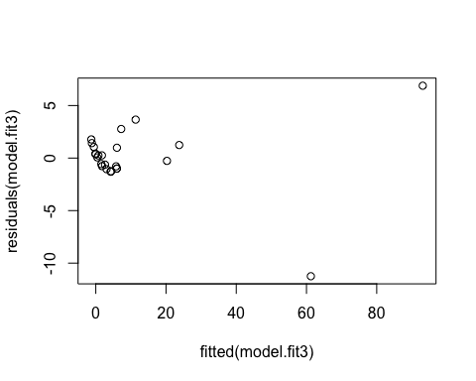

# Predicted values and confidence intervals  
polypredicted.intervals <- predict(model.fit3,data.frame(x=area.ratio),interval='prediction',  
 level=0.95)  
  
# Add lines to the existing plot  
plot(area.ratio,LMC.conc,type='p',col='navy',main='Nonlinear relationship',lwd=1)  
  
lines(area.ratio,polypredicted.intervals[,1],col='green',lwd=3)  
lines(area.ratio,polypredicted.intervals[,2],col='black',lwd=1)  
lines(area.ratio,polypredicted.intervals[,3],col='black',lwd=1)  
  
# Add a legend  
legend("topleft",c("Observ.","Predicted"),   
 col=c("deepskyblue4","green"), lwd=3)

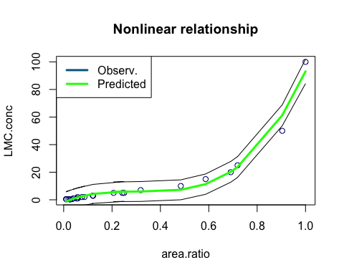

The next step is to develop uncertainty in % LMC for a given area ratio, third-order polynomial.

# Predicted values and confidence intervals  
testvalue = data.frame(area.ratio=0.1)  
predicted.value <- predict(model.fit3,testvalue,interval='prediction', level=0.95)  
predicted.value

## fit lwr upr  
## 1 3.589342 -3.264793 10.44348

Now a spline model: # <https://www.r-bloggers.com/splines-opening-the-black-box/> # <http://stackoverflow.com/questions/15837763/b-spline-confusion> # <https://www.rdocumentation.org/packages/splines2/versions/0.2.4/topics/predict>

library(splines)  
spline1.pred <- lm(LMC.conc ~ bs(area.ratio, df=4))#df=4 means knots at end points and quantiles of X  
summary(spline1.pred)

##   
## Call:  
## lm(formula = LMC.conc ~ bs(area.ratio, df = 4))  
##   
## Residuals:  
## Min 1Q Median 3Q Max   
## -10.7331 -0.4989 0.0074 0.7546 6.2194   
##   
## Coefficients:  
## Estimate Std. Error t value Pr(>|t|)   
## (Intercept) 0.9148 1.7622 0.519 0.609357   
## bs(area.ratio, df = 4)1 -1.9528 2.9300 -0.666 0.512723   
## bs(area.ratio, df = 4)2 22.2066 5.1941 4.275 0.000370 ***  
## bs(area.ratio, df = 4)3 -24.1840 6.0673 -3.986 0.000727 ***  
## bs(area.ratio, df = 4)4 92.8657 3.1859 29.149 < 2e-16 ***  
## ---  
## Signif. codes: 0 '***' 0.001 '**' 0.01 '*' 0.05 '.' 0.1 ' ' 1  
##   
## Residual standard error: 3.073 on 20 degrees of freedom  
## Multiple R-squared: 0.9832, Adjusted R-squared: 0.9799   
## F-statistic: 293.2 on 4 and 20 DF, p-value: < 2.2e-16

plot(area.ratio,LMC.conc)  
u=seq(min(area.ratio),max(area.ratio),by=.05)  
B=data.frame(area.ratio=u)  
splinepredicted.interval=predict(spline1.pred,newdata=B,interval ="prediction",level=0.95)  
lines(u,splinepredicted.interval[,1],lwd=2,col="green")  
lines(u,splinepredicted.interval[,2],col='red',lwd=1)  
lines(u,splinepredicted.interval[,3],col='red',lwd=1)  
  
# Add a legend  
legend("topleft",c("Observ.","Predicted"),   
 col=c("black","green"), lwd=3)

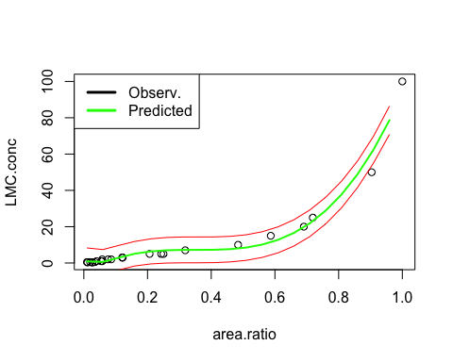 The last step is to develop uncertainty in % LMC for a given area ratio, spline model.

# Predicted values and confidence intervals  
predicted.splinevalue <- predict(spline1.pred,testvalue,interval='prediction', level=0.95)  
predicted.splinevalue

## fit lwr upr  
## 1 2.417768 -4.364464 9.199999

Export fits and prediction intervals:

polyout <- cbind(area.ratio,polypredicted.intervals)  
splineout <- cbind(u,splinepredicted.interval)  
write.csv(polyout, file="../reports/UF_LMC_polyfit.csv")  
write.csv(splineout, file="../reports/UF_LMC_splinefit.csv")