Calculating Chemicals

Suggested percentages from Natures's Colors / Ida Grae

Weight of fiber: ______________

Alum (potassium allum): 25% .25 x _____________
Cream of Tartar (tartaric acid) 6% .06 x _____________

Copper (cupric sulfate ) 1-4% 1 1/2% .015 x ____________
Cream of Tartar 3% .03 x _____________

Iron (ferrous sulfate) 4-8% 4% ,04 x _____________
Cream of Tartar 6% .06 x ______________

Calculating Chemicals with Standard Sized Skeins
and Avoiding Metric
If you are dyeing a skein that comes in a standard weight (ie. Ounces or pounds) it may not be simpler to use a chart with pre-calculated amounts. The chart on p.8 of Dyeing with natural materials is a good example.

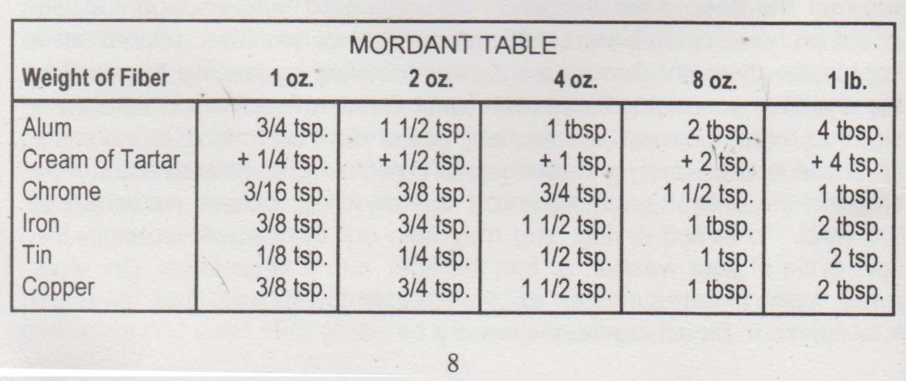

Grae, Nature’s Colors: Dyes from Plants., 186-187.
Las Aranas Spinners and Weavers Guild, Inc., Dyeing with Natural Materials., p.8.

