Jina Jamison
Program 3 part 1

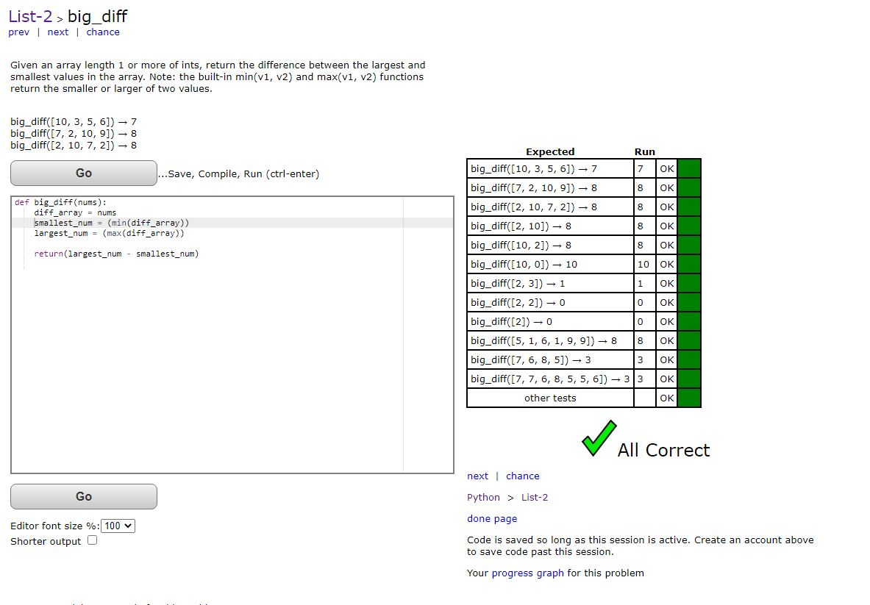
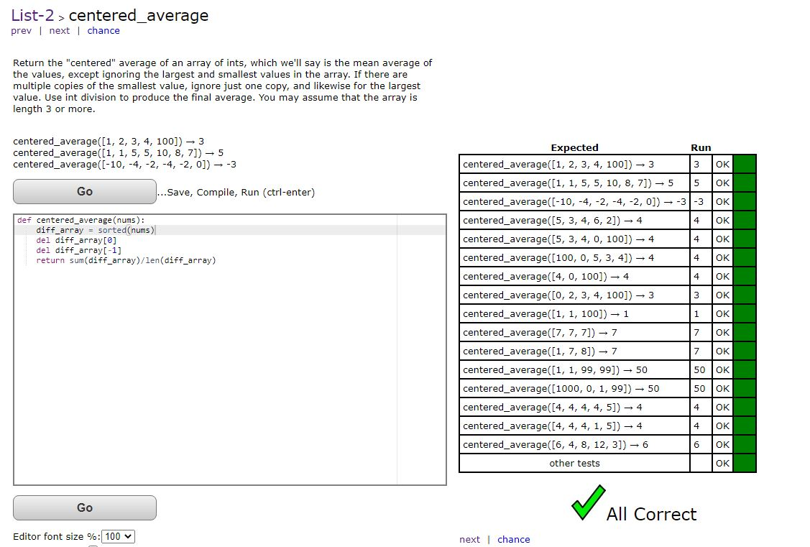
This one I can run on my desktop machine (win 10 and linux) but it doesn’t run at the coding bat interface. Not sure what is wrong here.

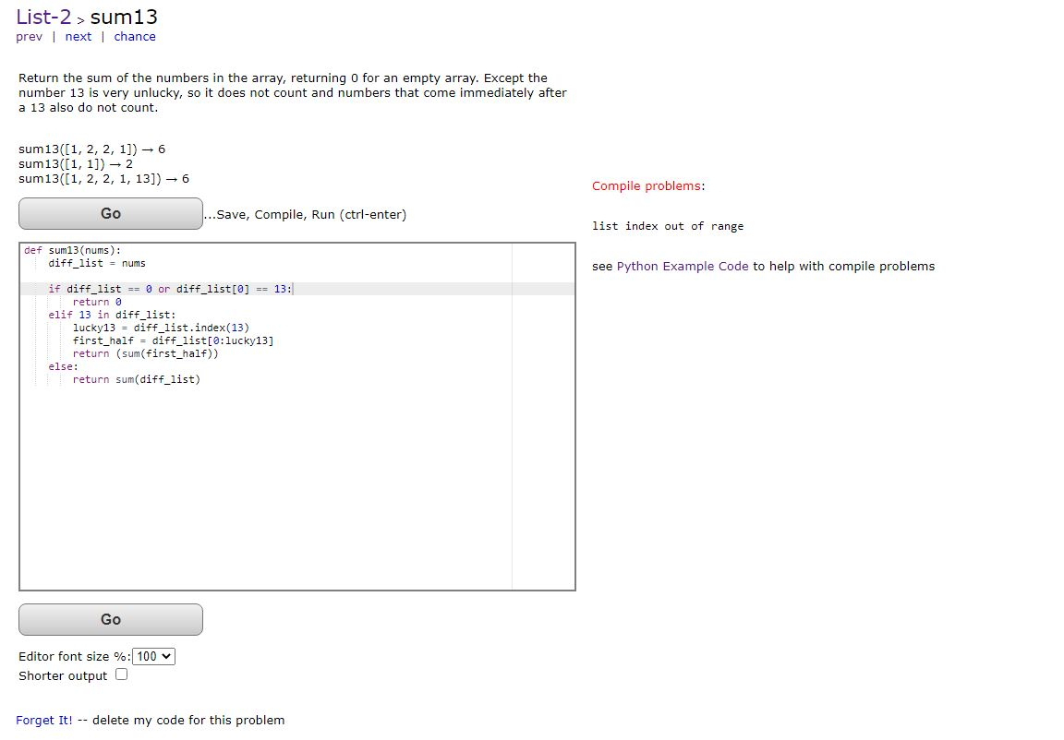

def sum13(nums):
diff_list = nums

if diff_list == 0 or diff_list[0] == 13:
return 0
elif 13 in diff_list:
lucky13 = diff_list.index(13)
print("lucky13 ", lucky13)
first_half = diff_list[0:lucky13]
print(first_half)
return (sum(first_half))
else:
return sum(diff_list)

# Press the green button in the gutter to run the script.
if __name__ == '__main__':
print(sum13([1, 2, 2, 1]))
print(sum13([13, 1, 2, 13, 2, 1, 13]) )
print(sum13([1, 2, 2, 1]))
print(sum13([1, 2, 13, 2, 1, 13]))
print(sum13([13, 1, 2, 13, 2, 1, 13]))
print(sum13([1, 1]))

