Movie STAR Ticketing System

Software Requirements Specification

Version 1.2

February 15, 2024

Group 2

Leah Bogomolny, Jake Jaro, Alisa Sriphet

Prepared for

CS 250- Introduction to Software Systems

Instructor: Gus Hanna, Ph.D.

Spring 2024

# Revision History

| **Date** | **Description** | **Author** | **Comments** |
| --- | --- | --- | --- |
| 2/1/2024 | 1.1 | Leah, Jake, Alisa | Initial brainstorming and thoughts |
| 2/6/2024 | Worked on 1.2 | Leah | Added information |
| 2/14/2024 | Continued revisions of 1.2 | Alisa | Added information |
| 2/15/2024 | Continued additions and revisions of 1.2 | Leah, Jake, Alisa | Added information and revised previous work |

# Document Approval

The following Software Requirements Specification has been accepted and approved by the following:

| **Signature** | **Printed Name** | **Title** | **Date** |
| --- | --- | --- | --- |
|  | <...> | Software Eng. |  |
|  | Dr. Gus Hanna | Instructor, CS 250 |  |
|  |  |  |  |

**Table of Contents**

**Revision History 1**

**Document Approval 1**

**1. Introduction 4**

1.1 Purpose 4

1.2 Scope 4

1.3 Definitions, Acronyms, and Abbreviations 4

1.4 References 5

1.5 Overview 5

**2. General Description 5**

2.1 Product Perspective 5

2.2 Product Functions 5

2.3 User Characteristics 5

2.4 General Constraints 5

2.5 Assumptions and Dependencies 5

**3. Specific Requirements 6**

3.1 External Interface Requirements 6

3.1.1 User Interfaces 6

3.1.2 Hardware Interfaces 6

3.1.3 Software Interfaces 6

3.1.4 Communications Interfaces 6

3.2 Functional Requirements 6

3.2.1 Search Movie Database by Title and Theater Location 6

3.2.2 Select Movie Viewing Time and Date 7

3.2.3 Selecting Desired Seats 8

3.2.4 Offer multiple payment methods and send an order confirmation email 8

3.2.6 User Feedback 10

3.2.7 Load Bearing 10

3.2.8 Robot Blocking 10

3.3 Use Cases 11

3.3.1 Getting a Refund/Canceling Order 11

3.3.2 Card Declining 12

3.3.3 Submitting a Request 13

3.3.4 Purchasing a Ticket 14

3.4 Classes / Objects 14

3.4.1 Movie Class 14

3.4.2 Ticket Class 15

3.5 Non-Functional Requirements 15

3.5.1 Performance 15

3.5.2 Reliability 15

3.5.3 Availability 15

3.5.4 Security 15

3.5.5 Maintainability 15

3.5.6 Portability 15

3.6 Inverse Requirements 15

3.7 Design Constraints 16

3.8 Logical Database Requirements 16

3.9 Other Requirements 16

**4. Analysis Models 16**

4.1 Sequence Diagrams 16

4.3 Data Flow Diagrams (DFD) 16

4.2 State-Transition Diagrams (STD) 16

**5. Change Management Process 16**

**A. Appendices 16**

A.1 Appendix 1 16

A.2 Appendix 2 16

# 

# 1. Introduction

## 1.1 Purpose

The purpose of this document is to provide a detailed outline of the expectations for the movie ticket distribution software, *Movie STAR Ticketing System*. It is intended for software developers as well as all additional individuals who will be involved in the production of the application.

## 1.2 Scope

This document specifies requirements, features, and functions of *Movie STAR Ticketing System* as well as how the program will work. Specifically, this document caters towards developers and stakeholders of *Movie STAR Ticketing System* in order to describe the functionality of the system.

## 1.3 Definitions, Acronyms, and Abbreviations

Definitions, acronyms, and abbreviations used in this document are listed below:

| Android: | Android operating system for mobile devices |
| --- | --- |
| Customer: | The person or organization that commissioned this software |
| Developer: | The people that develop and create the software |
| HTML: | HyperText Markup Language |
| HTTPS: | HyperText Transfer Protocol Secure |
| IOS: | iPhone Operating system |
| IP: | Internet Protocol |
| macOS: | Operating system for Apple computers |
| SCRUM | An agile software development life cycle that has work done over sprints |
| SRS: | Software Requirements Specification |
| TCP: | Transmission Control Protocol |
| URL: | Uniform Resource Locator |
| User: | Ideal audience that will be utilizing this software to buy tickets |
| Windows: | Operating system developed by Microsoft |

## 1.4 References

This SRS does not reference any outside materials.

## 1.5 Overview

This SRS contains the various features and requirements for building *Movie STAR Ticketing System*. It is organized through the headers, which serve as a general description before getting increasingly more detailed with specific requirements and use case examples.

# 2. General Description

## 2.1 Product Perspective

The application will connect to third-party APIs to process payments. It will also require the use of databases to store theater, movie, and order information.

## 2.2 Product Functions

*Movie STAR Ticketing System* will be used by customers in order to search for movies by title and location, select movie times and seats, and buy up to 10 tickets to view a movie in theaters. The customers will also be able to pay online with credit or debit card or PayPal and get refunds or cancel orders as needed. Users will also receive an email confirmation after purchasing a ticket.

## 2.3 User Characteristics

The software can be utilized by users of any age or education level. However, payments should be made by individuals who are at least 18 years old. Technical expertise is also not required to use the application.

## 2.4 General Constraints

Our constraints include a short timeline of six months, and a budget of $75,000. Also, the software must be able to function across most web browsers and various mobile devices. It also must follow general protection and security regulations to protect user’s sensitive information. Additionally, it must also adhere to regulations regarding the sale of official movie tickets. It must be able to support at least 1000 users simultaneously.

## 2.5 Assumptions and Dependencies

The software will be developed for Windows, macOS, Android, and IOS and will function on everything Windows 10 and later. For web browsers, it will run on Google Chrome, Microsoft Edge, FireFox, Safari, and DuckDuckGo. It is also assumed that the website and URL are available, and that the theaters will provide *Movie STAR Ticketing System* with the total number of seats, so maximum capacity can be known. Additionally, it is assumed that this site will support multiple theater franchises, with locations nationwide. Finally, it is assumed that the users have a working email address in order to receive tickets.

# 3. Specific Requirements

## 3.1 External Interface Requirements

### 3.1.1 User Interfaces

The user interfaces will be a computer or mobile device with access to the internet through a browser such as Google Chrome, Microsoft Edge, FireFox, Safari and DuckDuckGo.

### 3.1.2 Hardware Interfaces

The site requires the use of the internet, so on both the server side and the user’s side, the hardware must connect to the internet through the use of ethernet cable for the server, and either ethernet cable, Wifi, or cellular data for the user. The site must function on personal, and workclass computers, along with mobile devices.

### 3.1.3 Software Interfaces

*Movie STAR Ticketing System* will interface and interact with Windows, macOS, Android, IOS, the billing software that is used, and the database management system.

### 3.1.4 Communications Interfaces

The system will use HTTPS protocol when transmitting information in order to keep sensitive user details secure. TCP/IP will also be used to connect devices across the internet.

## 3.2 Functional Requirements

### 3.2.1 Search Movie Database by Title and Theater Location

3.2.1.1 Introduction

* Users will be able to scroll through our database of movies ordered by popularity and also be able to use the search bar to search through the databases for the specific movie or theater they desire.

3.2.1.2 Inputs

* The inputs in using the search bar will be the theater name, the movie name, or the theater and movie name together (order does not matter).

3.2.1.3 Processing

* If scrolling through the database, the user can select the movie’s poster or name which will be displayed below the poster, and will be brought to another page of just the movie. It will display the theaters that are showing it within 10 miles of the user’s location, and under each theater will be listed that theater’s offered times. The user can then select the time under their desired theater and will proceed to the ticket buying page.
* If the user uses the search bar, the site will take the input and sort through the database for theater or location depending on what is entered. If both the theater name and movie name are entered, it will go to a database of just that theater and what movies it includes. Then it will display the corresponding results depending on what is entered. The user will be able to select their desired theater/time from there.

3.2.1.4 Outputs

* It will output the theater locations if the search was just the movie name. If the search was just the theater name it will output the supported movies. If the search was the theater name and the movie name, it will display the movie at that theater and the supported times.

3.2.1.5 Error Handling

* If the movie is not being carried anywhere, or is otherwise not recognized, then the search will display a, ‘Movie not found’ page. If the theater does not exist, is not carried by the system, or is otherwise not recognized, it will have a line saying, ‘Could not find theater’ then below it will list supported theaters. If the search is a movie and theater, and the movie is not being shown at the theater, or the movie is otherwise not found in that theater’s database, it will display the database of other movies being shown at the theater. If the search is a movie and theater, but the theater is not recognized, it will list all other locations of the movie as if only the movie was searched. If the search is the movie and the theater, but neither is recognized, a line will display that says, ‘Could not find ___’ with their search input in the underlined area. Below the line will display the popular movies in the same format as the homepage.

### 

### 3.2.2 Select Movie Viewing Time and Date

3.2.2.1 Introduction

* Users of *Movie STAR Ticketing System* will be able to select their movie showing based on the desired time and date.

3.2.2.2 Inputs

* The inputs will include the specific desired movie.

3.2.2.3 Processing

* After selecting the desired movie, the user will be given lists of the available times for the specified movie at various theaters assuming they didn’t already pick a theater. If both movie and theater have been previously selected, then the list of times will only include the times from that theater. In both cases it will only display times for the day the search is taking place at the times that have not yet passed. At the latest, users will be able to purchase tickets 10 minutes after the movie showing starts. If the user would like to select a day farther in the future, they can select any time within the following seven days that the search is taking place. The days will be listed at the top above in the time from the selected day. After clicking on a different day, it will reload to show a new list of times that corresponds to the movie showing times for that day.

3.2.2.4 Outputs

* The outputs will be that the user has successfully selected their desired time and date, and will allow them to proceed with selecting seat placement.

3.2.2.5 Error Handling

* If there is no time being provided on a specific day within seven days of the search, selecting the day will result in a ‘No times available’ message for that day. If the movie is removed after less than seven days from the search date then the amount of days listed will only include up to the last day instead of the full seven.

### 3.2.3 Selecting Desired Seats

3.2.3.1 Introduction

* The user of *Movie STAR Ticketing System* will be able to select 1-10 seats for a movie showing at a time and location that they choose and may also buy tickets to more than one movie at a time.

3.2.3.2 Inputs

* The inputs to this function will be the time of screening, selected movie, theater location, and selected seat location.

3.2.3.3 Processing

* This functionality will be processed by the user first selecting the seats they choose (up to 10 tickets for each movie and for multiple movies), adding them to cart, reviewing the cart, and then purchasing (discussed below).

3.2.3.4 Outputs

* Output for this functionality will be that the seat has been successfully chosen and will allow the user to continue on to paying for their ticket(s).

3.2.3.5 Error Handling

* Errors will be handled by having a popup that tells the user that there was an error and to try again with a different seat selection. Possible errors include that the seat is already taken, the showing was canceled, or the showing is sold out. If the showing was canceled or is sold out, the pop up will instead say that the showing is unavailable and ask the user to select a different showing or even a different location.

### 3.2.4 Offer multiple payment methods and send an order confirmation email

3.2.4.1 Introduction

* The system will allow users to purchase tickets via debit card, credit card, and PayPal.

3.2.4.2 Inputs

* The system will receive user debit/credit card information or PayPal login credentials as input, along with the user’s email address.

3.2.4.3 Processing

* Confidential payment information will be securely transferred over HTTPS for every payment method. External APIs will be used to access the payment gateways.

3.2.4.4 Outputs

* The system will send the user a confirmation email containing a digital, printable receipt of the transaction, as well as their tickets.

3.2.4.5 Error Handling

* If the card is expired or declined, or if the user enters an incorrect card number, the system will display an error message and prompt the user to re-enter their information.

**3.2.5 Cancel orders and provide refunds**

3.2.5.1 Introduction

* Users shall be allowed to cancel their orders up to 1 hour in advance of the time of their selected movie, and they will be provided a full refund. Canceling an order will mean a refund of all tickets purchased in that order.

3.2.5.2 Inputs

* Users will be able to submit an order cancellation form that will prompt them for their order number, their email address, and their reason for canceling the order. The form can be accessed directly through the website or through a link found in the order confirmation email.

3.2.5.3 Processing

* The system will access the user’s payment details and initiate the refund based on the order number provided in the cancellation form. The order number must be valid, and the email address must be the same as the one used to place the order initially. The refund will be immediately transferred to the user’s account, and their previously selected seats will be reopened for purchase.

3.2.5.4 Outputs

* Users shall receive an additional email confirming that their order was canceled and their payment was refunded.

3.2.5.5 Error Handling

* If a user attempts to cancel their order less than 1 hour before their scheduled movie, the system will notify them that this action is not allowed and prevent them from submitting the form. If the provided order number is invalid, or the order number and email address do not correspond, the system will indicate that the information is invalid/incorrect and once again prevent the user from submitting the form. The user will then be given the opportunity to correct their input and submit the form.

### 3.2.6 User Feedback

3.2.6.1 Introduction

* Users of the system will be able to access a help form in order to submit complaints or inquiries.

3.2.6.2 Inputs

* Users will input their email, name, order number (if applicable), and questions/concerns.

3.2.6.3 Processing

* A customer service representative will view feedback from users and respond accordingly.

3.2.6.4 Outputs

* After the user submits a request, they will receive a confirmation email including the contents of their request. There will also be a popup on screen that the request was successfully submitted. Additionally, any response from a customer service representative will be sent to the email provided by the user.

3.2.6.5 Error Handling

* If the email that the user inputs can not receive emails, there will be a popup on the screen asking for the user to input a different email.

### 3.2.7 Load Bearing

* The system must be able to support at least 1000 users at once.

### 3.2.8 Robot Blocking

* The system will block bots from purchasing large quantities of movie tickets at once.

## 3.3 Use Cases

### 3.3.1 Getting a Refund/Canceling Order



3.3.1.1 Actor(s):

* The actors are the ticket buyer, the authenticator that authenticates the ticket buyer’s identity claim, the identity provider, which provides the proposed identity, the credit/debit provider and Paypal, which serve as the financial institutions.

3.3.1.2 Flow of Events:

1. Ticket buyer connects to the cancellation form through either email or website
2. Ticket buyer enters their order number, email address, and reason for cancellation
3. System checks their validity by connecting to their authenticator and identifier
4. Assuming all is well, proceeds to access payment details, connecting to authenticator to authenticate their action, identity verification to verify their identity, and the credit/debit, or Paypal in order to access the person’s financial account.
5. Transfer the money back to the person’s respective financial account

3.3.1.3 Possible Inclusions and Exclusions

* Possible inclusions are purchasing tickets. Possible exclusions are invalid order number or email address.

3.3.1.4 Entry Conditions:

1. internet connection
2. supported browser
3. required information (order number, email address, and reason for cancellation)

### 3.3.2 Card Declining



3.3.2.1 Actor(s)

* The actor in this use case is TicketBuyer, the person who is purchasing a ticket.

3.3.2.2 Flow of Events

1. TicketBuyer inputs payment information and purchases
2. Payment declined
3. System displays an error message and prompts TicketBuyer to re-enter payment information

3.3.2.3 Possible Exclusions and Inclusions

* Inclusions to this situation would be searching the website and selecting a movie and seats.

3.3.2.4 Entry Conditions

* Entry conditions for this situation would be a connection to the internet, a supported browser, and payment information.

### 3.3.3 Submitting a Request



3.3.3.1 Actor(s)

* The actors are the TicketSubmitter who is a user that has an inquiry and is submitting some sort of request. The second actor is the Customer Service Representative who is an employee that responds to the inquiry submitted by TicketSubmitter.

3.3.3.2 Flow of Events

1. TicketSubmitter submits request after filling out contact information and inquiry
2. Then the Customer Service Representative sends the TicketSubmitter a response

3.3.3.3 Possible Exclusions and Inclusions

* A possible exclusion is if the email that the TicketSubmitter submits does not exist or can not receive emails. If this happens, the TicketSubmitter is prompted to submit a different email.

3.3.3.4 Entry Conditions

* Entry conditions for this situation would be a connection to the internet, a supported browser, and an email account.

### 3.3.4 Purchasing a Ticket



3.3.4.1 Actor(s)

* The actor for this use case is someone who is looking to purchase a ticket through *Movie STAR Ticketing System,* who will be called “TicketBuyer”

3.3.4.2 Flow of Events

1. TicketBuyer connects to the website
2. TicketBuyer searches the database to find a movie showing to buy tickets for
3. TicketBuyer selects desired showing and seats
4. TicketBuyer goes to cart, inputs payment information, and purchases tickets
5. TicketBuyer receives an email confirmation for the order

3.3.4.3 Possible Exclusions and Inclusions

* Possible exclusions for this use case include that the TicketBuyer’s search query may not return results, the payment information may be declined, or they may have selected a taken seat. See other use cases to see how these are handled.

3.3.4.4 Entry Conditions

* Entry conditions for this situation would be a connection to the internet, a supported browser, and valid payment information.

## 3.4 Classes / Objects

### 3.4.1 Movie Class

3.4.1.1 Attributes

* Title
* Release date
* Rating
* Description/summary

3.4.1.2 Functions

* ‘Get’ methods for each attribute

### 3.4.2 Venue Class

3.4.2.1 Attributes

* Venue name
* Venue address
* Current showings array

3.4.2.2 Functions

* ‘Get’ methods for each attribute

### 3.4.3 Theater Class

3.4.3.1 Attributes

* Theater number

3.4.3.2 Functions

* ‘Get’ methods for each attribute

### 3.4.4 Showing Class

3.4.4.1 Attributes

* Movie object
* Date
* Time
* Seats

3.4.4.2 Functions

* ‘Get’ methods for each attribute
* isSeatAvailable(Seat)

### 3.4.5 Seat Class

3.4.5.1 Attributes

* Showing object
* Seat row
* Seat number
* Availability
* Price

3.4.5.2 Functions

* ‘Get’ methods for each attribute

### 3.4.6 Order Class

3.4.6.1 Attributes

* Time the order was placed
* Date the order was placed
* Order cost
* User email
* User first name
* User last name
* User billing address
* Tickets purchased, and the quantity of each
* Payment object

3.4.6.2 Functions

* ‘Get’ methods for each attribute

### 3.4.7 PayPalPayment Class

3.4.7.1 Attributes

* User email
* User password

3.4.7.2 Functions

* userDetails()

### 3.4.8 CardPayment Class

3.4.8.1 Attributes

* Card number
* Card security code
* Card expiration date

3.4.8.2 Functions

* userDetails()

## 3.5 Non-Functional Requirements

### 3.5.1 Performance

Performance standards are that 95% of transactions will be processed in less than 5 seconds.\

### 3.5.2 Reliability

The mean time between failure and downtime of the system will be greater than 30 days.

### 3.5.3 Availability

The system’s downtime will not exceed greater than 5 minutes per day.

### 3.5.4 Security

This system aims to have 95% of transactions be secure and aims to report any fraudulent activity within a day of it occurring. Additionally, this system will strive to ensure that no user data is leaked or hacked.

### 3.5.5 Maintainability

If the system does fail, it will be fixed and running again within 5 minutes.

### 3.5.6 Portability

This program runs on common web browsers such as Google Chrome, Microsoft Edge, FireFox, Safari and DuckDuckGo.

## 3.6 Inverse Requirements

* The site will not offer tickets for any non-movie showings at the theaters.
* It will not be possible to buy concessions through the site.
* The site will not offer a map to, or of, the theater(s), but the site will provide the address of the selected theater location.

## 3.7 Design Constraints

* The site must obtain all necessary licenses and follow all regulations to display images and handle the selling of tickets for the carried movies.
* The site must have a sleek background that does not draw attention away from the movie posters.
* All devices must have a web browser in order to access the site.
* All products displayed on the site must be easily accessible and clearly displayed for the user.

## 3.8 Logical Database Requirements

*Will a database be used? If so, what logical requirements exist for data formats, storage capabilities, data retention, data integrity, etc.*

## 3.9 Other Requirements

*Catchall section for any additional requirements.*

# 4. Analysis Models

As shown in the Architecture Diagram, the system will include multiple pages: home, search, movie selection, time and theater selection, seat selection, payment, and the confirmation of payment, for the user to progress through. As the project is built, we will follow the hierarchy outlined in the UML Diagram, which includes Venue, Theater, and Showing. Each of these classes will have their own methods and variables. We plan to use a SCRUM development life cycle (more details under Task Partitioning) and should complete the development in eight weeks.

## 4.1 Architecture Diagram

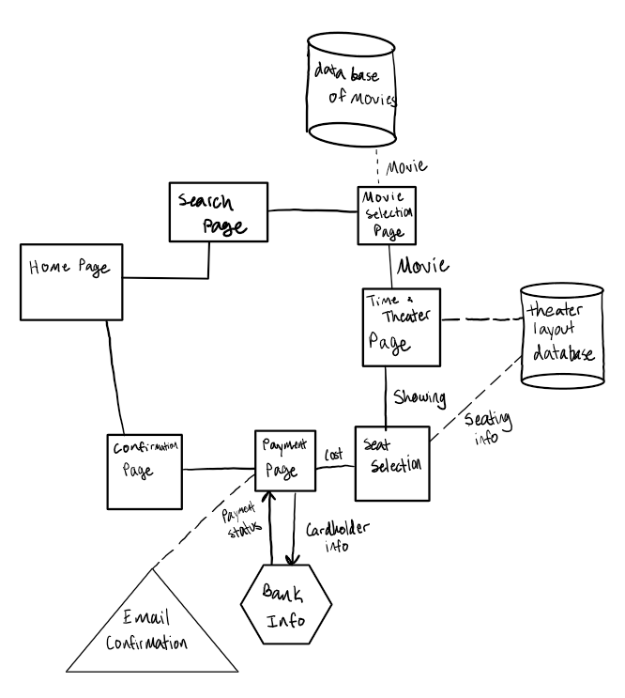

The user begins on the home page and from there can go to the search page in order to search for a movie, using the movie database. Then, the user can select a movie and move to the time and theater page, passing the movie that the user has selected. Then the user selects a showing and moves to the seat selection page, while passing the selected showing. The user then selects a seat through the theater layout database, which passes seating information. Then the user continues to the payment page which has a parameter of cost. The user then inputs payment information which is sent to an API of bank information which exchanges cardholder information and payment status. After the payment goes through, the user ends up at the confirmation page and also receives an email confirmation. Then, the user can return to the home page if desired.

## 4.2 UML Class Diagram

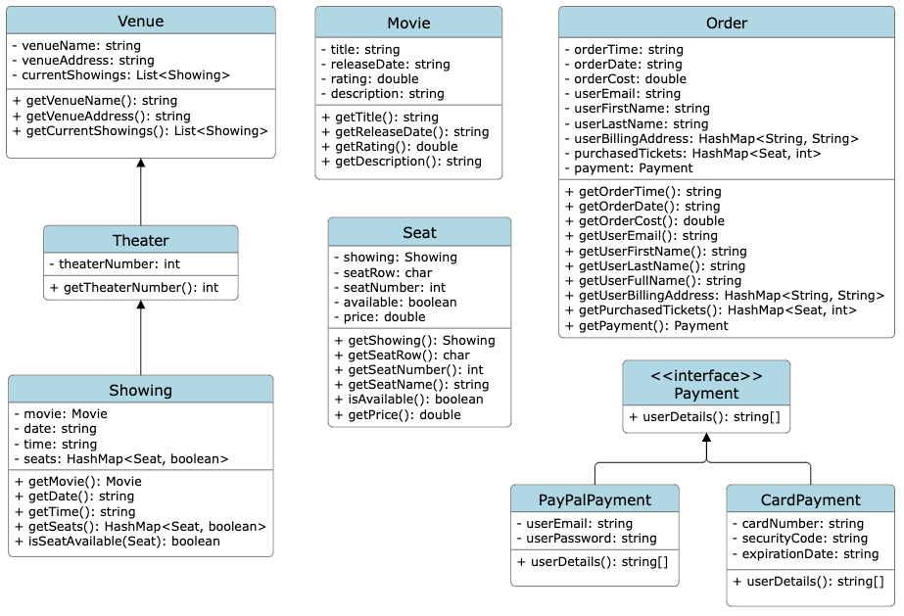

**4.2.1 Overview**

* The primary class hierarchy is Venue > Theater > Showing. The logic behind this inheritance chain stems from the fact that each venue contains multiple theaters, which each provide certain showings throughout the day. The other classes are not related through inheritance, but they are still utilized within one another. Additionally, most of the classes contain getter methods for most, if not all, of their fields.

**4.2.2 Venue**

* This class represents the actual building/location that offers the movie showings. It contains fields for the most essential information about the location, like its name, address, and current movie offerings.

**4.2.3 Theater**

* This class represents the room where people actually sit down and watch movies. Every venue has several different theaters. The class inherits from the Venue base class, and also includes a field for the theater number used to identify a certain theater within a venue.

**4.2.4 Showing**

* A showing is a specific movie at a specific time and location that users will go watch. The Showing class stores these details, as well as a HashMap that contains the seats for that showing and their respective availability. The isSeatAvailable() function returns true if the given seat is available for purchase for that particular showing.

**4.2.5 Movie**

* This class simply holds the basic information about a movie, like its title, rating, release date, and a short description.

**4.2.6 Seat**

* A seat is what users will ultimately be purchasing. Every showing has a selection of seats that are available for purchase, which are identified by their row and number (e.g A2 is seat 2 of row A). The ‘available’ field indicates whether or not a seat is still able to be selected and bought.

**4.2.7 Order**

* The Order class stores all of the information that is entered when a user checks out. This includes the date and time of the purchase, the user’s contact information, the contents of the order, and payment details.

**4.2.8 Payment (Interface)**

* This interface primarily serves as a way to relate the two payment methods and allow for polymorphism. It contains one method, userDetails, which must be implemented by both child classes. We will ensure the protection and encryption of all sensitive information.

**4.2.9 PayPalPayment**

* If the user chooses PayPal as their payment method, this class will store their login credentials.

**4.2.10 CardPayment**

* If the user opts to use a credit or debit card, their card information will be stored in this class.

## 4.3 Task Partitioning

This system will be developed using the SCRUM development life cycle. Each sprint will focus on a different database and the associated functionality with that database. The first sprint will focus on the movie database and how to implement the search functionality as well as the home page, search page, and movie selection. After this first sprint, which will take around two weeks, the team will move on to the next sprint which will focus on showing and seat selection and incorporate the database of theaters and their layouts. This sprint will also aim to be around two weeks. The final sprint will be to complete the payment page while utilizing the API for processing payments and also sending a confirmation email to the user. It will also include the confirmation page and take around two weeks. After this sprint, the team will regroup and check for any errors that have been missed, since testing will also occur during each sprint. This system will take about eight weeks to complete if a conservative estimate is used.

# 5. Change Management Process

*Identify and describe the process that will be used to update the SRS, as needed, when project scope or requirements change. Who can submit changes and by what means, and how will these changes be approved.*

# A. Appendices

*Appendices may be used to provide additional (and hopefully helpful) information. If present, the SRS should explicitly state whether the information contained within an appendix is to be considered as a part of the SRS’s overall set of requirements.*

*Example Appendices could include (initial) conceptual documents for the software project, marketing materials, minutes of meetings with the customer(s), etc.*

## A.1 Appendix 1

## A.2 Appendix 2