2

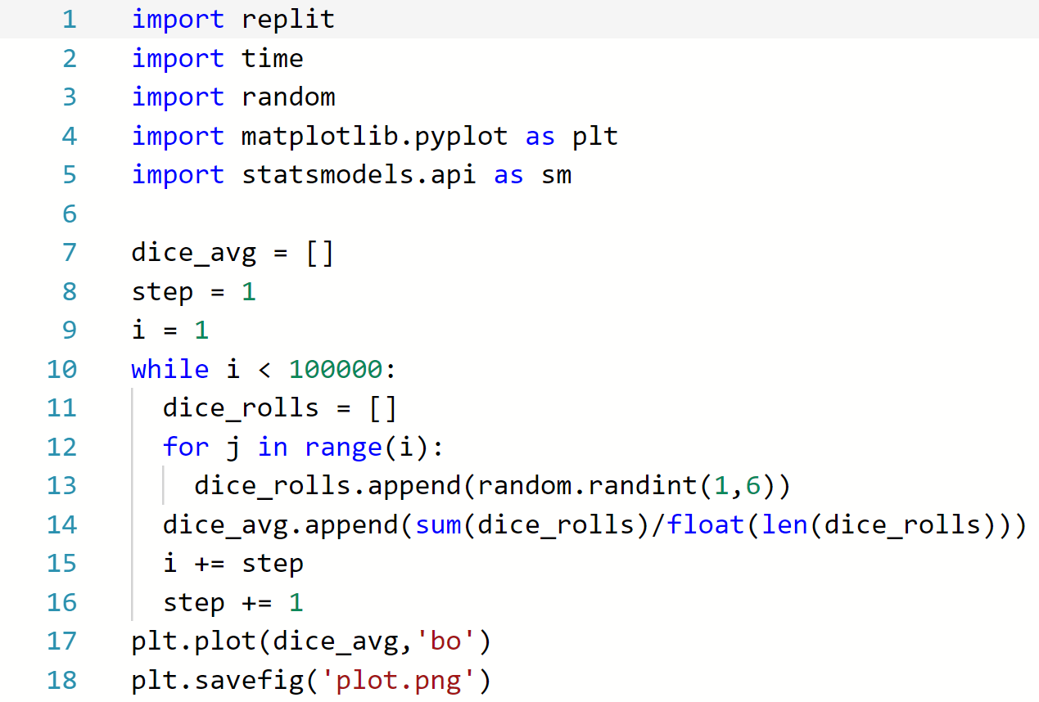

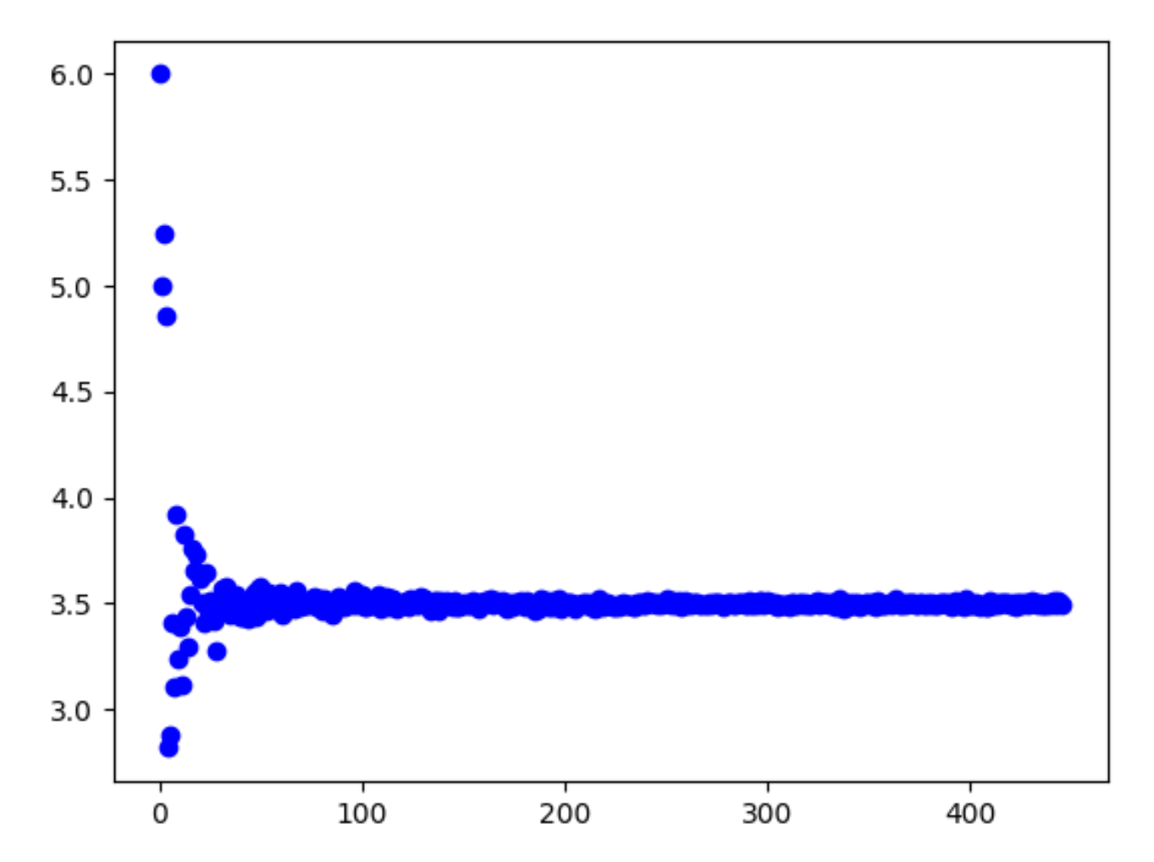

As we increase the number of dice rolls from 1 to 100000 the calculated average converges to 3.5

3

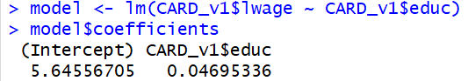



Educ seems to have a very low coefficient. Therefore we should study it further.

Yes, because the decision to live near does not seem to be related to the kid.