John michaael Ferrer  
BSIT-3B

OUTPUT:

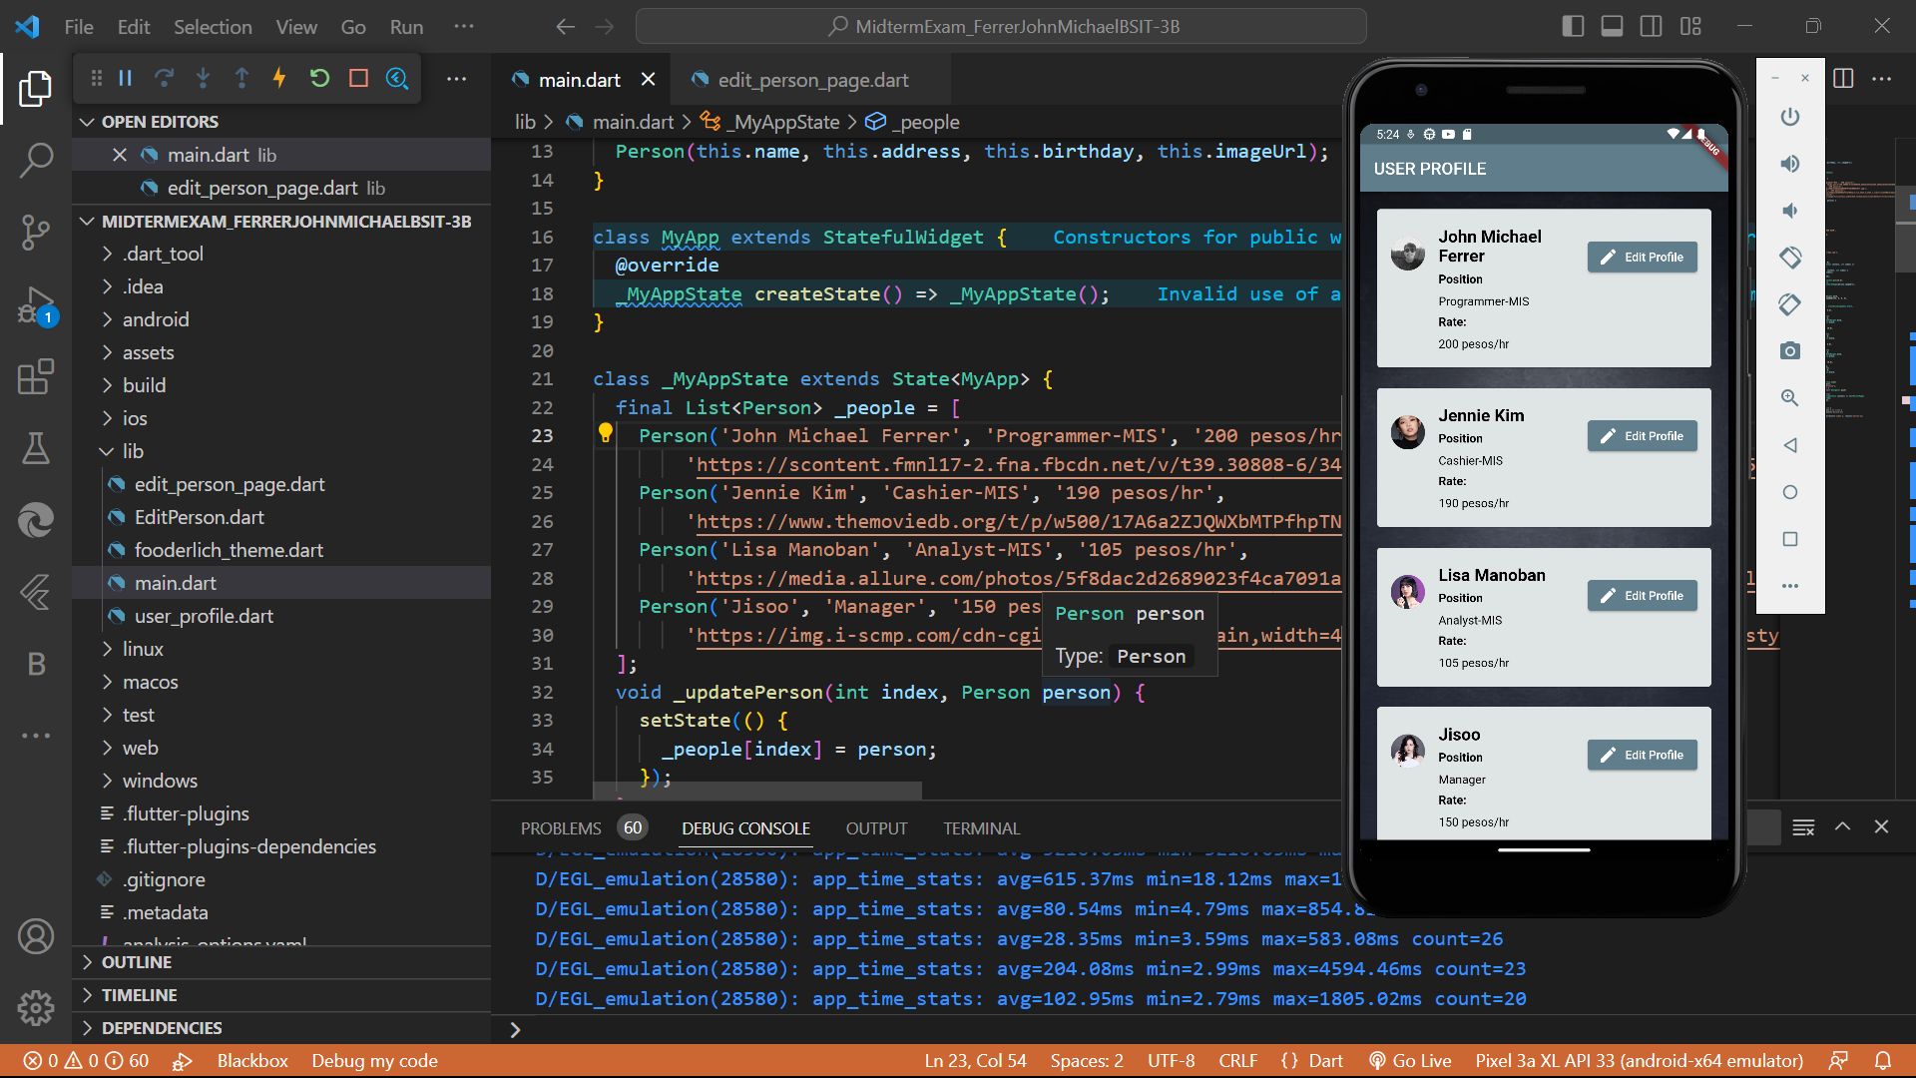

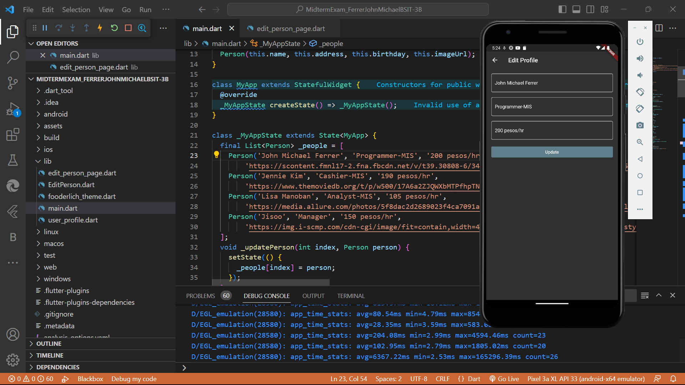

**SOURCECODE:**

**Main.dart**

import 'package:flutter/material.dart';

import 'edit_person_page.dart';

void main() {

runApp(MyApp());

}

class Person {

final String name;

final String address;

final String birthday;

final String imageUrl;

Person(this.name, this.address, this.birthday, this.imageUrl);

}

class MyApp extends StatefulWidget {

@override

_MyAppState createState() => _MyAppState();

}

class _MyAppState extends State<MyApp> {

final List<Person> _people = [

Person('John Michael Ferrer', 'Programmer-MIS', '200 pesos/hr',

'https://scontent.fmnl17-2.fna.fbcdn.net/v/t39.30808-6/341606468_646241437521285_2043216163154618664_n.jpg?_nc_cat=107&ccb=1-7&_nc_sid=e3f864&_nc_eui2=AeHGcztdOzQ2Gpk0IjdMlqZKuwtsj_S9T1-7C2yP9L1PX61BoSKGnj9hd4hmTvz6s7BinzBJQuBR9zYSBLPJX76E&_nc_ohc=rnRS4tNqvEcAX8hmOM2&_nc_ht=scontent.fmnl17-2.fna&oh=00_AfAwzL43zsI894OmCaKU5fypiUY7BIWXh6r9gqHIfZs3xA&oe=64587CE7'),

Person('Jennie Kim', 'Cashier-MIS', '190 pesos/hr',

'https://www.themoviedb.org/t/p/w500/17A6a2ZJQWXbMTPfhpTNBQhtDv7.jpg'),

Person('Lisa Manoban', 'Analyst-MIS', '105 pesos/hr',

'https://media.allure.com/photos/5f8dac2d2689023f4ca7091a/1:1/w_2333,h_2333,c_limit/lisa%20blackpink%20mac%20campaign.jpg'),

Person('Jisoo', 'Manager', '150 pesos/hr',

'https://img.i-scmp.com/cdn-cgi/image/fit=contain,width=425,format=auto/sites/default/files/styles/768x768/public/d8/images/methode/2020/06/08/4b0bdfc6-a639-11ea-8ea0-d7434be00753_image_hires_121748.jpg?itok=zq4iUnBF&v=1591589877'),

];

void _updatePerson(int index, Person person) {

setState(() {

_people[index] = person;

});

}

void _addPerson(Person person) {

setState(() {

_people.add(person);

});

}

@override

Widget build(BuildContext context) {

return MaterialApp(

title: 'John Michael Ferrer MIDTERM EXAM',

theme: ThemeData(

primarySwatch: Colors.blueGrey,

),

home: Scaffold(

appBar: AppBar(

title: Text('USER PROFILE'),

),

body: Container(

decoration: BoxDecoration(

image: DecorationImage(

image: AssetImage('assets/bg1.jpg'),

fit: BoxFit.cover,

),

),

child: ListView.separated(

padding: EdgeInsets.all(16.0),

separatorBuilder: (BuildContext context, int index) =>

SizedBox(height: 16.0),

itemCount: _people.length,

itemBuilder: (BuildContext context, int index) {

Person person = _people[index];

return Card(

color: Color(0xFFDFE4E4),

child: ListTile(

contentPadding: EdgeInsets.all(16.0),

leading: CircleAvatar(

backgroundImage: NetworkImage(person.imageUrl),

),

title: Text(

person.name,

style: TextStyle(

fontSize: 20.0,

fontWeight: FontWeight.bold,

color: Color.fromARGB(255, 0, 0, 0),

),

),

subtitle: Column(

crossAxisAlignment: CrossAxisAlignment.start,

children: [

SizedBox(height: 8.0),

Text(

'Position',

style: TextStyle(

fontSize: 14.0,

fontWeight: FontWeight.bold,

color: Colors.black,

),

),

SizedBox(height: 10.0),

Text(

person.address,

style: TextStyle(

fontSize: 14.0,

color: Colors.black,

),

),

SizedBox(height: 8.0),

Text(

'Rate:',

style: TextStyle(

fontSize: 14.0,

fontWeight: FontWeight.bold,

color: Colors.black,

),

),

SizedBox(height: 10.0),

Text(

person.birthday,

style: TextStyle(

fontSize: 14.0,

color: Colors.black,

),

),

],

),

trailing: ElevatedButton.icon(

icon: Icon(Icons.edit),

label: Text("Edit Profile"),

onPressed: () async {

final result = await Navigator.push(

context,

MaterialPageRoute(

builder: (BuildContext context) => EditPersonPage(

person: person,

index: index,

),

),

);

if (result != null) {

if (result['isNew'] == true) {

_addPerson(result['person']);

} else {

_updatePerson(result['index'], result['person']);

}

}

},

),

),

);

},

),

),

),

);

}

}

**Edit_person_page.dart**

import 'package:flutter/material.dart';

import 'main.dart';

class EditPersonPage extends StatefulWidget {

final Person person;

final int index;

EditPersonPage({required this.person, required this.index});

@override

_EditPersonPageState createState() => _EditPersonPageState();

}

class _EditPersonPageState extends State<EditPersonPage> {

final _formKey = GlobalKey<FormState>();

final _nameController = TextEditingController();

final _addressController = TextEditingController();

final _birthdayController = TextEditingController();

@override

void initState() {

super.initState();

_nameController.text = widget.person.name;

_addressController.text = widget.person.address;

_birthdayController.text = widget.person.birthday;

}

@override

void dispose() {

_nameController.dispose();

_addressController.dispose();

_birthdayController.dispose();

super.dispose();

}

void _savePerson() {

if (_formKey.currentState!.validate()) {

Person updatedPerson = Person(

_nameController.text.trim(),

_addressController.text.trim(),

_birthdayController.text.trim(),

widget.person.imageUrl,

);

Navigator.pop(context, {'person': updatedPerson, 'index': widget.index});

}

}

@override

Widget build(BuildContext context) {

return Scaffold(

backgroundColor: Color.fromRGBO(47, 49, 50, 1),

appBar: AppBar(

title: Text('Edit Profile'),

backgroundColor: Colors.transparent,

elevation: 0,

),

body: Padding(

padding: const EdgeInsets.all(16.0),

child: Form(

key: _formKey,

child: Column(

crossAxisAlignment: CrossAxisAlignment.stretch,

children: [

Container(

decoration: BoxDecoration(

border: Border.all(

color: Colors.white.withOpacity(0.5),

width: 2.0,

),

borderRadius: BorderRadius.circular(5.0),

),

child: Padding(

padding: const EdgeInsets.symmetric(

horizontal: 10.0,

vertical: 5.0,

),

child: TextFormField(

controller: _nameController,

decoration: InputDecoration(

border: InputBorder.none,

hintText: 'Full Name',

hintStyle: TextStyle(

color: Colors.white.withOpacity(0.5),

),

focusedBorder: UnderlineInputBorder(

borderSide: BorderSide(

color: Colors.white.withOpacity(0.5),

width: 2.0,

),

),

),

style: TextStyle(

color: Colors.white,

),

validator: (value) {

if (value == null || value.isEmpty) {

return 'Full Name is required';

}

return null;

},

),

),

),

SizedBox(height: 16.0),

Container(

decoration: BoxDecoration(

border: Border.all(

color: Colors.white.withOpacity(0.5),

width: 2.0,

),

borderRadius: BorderRadius.circular(5.0),

),

child: Padding(

padding: const EdgeInsets.symmetric(

horizontal: 10.0,

vertical: 5.0,

),

child: TextFormField(

controller: _addressController,

decoration: InputDecoration(

border: InputBorder.none,

hintText: 'Address',

hintStyle: TextStyle(

color: Colors.white.withOpacity(0.5),

),

focusedBorder: UnderlineInputBorder(

borderSide: BorderSide(

color: Colors.white.withOpacity(0.5),

width: 2.0,

),

),

),

style: TextStyle(

color: Colors.white,

),

validator: (value) {

if (value == null || value.isEmpty) {

return 'Address is required';

}

return null;

},

),

),

),

SizedBox(height: 16.0),

Container(

decoration: BoxDecoration(

border: Border.all(

color: Colors.white.withOpacity(0.5),

width: 2.0,

),

borderRadius: BorderRadius.circular(5.0),

),

child: Padding(

padding: const EdgeInsets.symmetric(

horizontal: 10.0,

vertical: 5.0,

),

child: TextFormField(

controller: _birthdayController,

decoration: InputDecoration(

border: InputBorder.none,

hintText: 'Birthday (MM/DD/YYYY)',

hintStyle: TextStyle(

color: Colors.white.withOpacity(0.5),

),

focusedBorder: UnderlineInputBorder(

borderSide: BorderSide(

color: Colors.white.withOpacity(0.5),

width: 2.0,

),

),

),

style: TextStyle(

color: Colors.white,

),

validator: (value) {

if (value == null || value.isEmpty) {

return 'Birthday is required';

}

return null;

},

),

),

),

SizedBox(height: 16.0),

ElevatedButton(

onPressed: _savePerson,

child: Text('Update'),

),

],

),

),

),

);

}

}