# Example Report

​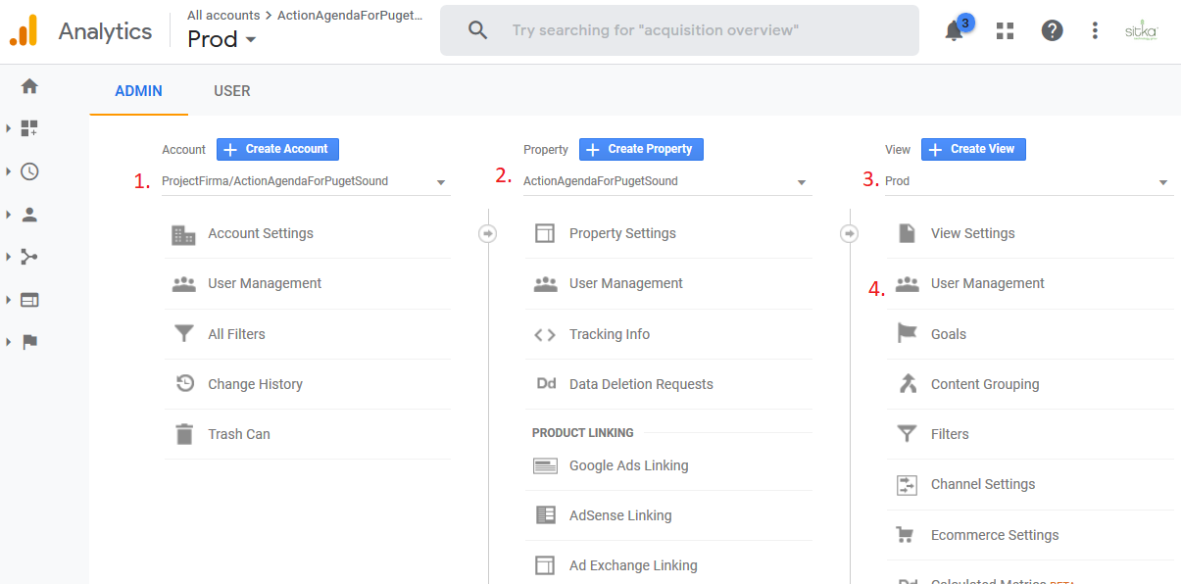

This many projects: 1