John Metcalfe, Josh Jenson, Jake Kennedy

EECS 448

**Lab 6**

**Source**

//////////////////////////////////

**main.cpp**

#include "checkMatrix.cpp"

#include "matrixAdd.cpp"

#include "matrixMult.cpp"

#include "matrixSize.cpp"

#include "reader.cpp"

#include "matrixTrans.cpp"

#include <vector>

#include <iostream>

using namespace std;

void PrintMatrix (vector<vector<int> > m);

int main()

{

vector<vector<int> > matrixAdd1;

vector<vector<int> > matrixAdd2;

vector<vector<int> > matrixMult1;

vector<vector<int> > matrixMult2;

vector<vector<int> > matrixTrans1;

if(ReadFile("add1.csv", matrixAdd1) && ReadFile("add2.csv", matrixAdd2))

{

if(checkMatrix(matrixAdd1) && checkMatrix(matrixAdd2))

{

if(matrixSize(matrixAdd1, matrixAdd2, 1))

{

cout << "-----Adding matrixes-----\n";

cout << "Matrix 1:\n";

PrintMatrix(matrixAdd1);

cout << "Added with Matrix 2:\n";

PrintMatrix(matrixAdd2);

cout << "Equals matrix 3:\n";

PrintMatrix(matrixAdd(matrixAdd1, matrixAdd2));

}else{

cout << "Matrix is not the right size (add)." << endl;

}

}else{

cout << "File is not a matrix." << endl;

}

}else{

cout << "Failed to read addition matrix." << endl;

}

if(ReadFile("mult1.csv", matrixMult1) && ReadFile("mult2.csv", matrixMult2))

{

if(checkMatrix(matrixMult1) && checkMatrix(matrixMult2))

{

if(matrixSize(matrixMult1, matrixMult2, 2))

{

cout << "-----Multiplying matrixes-----\n";

cout << "Matrix 1:\n";

PrintMatrix(matrixMult1);

cout << "Multiplied with Matrix 2:\n";

PrintMatrix(matrixMult2);

cout << "Equals matrix 3:\n";

PrintMatrix(matrixMult(matrixMult1, matrixMult2));

}else{

cout << "Matrix is not the right size (mult)." << endl;

}

}else{

cout << "File is not a matrix." << endl;

}

}else{

cout << "Failed to read multiplication matrix." << endl;

}

if(ReadFile("mult1.csv", matrixTrans1))

{

if(checkMatrix(matrixTrans1))

{

if(matrixSize(matrixTrans1, matrixTrans1, 3))

{

cout << "-----Transposing matrix-----\n";

cout << "Matrix 1:\n";

PrintMatrix(matrixTrans1);

transpose(matrixTrans1);

cout << "The Transpose of matrix 1 is:\n";

PrintMatrix(matrixTrans1);

}else{

cout << "Matrix is not the right size." << endl;

}

}else{

cout << "File is not a matrix." << endl;

}

}else{

cout << "Failed to read transpose matrix." << endl;

}

return 0;

}

void PrintMatrix(vector<vector<int> > m)

{

for(int i = 0; i < m.size(); i++)

{

for(int j = 0; j < m[0].size(); j++)

{

cout << m[i][j] << " ";

}

cout << endl;

}

}

//////////////////////////////////

**checkMatrix.cpp**

#include <vector>

#include <iostream>

using namespace std;

//takes in a 2D vector of ints

bool checkMatrix(vector< vector<int> > matrix) {

//goes along each row of the input vector, ends at second-to-last row to avoid calling an out-of-bounds indexdoes not need to run for the last row, it will be compared with the second-to-last row

for (int i=0; i < matrix.size()-1; i++) {

//checks if the ith and i+1th rows have the same # of elements, TRUE(1) if not equal, FALSE(0) otherwise

if(matrix[i].size() != matrix[i+1].size()) {

//returns FALSE(0) to function call when two rows are not equal, indicates that the 2D vector is not a valid matrix

return false;

}

}

//returns TRUE(1) to function call if the input vector passes all tests, indicates that the 2D vector is a valid matrix

return true;

};

////////////////////////////////

**matrixSize.cpp**

#include <vector>

bool matrixSize(vector<vector<int> > mat1, vector<vector<int> > mat2, int op){

if (op == 1){//Addition

//Matricies must be same size

if(mat1[1].size == mat2[1].size() && mat1.size() == mat2.size()){

//Checks dimensions

return true;

}else{

return false;

}

}else if(op == 2){//Multiplication

//1st matrix is 2*3, second is 3*4

if(mat1.size() == 2 && mat1[1].size() == 3 && mat2.size() == 3 && mat2[1].size() == 4){

return true;

}else

return false;

}

}else if(op == 3){//transpose

//Only uses 1 matrix, is 2*3

if(mat1.size() == 2 && mat1[1].size() == 3){

return true;

}else{

return false;

}

}else{//op is bad

return false;

}

}

////////////////////////////////

**reader.cpp**

#include <string>

#include <vector>

#include <fstream>

#include <iostream>

#include <algorithm>

#include <sstream>

using namespace std;

//************************

// filepath: path to the .cvs file to read

// matrix: a reference to the matrix that the function will fill with the contents of the tile

// return: whether the read was successful

bool ReadFile(string filepath, vector<vector<int> > & matrix)

{

string buffer;

ifstream file;

//Opens the file

file.open(filepath.c_str());

//Check to see if file opened successfully

if(file.is_open())//file open

{

int rows = 0;

int columns = 0;

int tempColumns;

//Find the number of rows and columns in the file

while( getline(file, buffer))

{

tempColumns = 1;

//Count ',' to find columns

for(int i = 0; i < buffer.size(); i++)

{

if(buffer[i] == ',')

{

tempColumns++;

}

}

if(columns == 0)

{

columns = tempColumns;

}else{

if(tempColumns != columns)

{

cout << "The file is not correctly formatted. Cannot be read.\n";

return false;

}

}

rows++;

}

//Resize the vectors to the right size

matrix.resize(rows);

for(int i = 0; i < rows; i++)

{

matrix[i].resize(columns);

}

//Reset the ifstream

file.clear();

file.seekg(0, ios::beg);

//Read in an assign the values

int vectorRowIndex = 0;

int vectorColIndex;

int beginningOfNumIndex;

stringstream ss;

while( getline(file, buffer))

{

vectorColIndex = 0;

beginningOfNumIndex = 0;

for(int i = 0; i <= buffer.size(); i++)

{

//If its the end of a number

if((buffer[i] == ',') || (i == (buffer.size())))

{

//Put that chunk in a string stream

for(int j = beginningOfNumIndex; j < i; j++)

{

ss << buffer[j];

}

//Put the stringstream into the vector to convert to int

ss >> matrix[vectorRowIndex][vectorColIndex];

//Check for conversion failure

if(ss.fail())

{

cout << "Failed to create matrix (bad conversion)." << endl;

return false;

}

//Reset and clear the string stream

ss.str("");

ss.clear();

beginningOfNumIndex = i+1;

vectorColIndex++;

}

}

vectorRowIndex++;

}

}else //file failed to open

{

cout << "File failed to open.\n";

return false;

}

//Close file

file.close();

return true;

}

////////////////////////////////

**matrixAdd.cpp**

#include <vector>

#include <iostream>

using namespace std;

//********************

// m1: the first matrix to be added

// m2: the second matrix to be added

// return: a matrix that is the result of the addition

vector<vector<int>> matrixAdd(vector<vector<int> > m1, vector<vector<int> > m2)

{

vector<vector<int> > result = {{0}};

//make sure they are the same size

if((m1.size() != m2.size()) || (m1[0].size() != m2[0].size()))

{

cout << "Matrixes are not the same size. Matrixes not added" << endl;

return result;

}

//Resize the result matrix

result.resize(m1.size());

for(int i = 0; i < result.size(); i++)

{

result[i].resize(m1[0].size());

}

//Assign the values

for(int i = 0; i < result.size(); i++)

{

for(int j = 0; j < result[0].size(); j++)

{

result[i][j] = m1[i][j] + m2[i][j];

}

}

//Return the result

return result;

}

////////////////////////////////

**matrixMult.cpp**

//Matrix Multiplication

//Author: Jake Kennedy

//Made on 3/26/15

#include <vector>

#include <iostream>

using namespace std;

vector<vector<int> > matrixMult(vector<vector<int> > m1, vector<vector<int> > m2){

//Should be a 2*3 matrix times a 3*4 matrix to produce a 2*4 matrix

//Create a 2*4 vector

vector<int> rsltCol(4);

vector<vector<int> > rslt(2,rsltCol);

//Multiplication and Storage

for(int i=0;i<rslt.size();i++){

for(int j=0;j<rslt[i].size();j++){

int product = 0;

for(int k=0;k<3;k++){

//Multiply the values and add to the product

product += m1[i][k]*m2[k][j];

}

//assign the product to the correct matrix cell

rslt[i][j] = product;

}

}

//Here is where you would return/print the resulting matrix.

return rslt;

}

////////////////////////////////

**matrixTranspose.cpp**

#include <vector>

#include <iostream>

using namespace std;

//takes in a 2D vector of ints by reference

void transpose(vector<vector<int> > &matrix) {

int Aheight = matrix.size();

int Awidth = matrix[0].size();

//creates 2D vector of transposed dimensions

vector< vector<int> > transposed (Awidth , vector<int> (Aheight));

//fills in new matrix with the transposed values

for(int i=0 ;i<Aheight ;i++) {

for(int j=0 ;j<Awidth ;j++) {

transposed[j][i] = matrix[i][j];

}

}

//resizes original matrix height to transposed size (original width)

matrix.resize(Awidth);

//resizes # of elements in ith row of original matrix to transposed size (original height)

for(int i=0; i<Awidth; i++){

matrix[i].resize(Aheight);

}

//copies values from transposed matrix to the original

for(int i=0 ;i<Awidth ;i++) {

for(int j=0 ;j<Aheight ;j++) {

matrix[i][j] = transposed[i][j];

}

}

}

**GitHub**

Link: <https://github.com/jmkennedy/448_Lab6>

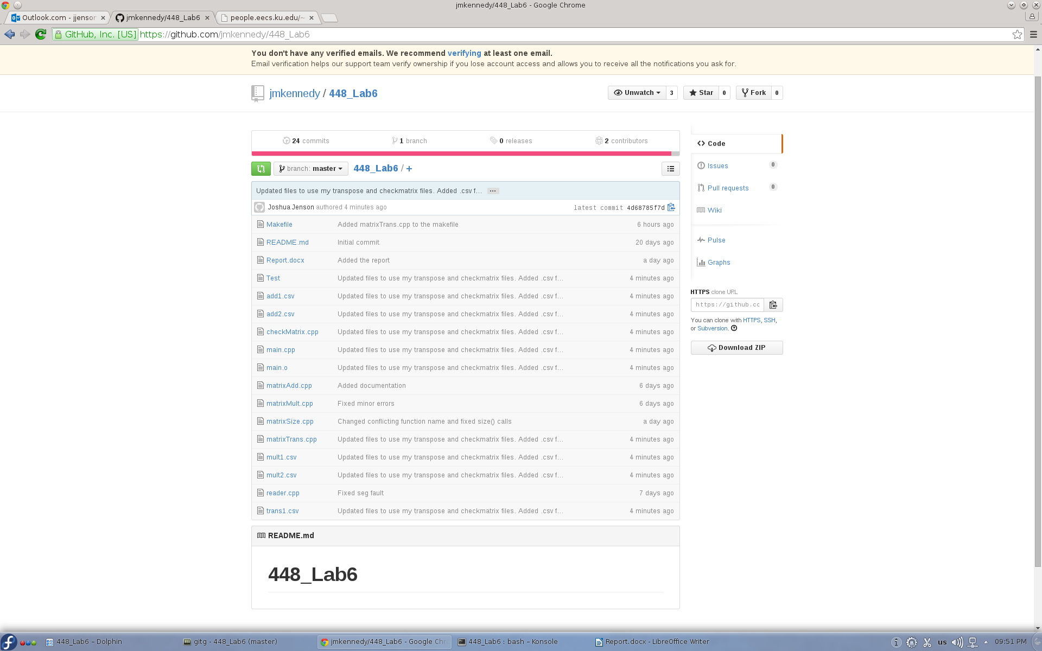

**Program Output**

